Weekly Progress Report for Liu Weihao for period 07 Mar 2022 to 21 Mar 2022
1 to 2 pages long. Send by e-mail to CK Tham (eletck@nus.edu.sg) by 9am on Monday.

Describe significant tasks that take more than 2 hours in bullet points with a short description.
If you have found and read a useful article, include the URL or attach the paper.

A. Major Tasks accomplished in past 1 week (indicate approx. no. of hours spent)

Readings:

Design & Development:
- Complete Blockchain part with Arunawa. Now we can upload data to blockchain, select consensus node. (25 hours)
- Integrate Blockchain, SAC, Rpi program. SAC program will upload all the data which DDQN need. (8 hours)
- Re-design SAC program, add a pretraining part. After that, we will ues the real data to train the model. (10 hours)
- Update Rpi program, generate some task, estimate Dn, Cn and tau_n. (8 hours)

Analysis, Algorithm/Protocol Devt, Results collection, Performance Evaluation:
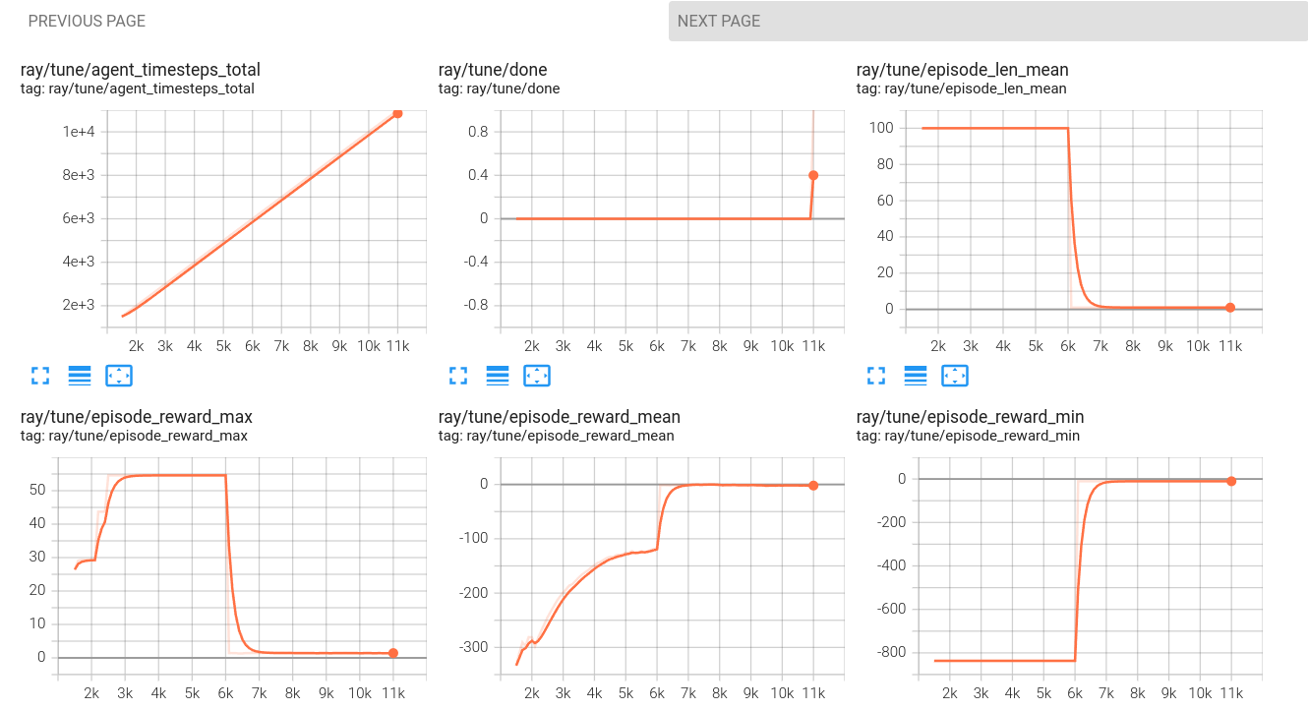

Technical paper writing/Presentation preparation:

B. Comments

Project Goals met:

Queries & Points for Discussion:

Problems encountered:

C. Plans for the next 1 week (indicate planned time where possible)

Readings:

Design & Development:

1. We need to design some spesicific senario, and verify the SAC and DDQN model could work properly.

Analysis, Algorithm/Protocol Devt, Results collection, Performance Evaluation:
- …
Technical paper writing/Presentation preparation:

