Special Topics in Automation and Control

Autonomous Systems: Unmanned Aerial Vehicles

Student ID: | A0232935A
Name: | Liu Weihao

1. Hardware Design
For a UAV, it requires a lot of sensors and hardware devices. Such as: MCU, image processor, GPS, communication model, attitude control sensor (RPM, gyroscope, accelerometer, etc.) and so on. In this part, I try to research these devices, and will give a general instruction.

1.1 MCU
MCU is the core of UAV control. It needs to integrate all his attitude sensors to control its attitude. Besides, after GPS and image sensor give it the position information, MCU needs to plan a path to a specified location.
At present, most of UAV manufacturers are using ARM or DSP as MCU. Because they RTOS, such as ArduPilot, could run on these platforms.
- The representative ARM-based chip is STM32, such as STM32F303, STM32F407.
- The DSP chips is mainly from TI, like TMS320C6678.
- TI also provides ARM-based chips, like TMS570LC4357-EP, RM41L232
Here, I choose STM32F303, TMS320C6678 and TMS570LC4357-EP to compare their parameters.
Table 1-1 MCU compare
 | STM32F303 | TMS320C6678 | TMS570LC4357-EP
CPU/DSP | ARM cortex-M4 | 8 C66x | ARM cortex-R5F
Frequency(MHz) | 150 | 1000,1250(Max) | 300
ADC | 12 Bit | / | 2 * 12-Bit
GPIO | 88 | 16 | 168
Power | 1W | 10W | 1.5W
Each of them can used for UAV control. We just need to choose the suitable chip according to the computing resources we need.

1.2 Image sensor and processors
Cameras are widely used in UAV navigation and target recognition. In the image process module, we need image sensor and processor (ISP).

1.2.1 Image sensor
There are many image sensor manufacturers, like SONY, SAMSUNG, OmniVision, GALAXYCODE, etc. The main parameters of the sensor include: sensor size, pixel size, resolution, frame rate. I chose three of them to compare these parameters.
Table 1-2 Image sensor compare
 | IMX317 | OS04A10 | GC4653
Sensor size | 1/2.5 inch | 1/1.8 inch | 1/3 inch
Pixel size | 1.62 µm | 2.9 µm | 2.0 µm
Resolution | 8 MP | 4 MP | 4 MP
Frame rate | 60 FPS | 30×3 FPS | 60 FPS
The sensor should match the lens we chose. The pixel size should close the radius of Airy disk, which can be expressed as:
is the diameter of Airy disk, is the wavelength of the light in meters, is the f-number of a lens. In our project, we can assume .

1.2.2 Image processor
Although some MCU can also process the image signal, but most of them don’t have MIPI interface. Besides, if we want use some open resources programs like OpenCV, we need a linux system rather than RTOS.
Same as other modules, there are many ISP manufacturers, such as HUAWEI Hisilicon, Sigmastar, Novatek, etc. The most commonly used chip include Hi3516, SSC337, NT98566.
The Hi3516 Functional Block Diagram is as follow.
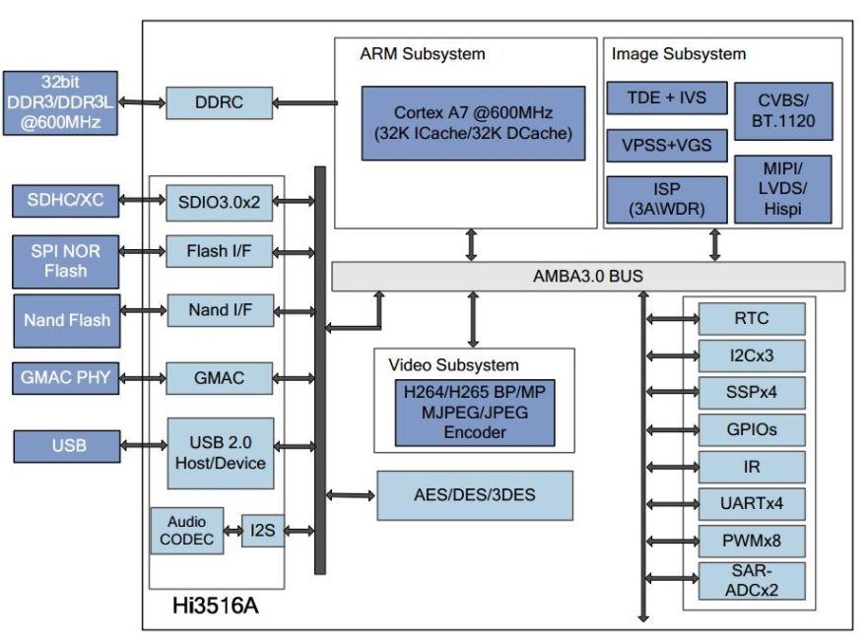
Figure 1-1 Hi3516 Functional Block Diagram
The total power of ISP and image sensor is less than 2W.

1.3 Communication Module
In our project, the aisle length only 80m, so we don’t need long distance commu-nication, Wi-Fi is enough. So I decide to use 802.11 b/g/n protocol. In the this module, we need PHY chip and Wi-Fi chip. Because we don’t need too much features, I just pick two chips randomly.
PHY: BCM5421
Wi-Fi: RTL8188
That’s enough for our project.

1.4 Hardware choice and Power Consumption
In conclusion, I chose the following devices.
MCU: STM32F303
Image sensor: GC4653
Image processor: SSC337
Communication: BCM5421+RTL8188
Then we can assume that the chips, PCB and lens weigh about 0.5 Kg, the motor, structural components, and battery weigh about 1.5 Kg. The total weigh is about 2Kg. We can choose X3508S-700KV as our motor, and a 4S5000 mAh battery. The total power consumption is about 240W, the endurance of UAV more than 30 minutes.

2. Autonomous flight control
In our project, we need indoor navigation algorithm, so I choose Stereo Vision SLAM Algorithm and Inertial navigation.
If we have two cameras, we can calculate the three-dimensional coordinates of the object.
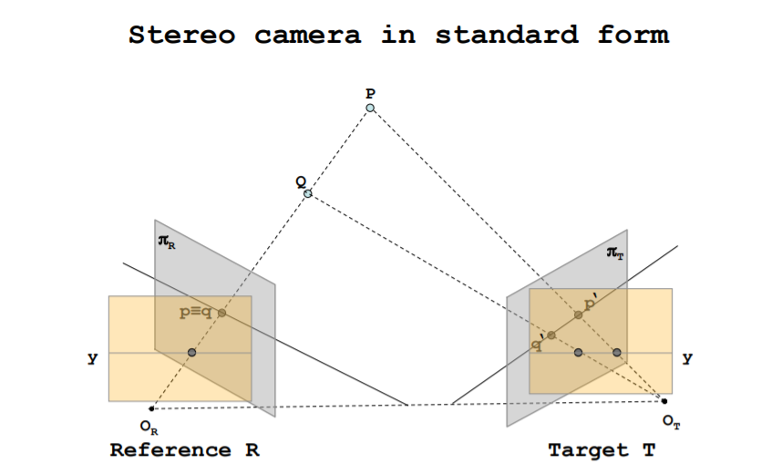
Figure 2-1 Stereo vision
After that, we can use slam algorithm to build the model of the interior space. Then use A* algorithm to find the shortest path to our target. When UAV is moving, we can use Kalman filtering to combine the data from camera and other sensors like accelerometer.

