
Sri Lanka Institute of Information Technology

SE2030 – Software Engineering
Year 2, Semester 1- 2026

Web-Based Event Planning System (Evenza)
Lab 03 – Use Case Diagram

2026-Y2-S1-MLB-B10G1-02

IT Number | Name
IT25101514 | Chathuranga B. G.
IT25102322 | Wickramarathna W. L. S.
IT25103301 | Keshavan M.
IT25100916 | Suriyage O. W.
IT25102923 | Gunasekara N. B.
IT25100220 | Wickramasinghage C. P. W.
1. Complete Use Case Diagram

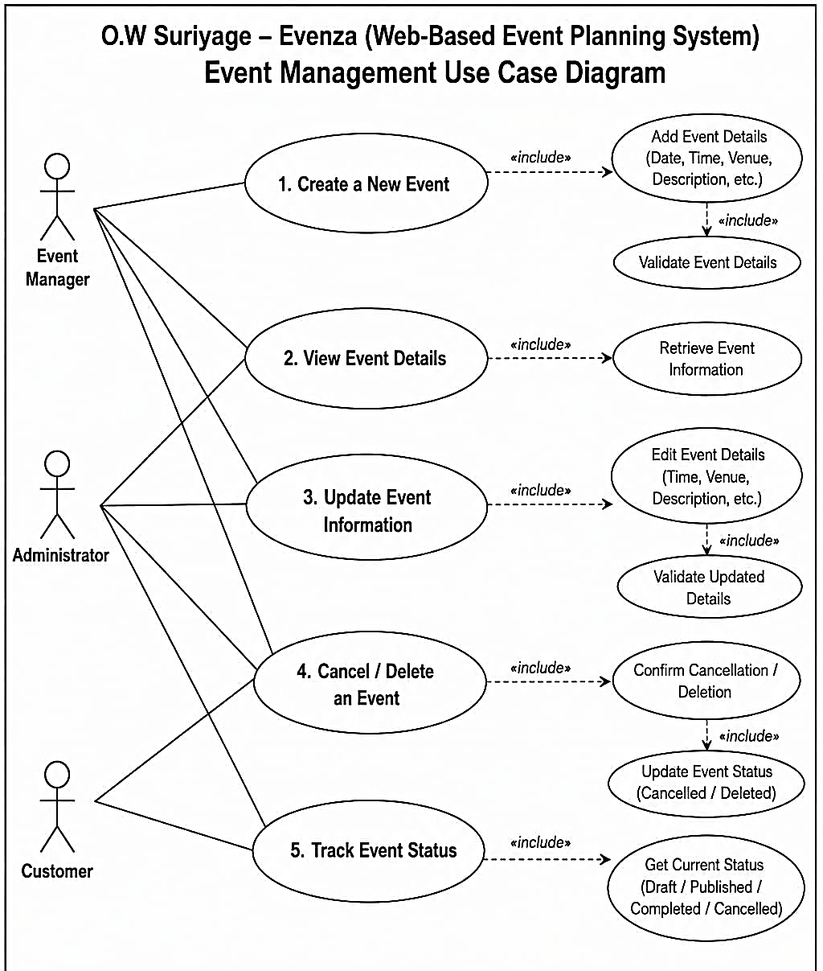

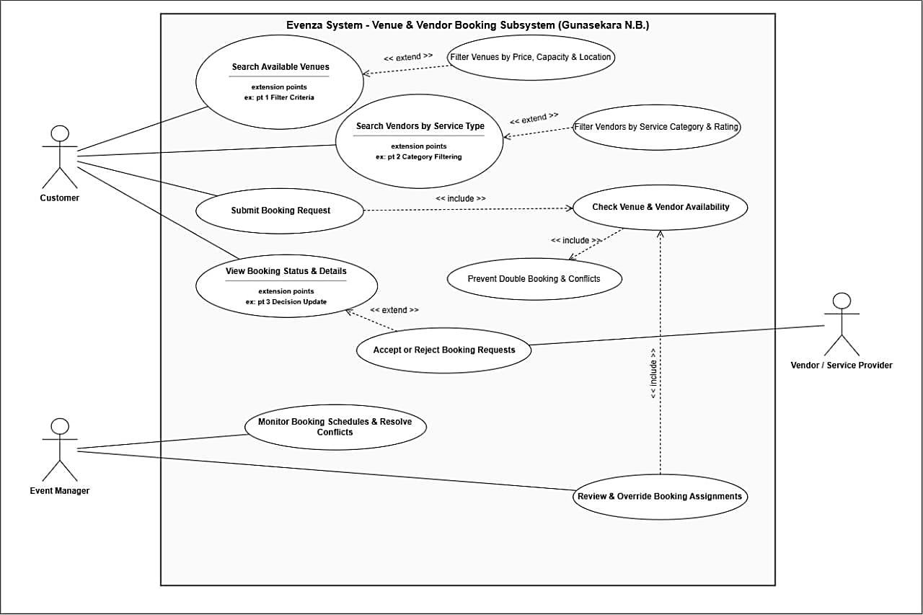
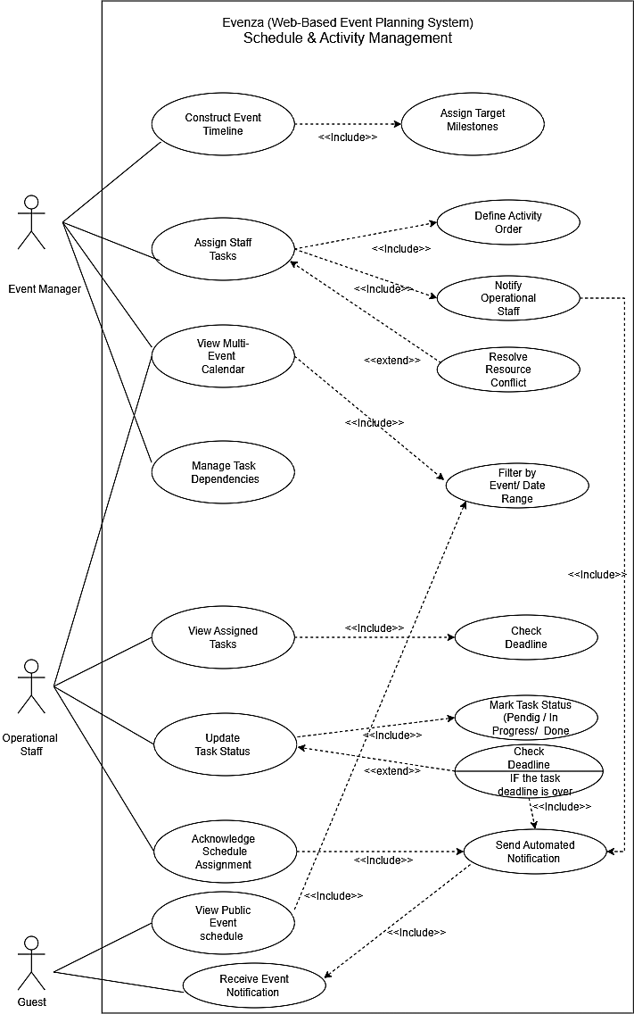
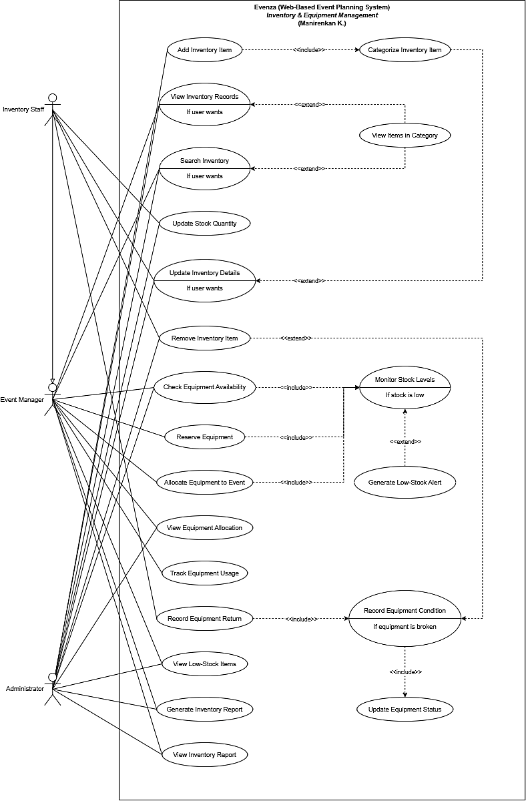
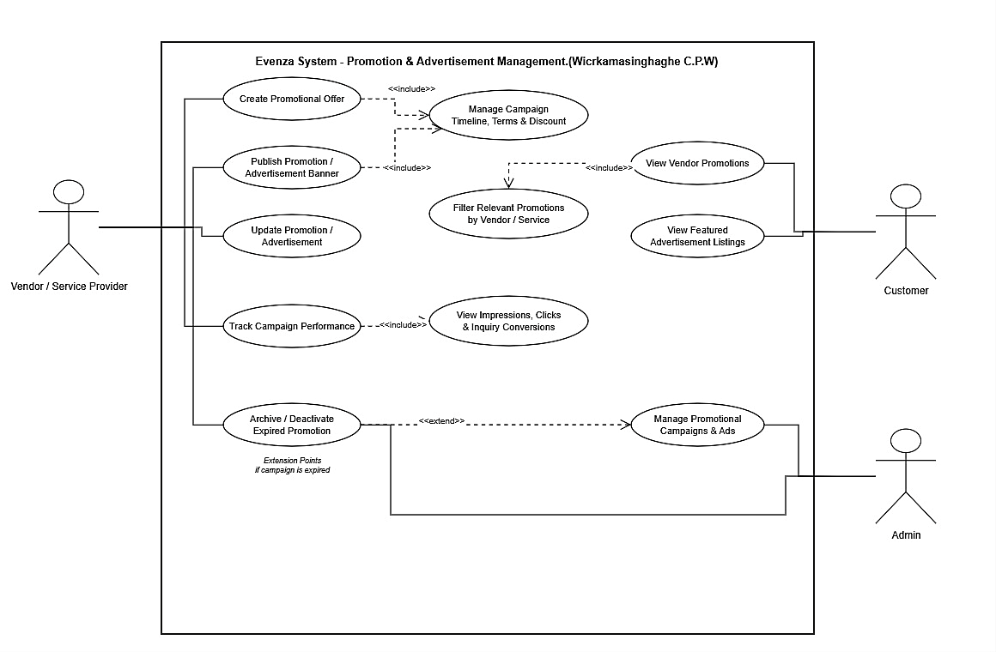

2. Individual Use Case Scenarios
Inventory & Equipment Management – Manirenkan K.
Number | 1
Name | Add Inventory Item
Summary | Inventory Staff adds a new inventory item to the system, including the item's category.
Priority | 5
Preconditions | Inventory Staff are logged into the system.
Postconditions | A new inventory item is created and stored, with a category assigned.
Primary Actor(s) | Inventory Staff
Secondary Actor(s) | None
Trigger | Inventory Staff choose to add a new inventory item.
Main Scenario
  Step | Action
  1 | System displays the Add Inventory Item form.
  2 | Inventory Staff enters item details (name, quantity, unit, condition, etc.).
  3 | System prompts for item category.
  4 | Inventory Staff selects or creates a category (includes Categorize Inventory Item).
  5 | Inventory Staff submits the form.
  6 | System validates the entered data.
  7 | System saves the new inventory item and displays a confirmation message.
Extensions
  Step | Branching Action
  6a | If validation fails, system displays an error message and returns to Step 2.
Open Issues | Should duplicate item names within the same category be allowed?

