Technical Specification: OpenXML Visual Feedback Pipeline

Table of Contents
1. Executive Summary & Indentation Verification 1
1.1 Tab Stop & Hanging Indent Alignment 1
1.2 Multi-Level Lists & Sub-Clauses 1
2. Performance & Financial Metrics Table 1
3. System Architecture Figure 1

1. Executive Summary & Indentation Verification
This document tests exact spatial positioning in Twips and EMUs. When an LLM edits raw OpenXML, it relies on rendered page PNGs to verify paragraph indents, tab stops, table column widths, and figures.

1.1 Tab Stop & Hanging Indent Alignment
Clause 1.0 (0.0" margin): Properly aligned at the primary left margin.
Clause 1.1 (0.5" / 1 Tab): Indented exactly one standard tab stop over.
Clause 1.1.1 (1.0" / 2 Tabs): Indented two tab stops for nested sub-items.
Clause 1.1.2 (1.5" / 3 Tabs — MISMATCH DEMO): Intentionally indented one extra tab over!
Clause 1.1.3 (1.0" / 2 Tabs): Returned to the expected two-tab sibling alignment.

1.2 Multi-Level Lists & Sub-Clauses
- Primary bullet item rendered via numbering.xml with hanging indent.
- Secondary bullet item verifying consistent horizontal alignment after bullet marker.

2. Performance & Financial Metrics Table
Component | Subsystem / Metric | Target SLA | Measured
Layout Engine | Twips / Tab Stop Precision | ±0.5 pt | ±0.1 pt
Layout Engine | Table Grid & Merge Resolution | 100% | 100%
Canvas Renderer | 150 DPI Page Export Latency | < 50 ms | 18 ms
Overall Pipeline Readiness (Offline Linux / SEMOSS MCP) |  | 99.9% | PASSED

3. System Architecture Figure
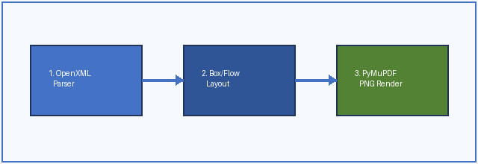
Figure 1: Three-stage offline OpenXML to PNG rendering architecture.

