AvB

Upregulated genes: 60

Downregulated genes: 215

Maximum p value: 1.0

Minimum p value: 9.164259e-16

Median p value: 0.19

Standard deviation of p value: 0.32

Maximum 2 fold log: 20.89575

Minimum 2 fold log: -25.53405

Median 2 fold log: -0.01

Standard deviation of 2 fold log: 1.12

AvE

Upregulated genes: 561

Downregulated genes: 921

Maximum p value: 1.0

Minimum p value: 3.8458470000000005e-219

Median p value: 0.05

Standard deviation of p value: 0.31

Maximum 2 fold log: 22.73216

Minimum 2 fold log: -24.8829

Median 2 fold log: -0.02

Standard deviation of 2 fold log: 1.43

As the pvalues did not form a normal distribution, it was determined that the median value would be of more use than the mean.

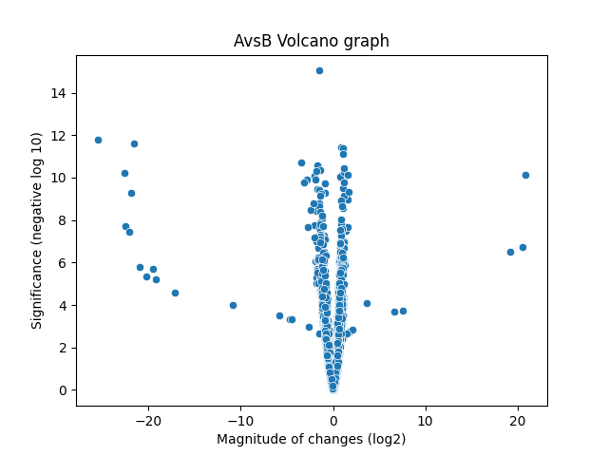

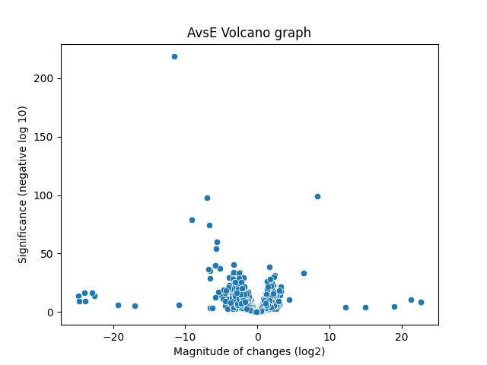

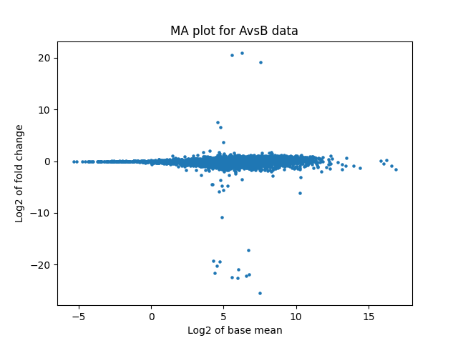

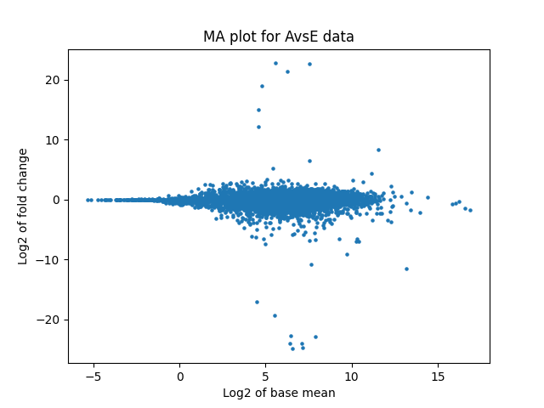

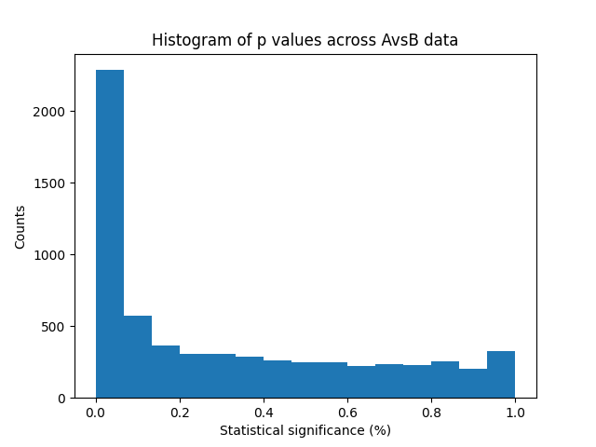

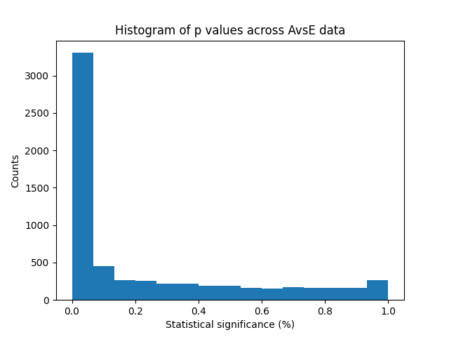

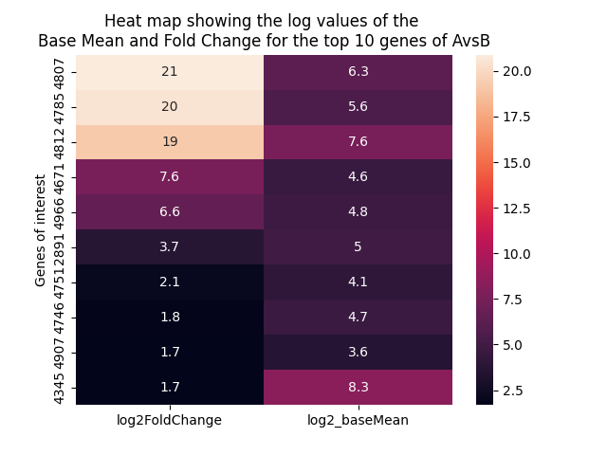

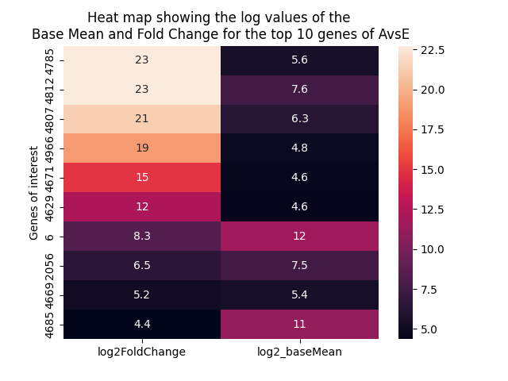

|  |  |  |  |
| --- | --- | --- | --- |
| gene_id | log2FoldChange | pvalue | padj |
| YIL172C | 3.686138 | 0.00007750669 | 0.001220093 |
| YJL199C | -3.490265 | 2.012898E-11 | 0.00000001788029 |
| YJL221C | -21.56839 | 2.53946E-12 | 0.000000005262751 |
| YNCB0007W | -19.46467 | 0.000001904566 | 0.00007231587 |
| YNCB0013W | -2.708207 | 0.00000002118546 | 0.000002311074 |
| YNCC0007C | -2.611889 | 0.001061201 | 0.008834469 |
| YNCD0001W | -21.89101 | 4.995415E-10 | 0.0000001001984 |
| YNCD0004W | -10.81875 | 0.00009998116 | 0.001498031 |
| YNCD0007C | -2.401159 | 0.000000003440592 | 0.0000004862183 |
| YNCD0031C | 7.573808 | 0.0001760534 | 0.002358243 |
| YNCD0034C | -2.129494 | 0.000000001640577 | 0.0000002550277 |
| YNCE0028C | -2.867877 | 1.188376E-10 | 0.00000003358783 |
| YNCG0005W | -25.53405 | 1.586634E-12 | 0.000000004932845 |
| YNCG0009C | -22.48238 | 0.00000001911268 | 0.000002160775 |
| YNCG0017W | -4.718408 | 0.0004686992 | 0.004889886 |
| YNCG0018C | -22.12039 | 0.0000000349134 | 0.000003392055 |
| YNCG0024W | -2.008036 | 8.072031E-11 | 0.00000002788438 |
| YNCG0032W | -20.22577 | 0.000004458327 | 0.0001379198 |
| YNCG0039W | 2.062648 | 0.001450917 | 0.01139133 |
| YNCI0010C | 20.49454 | 0.0000001893933 | 0.00001239629 |
| YNCJ0005C | -22.6399 | 5.844017E-11 | 0.00000002595579 |
| YNCJ0008W | -3.095671 | 1.655288E-10 | 0.00000004117033 |
| YNCJ0018W | -17.15844 | 0.00002735521 | 0.0005382743 |
| YNCJ0019C | 20.89575 | 7.708091E-11 | 0.00000002788438 |
| YNCJ0024W | 19.2018 | 0.0000003238643 | 0.00001974302 |
| YNCL0001W | -5.845278 | 0.0003198106 | 0.003710041 |
| YNCL0032C | -19.22198 | 0.000006209802 | 0.0001771218 |
| YNCM0022C | -20.96729 | 0.000001650254 | 0.00006453634 |
| YNCN0017W | -4.505594 | 0.0004673985 | 0.004884511 |
| YNCP0007C | 6.604124 | 0.0002006194 | 0.002598857 |

As the list of significant AvsE genes is over 300 rows long, I did not include them in this Word document, however a CSV file is generated by running the accompanying script.

Significance was defined as having a log2fold change of either above 2 or below -2, and a p value of less than 0.05%.