Question 2:

The heaviest pumpkin was 2725-P in the year 2725, which was a Knuclehead. It was from Chicago in Place 60 and weighed 2707.788 lb

Qu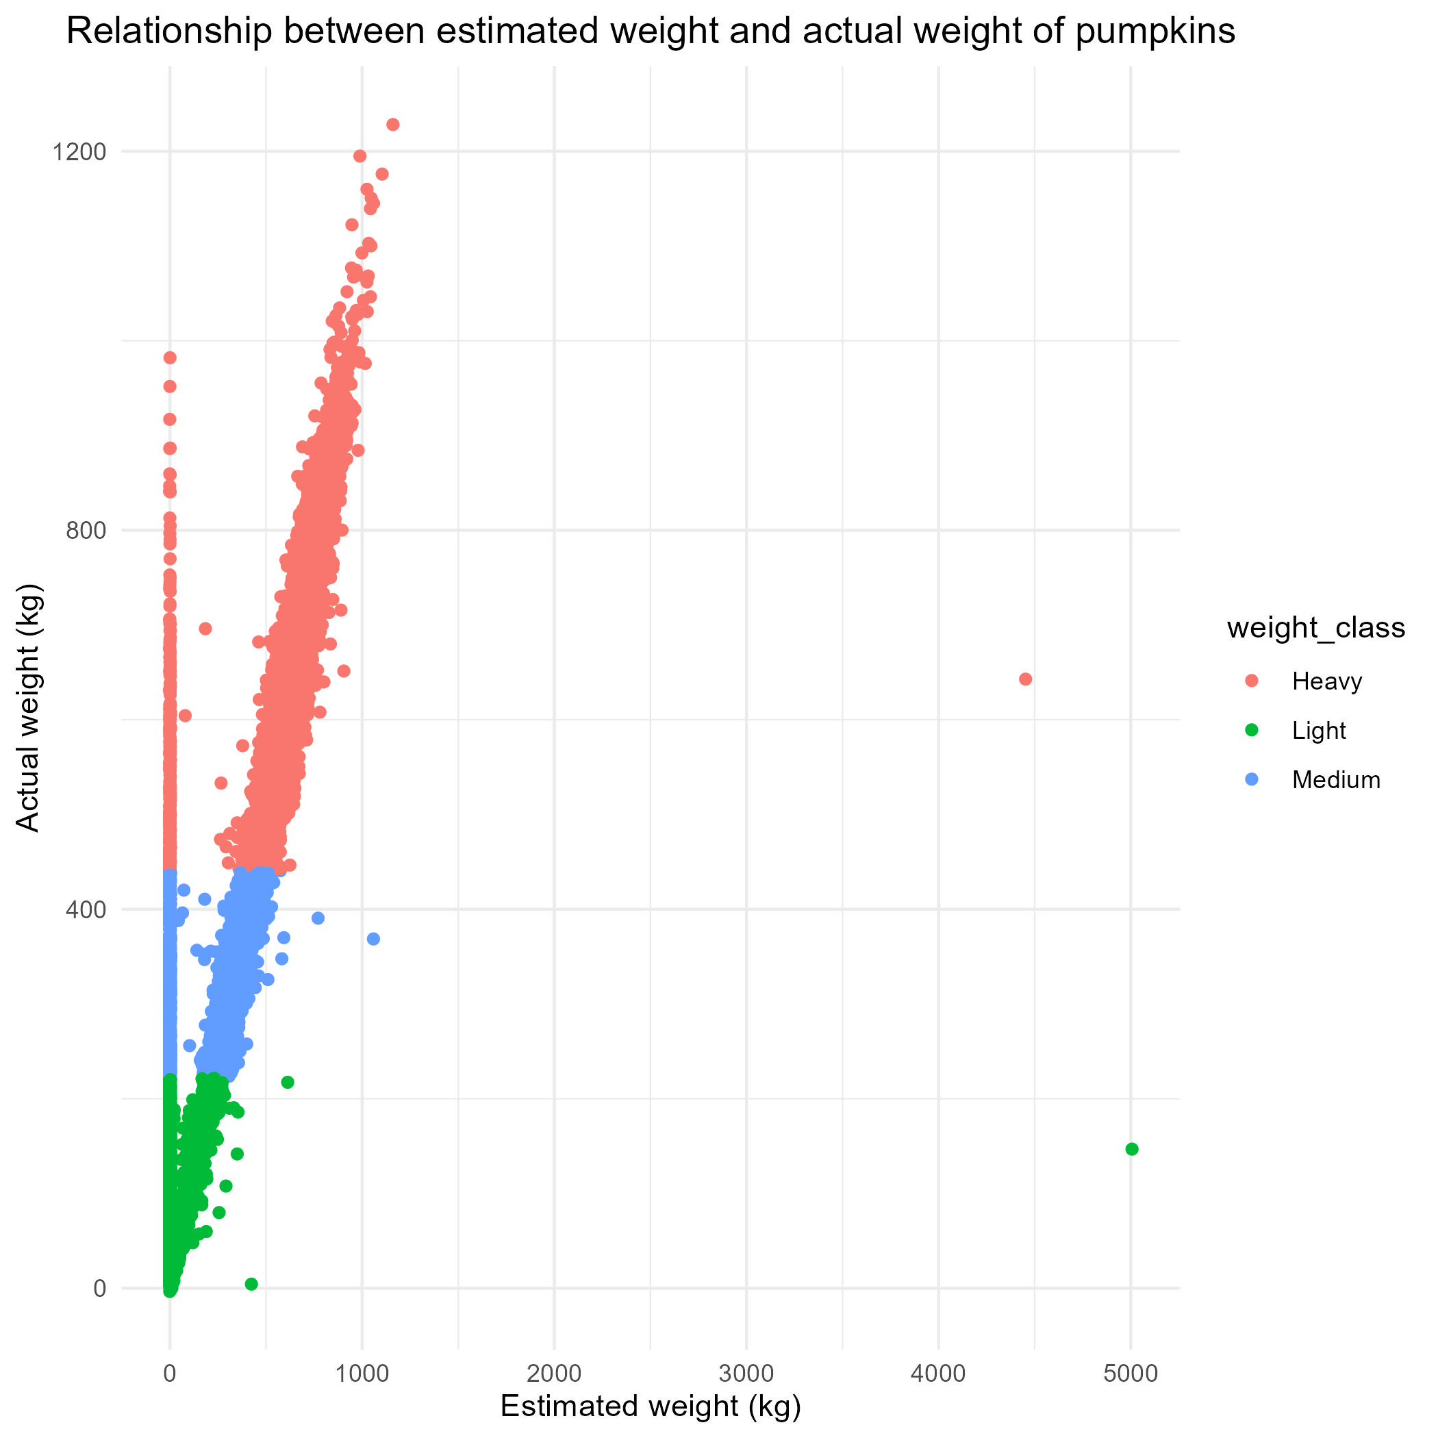estion 5:

The graph shows that there is a strong relationship between the estimated weight and the actual weight, however there are a large number of estimated weights that are significantly below the actual weight, and two estimates that are much higher than any actually recorded pumpkin.

Question 7:

a) The country with the highest mean pumpkin weight was Canada, with a mean weight of 360.40kg

b) The variety in the country with the lowest mean weight was the Jarrahdale in Canada

Question 8)

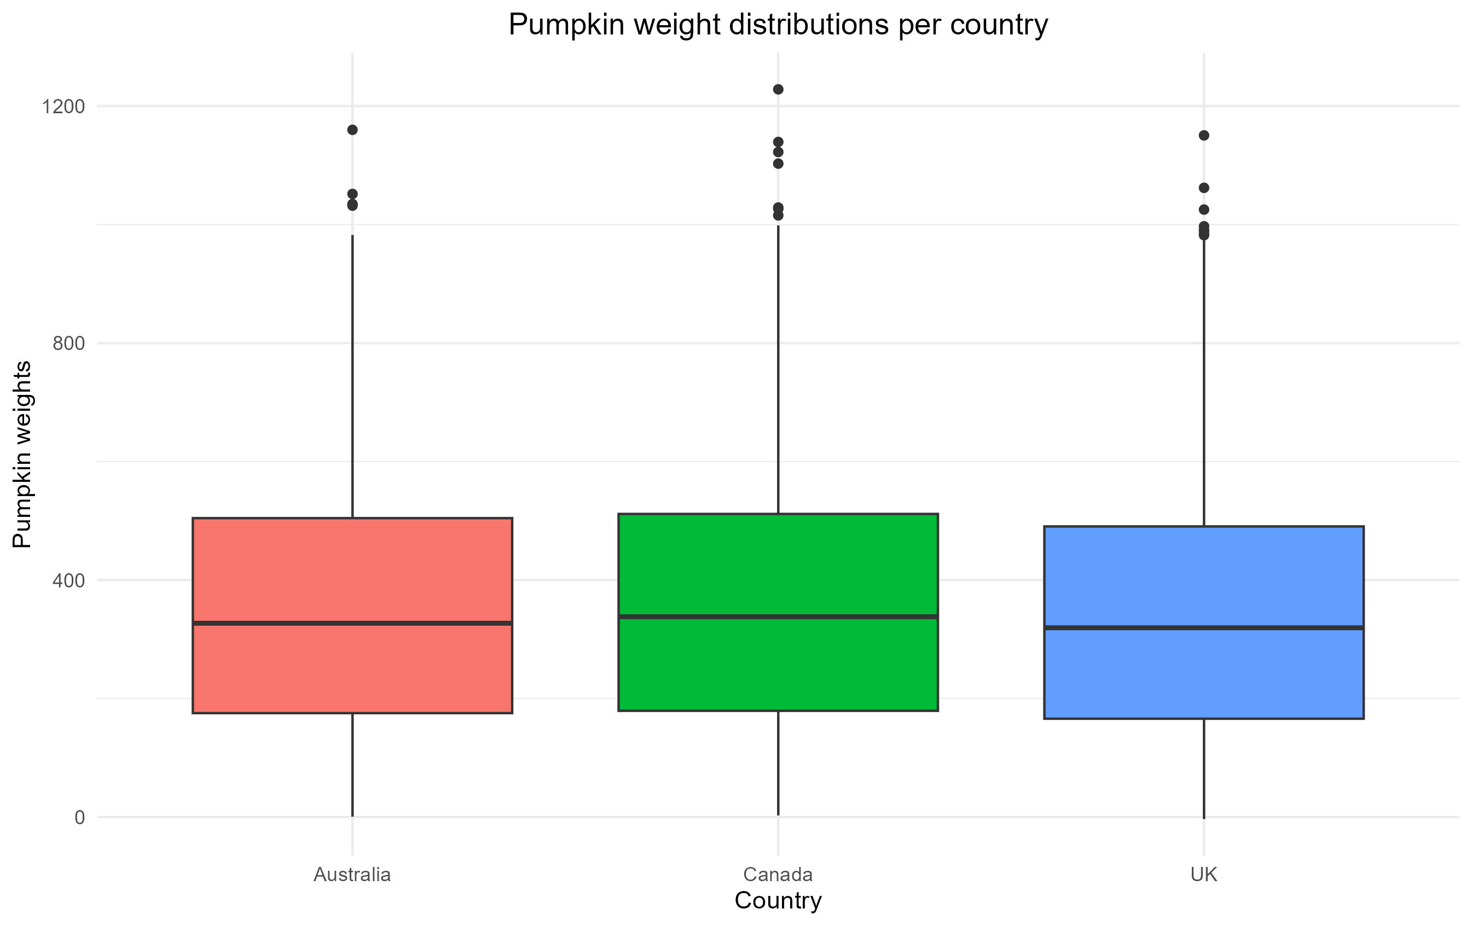

This plot shows that there are no dramatic differences in the distribution of pumpkin weights across the UK, Canada or Australia.

Question 9)

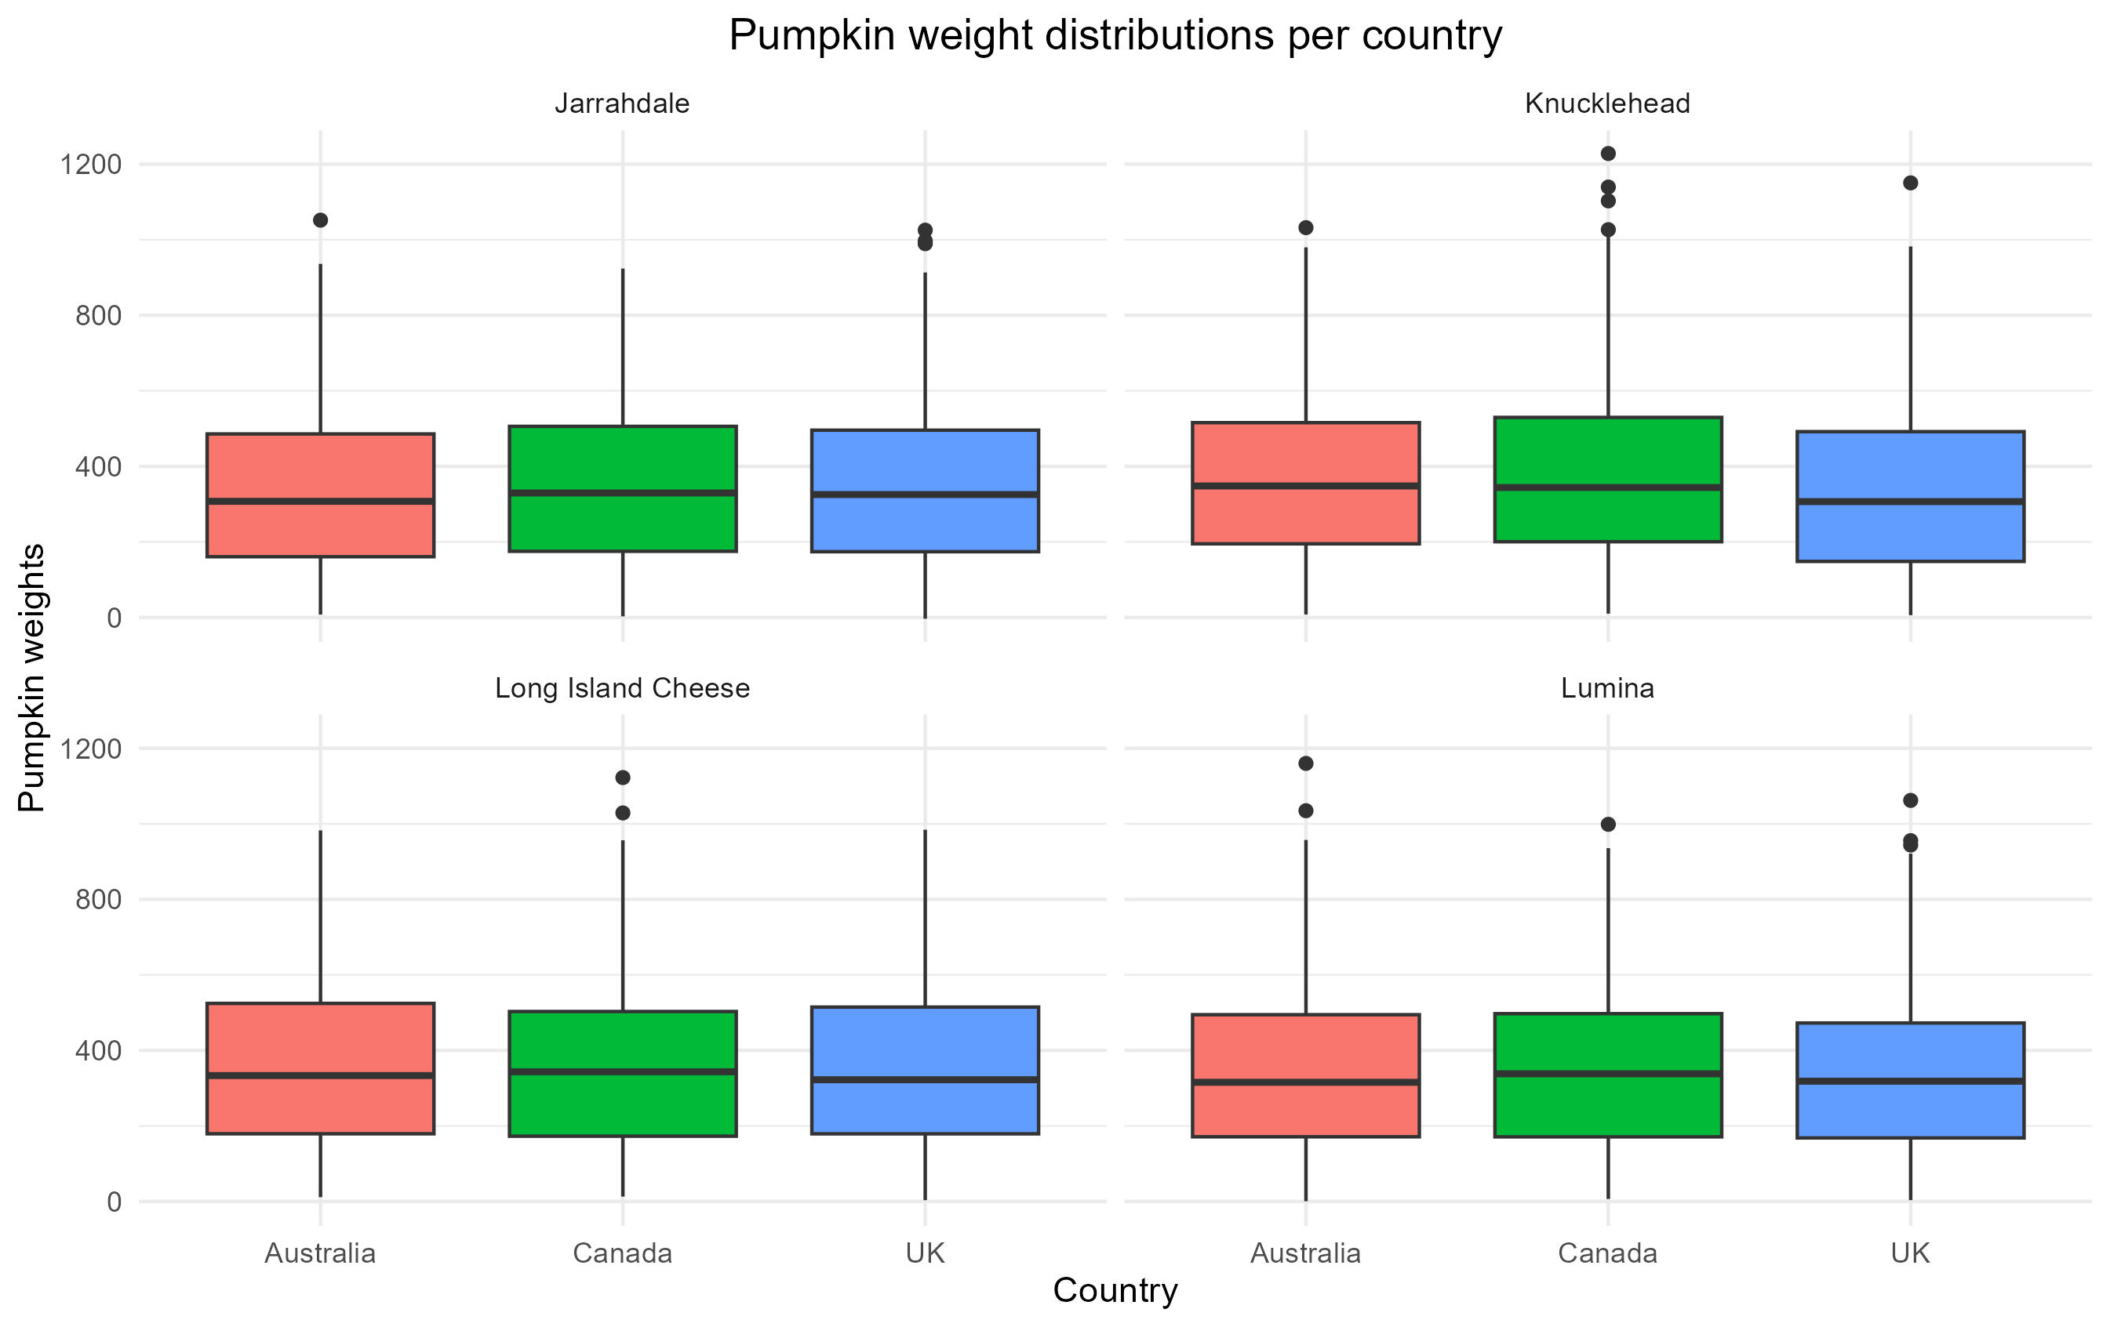

This plot shows that the Knucklehead in Canada has the most pumpkins that are outside of the usual distribution, and may be causing a skewing of the mean weight of pumpkins in Canada.