# [Site name] Site Plan

## [Erik Woodruff]

## WDD 130

## Overview

### Purpose

The purpose of this website is to provide learning and information about swimming and to engage everyone of all ages with a target towards parents and their children.

### Audience

Children and parents

## Branding

### Website Logo

## Style Guide

### Color Palette

|  |  |  |  |
| --- | --- | --- | --- |
| **Primary** | **Secondary** | **Accent 1** | **Accent 2** |
| 5BC0EB | 0D1321 | 1AFFD5 | FFEDDF |

### Typography

#### Heading Font: Noto Serif

#### Paragraph Font: Atma

#### .atma-light {

#### font-family: "Atma", system-ui;

#### font-weight: 300;

#### font-style: normal;

#### }

#### .atma-regular {

#### font-family: "Atma", system-ui;

#### font-weight: 400;

#### font-style: normal;

#### }

#### .atma-medium {

#### font-family: "Atma", system-ui;

#### font-weight: 500;

#### font-style: normal;

#### }

#### .atma-semibold {

#### font-family: "Atma", system-ui;

#### font-weight: 600;

#### font-style: normal;

#### }

#### .atma-bold {

#### font-family: "Atma", system-ui;

#### font-weight: 700;

#### font-style: normal;

#### }

### Navigation

Home Page2 [Swim tutorials] Page3 [History of Swim Olympics/world History]

**Content**

[put all content for the pages here, including written text and images]

Home Page

Who we are: We are a Company who seeks to educate children and parents about swimming and to make it engaging and to spread enthusiasm to everyone about swimming.

Mission: The purpose of this website is to provide learning and information about swimming and to engage everyone of all ages with a target towards parents and their children.

Goal: Our goal is to appeal the fun swimming can be and to encourage young children to be active and healthy, and to appeal the fun parents can have with their children in swim.

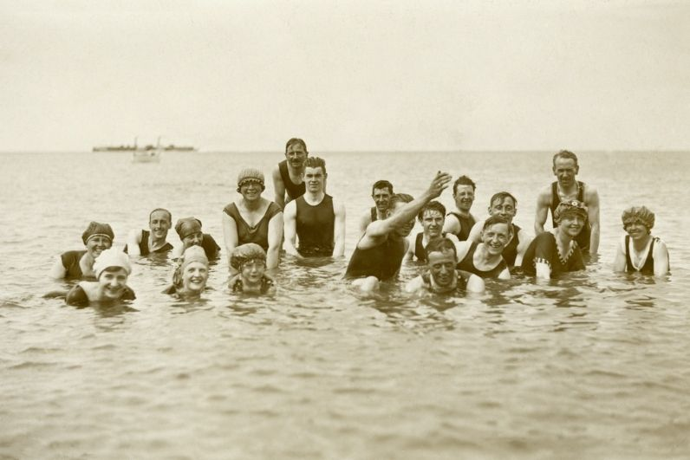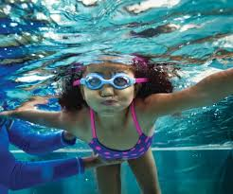

Swim tutorial Page:

**🐸 1. Breaststroke – “The Frog Kick”**

This stroke is smooth, slow, and great for beginners!

**How to do it:**

* **Body**: Keep your body flat like you're floating.
* **Arms**: Scoop your arms out in front of you in a circle, then bring your hands together under your chest.
* **Legs**: Bend your knees and kick your legs out like a frog, then snap them together.
* **Breathing**: Lift your head to breathe when your arms scoop.

**Tips:**

* Glide between strokes like you're sliding through the water.
* Keep your movements gentle and steady.

**🏊‍♀️ 2. Freestyle – “Front Crawl”**

This is the fastest and most common stroke.

**How to do it:**

* **Body**: Stay flat and straight in the water.
* **Arms**: Reach forward one arm at a time and pull the water back past your hip.
* **Legs**: Kick your legs up and down quickly and gently.
* **Breathing**: Turn your head to the side to breathe every few strokes.

**Tips:**

* Try not to lift your head too high—just turn it like you're peeking to the side.
* Kick from the hips, not the knees.

**🐬 3. Butterfly – “The Dolphin Stroke”**

This stroke is powerful and fun—but takes practice!

**How to do it:**

* **Body**: Use a wave-like motion with your whole body.
* **Arms**: Swing both arms together out of the water, then pull them back under together.
* **Legs**: Keep your legs straight and kick them like a dolphin tail—both legs at once.
* **Breathing**: Lift your head forward to take a breath after every 1 or 2 strokes.

**Tips:**

* Try saying “kick-pull-breathe” to keep the rhythm.
* Stay low over the water—don’t jump too high.

**🐢 4. Backstroke – “Float and Paddle”**

This stroke is done on your back—it feels like floating!

**How to do it:**

* **Body**: Lie flat on your back, ears in the water.
* **Arms**: Lift one arm up and back over your head, then pull it through the water down to your side. Alternate arms like a windmill.
* **Legs**: Kick your legs up and down gently.
* **Breathing**: You’re on your back, so just breathe normally!

**Tips:**

* Keep your tummy up and chin back.
* Use smooth arm circles, and look up at the ceiling or sky.

**🏅 Encouraging Words for Kids:**

* "Take your time and practice each part!"
* "Every swimmer learns at their own pace!"
* "Have fun—splashing is part of learning!"
* "The more you practice, the better you’ll float, kick, and glide!"

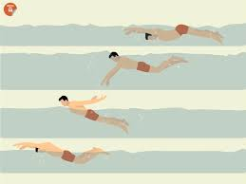

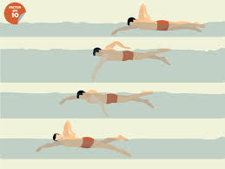

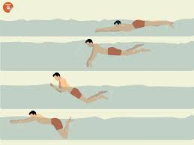

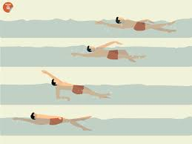

**History page:**

<https://www.olympics.com/en/news/the-history-of-olympic-swimming> [Reference page]

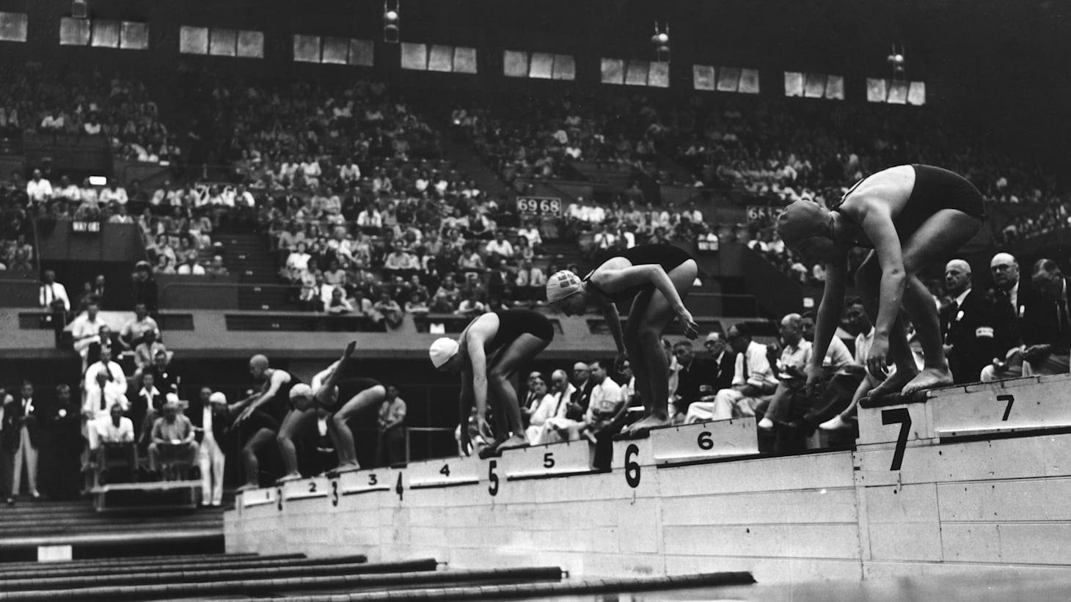

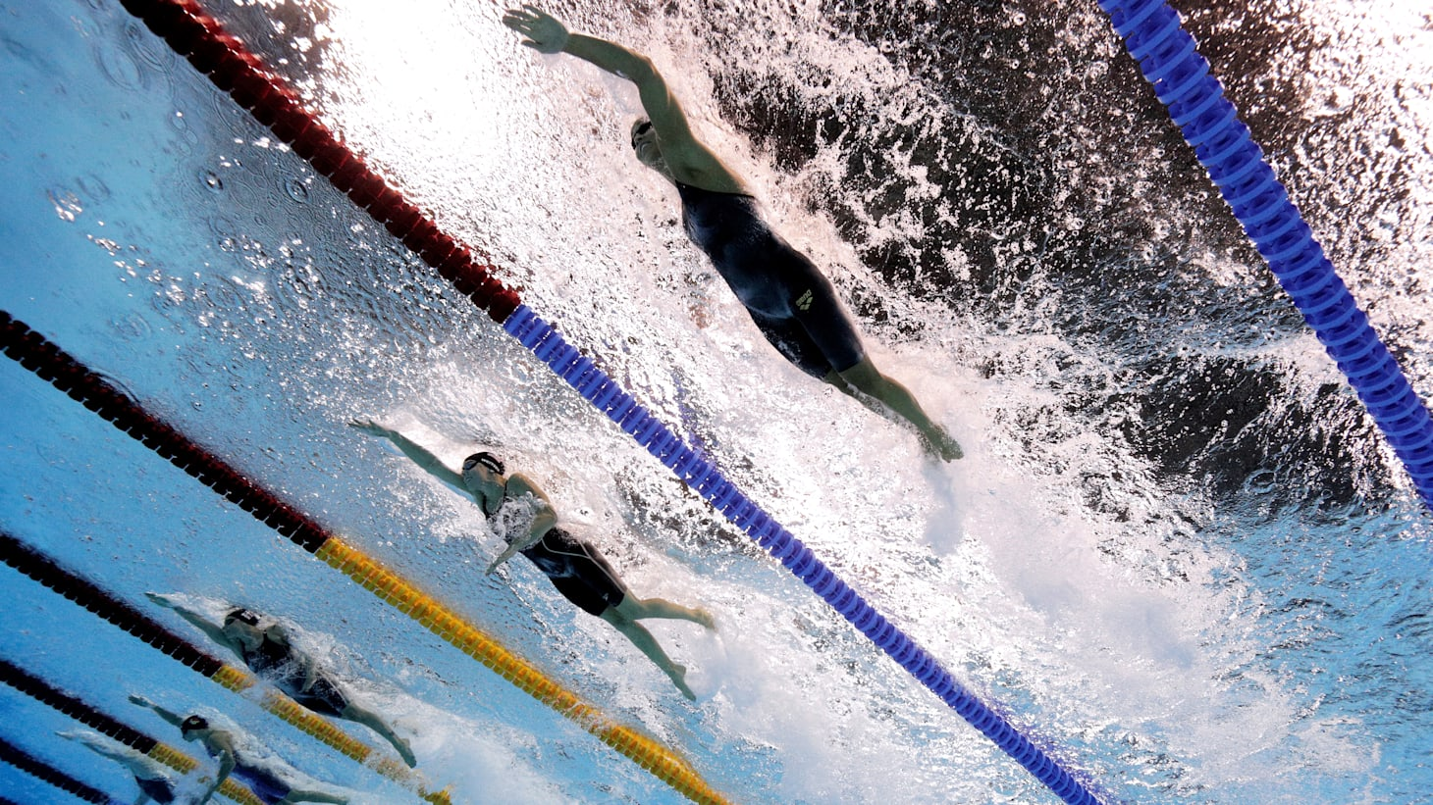

**🏊‍♂️ The Story of Olympic Swimming – Made Simple**

**Did you know people have been swimming for thousands of years? The Ancient Egyptians swam in the Nile for fun, while the Greeks and Romans used it to train soldiers. But how did swimming become an Olympic sport?**

**🏅 From Training to Competing**

* **1837: The first swimming group was formed in London.**
* **1846: Australia held the first swimming race championship.**
* **1896: Swimming became an Olympic sport at the very first modern Games in Athens.**
* **At first, only men were allowed to compete. Women joined in 1912, starting with just two races.**

**🌊 Rough Beginnings**

* **Early Olympic swimmers had to swim in open water like seas or rivers—cold and wavy!**
* **One swimmer said he swam not just to win, but to survive the cold water!**

**🏊‍♀️ Big Changes and Fast Swims**

* **Over time, pools became indoor and better designed—with lanes, smoother water, and warmer temperatures.**
* **Swimsuits also changed from heavy fabrics to sleek materials that help swimmers move faster.**

**⭐ Meet the Superstars**

* **Mark Spitz (USA): Won 7 gold medals in 1972.**
* **Kristin Otto (Germany): Won 6 golds in 1988—the most ever for a woman at one Games.**
* **Michael Phelps (USA): The greatest of all! He won 8 golds in 2008 and holds the record for most Olympic medals ever: 28!**

**🌟 A New Era: Swimming Together**

* **By Tokyo 2020, men and women finally had equal events.**
* **A brand-new race called the mixed 4×100m medley relay was introduced—teams of both men and women swimming together!**

**Swimming has come a long way—from ancient rivers to modern stadiums, and now to exciting mixed-gender races. Whether for fun or for gold medals, swimming continues to inspire people of all ages around the world! 🏊‍♂️🌍🥇**

**Wireframes**

### Home

