4. Prediction of Agriculture Crop Production In India



**Project Submission Report**



.

# 1 Brief on the Project

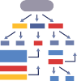

India is the second largest producer of wheat and rice, the world's major food staples. India is currently the world's second largest producer of several dry fruits, agriculture-based textile raw materials, roots and tuber crops, pulses, farmed fish, eggs, coconut, sugarcane and numerous vegetables

2 Deliverables of the Project



**1.**Firstly opened jupyter notebook. And upload the csv file.

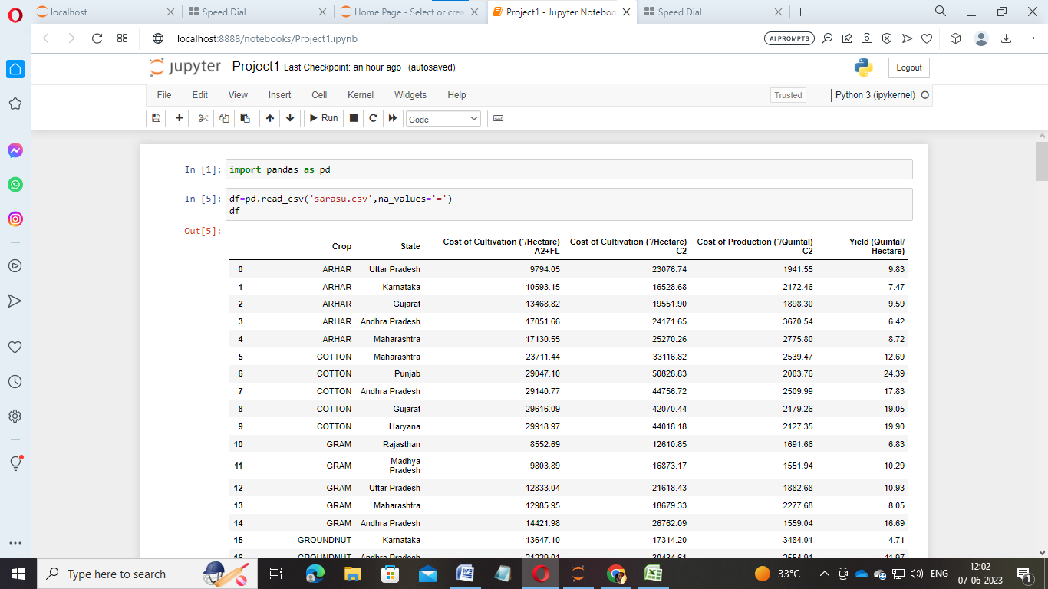

2.

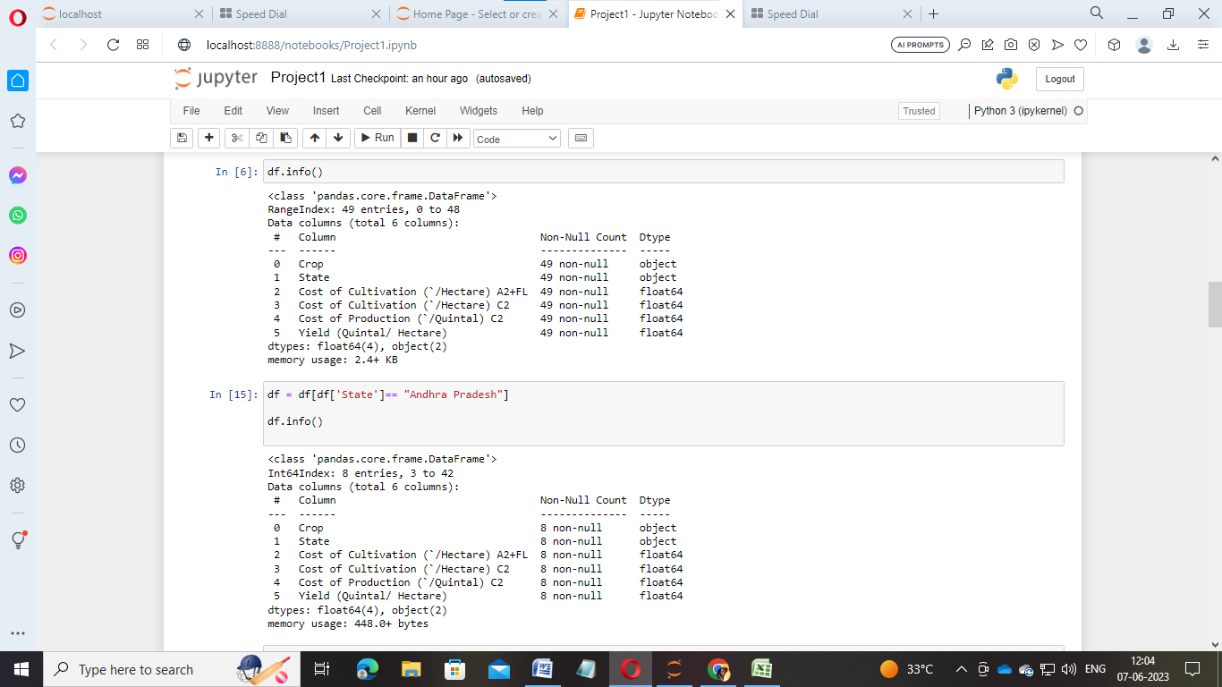

3.

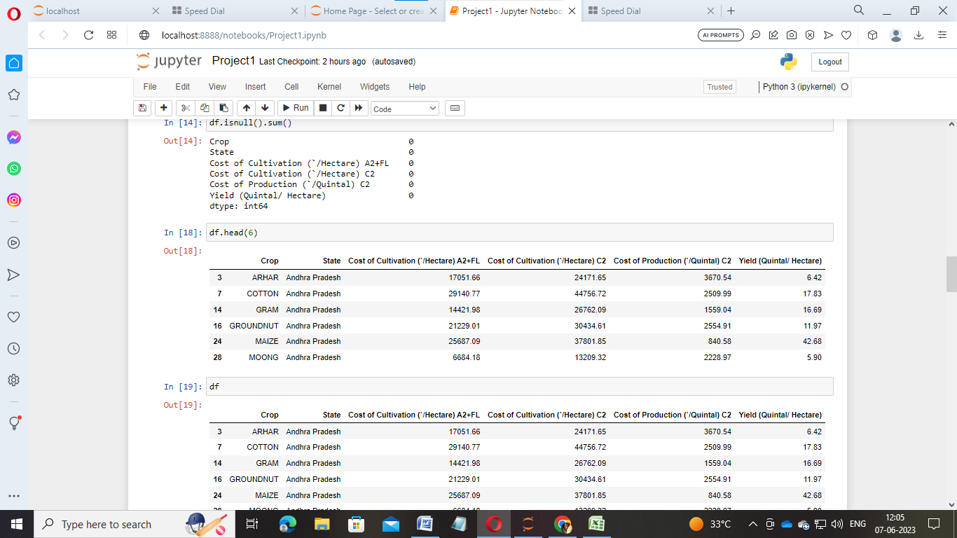

4.

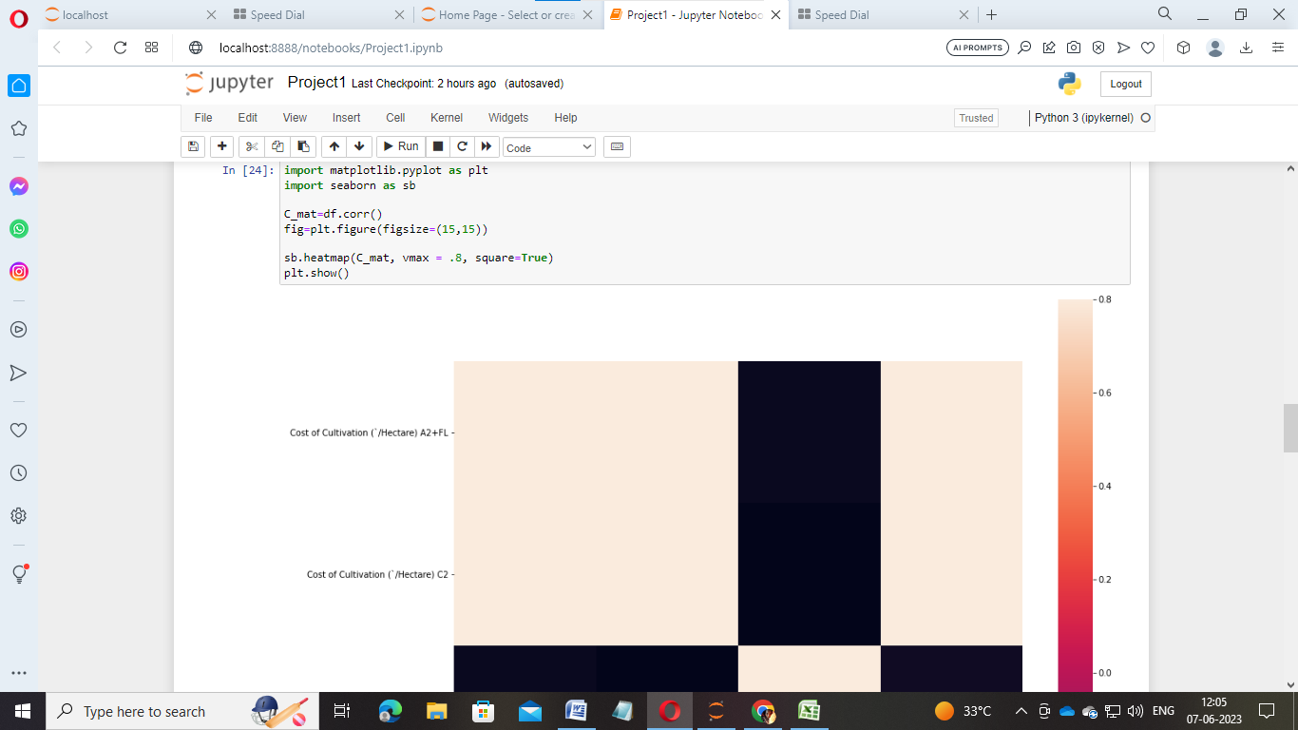

**5.**

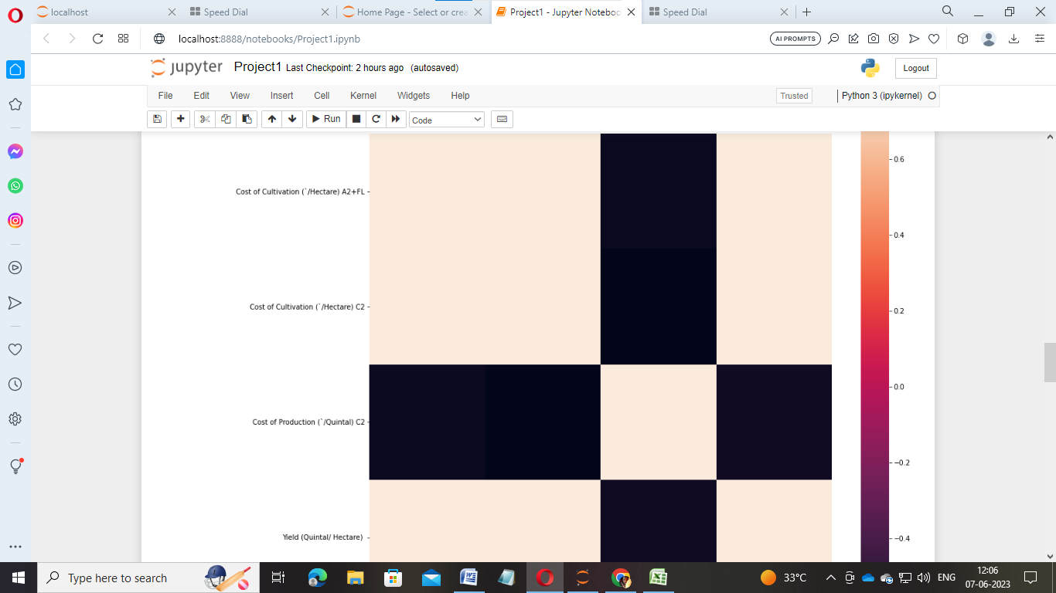

**6.**

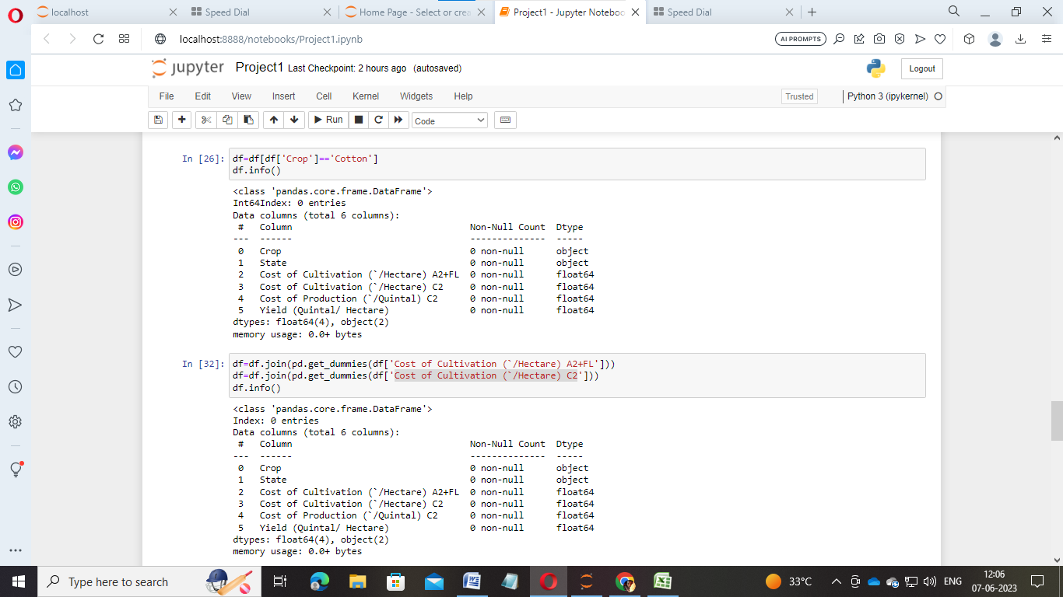

**7.**

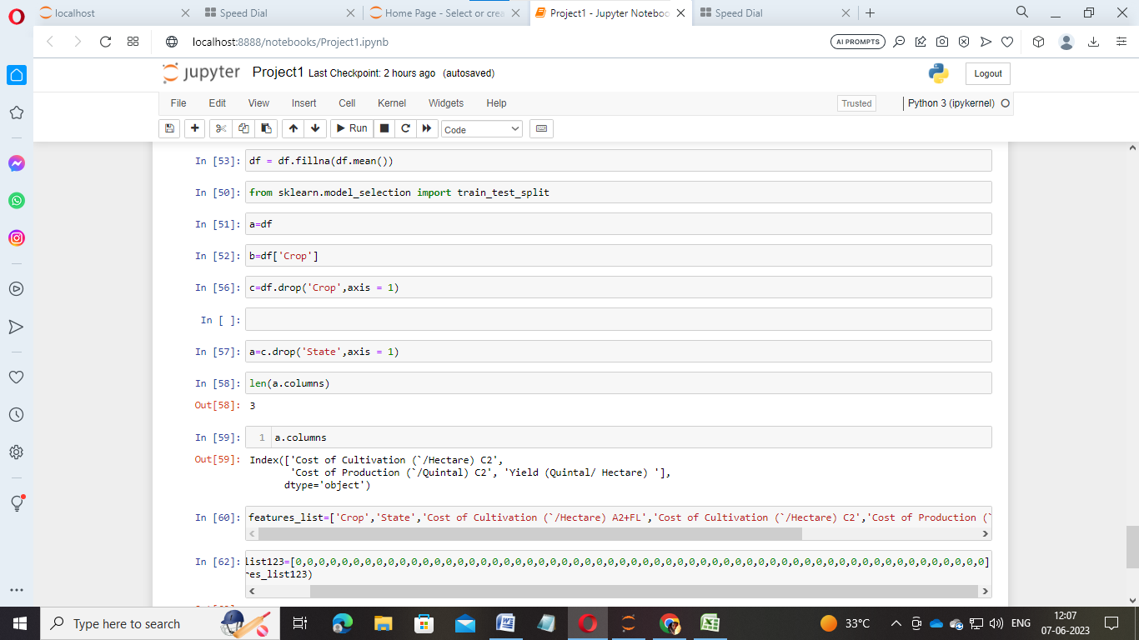

**8.**

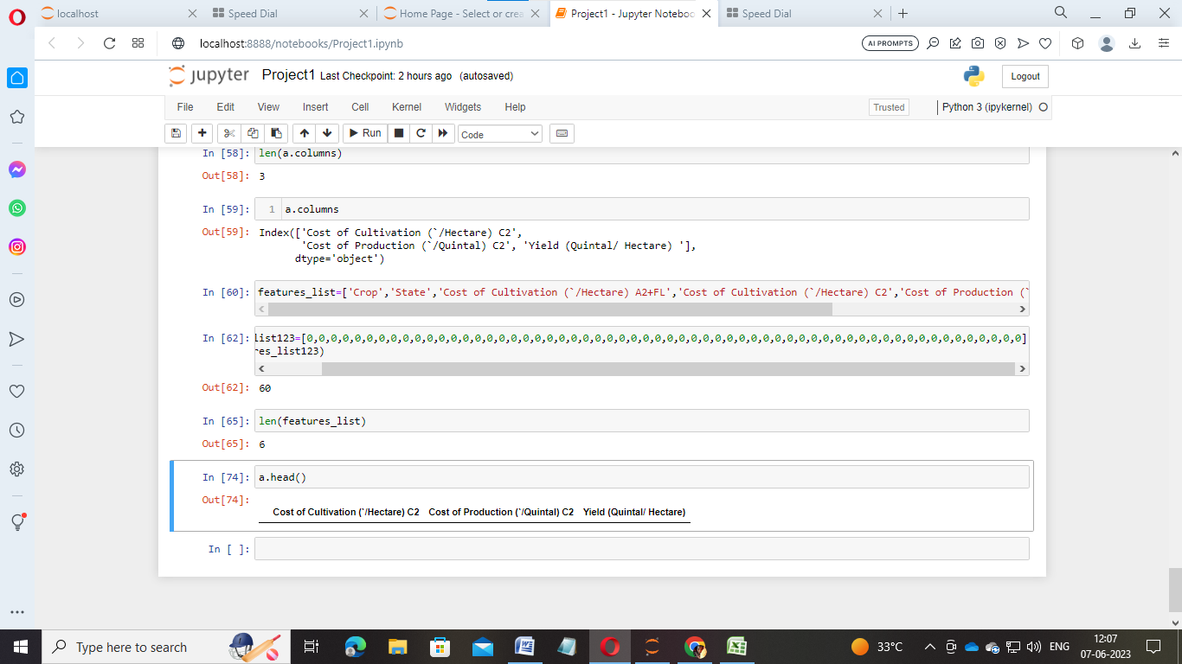

# 4 Resources



5 Personal Details

**Data set source:** 

**Data set source:** data set is taking from Kaggle.

**References: https://www.kaggle.com/datasets/atharvaingle/crop-recommendation-dataset?resource=download**

Name: -

E-mail Id: -obulusaraswathi800@gmail.com



Phone Number: -90



# 6 Milestones

Reference for this – Data Science

|  |
| --- |
| Milestones |
|  |
| Deﬁne a problem |
| Understanding the business problem |
| Understanding the business problem |
| Get the Data |
| Explore and pre-process data |
| Choosing the python platform |

|  |
| --- |
| Milestones |
|  |
| Create Features |
| EDA |
| Create Model |
| Model Evaluation |
| Report Writing |
| Project submission |