LIST OF PROGRAMS

EXPERIMENT 1:-ADDITION OF TWO 8 BIT DATA

LDA 8500

MOV B,A

LDA 8501

ADD B

STA 8502

RST1

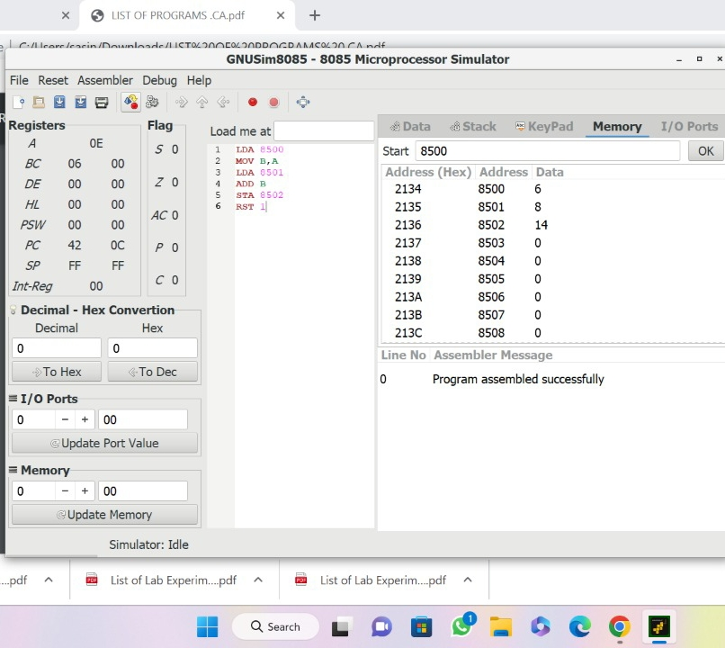

EXPERIMENT 2: SUBTRACTION OF TWO 8 BIT DATA

MVI A,2005

MVI B,2001

SUB B

STA 2006

HLT

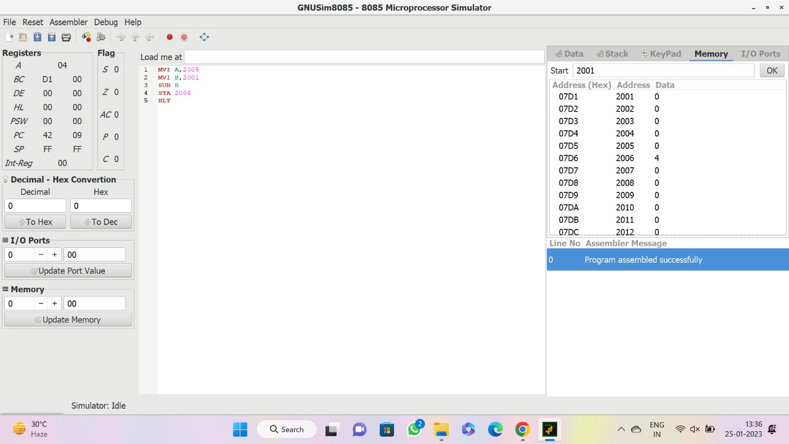

EXPERIMENT 3: ADDITION OF TWO 16 BIT DATA

LDA 2050

MOV B,A

LDA 2052

ADD B

STA 2062

LDA 2051

MOV B,A

LDA 2053

ADC B

STA 2063

HLT

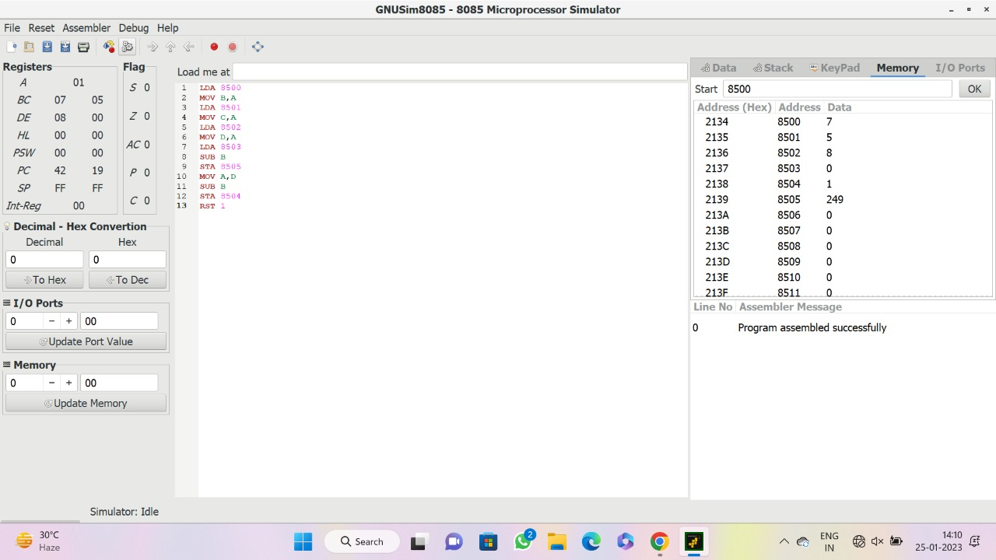

EXPERIMENT 4: SUBTRACTION OF TWO 16 BIT DATA

LDA 8500

MOV B,A

LDA 8501

MOV C,A

LDA 8502

MOV D,A

LDA 8503

SUB B

STA 8505

MOV A,D

SUB B

STA 8504

RST 1



EXPERIMENT 5: MULTIPLICATION OF TWO 8 BIT DATA

LDA 8500

MOV B,A

LDA 8501

MOV C,A

CPI 00

JZ LOOP1

XRA A

LOOP1: ADD B

DCR C

JZ LOOP

JMP LOOP1

LOOP: STA 8502

RST 1

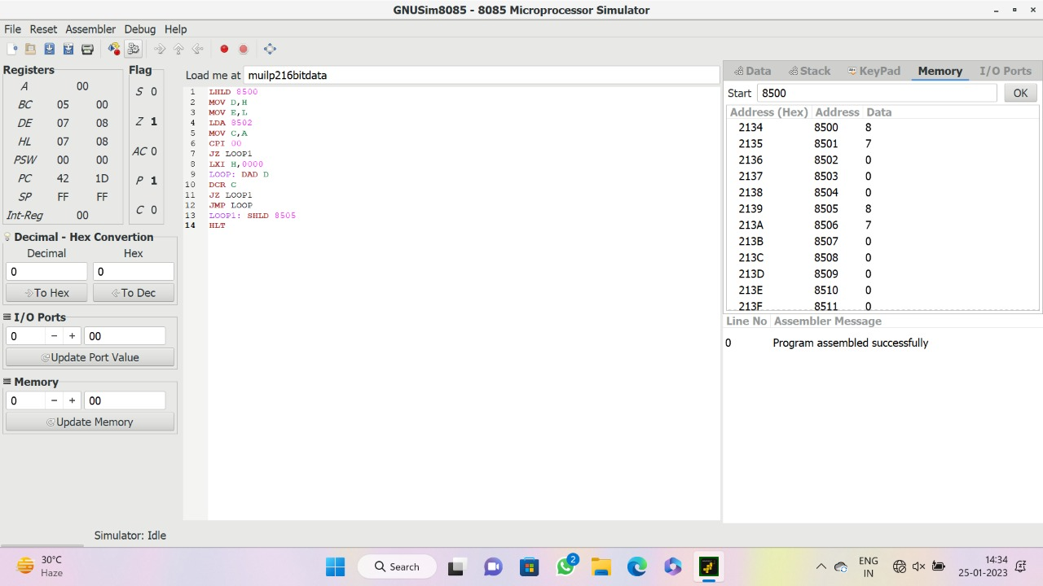

EXPERIMENT 6:DIVISION OF TWO 8 BIT DATA

LDA 8501

MOV B,A

LDA 8500

MVI C,00

LOOP: CMP B

JC LOOP1

SUB B

INR C

JMP LOOP

LOOP1: STA 8503

MOV A,C

STA 8503

RST 1

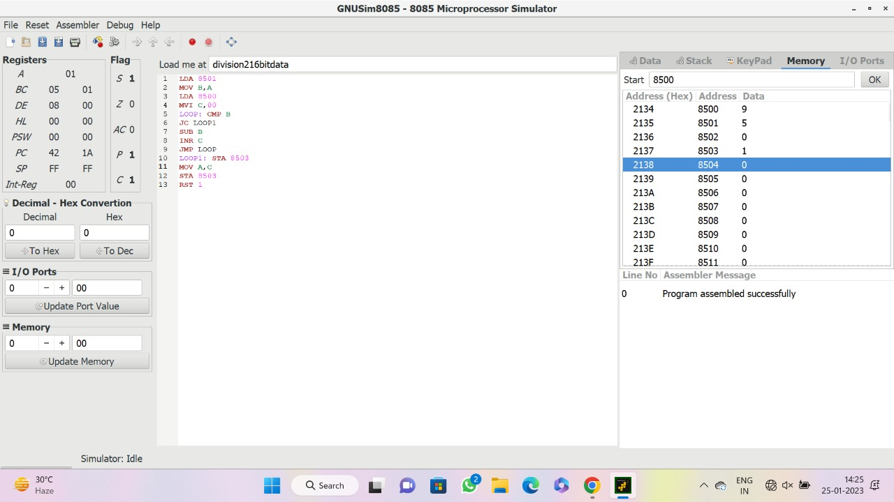

EXPERIMENT 7:MULTIPLICATION OF TWO 16 BIT DATA

LHLD 8500

MOV D,H

MOV E,L

LDA 8502

MOV C,A

CPI 00

JZ LOOP1

LXI H,0000

LOOP: DAD D

DCR C

JZ LOOP1

JMP LOOP

LOOP1: SHLD 8505

HLT



EXPERIMENT: 8 DIVISION OF TWO 16 BIT DATA

LXI B,0000H

LHLD 8002

XCHG

LHLD 8000

LOOP: MOV A,L

SUB E

MOV L,A

MOV A,H

SBB D

MOV H,A

JC SKIP

INX B

JMP LOOP

SKIP: DAD D

SHLD 8006

MOV L,C

MOV H,B

SHLD 8004

HLT

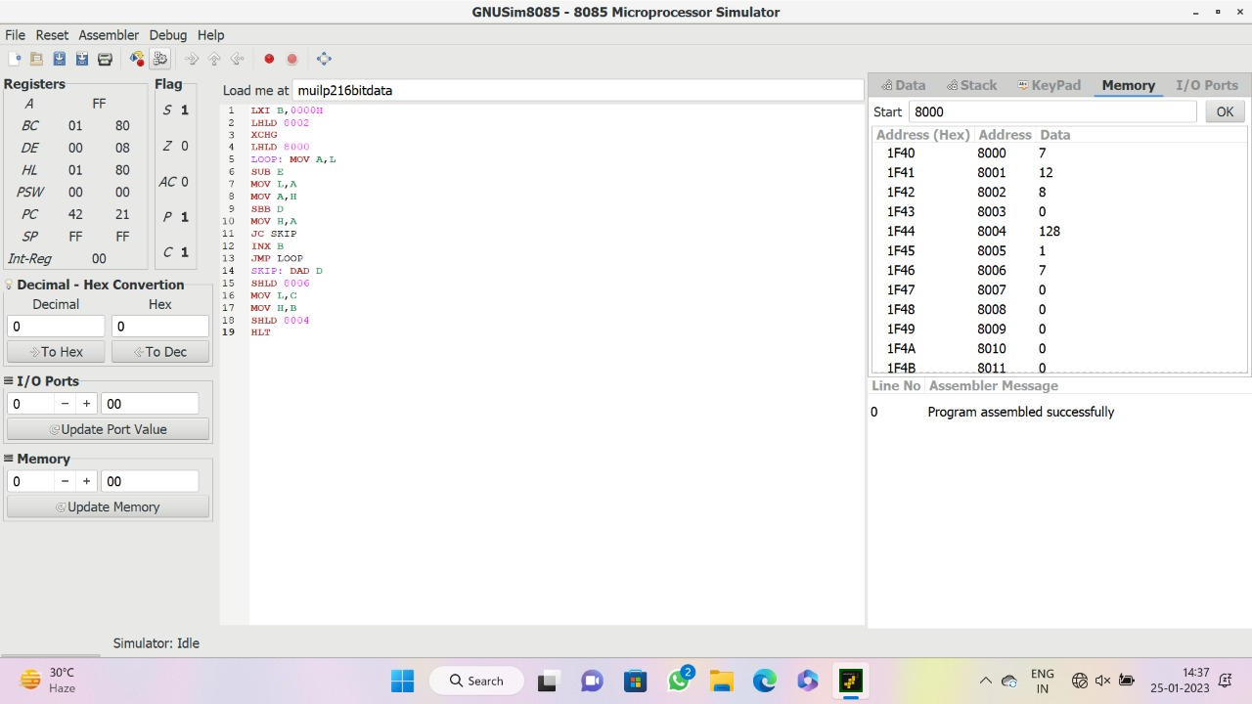

EXPERIMENT 9: 2-BIT HALF ADDER

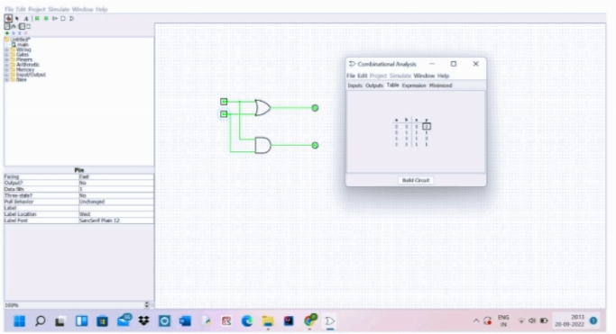

EXPERIMENT 10: 3-BIT FULL ADDER

