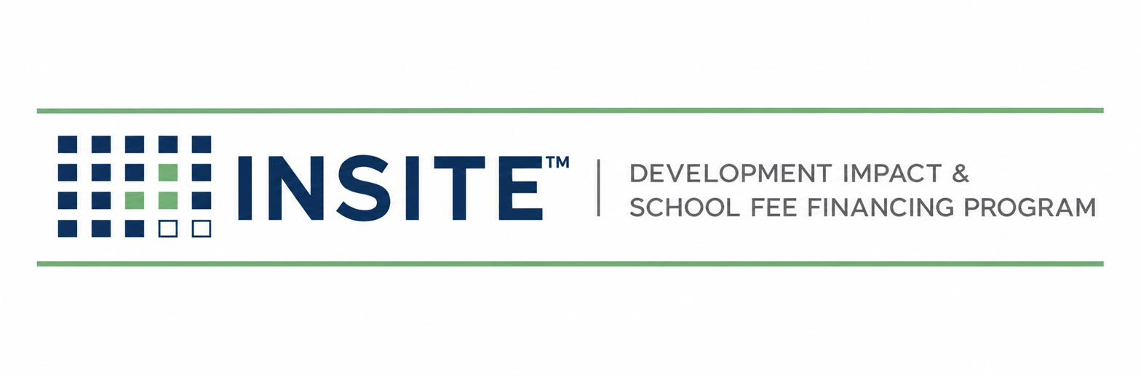
PUBLICATION INS-202
DEVELOPER INTAKE &
ELIGIBILITY MANUAL
Screening · Eligibility Criteria · Preliminary Sizing · Decisioning
Prepared by
HGF Management Company — Program Administrator
INSITE™ Development Impact Fee Financing Program
DOCUMENT CONTROL
Publication number | INS-202
Version | 1.0 (Draft)
Status | Draft for founder review
Publication date | July 2026
Owner | INSITE Program Administration
Classification | Internal — Confidential
Pre-launch program document. INSITE is a proposed program of HGF Management Company. Nothing herein is an offer or commitment of financing, legal, tax, or investment advice, or a securities solicitation. Program structure, eligibility, pricing, and availability are subject to public issuer approval, bond counsel review, and market conditions.

SECTION 1 — PURPOSE & POSITION IN THE LIFECYCLE
INS-202 governs Stages 1–2 of the INSITE lifecycle (INS-010 Ch.4): converting an inquiry into a screened, sized, and decisioned opportunity before any third-party cost is incurred. Its outputs feed Stage 3 (INS-201 Developer Data Package). The screen exists to protect three parties at once: the developer (no wasted appraisal fees on ineligible deals), the Issuer (only conforming projects reach its program), and the purchaser (a pipeline that already reflects credit policy).

SECTION 2 — ELIGIBILITY CRITERIA

2.1 Project criteria
Criterion | Standard | Basis
Location | Parcel(s) within a jurisdiction participating in an INSITE-administered program (or realistically onboardable per INS-601 before the developer’s deadline) | Program agreement
Project size | Approximately 2–50 residential lots/units; program design center ≈ 10 lots | Program policy (INS-102)
Entitlement status | Tentative map approved at minimum; final map recorded or on a definite path (SB 684 / SB 1123 ministerial projects explicitly welcomed) | Screen evidence; Claims Register B1–B2
Ownership & title | Single owner or unanimous owners willing to consent to annexation and special tax; no title condition that defeats a special-tax lien | Preliminary title
Value-to-lien (pre-screen) | Estimated as-is value ≥ 4× (proposed INSITE financing + all existing land-secured debt). Statute requires 3:1 (Gov. Code § 53345.8); 4:1 is INSITE policy | INS-101 Ch.9; INS-301
Special-tax burden | Projected total tax burden on completed homes within issuer policy (commonly ≤ 2% of value — confirm per issuer goals & policies) | Issuer policies; RMA consultant

2.2 Eligible costs (initial program scope)
- Development impact fees governed by the Mitigation Fee Act (Gov. Code §§ 66000–66025) payable to a participating agency and confirmed by that agency as CFD-eligible.
- Utility connection and capacity charges payable to public agencies, where the Issuer and counsel confirm eligibility.
- Public improvements required as conditions of approval (streets, water, sewer, storm drain, dry-utility trenching in public rights-of-way) where acquisition/eligibility is confirmed for the specific issuer program.

2.3 Excluded from initial eligibility
- School facilities fees (Ed. Code § 17620 / Gov. Code §§ 65995 et seq. fees): a roadmap item requiring school district, issuer, and counsel documentation; not marketed as available.
- Private, on-lot, or vertical construction costs of any kind.
- Fees already paid more than the issuer-permitted reimbursement window before financing, unless the issuer’s reimbursement procedure is confirmed in writing.
- Operating charges, ongoing service fees, fines, or processing fees without capital nexus.
Language discipline
Screening communications never state that a specific fee “is eligible.” They state that it “appears consistent with program criteria, subject to written confirmation by the [agency] and bond counsel.”

SECTION 3 — STAGE 1: INQUIRY HANDLING
- Log the inquiry in the pipeline (INS-010 §4.3) within one business day with: developer entity, contact, jurisdiction, APNs if known, lot count, entitlement status, target funding need and date.
- Send the standard introduction package: program overview (INS-002 summary), INS-202.01 Screening Form, and the fee-and-timeline disclosure.
- Do not discuss rates. The approved formulation: “privately placed, tax-secured financing repaid on the property tax bill; pricing is set by the purchaser at closing.”

SECTION 4 — STAGE 2: THE ELIGIBILITY SCREEN

4.1 Screening inputs (Form INS-202.01)
 | Required item | Notes / status
☐ | Developer entity, principals, and contact information
☐ | Jurisdiction (city/county) and APN list
☐ | Lot/unit count and product type; SB 684 / SB 1123 status if applicable
☐ | Entitlement documents: tentative map approval; final map status; conditions of approval
☐ | Fee estimate or agency fee schedule for the project (AB 602 requires local agencies to post fee schedules online — pull and file the source)
☐ | Requested financing amount and use (which fees / improvements)
☐ | Estimated as-is market value with basis (developer estimate, listing, prior appraisal)
☐ | Existing debt: mortgages/deeds of trust, assessments, existing CFDs (preliminary title if available)
☐ | Target funding date and constraint (e.g., permit issuance date)

4.2 Preliminary sizing method
- Financeable amount F = confirmed-appearing eligible fees (+ approved improvement costs) + estimated capitalized costs of issuance and reserves per program structure.
- Debt stack D = F + all existing land-secured obligations (existing CFD/assessment principal) + any senior debt that survives closing.
- Value test: V_est ≥ 4 × D, where V_est is the screened as-is value. If 3 ≤ V_est/D < 4, the file may proceed only with Principal exception noting the statutory 3:1 floor and the issuer’s policy.
- Burden test: projected annual special tax vs. issuer total-tax-burden policy (flag for RMA consultant if within 10% of the cap).
- Output: Preliminary Sizing Worksheet (INS-202.02) filed to the deal folder; numbers are labeled estimates in all developer communication.

4.3 Decision matrix
Outcome | Trigger | Action & communication
PASS | All §2 criteria met on screened facts | Issue screen-pass letter; open Stage 3 with INS-201 checklist; log state SCREENED-PASS
CONDITIONAL PASS | One criterion pending third-party confirmation (e.g., agency fee eligibility) | Pass letter names the condition and owner; Stage 3 may start; appraisal may not be ordered until cleared
HOLD | Jurisdiction not yet onboarded | Route to INS-601 pipeline; give developer a realistic onboarding timeline; revisit date set
FAIL | Any hard criterion failed (value test, ineligible costs only, title defeat) | Decline letter states the specific criterion; offer re-screen if facts change; log SCREENED-FAIL with reason code

4.4 Service levels & fees
Screen decision within 3 business days of a complete INS-202.01. The application/screening fee (INS-010 §2.5) is disclosed before submission; whether it credits at closing is a policy Open Item. No other cost is incurred by the developer before a written PASS.

SECTION 5 — RECORDS, REASON CODES & FAIR DEALING
- Every screen — pass or fail — is retained with its worksheet and evidence for program-integrity review.
- Reason codes: RC-1 value test · RC-2 ineligible costs · RC-3 jurisdiction · RC-4 title/ownership · RC-5 entitlement · RC-6 burden cap · RC-7 other (memo required).
- Identical facts get identical outcomes: exceptions require the Principal’s written memo and appear in the monthly KPI report.
- No screening data is shared with purchasers or agencies except in aggregate or under the deal’s disclosure consents.
CONFIRM BEFORE RELIANCE
Issuer-specific policies (total tax burden caps, reimbursement windows, eligible-fee lists) control over the generic standards in §2 and must be attached to this manual as jurisdiction appendices as each agency onboards (INS-601 §5).
INSITE(TM) is a pre-launch program concept administered by HGF Management Company. This material is not an offer of financing, legal advice, or investment advice. Program structure, eligibility, costs, and pricing are subject to issuer approval, bond counsel review, and program underwriting. Figures identified as targets or estimates are the founder's working numbers, not commitments.

