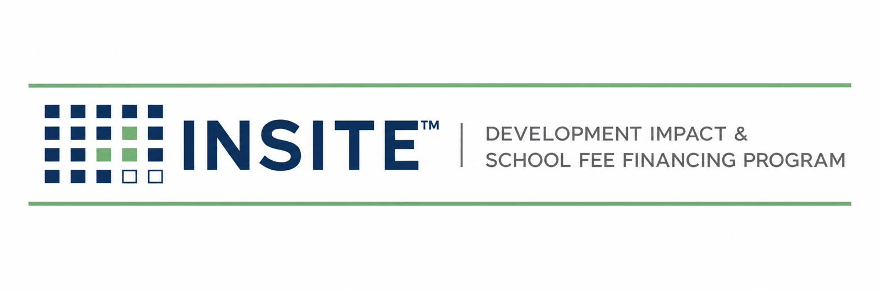
PUBLICATION INS-501
ANNUAL ADMINISTRATION
& TAX ROLL MANUAL
Levy Calculation · County Submission · Collections · Delinquency · Prepayment · Reporting
Prepared by
HGF Management Company — Program Administrator
INSITE™ Development Impact Fee Financing Program
DOCUMENT CONTROL
Publication number | INS-501
Version | 1.0 (Draft)
Status | Draft for founder & TRA review
Publication date | July 2026
Owner | INSITE Program Administration
Classification | Internal — Confidential
Pre-launch program document. INSITE is a proposed program of HGF Management Company. Nothing herein is an offer or commitment of financing, legal, tax, or investment advice, or a securities solicitation. Program structure, eligibility, pricing, and availability are subject to public issuer approval, bond counsel review, and market conditions.

SECTION 1 — PURPOSE, ROLES & THE ANNUAL CYCLE
INS-501 governs Stage 8 — the recurring machinery that makes INSITE a platform instead of a series of one-off deals. The special tax lives for decades; this manual defines the annual cycle that keeps every parcel correctly levied, every dollar reconciled, every delinquency escalated on covenant, and every stakeholder informed.

1.1 Division of labor
Function | Tax Roll Administrator (subcontract) | INSITE Operations
Levy calculation per RMA | R — computes | A — approves; maker/checker sample
County direct-charge file & submission | R | A — verifies confirmation
Collections reconciliation | R | A — reviews; investigates variances
Delinquency identification | R — flags after each installment | A — runs escalation ladder
Prepayment calculations & payoff letters | R — computes per RMA | A — issues; orders lien release
Investor & issuer reporting | C — data | R/A — assembles and issues

1.2 Annual cycle at a glance (fiscal year July 1 – June 30)
Window | Milestone
July | Parcel-change sweep: recorded maps, ownership transfers, completed prepayments; levy database frozen
July → county deadline | Levy computed per RMA; QC; county direct-charge file submitted in county format
August–September | County acceptance confirmation reconciled line-by-line to the computed levy
November → tax bills | Property tax bills issued by county include the INSITE special tax as a direct charge
After each installment | Collections reconciled; delinquency list produced; escalation ladder starts
January | Annual investor reporting package (prior calendar year) issued
Rolling | Prepayment quotes (SLA below), estoppels, data requests
CONFIRM BEFORE RELIANCE
County submission deadlines, file formats, direct-charge codes, and installment/delinquency dates were NOT independently verified this release and vary by county. Before the first levy year, obtain in writing from each county Auditor-Controller: (1) the direct-charge calendar; (2) the file specification; (3) the fund/charge code assignment. File these as Appendix 501-A per county.

SECTION 2 — THE LEVY DATABASE
- One row per APN: county, TRA/charge code, RMA land-use class, original principal allocation, outstanding principal, current-year special tax, status (active / prepaid / delinquent), and deal ID linking to the closing file.
- Changes enter only from four sources: a closing (INS-401 Gate 7→8), a recorded parcel change, a prepayment completion, or an annual RMA escalation — each with a document reference.
- INSITE holds a read-only mirror of the TRA’s database, reconciled quarterly; any mismatch is an incident with a written root cause.

SECTION 3 — LEVY CALCULATION & COUNTY SUBMISSION
- Compute each parcel’s annual special tax exactly per the recorded RMA (base tax, escalator if any, administrative-expense component).
- Maker/checker: a second person independently recomputes a sample (100% of parcels while the portfolio is under 500 parcels; thereafter a documented sampling plan) and signs the levy certificate.
- Generate the county file in the county’s specification; validate APN formats against the assessor roll; reject-and-fix any unmatched parcel BEFORE submission.
- Submit by the county deadline; obtain and file the county’s acceptance/confirmation.
- Reconcile the county-confirmed charge list to the computed levy line-by-line; zero unexplained variances is the only passing result.
- Issue the annual levy report to the Issuer (and purchaser if required): parcels levied, total levy, changes from prior year, exceptions.
Why this section is strict
A levy error is the one operational failure that touches a homeowner’s tax bill, the county, the Issuer, and the purchaser simultaneously. 100% reconciliation is cheaper than one correction cycle.

SECTION 4 — PREPAYMENTS, PAYOFFS & RELEASES
- Quote requests answered within 5 business days with a payoff computed per the RMA prepayment formula (principal portion, redemption premium if any, accrued/defeasance amounts, fees) — TRA computes, INSITE verifies and issues.
- Quotes carry an expiration date tied to the next levy cutoff; quotes crossing a levy date state both numbers.
- On receipt of good funds: apply per formula; instruct release/subordination of the special-tax lien as to the parcel per counsel procedure; record the release; update the levy database same cycle.
- Partial prepayments (per-lot payoffs at home sale, if the RMA permits) follow the same path with per-parcel allocation certificates.

SECTION 5 — DELINQUENCY MONITORING & ESCALATION

5.1 Ladder (default — conform to each note’s covenants)
Step | Trigger | Action | Owner
1 | Installment shows unpaid on county data | Log; courtesy notice to owner of record | TRA → Ops
2 | 30 days delinquent | Certified demand letter; Issuer informed | Ops
3 | Second missed installment or covenant threshold | Purchaser notified per note covenants; foreclosure-counsel consult | Ops/Prin
4 | Covenant foreclosure trigger (e.g., amount/aging thresholds in the fiscal agent agreement) | Issuer initiates judicial foreclosure per Mello-Roos remedies as directed by covenants | Issuer + counsel
The Mello-Roos framework secures the special tax with a lien and foreclosure remedy (California Debt Financing Guide, CDIAC). Exact triggers, cure periods, and mandatory-foreclosure covenants are set in each transaction’s documents; this ladder executes them — it never improvises around them.

5.2 Reporting
- Delinquency report after each installment: parcel, amount, aging, step, next action, and portfolio delinquency rate.
- Any Step-3+ event is reported to the Principal within 2 business days and included in the next investor package.

SECTION 6 — STAKEHOLDER REPORTING
Package | Audience | Contents | Frequency
Levy certificate & report | Issuer | §3 outputs | Annual
Portfolio report | Purchaser(s) | Outstanding principal, levy performance, delinquency, prepayments, covenant compliance certificate | Annual (or per note terms)
Program dashboard | Principal / partners | KPIs from INS-010 Ch.9 | Monthly
State reporting | CDIAC / as required | Issuance and any ongoing reports counsel confirms for privately placed land-secured notes | Per counsel calendar
INSITE(TM) is a pre-launch program concept administered by HGF Management Company. This material is not an offer of financing, legal advice, or investment advice. Program structure, eligibility, costs, and pricing are subject to issuer approval, bond counsel review, and program underwriting. Figures identified as targets or estimates are the founder's working numbers, not commitments.

