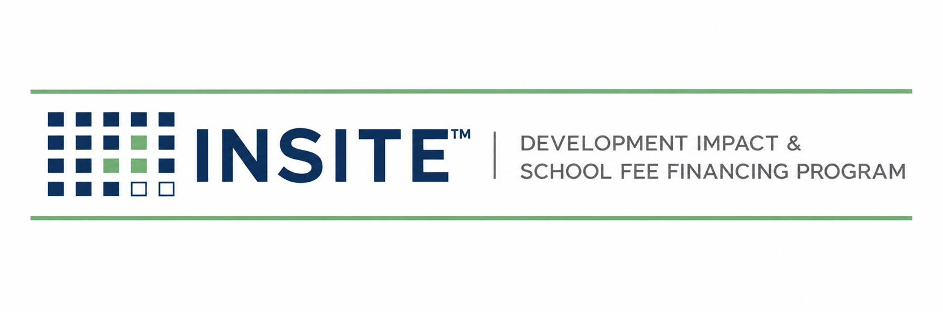
PUBLICATION INS-601
PUBLIC AGENCY
ONBOARDING GUIDE
For City Managers · Finance Directors · County Executives · Agency Counsel
Prepared by
HGF Management Company — Program Administrator
INSITE™ Development Impact Fee Financing Program
DOCUMENT CONTROL
Publication number | INS-601
Version | 1.0 (Draft)
Status | Draft for founder review
Publication date | July 2026
Owner | INSITE Program Administration
Classification | External — Agency distribution
Pre-launch program document. INSITE is a proposed program of HGF Management Company. Nothing herein is an offer or commitment of financing, legal, tax, or investment advice, or a securities solicitation. Program structure, eligibility, pricing, and availability are subject to public issuer approval, bond counsel review, and market conditions.

SECTION 1 — WHAT INSITE ASKS OF AN AGENCY (AND WHAT IT DOESN’T)
INSITE brings small residential projects a financing path your larger projects already have. Statewide land-secured programs — CSCDA’s SCIP and CMFA’s BOLD — let developers finance impact fees and public improvements through the property tax system; SCIP publishes a typical minimum around $500,000 in fees/improvements, and BOLD’s reported activity (≈$550 million across 65+ projects, 12,000+ units since 2020) averages project sizes far above a 6- or 10-lot infill map. INSITE is built for the projects underneath those programs’ economics — the 2–50 lot maps your housing element is counting on under SB 684 and SB 1123.
The agency keeps | INSITE carries
Every governmental decision: program approval, resolutions, policies, issuance | All operations: marketing, intake, underwriting, documentation, coordination
Fee eligibility determinations | Appraisal management under published standards (INS-101) consistent with CDIAC guidance
Its existing GO-bond capacity, untouched | Annual administration: levy, county tax-roll files, delinquency, reporting (with an established tax-roll administrator)
Zero program cost — costs are developer-deposit and proceeds funded (the BOLD/SCIP pattern) | Standardized documents your counsel reviews once, then reuses

SECTION 2 — TWO WAYS TO PARTICIPATE
 | Model A: JPA program | Model B: Agency-sponsored
Who issues | Partner JPA issues; your agency consents to the program in its territory and accepts financed fees | Your agency forms one INSITE-administered CFD with a future annexation area; projects annex in
Board actions | Membership/consent resolutions (the SCIP/BOLD pattern: join + approve) | Local goals & policies (incl. appraisal standards), resolution of intention, hearing, formation — one time
Control | Program-standard policies | Your policies; INSITE recommends, you adopt
Best for | Fast start; minimal staff time | Agencies wanting the program as their own
Either way, individual small projects join by annexation — no per-project district formation, hearings calendar, or staff report burden after setup.

SECTION 3 — WHY THIS SERVES AGENCY GOALS
- Housing delivery: SB 684 (eff. 7/1/2024) and SB 1123 (eff. 7/1/2025) require ministerial approval of ≤10-lot / ≤10-unit maps on qualifying sites — the approvals are streamlined, and INSITE addresses the financing of the fees and improvements those approvals still require.
- Fee revenue certainty: fees are paid at closing from note proceeds — the agency receives its money up front rather than carrying developer nonpayment risk (the benefit CSCDA highlights for SCIP).
- No new agency debt or liability: the special tax is a landowner obligation; notes are limited obligations payable from special taxes — standard Mello-Roos structure (Gov. Code § 53311 et seq.; California Debt Financing Guide).
- Discipline you can point to: statutory 3:1 value determination (Gov. Code § 53345.8) plus INSITE’s stricter 4:1 program policy — the same conservative ratio CSCDA adopts in its own Mello-Roos goals and policies.
- Context your council already knows: California development fees are substantial — statewide averages near $23,455 per single-family unit as far back as 2015 (≈3× the national average, Terner Center) — financing them is how other agencies keep small projects moving without waiving revenue.

SECTION 4 — ONBOARDING PATH & TIMELINE
- Discovery meeting (staff level): fit review; your fee schedule and pipeline of small maps; model selection.
- Counsel packet: program summary, draft resolutions, form agreements, INS-101 appraisal standards, this guide.
- Policy adoption: local goals & policies (Model B) or program consent resolutions (Model A).
- Program agreement executed: roles per Section 1; fee-payment mechanics; reporting.
- Fee-eligibility workshop: your departments confirm which fees/improvements are program-eligible; the written list becomes the jurisdiction appendix to INS-202.
- Go-live: intake opens; first annexation processed per INS-401; annual administration per INS-501.
Model A agencies typically require one to two board actions. Model B adds one-time district formation, a process the California Debt Financing Guide notes often takes six months or more — planned once, then never repeated per project.

SECTION 5 — AGENCY ONBOARDING CHECKLIST
 | Required item | Notes / status
☐ | Primary contacts named (finance, planning/permitting, counsel)
☐ | Fee schedule and nexus-study links collected (as posted under AB 602)
☐ | Participation model selected (A / B)
☐ | Resolutions calendared and adopted
☐ | Program agreement executed
☐ | Eligible fee list confirmed in writing (jurisdiction appendix to INS-202)
☐ | County Auditor-Controller direct-charge procedure confirmed (INS-501 Appendix 501-A)
☐ | First-year reporting expectations agreed
Pre-launch status
INSITE is preparing its first transactions now. Nothing in this guide is an offer of financing; program availability in any jurisdiction is subject to issuer approvals, bond counsel review, and market conditions. Sources for every external claim in this guide are maintained in the INSITE Claims Register and available on request.
INSITE(TM) is a pre-launch program concept administered by HGF Management Company. This material is not an offer of financing, legal advice, or investment advice. Program structure, eligibility, costs, and pricing are subject to issuer approval, bond counsel review, and program underwriting. Figures identified as targets or estimates are the founder's working numbers, not commitments.

