INS-303: Investor Guide
Banks, Private Credit, and Note Purchasers. Version 1.0, July 13, 2026, prepared for the founder’s review. This manual builds out the approved INS-303 outline of July 12 and carries the answer to program question 10, given July 13: each project or annexation issues its own note; the warehouse line and the credit facility are one instrument; and that facility funds every origination until the optional pooled bond take-out at portfolio stabilization. Every chapter is marked PUBLIC, meaning it may sit on the open website, or PORTAL, meaning it belongs behind credentials with the deal documents. Two chapters carry a bond counsel gate: Chapter 4 on credit enhancement and the waterfall detail inside Chapter 5 are structural placeholders that state what is settled and name precisely what is not, because those terms are set by counsel and by the first term sheet, not by marketing copy. Every factual claim traces to the INSITE Claims Register; the entry codes appear in Appendix A. Figures labeled founder estimate are the founder’s working numbers and are not commitments. No note has closed and no purchaser is committed.

Part I: The Program and the Paper

Chapter 1: Executive Overview
1.1 What an investor is being offered. PUBLIC. INSITE originates privately placed, tax-secured notes on small California residential subdivisions, roughly 2 to 50 lots, one note per project. Each note is repaid by a voluntary Mello-Roos special tax levied on the project’s own parcels and collected by the county with the annual property tax bill, under the Community Facilities Act of 1982, Government Code section 53311 and following (A1). The public agency is the issuer. HGF Management Company, operating the program under the INSITE name, is the administrator: it underwrites, prepares the documents, coordinates funding, and runs the annual levy for the life of the zone. It is not a lender and never holds the notes.
1.2 Why the paper exists at all. California development impact fees average about $23,455 per single-family home in the cited state-commissioned research, nearly three times the national average, and total development charges exceed $150,000 per unit in some cities (C1, C2). Those fees are due before a single home sells. Large builders carry that with institutional credit. Small builders pay cash or borrow private money that 2025 and 2026 rate guides place at roughly 9.5 to 15 percent (C5). The lien that repays an INSITE note sits in a senior, county-collected position that private paper cannot reach, which is the source of whatever pricing advantage the program eventually proves.
1.3 The size of the segment. In 2025 California authorized 103,856 housing units by building permit, of which 62,372 were in one-to-four-unit structures, computed directly from the Census Building Permits Survey annual file (D1). At an assumed $25,000 of financeable public fees per unit, an assumption stated rather than sourced, the measured segment carries on the order of $1.56 billion of annual fee obligation (D3). Senate Bills 684 and 1123 now compel ministerial approval of qualifying subdivisions of ten or fewer lots on a sixty-day clock, which grows this exact segment (B1, B2).
1.4 What is proven and what is not. Proven: the legal mechanism, the annexation architecture, the homeowner protections, and the fee problem. Operating today in Escondido, Chula Vista, and Roseville, and at statewide scale through CSCDA’s SCIP and CMFA’s BOLD (E1, E2, G11, G18). Not proven: INSITE’s own per-deal execution cost, which remains a founder estimate of $5,000 to $30,000 pending real quotes (F1); the pricing, which is set at term sheet and nowhere else; and purchaser appetite for small tax-secured notes, which the pilot exists to test. Any investor reading this should treat Chapter 6 and Appendix E as the honest part of the document.
1.5 How to read this manual. Chapters 1 through 3 describe the instrument and the capital stack. Chapters 4 through 6 describe security and credit. Chapters 7 and 8 describe what happens every year for thirty years after the money moves, which in land-secured paper is where the risk actually lives. Chapter 9 answers the questions a credit committee asks. Chapter 10 explains what is public and what sits behind the portal.

Chapter 2: Capital Structure
2.1 The instrument. PUBLIC. Each project’s annexation carries its own privately placed note, secured by the special taxes levied on that project’s parcels and nothing else. There is no cross-collateralization between zones. The Act permits each annexing territory to carry its own tax terms, set out in the landowner’s unanimous approval (section 53339.3(d), A1, G10), which is the statutory basis for treating every project as an isolated credit.
2.2 The facility above it. PUBLIC summary. One revolving warehouse credit facility funds every origination as projects are approved. The warehouse line and the credit facility are the same instrument, not two layers; this was confirmed by the founder on July 13, 2026, and the whitepaper carries it as section 11. The facility advances against approved annexations, is repaid from the annual special taxes and, at the program’s option, from the proceeds of a later pooled bond issue.
2.3 The optional take-out. PUBLIC summary. Pooled tax-exempt bonds are the permanent take-out once the portfolio of properties has stabilized. The take-out is optional. The program continues to originate and administer whether or not it ever occurs, and no annexation depends on it. This is the same architecture the statewide programs reached by a different road: local obligations, one per project, pooled upward into program-level financing (E1, E2).
2.4 What is set at term sheet, not here. PORTAL detail. Advance rate, borrowing base definition, facility size, pricing, covenants, concentration limits, eligibility criteria for the borrowing base, and the conditions of the bond take-out are commercial terms. They are negotiated with the first capital partner and reviewed by bond counsel. This manual does not state them, and any document that does state them before a term sheet exists is marketing, not structure.
2.5 The founder’s target pricing, labeled. FOUNDER ESTIMATE. The founder’s working expectation is that INSITE money prices below 6 percent, probably around 5.5 percent (C6). No term sheet exists. That number appears in no external document as anything but a target, and it is not a commitment, a quote, or a projection.

Chapter 3: Funding Flow, Origination to Permanent
3.1 The pipeline in one sentence. PUBLIC. Origination writes privately placed, tax-secured notes one project at a time; the warehouse credit facility carries the growing portfolio; and pooled tax-exempt bonds provide the optional permanent take-out once the properties stabilize.
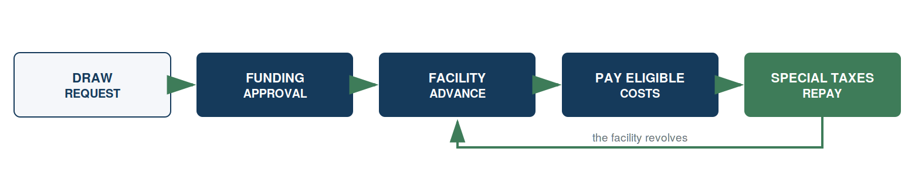
3.2 Origination. PUBLIC. A qualifying project applies through the developer intake and eligibility manual (INS-202) and the standard data package (INS-201, whose fields mirror what BOLD’s own developer application collects, G21). Underwriting sizes the note against an independent MAI appraisal performed to the standards the California Debt and Investment Advisory Commission publishes, and against the program’s four-to-one value-to-lien policy (A2, A3). The issuer’s council approves the annexation on its regular calendar. The landowner’s unanimous approval is signed and notarized. The amendment to the notice of special tax lien is recorded. No funding occurs before recording is confirmed (INS-401, Stage 6).
3.3 Advance and funding. PORTAL mechanics. At closing, the purchaser funds the note purchase price to the fiscal agent or designated account; costs of issuance are paid per the closing memorandum; eligible fees are paid to the agency or reimbursed to the developer against the district’s clearance evidence; and the deal file is indexed and the portfolio register updated the same day (INS-401, Stage 7). The draw conditions, the borrowing base test applied at each advance, and the mechanics of repayment into the facility are the commercial terms named in section 2.4.
3.4 Repayment. PUBLIC. The special tax is levied annually on the county roll, billed with the property tax bill, and collected by the county tax collector on the county’s own calendar (G3, G4). Collections flow to debt service on the note. The obligation runs for the note’s term, typically decades, and every parcel owner holds a statutory right to prepay and permanently satisfy the lien under section 53344 (G9).
3.5 The take-out, if it happens. PUBLIC. Once the portfolio of properties has stabilized, the program may issue pooled tax-exempt bonds and retire the facility. Stabilization triggers, pool composition, and the tax treatment of the pooled issue are bond counsel questions and appear in no document until counsel answers them.
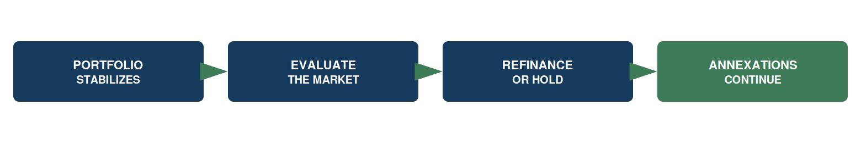

Part II: Security and Credit

Chapter 4: Credit Enhancements and Collateral
4.1 Bond counsel gate. PORTAL. This chapter is a structural placeholder, and it says so rather than filling the space with plausible language. Reserve funds, capitalized interest, coverage covenants, developer guaranties, letters of credit, and any other enhancement are terms that counsel and the first purchaser set together. Brad Neill at Stradling is identified as bond counsel and is in conversation with the founder; nothing in this chapter is settled until that engagement produces answers.
4.2 What is already settled, and needs no counsel. PUBLIC. Three protections exist by statute and by program policy, independent of any enhancement negotiated later:
- The recorded special-tax lien, billed and collected with the property tax bill, with the Mello-Roos foreclosure remedy behind it (A1).
- The four-to-one appraised value-to-lien cushion, an INSITE program policy above the statutory three-to-one condition of section 53345.8, matching CSCDA’s own adopted policy (A2, A3).
- Zone isolation. Each note is secured only by its own project’s special taxes; no zone answers for another zone’s debt (A1, G10).
4.3 The burden ceiling. PUBLIC. CSCDA’s policy caps the total tax burden on an owner-occupied home, all taxes and special taxes combined, at 2 percent of expected assessed value at completion (A3b). INSITE treats that as the benchmark and confirms each issuer’s own cap before sizing any zone. A zone that cannot be sized inside the cap does not get financed, which is a credit protection before it is a policy.
4.4 The questions this chapter must answer once counsel is engaged. PORTAL. Whether a reserve is required and how it is funded; whether capitalized interest is permitted and for how long; what coverage ratio the facility requires and how it is tested; whether any developer recourse survives closing; and what happens to enhancement at the bond take-out. These are listed so the gap is visible, not so it can be quietly filled.

Chapter 5: Security Interests and the Cash Flow Waterfall
5.1 Lien standing. PUBLIC. The special tax is secured by a continuing lien on the parcel, recorded as a notice of special tax lien and amended at each annexation. It is collected in the same manner and at the same time as ordinary ad valorem property taxes, with the same enforcement machinery behind it, and the Act supplies an accelerated judicial foreclosure remedy on delinquency. The exact remedy sequence in any given transaction is set by the note’s covenants and by counsel.
5.2 Rate stability for the payer, which is also credit stability. PUBLIC. Once a home has an occupancy permit for private residential use, its special tax may not be increased by more than 10 percent as a consequence of a neighbor’s delinquency (section 53321(d), G8). The tax can never be based on property value (section 53325.3). Both facts bound the payer’s exposure, which is precisely why the payer keeps paying.
5.3 The four-to-one test in practice. PUBLIC. Before notes are sold, the issuer must find the taxed property worth at least three times the debt (section 53345.8, A2). INSITE requires four. The value comes from an independent MAI appraiser on a standing panel, never an INSITE employee, working to the program’s written appraisal manual (INS-101) and to CDIAC’s land-secured standards (F5, second entry).
5.4 Illustrative sizing, labeled as arithmetic. PUBLIC. A ten-lot annexation financing $250,000 over 30 years at 6 percent carries annual debt service near $18,200; adding administration and a coverage cushion brings the zone’s annual requirement to roughly $23,000, about $2,300 per home per year. This is arithmetic shown for illustration, not a quote and not a term.
5.5 The waterfall. PORTAL, bond counsel gate. The order in which collected special taxes are applied, the accounts they pass through, the fiscal agent’s duties, the treatment of prepayments and partial payoffs at home sale, and the position of the administrative-expense component within that order are the mechanics of the first closing. Section 53317(d) of the Act does establish that district administrative expenses, including consultants, are recoverable through the special tax, which is why an administrative component sits inside the levy at all. The rest is drafted, not asserted.

Chapter 6: Underwriting and Risk Management
6.1 What the program underwrites. PUBLIC. Four things gate every deal: the appraisal and the four-to-one cushion; the total tax burden against the 2 percent benchmark and the issuer’s own cap; the completeness of the developer’s data package under INS-201; and the eligibility of the fees themselves. School fees are excluded at launch, definitely, as standing program policy (F2). The founder is researching whether a pay-then-reimburse structure avoids involving the school district at all; the register’s Riverside precedent suggests a thin joint community facilities agreement survives even under reimbursement (G7), and bond counsel resolves the question if it is ever reopened.
6.2 What can kill a deal at underwriting. PUBLIC. An appraisal that will not support four-to-one at the requested note size. A burden that breaks the cap once the special tax is stacked on the existing ad valorem bill. A title condition or an existing special tax or assessment that changes the lien position. A fee schedule that has moved between application and closing. Each of these stops the file rather than shrinking the cushion.
6.3 The risks a purchaser is actually taking. PUBLIC, and stated plainly. Per-project execution costs are a founder estimate until real quotes exist, and the model fails if small-deal costs stay high (F1). No capital purchaser is committed, and appetite for small tax-secured notes is exactly what the pilot must prove. City adoption speed is uncertain, and formation takes six months or more per jurisdiction (G13). Special taxes are repaid by property owners, and delinquencies, though remedied by the lien and the foreclosure process, take time to cure. The program name requires trademark clearance before public launch (F5, F6). And the incumbent statewide programs could move down-market and compete for the same projects, which is the competitive risk that will not appear in anyone else’s marketing.
6.4 Where the honest comparison sits. PUBLIC. SCIP publishes a typical $500,000 minimum and pools roughly three times a year; BOLD’s completed issues average far above this segment’s deal size (E1, E2, E5). Neither program is designed against the 2-to-50-lot project, and that is INSITE’s entire thesis. It is a claim about transaction economics, not about law, and it is falsifiable by the pilot.

Part III: Operations and Reporting

Chapter 7: Servicing and Administration
7.1 Who does what. PUBLIC summary. The program administrator runs the levy database, computes the annual special tax per the recorded rate and method of apportionment, submits the county file, reconciles collections, monitors delinquency, answers prepayment quotes, and reports. An established tax roll administration firm is contracted first, with the function brought in-house only on defined triggers (INS-004, INS-501). The county tax collector bills and collects. The issuer owns the district and every approval. Nothing about the arrangement puts city funds at risk: Elk Grove’s own staff report on the existing statewide programs states that the city acts as an intermediary, that no city funds are involved, and that the city incurs no financial liability or risk by participating (E6).
7.2 The annual cycle. PUBLIC. The fiscal and reporting year runs July 1 to June 30 (G3). Each year the levy is computed per the recorded rate and method, validated against the assessor roll, submitted to the county on the county’s own deadline and in its own specification, reconciled line by line against the county’s confirmed charge list, and reported to the issuer (G4, INS-501). Zero unexplained variance is the only passing result.
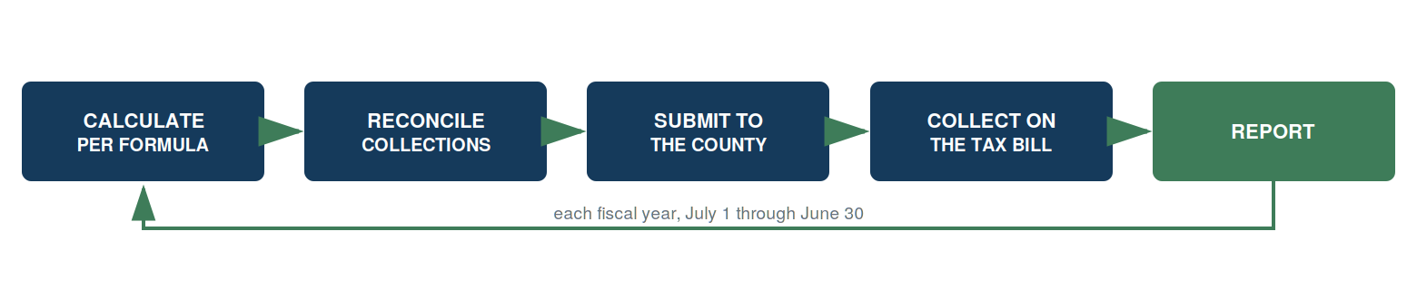
7.3 Maker and checker. PORTAL service-level detail. A second person independently recomputes the levy: 100 percent of parcels while the portfolio is under 500 parcels, a documented sample thereafter (INS-501). The administrator holds a read-only mirror of the tax roll administrator’s database, reconciled quarterly, and any mismatch is an incident with a written root cause.
7.4 Delinquency. PORTAL detail, PUBLIC principle. Delinquency is reported after each installment, by parcel, with aging and the next action, plus the portfolio delinquency rate. The escalation ladder conforms to each note’s covenants. Serious escalations are reported to the principal within two business days and appear in the next investor package (INS-501).
7.5 Prepayment. PUBLIC. Owners may prepay and permanently satisfy the special tax obligation under section 53344 (G9). Quotes are answered within five business days per the rate and method’s prepayment formula, and quotes crossing a levy date state both numbers (INS-501). A purchaser should expect prepayments as homes sell, and the note documents say what happens to the proceeds.

Chapter 8: Financial and Investor Reporting
8.1 The reporting package. PORTAL. What a note purchaser receives, and what a facility lender receives, is set in the documents. What the program is built to produce, from the operations manuals that already exist, is this: an annual levy report showing parcels levied, total levy, changes from the prior year, and exceptions; a delinquency report after each installment; a portfolio register updated the same day as any closing; and an investor data room updated within five business days of closing (INS-401, INS-501).
8.2 The statutory reporting that happens regardless. PUBLIC. Note issuance carries reporting duties to the California Debt and Investment Advisory Commission under Government Code 8855 (G2). Senate Bill 165, the Local Agency Special Tax and Bond Accountability Act, added Government Code 50075.3 and 53411 and requires annual accountability reporting on special taxes and bond proceeds (G20). These obligations belong to the issuer and are administered by the program, and they mean a participating agency’s district produces a public annual record whether or not any investor asks for one.
8.3 The portfolio tape. PORTAL. One row per parcel: county, tax rate area and charge code, land-use class under the rate and method, original principal allocation, outstanding principal, current-year special tax, and status. Changes enter the levy database from exactly four sources: a closing, a recorded parcel change, a completed prepayment, or an annual escalation under the rate and method (INS-501). The tape’s exact fields and delivery cadence for any given facility are a term sheet item.
8.4 Continuing disclosure. PORTAL, bond counsel gate. Whether and how continuing disclosure obligations attach depends on the form of the placement and, at take-out, on the bond issue. Counsel answers it. The program’s administration machinery is already built to produce the underlying facts either way.

Part IV: Answers and Surfaces

Chapter 9: Bank and Investor FAQ
9.1 What exactly secures the note? A recorded special-tax lien on the project’s parcels, collected with the property tax bill, with the statutory foreclosure remedy behind it, and an independent appraisal supporting at least four dollars of value for every dollar of debt (A1, A2, A3).
9.2 Am I exposed to other projects in the program? No. Each note is secured only by its own project’s special taxes. The Act permits each annexing territory to carry its own tax terms in its own unanimous approval, and the program uses that feature deliberately (A1, G10).
9.3 Is the city on the hook? No. The agency is the issuer and approves each annexation; it lends nothing and guarantees nothing. Elk Grove’s staff report on the equivalent statewide programs states the point in the city’s own words: the city incurs no financial liability or risk by participating (E6).
9.4 What if homeowners stop paying? The special tax stays on the tax roll with its lien and its foreclosure remedy, and an occupied home’s tax cannot be raised more than 10 percent to cover a neighbor’s delinquency (G8). Cure takes time, which is a real timing risk and is stated as one in Chapter 6.
9.5 Why has nobody done this at 10 lots? They have done it at 500. The mechanism is 44 years old and runs today in Escondido, Chula Vista, and Roseville (G11), and statewide through SCIP, which has issued over $1.5 billion for 450-plus projects since 2003 (G18). What has not existed is an operating model that makes the transaction economical at ten lots. That is the gap, and it is a claim about cost, not about law.
9.6 What is the yield? Set at term sheet. The founder’s working target is below 6 percent, probably 5.5 (C6, founder estimate). No purchaser is committed and no note has priced. Anyone quoting a yield today is quoting an aspiration.
9.7 What does it cost to do a deal? A founder estimate of $5,000 to $30,000 per annexation for appraisal, document preparation, notary, title, origination, and the annexation itself (F1). Real quotes replace that estimate at the pilot, and if the estimate is wrong, the program’s economics are wrong. That is the first thing the pilot tests.
9.8 What about school fees? Excluded at launch (F2). Both statewide programs finance them through joint community facilities agreements under Government Code 53316.2 (G7, G17, G19), so the bridge exists; INSITE simply does not cross it at launch, and the mechanics stay documented as a future path.
9.9 Where do I see the underlying documents? Behind the portal: the whitepaper, the claims register with source URLs, the appraisal manual, the structure map, the standard document set, and the deal file. The public surfaces are listed in Chapter 10.

Chapter 10: Marketing Surfaces and the Portal
10.1 What is public today. The capital partner brief, the stakeholder deck, the program website with the fee-financing comparison calculator, the fee estimator, and the tax-equivalent yield calculator. Each carries the pre-launch disclaimer, and the capital brief deliberately leads with what is unproven.
10.2 What belongs behind the portal. The detail inside Chapters 2, 3, and 5; Chapter 4 entirely; Chapter 8 entirely; deal-level documents; and the data room. The split is not a marketing choice. Anything that becomes a commercial term at term sheet, or a legal term at counsel’s opinion, does not belong on an open website where it will be read as a commitment.
10.3 The build decision. The portal itself is a build item, unlocked once the founder approves this chapter plan. The public half already exists and is live.
10.4 Sequence. Bond counsel is engaged first (Brad Neill at Stradling, already in conversation). The special tax consultant follows, approached with counsel’s endorsement (Webb Municipal Finance is the candidate). The pilot closes. Only then does any pricing, cost, or yield number in this manual stop being an estimate.

Appendix A: Claims Cited
Every factual claim in this manual carries a code from the INSITE Claims Register (01_EVIDENCE/Claims_Register.md), where each entry holds its source URL and fetch date.
Code | What it establishes
A1 | Mello-Roos Act authority, special tax, landowner election, zone terms by unanimous approval
A2 | Government Code 53345.8: the three-to-one value-to-lien condition before bond sale
A3 | Four-to-one is INSITE program policy, with CSCDA’s own adopted policy as precedent
A3b | CSCDA’s 2 percent total tax burden cap on owner-occupied homes
B1, B2 | SB 684 and SB 1123: ministerial approval, 60-day clock, ten-lot subdivisions
C1, C2 | Terner Center: $23,455 average fees per single-family home; charges above $150,000 per unit
C5 | Private and hard-money pricing, roughly 9.5 to 15 percent, 2025 to 2026
C6 | Founder’s target pricing, below 6 percent. FOUNDER ESTIMATE, no term sheet
D1, D3 | Census permits: 62,372 units in 1-to-4-unit structures, 2025; the $25,000 per unit assumption and its arithmetic
E1, E2, E5 | SCIP and BOLD: what they are, their minimums, their average deal size
E6 | Elk Grove staff report: no city funds, no city liability
F1 | Per-annexation execution cost, $5,000 to $30,000. FOUNDER ESTIMATE
F2 | Pilot definition and the school-fee exclusion
F5, F6 | Trademark screen: live Class 36 marks, clearance still required
G2, G3, G4 | CDIAC reporting duties, the fiscal calendar, county direct-charge mechanics
G7, G17, G19 | Joint community facilities agreements; school fees financeable statewide today
G8, G9 | The 10 percent delinquency protection; the statutory prepayment right
G10, G11 | Future annexation areas; the architecture running today in Roseville
G13 | Traditional formation timeline, six months or more
G18 | SCIP scale: 155-plus member agencies, over $1.5 billion, 450-plus projects since 2003
G20 | SB 165 accountability reporting, Government Code 50075.3 and 53411
G21 | BOLD’s developer application collects what INS-201 collects

Appendix B: The Parties and the Lifecycle
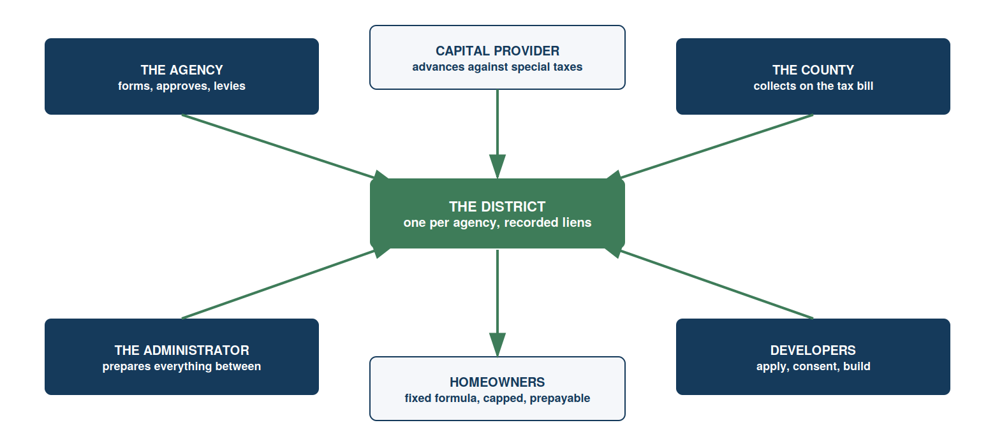
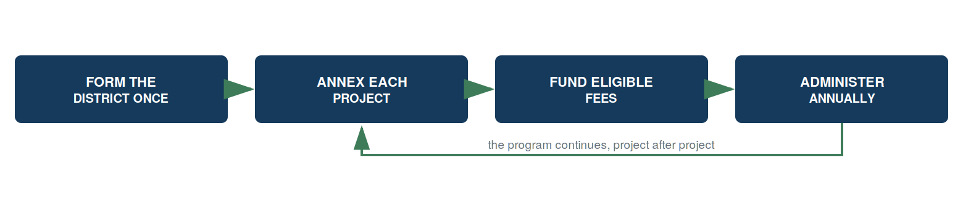

Appendix C: What Is Not Yet Proven
This appendix exists so that no reader has to hunt for the weaknesses.
- No note has closed. No capital purchaser is committed.
- Pricing is a founder target, not a term (C6).
- Per-deal execution cost is a founder estimate, and the model fails if it stays high (F1).
- No city has adopted the program. Formation takes six months or more per jurisdiction (G13).
- Bond counsel is engaged but has not yet opined. Chapter 4 and section 5.5 are gated on that.
- The program name is not cleared. Live Class 36 marks exist (F5, F6).
- The incumbent statewide programs could move down-market and compete directly.

Appendix D: Open Items This Manual Is Waiting On
- The founder’s edits to this chapter plan and to the public-versus-portal split.
- Bond counsel’s engagement, which unlocks Chapter 4 and section 5.5.
- The first term sheet, which converts every commercial term named in section 2.4 from a placeholder into a number.
- The pilot’s close, which converts the founder estimates into facts.

INSITE(TM) is a pre-launch program concept administered by HGF Management Company. This material is not an offer of financing, legal advice, or investment advice. It is not an offer to sell, or a solicitation of an offer to buy, any security. Program structure, eligibility, costs, and pricing are subject to issuer approval, bond counsel review, and program underwriting. Figures identified as targets or estimates are the founder’s working numbers, not commitments.

