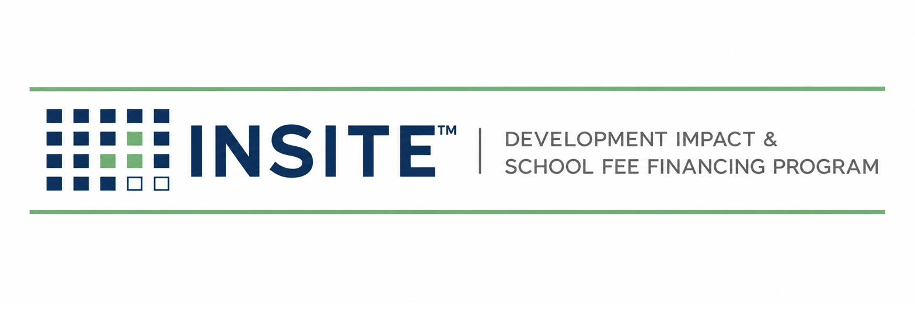
PUBLICATION INS-002
PROGRAM WHITEPAPER
Micro Land-Secured Financing for California’s Small Residential Projects — Overview, Evidence & Market Analysis
Prepared by
HGF Management Company — Program Administrator
INSITE™ Development Impact & School Fee Financing Program
DOCUMENT CONTROL
Publication number | INS-002
Version | 1.0
Status | Evidence-verified release
Publication date | July 2026
Owner | INSITE Program Administration
Classification | External — Stakeholder distribution
Pre-launch program document. INSITE is a proposed program of HGF Management Company. Nothing herein is an offer or commitment of financing, legal, tax, or investment advice, or a securities solicitation. Program structure, eligibility, pricing, and availability are subject to public issuer approval, bond counsel review, and market conditions.

EXECUTIVE SUMMARY
California’s housing laws now fast-track exactly the projects its financing markets serve worst. SB 684 (effective July 1, 2024) and SB 1123 (effective July 1, 2025) require ministerial, 60-day approval of subdivisions of up to 10 lots and 10 homes — no CEQA review, no hearings, no appeals. But before those homes can be built, developers must still pay development impact fees that averaged $23,455 per single-family unit statewide as far back as 2015 (about three times the national average, per the Terner Center at UC Berkeley), that averaged roughly $19,800 per unit on 2020–2023 affordable projects, and that can exceed $150,000 per unit in some jurisdictions. Small developers typically pay these fees with cash or private credit that priced around 9.5%–15% in 2025–2026.
Land-secured financing already solves this problem for larger projects. CSCDA’s SCIP and CMFA’s BOLD let developers finance impact fees and public improvements through property-tax-collected assessments and Mello-Roos special taxes; SCIP publishes a typical minimum around $500,000 in fees/improvements and pools bonds about three times a year, and BOLD reports roughly $550 million financed across 65+ projects and 12,000+ housing units since 2020 — an average well above 180 units per project. INSITE™ is a proposed program built for everything underneath: a standardized, annexation-based operating model that makes 2–50 lot transactions — the design center is a 10-lot map — economical to execute, with privately placed, tax-secured notes and a professional administration platform. Approximately 62,372 of California’s 103,856 permitted housing units in 2025 (60.1%) were in 1–4 unit structures (U.S. Census Building Permits Survey). At an assumed $25,000 of financeable public fees per unit, that conservative segment alone implies a ≈$1.56 billion annual financing opportunity.
What INSITE is not
INSITE is not a lender, not a public agency, and not the first land-secured fee-financing mechanism — SCIP and BOLD demonstrate the concept at larger scale. INSITE’s innovation is operational: standardization and annexation that change the economics of small balances. This paper is pre-launch; see the disclaimer on the cover.

1. THE PROBLEM: FEES ARE FRONT-LOADED; SMALL-PROJECT CAPITAL IS EXPENSIVE

1.1 The fee burden is real and documented
- Statewide averages: $23,455 per single-family home and $19,558 per multifamily unit in 2015 — ≈3× the national average (Terner Center, Cost of Building Housing series).
- Upper range: total development charges can exceed $150,000 per unit, excluding utility fees (Terner Center / HCD study under AB 879).
- Current data: 2020–2023 LIHTC projects paid an average ≈$19,806 per unit in impact fees; 134 projects were charged over $30,000 per unit (Terner Center, January 2026).
- Why fees exist: Proposition 13 constrains local property-tax funding, so growth infrastructure is financed heavily through exactions on new homes (Terner Center; CalMatters).

1.2 The capital gap for small projects
Banks rarely finance fee payments and horizontal work on small maps; the practical alternative is private/hard-money credit, which published sources place at roughly 9.5%–12% for first-position loans and up to 15% overall in 2025–2026, with land transactions priced at a premium and lower advance rates. Every fee dollar paid this way is working capital removed from construction — on a 10-lot project at ≈$25,000–$50,000 per unit of fees, that is $250,000–$500,000 of cash absorbed before vertical work begins (founder-observed range; fee evidence above).

1.3 Policy has opened the gate the capital markets haven’t
- SB 684 (Caballero, 2023; eff. 7/1/2024): ministerial approval, 60-day clock, no CEQA/appeals for ≤10-lot, ≤10-unit projects in multifamily zones (≤5 acres); building permits may issue before the final map records.
- SB 1123 (Caballero, 2024; eff. 7/1/2025): extends the same path to vacant single-family-zoned lots ≤1.5 acres; units average ≤1,750 net habitable sq ft; ADUs may be added at local option without counting against the cap.
- Implementation is live: Los Angeles, the Bay Area’s ABAG (model ordinance + checklists), and cities like Hawthorne and Cudahy have published SHRA application materials.

2. THE MECHANISM: ESTABLISHED CALIFORNIA LAW
Two land-secured paths are settled practice. (1) The Mello-Roos Community Facilities Act of 1982 (Gov. Code § 53311 et seq.) lets cities, counties, special districts, and JPAs form CFDs that levy special taxes secured by a continuing lien, collected with property taxes, with foreclosure remedies — and CFDs are expressly used to finance development impact fees, mitigation payments, and public improvements (this is BOLD’s structure). (2) The Municipal Improvement Act of 1913 with Improvement Bond Act of 1915 bonds imposes assessment liens for the same purposes (SCIP’s primary structure). Credit discipline is statutory: before bonds are sold, the legislative body must determine value of at least three times the land-secured debt (Gov. Code § 53345.8), supported by appraisals under CDIAC-recommended standards. INSITE selects the Mello-Roos path for its flexibility — scattered sites, future annexation areas, and fee financing — and adopts a stricter 4:1 program policy, the same ratio CSCDA sets in its own adopted CFD goals and policies.

3. THE GAP: EXISTING PROGRAMS ARE BUILT FOR BIGGER BALANCES
 | SCIP (CSCDA) | BOLD (CMFA) | INSITE (proposed)
Structure | 1913/1915 assessments; CFDs available | Mello-Roos CFD per project | One Mello-Roos CFD per jurisdiction; projects annex in
Published scale signal | “Typically … as little as $500,000 in impact fees and/or public infrastructure” (Sacramento County SCIP page); pooled bonds ≈3×/year | ≈$550M, 65+ projects, 12,000+ units since 2020 → ≈185 units/project average | Design center: ≈10 lots; range ≈2–50; pilot screens larger until purchaser terms are set
Cadence | Pooled issuance windows | Stand-alone or pooled | Rolling annexations; private placement per deal or small pools
Cost structure (published) | App fee $1,500; issuance ≈4–5%; county admin add-ons | Costs bundled into financing; no agency cost | Targeted per-annexation execution $5,000–$30,000 (founder estimate — pending executed vendor quotes)
Small-map fit | Timing + minimums strain 2–10 lot deals | Track record centers on larger projects | Purpose-built: standardized docs, one appraisal framework, annexation not formation
Sources: cscda.org; development.saccounty.gov (SCIP & BOLD pages); cmfa-ca.com; pipersandler.com. Averages computed from published totals; “designed for larger projects” is an inference from published minimums and averages, not a statement of capability limits.

4. THE INSITE MODEL
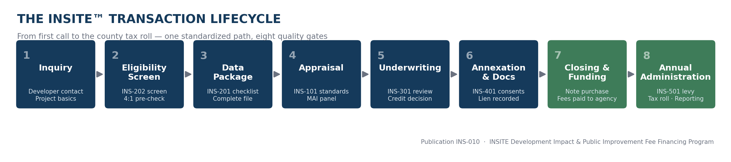
- One host CFD per participating jurisdiction with a future annexation area; each small project joins by administrative annexation, not new formation — the cost structure that makes small balances work.
- One publication library runs everything: appraisal standards consistent with CDIAC guidance (INS-101), preferred MAI panel (INS-102), intake/eligibility (INS-202), underwriting review with a scored QC gate (INS-301), execution (INS-401), and annual administration with an established tax-roll administrator (INS-501).
- Credit policy: 4:1 value-to-lien program standard on an as-is appraisal (statutory floor 3:1, Gov. Code § 53345.8); issuer total-tax-burden policies respected.
- Capital: privately placed, tax-secured notes to banks, insurance companies, and family offices — pricing set by the purchaser at closing (no rate is quoted pre-launch).
- Governance: a public issuer (JPA partner or the agency itself) owns every governmental act; HGF Management Company administers everything else (full division of functions: INS-010 Ch.2).
- Initial eligibility: Mitigation Fee Act impact fees, public utility connection charges, and conditioned public improvements confirmed by the agency. School facilities fees are a roadmap item and are excluded from initial eligibility.

5. MARKET SIZE (SHOW-THE-MATH VERSION)
U.S. Census Building Permits Survey, final annual 2025 (released May 14, 2026): California authorized 103,856 housing units — 57,739 in 1-unit structures, 3,496 in 2-unit, 1,137 in 3–4 unit, 41,484 in 5+ unit structures. The conservative INSITE-relevant segment is the 1–4 unit total: 62,372 units (60.1%). Census reports all 5+ structures in one bucket, so 5–50 unit projects — squarely in scope — cannot be separated and are excluded, making every figure below conservative.
Assumed financeable fees/unit | Annual segment opportunity | 1% capture | 5% capture | 10% capture
$20,000 | $1.25 B | $12.5 M | $62.4 M | $124.7 M
$25,000 (base case) | $1.56 B | $15.6 M | $78.0 M | $155.9 M
$35,000 | $2.18 B | $21.8 M | $109.2 M | $218.3 M

5.1 Where the units are (top counties, 1–4 unit permits, 2025)
County | 1–4 unit permits | @$25k/unit
Los Angeles | 11,422 | $285.6 M
Riverside | 6,235 | $155.9 M
Sacramento | 4,762 | $119.1 M
San Diego | 4,385 | $109.6 M
San Bernardino | 3,771 | $94.3 M
Orange | 3,106 | $77.7 M
Kern | 3,013 | $75.3 M
Placer | 2,690 | $67.3 M
San Joaquin | 2,522 | $63.1 M
Fresno | 2,068 | $51.7 M
County figures computed from the Census county file (co2512y.txt, year-to-date December 2025). County-file totals differ slightly from the final state annual estimate due to Census imputation; the statewide figures above use the official state annual file. The $25,000/unit financeable-fee assumption is an internal estimate grounded in the fee evidence of §1.1; actual financeable amounts are project-specific.

6. LAUNCH PLAN & PILOT
- Pilot: a 27-lot subdivision in the City of Sacramento with finished lots recording July 2026; first scope is eligible permit/impact fees (school fees excluded). Details are being documented for issuer and purchaser review.
- Rollout sequence (founder plan): City of Sacramento → Sacramento County → Placer County → City of Napa → responsive onboarding across the top permit counties (§5.1).
- Issuer strategy: launch with a JPA partner for speed, add direct-agency programs as demand appears, run both permanently (INS-010 §2.2).
- Capital: initial purchaser conversations underway (a regional bank relationship and a California family office); no commitments exist and none are represented.
- Positioning until first close: “feasibility screening and issuer-ready preparation” — INSITE will screen, size, and package projects now, and will not represent financing as available before it is.

7. WHAT WOULD HAVE TO BE TRUE (RISK HONESTY)
Risk | Status | Mitigation
Purchaser appetite for small tax-secured notes at workable pricing | Unproven — the load-bearing unknown | Term-sheet-first launch; pool small annexations; pilot screens larger until quotes exist
Per-annexation execution cost low enough for ≈10-lot deals | Founder estimate ($5–30k) pending executed vendor quotes | RMA + tax-roll subcontracts with fixed per-deal pricing before marketing minimums
Agency adoption pace | Standard gov-sales risk | JPA path first; INS-601 packet built for counsel; SB 684/1123 pipeline gives agencies a reason
Incumbent response (SCIP/BOLD move down-market) | Possible | Speed, small-deal cost structure, and service standards are the moat; document library is the asset
Trademark/name clearance | Open — a live INSITE registration exists in software class | Professional clearance before public launch; program name under review

SOURCES
- CDIAC, California Debt Financing Guide — Mello-Roos: debtguide-api.treasurer.ca.gov (§3.3.7.2).
- CDIAC, Recommended Practices in the Appraisal of Real Estate for Land-Secured Financings: treasurer.ca.gov/sites/default/files/cdiac/recmndPracticeR-E.pdf.
- CSCDA SCIP: cscda.org/infrastructure-finance-programs; Sacramento County SCIP: development.saccounty.gov (SCIP page).
- CSCDA Local Goals & Policies (4:1): cscda.org/wp-content/uploads/2021/01/…Goals-and-Policies….pdf.
- CMFA BOLD: cmfa-ca.com/bold; Sacramento County BOLD page: development.saccounty.gov (BOLD page); Piper Sandler: pipersandler.com/CApublicfinance.
- Terner Center: ternercenter.berkeley.edu — Cost of Building Housing series; Residential Impact Fees in California (with HCD, AB 879); January 2026 LIHTC impact-fee brief.
- U.S. Census Building Permits Survey: census.gov/construction/bps — stateannual_202599.xls; County/co2512y.txt.
- SB 684 / SB 1123: allenmatkins.com legal alerts; abag.ca.gov technical assistance; planning.lacity.gov SHRA page.
- AB 602 / Mitigation Fee Act: leginfo.legislature.ca.gov (AB 602, 2021); Gov. Code §§ 66000–66025 commentary (beninkslavens.com; bwslaw.com).
- Private lending rates: northcoastfinancialinc.com; offermarket.us; amerisave.com (2025–2026 rate guides).
- Full claim-by-claim register with verification status: 01_EVIDENCE/Claims_Register.md (this package).

