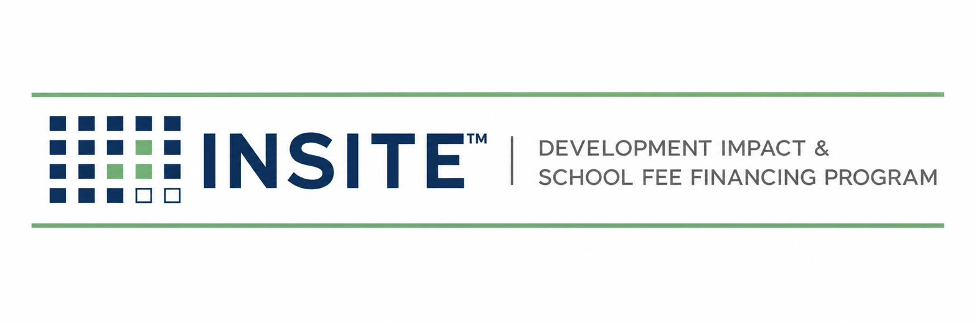
PUBLICATION INS-202
DEVELOPER INTAKE &
ELIGIBILITY MANUAL
Screening · Eligibility Criteria · Preliminary Sizing · Decisioning
Prepared by
HGF Management Company — Program Administrator
INSITE™ Development Impact & School Fee Financing Program
DOCUMENT CONTROL
Publication number | INS-202
Version | 1.0 (Draft)
Status | Draft for founder review
Publication date | July 2026
Owner | INSITE Program Administration
Classification | Internal — Confidential
Pre-launch program document. INSITE is a proposed program of HGF Management Company. Nothing herein is an offer or commitment of financing, legal, tax, or investment advice, or a securities solicitation. Program structure, eligibility, pricing, and availability are subject to public issuer approval, bond counsel review, and market conditions.

SECTION 1 — PURPOSE & POSITION IN THE LIFECYCLE
INS-202 governs Stages 1–2 of the INSITE lifecycle (INS-010 Ch.4): converting an inquiry into a screened, sized, and decisioned opportunity before any third-party cost is incurred. Its outputs feed Stage 3 (INS-201 Developer Data Package). The screen exists to protect three parties at once: the developer (no wasted appraisal fees on ineligible deals), the Issuer (only conforming projects reach its program), and the purchaser (a pipeline that already reflects credit policy).

SECTION 2 — ELIGIBILITY CRITERIA

2.1 Project criteria
Criterion | Standard | Basis
Location | Parcel(s) within a jurisdiction participating in an INSITE-administered program (or realistically onboardable per INS-601 before the developer’s deadline) | Program agreement
Project size | Approximately 2–50 residential lots/units; program design center ≈ 10 lots | Program policy (INS-102)
Entitlement status | Tentative map approved at minimum; final map recorded or on a definite path (SB 684 / SB 1123 ministerial projects explicitly welcomed) | Screen evidence; Claims Register B1–B2
Ownership & title | Single owner or unanimous owners willing to consent to annexation and special tax; no title condition that defeats a special-tax lien | Preliminary title
Value-to-lien (pre-screen) | Estimated as-is value ≥ 4× (proposed INSITE financing + all existing land-secured debt). Statute requires 3:1 (Gov. Code § 53345.8); 4:1 is INSITE policy | INS-101 Ch.9; INS-301
Special-tax burden | Projected total tax burden on completed homes within issuer policy (commonly ≤ 2% of value — confirm per issuer goals & policies) | Issuer policies; RMA consultant

2.2 Eligible costs (initial program scope)
- Development impact fees governed by the Mitigation Fee Act (Gov. Code §§ 66000–66025) payable to a participating agency and confirmed by that agency as CFD-eligible.
- Utility connection and capacity charges payable to public agencies, where the Issuer and counsel confirm eligibility.
- Public improvements required as conditions of approval (streets, water, sewer, storm drain, dry-utility trenching in public rights-of-way) where acquisition/eligibility is confirmed for the specific issuer program.

2.3 Excluded from initial eligibility
- School facilities fees (Ed. Code § 17620 / Gov. Code §§ 65995 et seq. fees): a roadmap item requiring school district, issuer, and counsel documentation; not marketed as available.
- Private, on-lot, or vertical construction costs of any kind.
- Fees already paid more than the issuer-permitted reimbursement window before financing, unless the issuer’s reimbursement procedure is confirmed in writing.
- Operating charges, ongoing service fees, fines, or processing fees without capital nexus.
Language discipline
Screening communications never state that a specific fee “is eligible.” They state that it “appears consistent with program criteria, subject to written confirmation by the [agency] and bond counsel.”

SECTION 3 — STAGE 1: INQUIRY HANDLING
- Log the inquiry in the pipeline (INS-010 §4.3) within one business day with: developer entity, contact, jurisdiction, APNs if known, lot count, entitlement status, target funding need and date.
- Send the standard introduction package: program overview (INS-002 summary), INS-202.01 Screening Form, and the fee-and-timeline disclosure.
- Do not discuss rates. The approved formulation: “privately placed, tax-secured financing repaid on the property tax bill; pricing is set by the purchaser at closing.”

SECTION 4 — STAGE 2: THE ELIGIBILITY SCREEN

4.1 Screening inputs (Form INS-202.01)
 | Required item | Notes / status
☐ | Developer entity, principals, and contact information
☐ | Jurisdiction (city/county) and APN list
☐ | Lot/unit count and product type; SB 684 / SB 1123 status if applicable
☐ | Entitlement documents: tentative map approval; final map status; conditions of approval
☐ | Fee estimate or agency fee schedule for the project (AB 602 requires local agencies to post fee schedules online — pull and file the source)
☐ | Requested financing amount and use (which fees / improvements)
☐ | Estimated as-is market value with basis (developer estimate, listing, prior appraisal)
☐ | Existing debt: mortgages/deeds of trust, assessments, existing CFDs (preliminary title if available)
☐ | Target funding date and constraint (e.g., permit issuance date)

4.2 Preliminary sizing method
- Financeable amount F = confirmed-appearing eligible fees (+ approved improvement costs) + estimated capitalized costs of issuance and reserves per program structure.
- Debt stack D = F + all existing land-secured obligations (existing CFD/assessment principal) + any senior debt that survives closing.
- Value test: V_est ≥ 4 × D, where V_est is the screened as-is value. If 3 ≤ V_est/D < 4, the file may proceed only with Principal exception noting the statutory 3:1 floor and the issuer’s policy.
- Burden test: projected annual special tax vs. issuer total-tax-burden policy (flag for RMA consultant if within 10% of the cap).
- Output: Preliminary Sizing Worksheet (INS-202.02) filed to the deal folder; numbers are labeled estimates in all developer communication.

4.3 Decision matrix
Outcome | Trigger | Action & communication
PASS | All §2 criteria met on screened facts | Issue screen-pass letter; open Stage 3 with INS-201 checklist; log state SCREENED-PASS
CONDITIONAL PASS | One criterion pending third-party confirmation (e.g., agency fee eligibility) | Pass letter names the condition and owner; Stage 3 may start; appraisal may not be ordered until cleared
HOLD | Jurisdiction not yet onboarded | Route to INS-601 pipeline; give developer a realistic onboarding timeline; revisit date set
FAIL | Any hard criterion failed (value test, ineligible costs only, title defeat) | Decline letter states the specific criterion; offer re-screen if facts change; log SCREENED-FAIL with reason code

4.4 Service levels & fees
Screen decision within 3 business days of a complete INS-202.01. The application/screening fee (INS-010 §2.5) is disclosed before submission; whether it credits at closing is a policy Open Item. No other cost is incurred by the developer before a written PASS.

SECTION 5 — RECORDS, REASON CODES & FAIR DEALING
- Every screen — pass or fail — is retained with its worksheet and evidence for program-integrity review.
- Reason codes: RC-1 value test · RC-2 ineligible costs · RC-3 jurisdiction · RC-4 title/ownership · RC-5 entitlement · RC-6 burden cap · RC-7 other (memo required).
- Identical facts get identical outcomes: exceptions require the Principal’s written memo and appear in the monthly KPI report.
- No screening data is shared with purchasers or agencies except in aggregate or under the deal’s disclosure consents.
CONFIRM BEFORE RELIANCE
Issuer-specific policies (total tax burden caps, reimbursement windows, eligible-fee lists) control over the generic standards in §2 and must be attached to this manual as jurisdiction appendices as each agency onboards (INS-601 §5).

