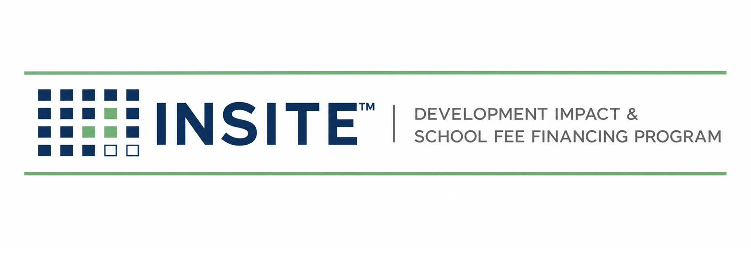
PUBLICATION INS-401
TRANSACTION EXECUTION
MANUAL
Annexation · Documentation · Recording · Closing & Funding
Prepared by
HGF Management Company — Program Administrator
INSITE™ Development Impact & School Fee Financing Program
DOCUMENT CONTROL
Publication number | INS-401
Version | 1.0 (Draft)
Status | Draft for founder & bond counsel review
Publication date | July 2026
Owner | INSITE Program Administration
Classification | Internal — Confidential
Pre-launch program document. INSITE is a proposed program of HGF Management Company. Nothing herein is an offer or commitment of financing, legal, tax, or investment advice, or a securities solicitation. Program structure, eligibility, pricing, and availability are subject to public issuer approval, bond counsel review, and market conditions.

SECTION 1 — PURPOSE & PRECONDITIONS
INS-401 governs Stages 6–7: turning an approved credit into a recorded lien and a funded transaction. It is written to be executed with bond counsel; every legal instrument named here is a counsel-controlled template, and this manual controls sequence, evidence, and quality gates — not legal sufficiency.

1.1 Entry conditions (all required)
 | Required item | Notes / status
☐ | Written underwriting approval memo (INS-301) with conditions listed and cleared or scheduled
☐ | Final INS-101-conforming appraisal on file; 4:1 program test computed and passing (3:1 statutory floor noted)
☐ | Issuer written confirmation that the specific fees/improvements are program-eligible
☐ | Preliminary title report current within issuer policy; all owners identified
☐ | Purchaser indication or commitment consistent with deal size and structure
☐ | Deal folder complete per INS-201 with developer certification

SECTION 2 — THE ANNEXATION MODEL
Each participating jurisdiction hosts one INSITE-administered CFD with a designated future annexation area. Individual projects join by annexation rather than by forming new districts — the structural choice that spreads formation cost across many transactions and makes small balances economical. Formation of the host CFD (a one-time event per issuer) follows the Mello-Roos Act process summarized in the California Debt Financing Guide: local goals and policies (including adopted appraisal standards), resolution of intention, hearing, landowner election where applicable, and recording of the notice of special tax lien.
CONFIRM BEFORE RELIANCE
Annexation mechanics — including unanimous-approval procedures for territory proposed for annexation, election waivers, and the form of the amended notice of special tax lien — are prescribed by the Act and implemented by bond counsel. This manual intentionally does not restate statutory steps; counsel’s closing memorandum for the first transaction becomes Appendix 401-A and controls thereafter. Confirm with counsel: annexation article procedures, recording requirements, and any county-recorder formatting rules.

2.1 Standard annexation document set (counsel-controlled)
Doc | Instrument | Signer(s) | Filed / recorded
401.D1 | Petition / consent and waiver of owner(s) of territory to be annexed | All record owners | Issuer file
401.D2 | Unanimous approval / landowner ballot materials (as applicable) | Owners; Issuer officer | Issuer file
401.D3 | Rate and Method of Apportionment exhibit for the annexed territory | RMA consultant certification | Attached to D2/D4
401.D4 | Amendment to Notice of Special Tax Lien | Issuer officer | County Recorder
401.D5 | Financing / acquisition & fee-payment agreement (developer · issuer · administrator) | All parties | Deal file
401.D6 | Note purchase agreement & note (private placement) | Issuer; Purchaser | Deal file
401.D7 | Closing certificate & instruction letter; counsel opinion | Counsel; parties | Deal file

SECTION 3 — EXECUTION WORKFLOW (STAGE 6)
- Kickoff: Operations Lead opens the closing checklist (INS-401.01), circulates the working-group list (developer, counsel, RMA consultant, issuer contact, purchaser, title), and sets the target closing date.
- Data lock: APN list, legal description, owner vesting, and fee amounts frozen against the title report and agency fee confirmation; any change re-opens underwriting review of the 4:1 test.
- RMA exhibit: consultant produces the annexation tax exhibit; Operations verifies lot count, land-use classes, and maximum tax against the sizing worksheet (maker/checker).
- Document assembly: bracketed fields only; no template edits without counsel email approval saved to file.
- Signatures: owners’ consents notarized as required; issuer officer execution per its authorizing resolution.
- Recording: D4 amendment to notice of special tax lien recorded; conformed copy with recorder stamp saved to file. NO FUNDING BEFORE CONFIRMED RECORDING.
- Pre-closing call: checklist read-down with counsel and purchaser; conditions confirmed cleared.

SECTION 4 — CLOSING & FUNDING (STAGE 7)

4.1 Flow of funds
Purchaser funds the note purchase price to the fiscal agent / designated account → costs of issuance paid per the closing memorandum → eligible fees paid directly to the agency on the developer’s behalf (or developer reimbursed per the issuer’s confirmed reimbursement procedure) → any reserve funded → remainder, if any, per the financing agreement. The developer never routes program funds through its own accounts except in a documented reimbursement structure.

4.2 Closing checklist INS-401.01 (summary form)
 | Required item | Notes / status
☐ | All D1–D7 executed; notarizations verified
☐ | D4 recorded — conformed copy in file (date, instrument number logged)
☐ | Title date-down: no new liens; taxes current
☐ | Agency payment instructions verified by call-back to a known number (wire-fraud control)
☐ | Purchaser funding confirmation received
☐ | Fees paid / reimbursement executed; agency receipt in file
☐ | Funding authorization signed by Principal
☐ | Levy-system record created: APNs, RMA class, principal, first levy year (maker/checker) — Gate 7→8
☐ | Welcome package sent to developer: recorded lien copy, tax expectations, prepayment rights, contacts
☐ | CDIAC / state reporting task opened with counsel (Gov. Code § 8855 — confirm applicability and timing)

4.3 Post-closing file
- Deal file indexed to the INS-201 folder structure plus a CLOSING folder holding D1–D7, recording confirmation, funding evidence, and the final sizing worksheet.
- Portfolio register updated same day; investor data room updated within 5 business days.
- Lessons-learned note (≤ 1 page) filed for any gate that required rework — feeds manual revisions.
Hard rule
If any element of the debt stack, APN list, or fee amount changes after underwriting approval, Stage 6 pauses and the file returns to INS-301 for a delta review. Speed never overrides the 4:1 recomputation.

