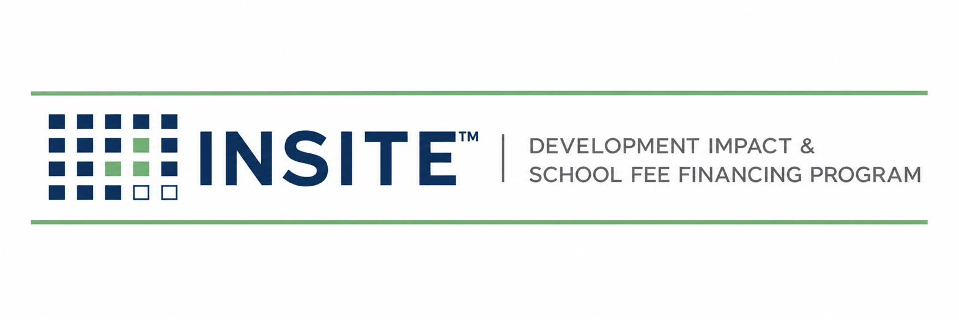
PUBLICATION INS-501
ANNUAL ADMINISTRATION
& TAX ROLL MANUAL
Levy Calculation · County Submission · Collections · Delinquency · Prepayment · Reporting
Prepared by
HGF Management Company — Program Administrator
INSITE™ Development Impact & School Fee Financing Program
DOCUMENT CONTROL
Publication number | INS-501
Version | 1.0 (Draft)
Status | Draft for founder & TRA review
Publication date | July 2026
Owner | INSITE Program Administration
Classification | Internal — Confidential
Pre-launch program document. INSITE is a proposed program of HGF Management Company. Nothing herein is an offer or commitment of financing, legal, tax, or investment advice, or a securities solicitation. Program structure, eligibility, pricing, and availability are subject to public issuer approval, bond counsel review, and market conditions.

SECTION 1 — PURPOSE, ROLES & THE ANNUAL CYCLE
INS-501 governs Stage 8 — the recurring machinery that makes INSITE a platform instead of a series of one-off deals. The special tax lives for decades; this manual defines the annual cycle that keeps every parcel correctly levied, every dollar reconciled, every delinquency escalated on covenant, and every stakeholder informed.

1.1 Division of labor
Function | Tax Roll Administrator (subcontract) | INSITE Operations
Levy calculation per RMA | R — computes | A — approves; maker/checker sample
County direct-charge file & submission | R | A — verifies confirmation
Collections reconciliation | R | A — reviews; investigates variances
Delinquency identification | R — flags after each installment | A — runs escalation ladder
Prepayment calculations & payoff letters | R — computes per RMA | A — issues; orders lien release
Investor & issuer reporting | C — data | R/A — assembles and issues

1.2 Annual cycle at a glance (fiscal year July 1 – June 30)
Window | Milestone
July | Parcel-change sweep: recorded maps, ownership transfers, completed prepayments; levy database frozen
July → county deadline | Levy computed per RMA; QC; county direct-charge file submitted in county format
August–September | County acceptance confirmation reconciled line-by-line to the computed levy
November → tax bills | Property tax bills issued by county include the INSITE special tax as a direct charge
After each installment | Collections reconciled; delinquency list produced; escalation ladder starts
January | Annual investor reporting package (prior calendar year) issued
Rolling | Prepayment quotes (SLA below), estoppels, data requests
CONFIRM BEFORE RELIANCE
County submission deadlines, file formats, direct-charge codes, and installment/delinquency dates were NOT independently verified this release and vary by county. Before the first levy year, obtain in writing from each county Auditor-Controller: (1) the direct-charge calendar; (2) the file specification; (3) the fund/charge code assignment. File these as Appendix 501-A per county.

SECTION 2 — THE LEVY DATABASE
- One row per APN: county, TRA/charge code, RMA land-use class, original principal allocation, outstanding principal, current-year special tax, status (active / prepaid / delinquent), and deal ID linking to the closing file.
- Changes enter only from four sources: a closing (INS-401 Gate 7→8), a recorded parcel change, a prepayment completion, or an annual RMA escalation — each with a document reference.
- INSITE holds a read-only mirror of the TRA’s database, reconciled quarterly; any mismatch is an incident with a written root cause.

SECTION 3 — LEVY CALCULATION & COUNTY SUBMISSION
- Compute each parcel’s annual special tax exactly per the recorded RMA (base tax, escalator if any, administrative-expense component).
- Maker/checker: a second person independently recomputes a sample (100% of parcels while the portfolio is under 500 parcels; thereafter a documented sampling plan) and signs the levy certificate.
- Generate the county file in the county’s specification; validate APN formats against the assessor roll; reject-and-fix any unmatched parcel BEFORE submission.
- Submit by the county deadline; obtain and file the county’s acceptance/confirmation.
- Reconcile the county-confirmed charge list to the computed levy line-by-line; zero unexplained variances is the only passing result.
- Issue the annual levy report to the Issuer (and purchaser if required): parcels levied, total levy, changes from prior year, exceptions.
Why this section is strict
A levy error is the one operational failure that touches a homeowner’s tax bill, the county, the Issuer, and the purchaser simultaneously. 100% reconciliation is cheaper than one correction cycle.

SECTION 4 — PREPAYMENTS, PAYOFFS & RELEASES
- Quote requests answered within 5 business days with a payoff computed per the RMA prepayment formula (principal portion, redemption premium if any, accrued/defeasance amounts, fees) — TRA computes, INSITE verifies and issues.
- Quotes carry an expiration date tied to the next levy cutoff; quotes crossing a levy date state both numbers.
- On receipt of good funds: apply per formula; instruct release/subordination of the special-tax lien as to the parcel per counsel procedure; record the release; update the levy database same cycle.
- Partial prepayments (per-lot payoffs at home sale, if the RMA permits) follow the same path with per-parcel allocation certificates.

SECTION 5 — DELINQUENCY MONITORING & ESCALATION

5.1 Ladder (default — conform to each note’s covenants)
Step | Trigger | Action | Owner
1 | Installment shows unpaid on county data | Log; courtesy notice to owner of record | TRA → Ops
2 | 30 days delinquent | Certified demand letter; Issuer informed | Ops
3 | Second missed installment or covenant threshold | Purchaser notified per note covenants; foreclosure-counsel consult | Ops/Prin
4 | Covenant foreclosure trigger (e.g., amount/aging thresholds in the fiscal agent agreement) | Issuer initiates judicial foreclosure per Mello-Roos remedies as directed by covenants | Issuer + counsel
The Mello-Roos framework secures the special tax with a lien and foreclosure remedy (California Debt Financing Guide, CDIAC). Exact triggers, cure periods, and mandatory-foreclosure covenants are set in each transaction’s documents; this ladder executes them — it never improvises around them.

5.2 Reporting
- Delinquency report after each installment: parcel, amount, aging, step, next action, and portfolio delinquency rate.
- Any Step-3+ event is reported to the Principal within 2 business days and included in the next investor package.

SECTION 6 — STAKEHOLDER REPORTING
Package | Audience | Contents | Frequency
Levy certificate & report | Issuer | §3 outputs | Annual
Portfolio report | Purchaser(s) | Outstanding principal, levy performance, delinquency, prepayments, covenant compliance certificate | Annual (or per note terms)
Program dashboard | Principal / partners | KPIs from INS-010 Ch.9 | Monthly
State reporting | CDIAC / as required | Issuance and any ongoing reports counsel confirms for privately placed land-secured notes | Per counsel calendar

