Cryptography Homework

Question 2:
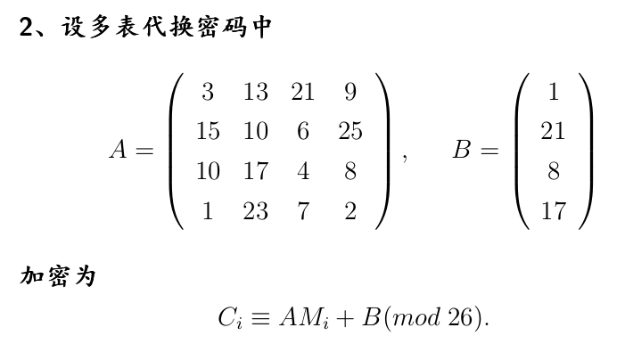
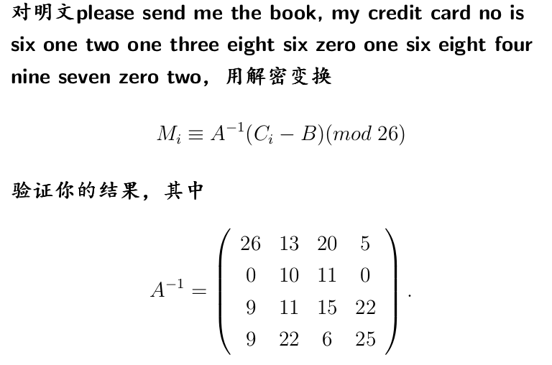
Solution: I use Python to solve it
correction: change inverseA[0, 0] to 23, 26 is a wrong number

verify that the given inverseA is correct:
in the following pictures , you can see that (inverseA * A) % 26 is an identity matrix
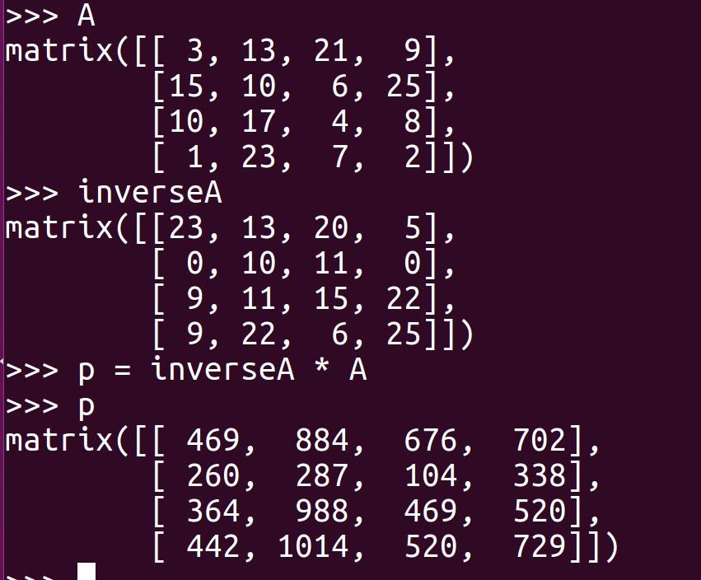
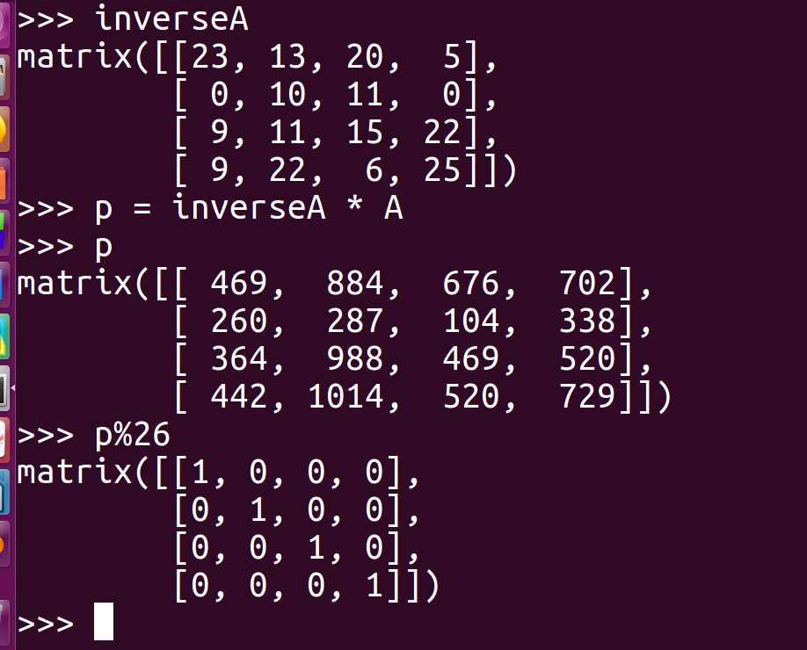
The procedure of my code is as follows:
1. verify that the given A and inverseA are correct
2. preprocess_plain_text(): preprocess the original plain text to get only English letters(all transfomed into lower case), results is stored in processed_plain.txt as follows:

pleasesendmethebookmycreditcardnoissixonetwoonethreeeightsixzeroonesixeightfourninesevenzerotwo

3. encryption(): encrypt the above contents, and store cipher text in encrypted.txt:

NQXBBTWBDCJJIJDTXDCFYFSGLYGDMOXNLLGNHAPCQZZQZCRGZEZJUIEBRRSGNEMVQDJEMXNAIERPXAKMYRBYTQFMNEMVNPGK

4. decryption(): decrypt the above contents, and store decrypted text in decrypted.txt:

pleasesendmethebookmycreditcardnoissixonetwoonethreeeightsixzeroonesixeightfourninesevenzerotwox
remove last 1 chars

(I add ‘x’ at the end of the processed plain text to fill the 4x1 matrix M, so the last 4 chars are “twox”, not “two”)

running result of my code is as follows:

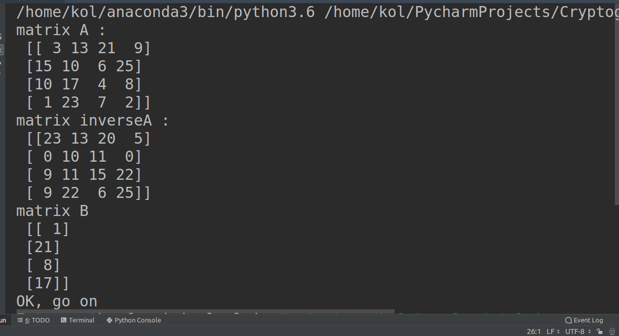

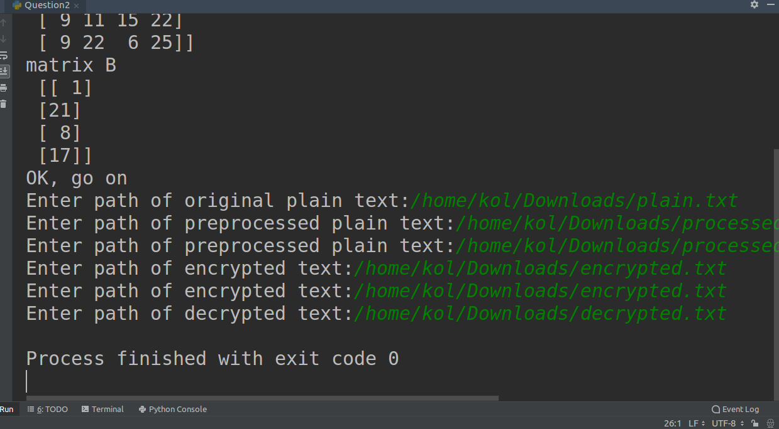

source code in Question2.py:

# question 2
import numpy as np

A = [[3, 13, 21, 9], [15, 10, 6, 25], [10, 17, 4, 8], [1, 23, 7, 2]]
inverseA = [[23, 13, 20, 5], [0, 10, 11, 0], [9, 11, 15, 22], [9, 22, 6, 25]]
B = [[1], [21], [8], [17]]

class Polyalphabetic_Substitution_With_Matrix:
"""
A and inverseA are both entered by the user
"""
def __init__(self, A, inverseA, B):
"""
verify that inverseA * A is an identity matrix
after modulo 26
:param A:
:param inverseA:
:param B:
"""
A = np.mat(A)
inverseA = np.mat(inverseA)
B = np.mat(B)
print('matrix A :\n', A)
print('matrix inverseA :\n', inverseA)
print('matrix B\n', B)
product = (A * inverseA) % 26
if (product == np.mat(np.eye(A.shape[0]))).all():
print('OK, go on')
else:
print('Wrong! A * inverseA must be an identity matrix after modulo 26')

self._A, self._inverseA, self._B = A, inverseA, B
self._dim = A.shape[0]
self._number_of_added_chars = 0 # add 'x' at end to help transform

def preprocess_plain_text(self):
"""
get only English letters, and transform them all
to lower case
"""
filepath1 = input('Enter path of original plain text:')
try:
f1 = open(filepath1, 'r')
except IOError:
print('cannot open', filepath1)
filepath2 = input('Enter path of preprocessed plain text:')
try:
f2 = open(filepath2, 'w')
except IOError:
print('cannot open', filepath2)

for line in f1.readlines():
for original_char in line:
if original_char.isalpha():
if original_char.isupper():
original_char = original_char.lower()
f2.write(str(original_char))

def encryption(self):
"""
if the number of chars is not multiple of self._dim,
then add 'x' at the end
:return:
"""
filepath1 = input('Enter path of preprocessed plain text:')
try:
f1 = open(filepath1, 'r')
except IOError:
print('cannot open', filepath1)
filepath2 = input('Enter path of encrypted text:')
try:
f2 = open(filepath2, 'w')
except IOError:
print('cannot open', filepath2)

M = np.mat([[0] for i in range(self._dim)])
i = 0
for line in f1.readlines():
for plain_char in line:
if i < self._dim - 1:
M[i, 0] = ord(plain_char)
i = i + 1
else:
# once M is full, process it immediately
# otherwise you may lose the last self._dim chars
M[i, 0] = ord(plain_char)
M = M - ord('a')
C = (self._A * M + self._B) % 26 + ord('A')
for j in range(self._dim):
cipher_char = chr(C[j, 0])
f2.write(str(cipher_char))
i = 0

if i < self._dim:
self._number_of_added_chars = self._dim - i
while i < self._dim:
M[i, 0] = ord('x')
i = i + 1
M = M - ord('a')
C = (self._A * M + self._B) % 26 + ord('A')
for j in range(self._dim):
cipher_char = chr(C[j, 0])
f2.write(str(cipher_char))

def decryption(self):
"""
the code is very similar to that of encryption()
:return:
"""
filepath1 = input('Enter path of encrypted text:')
try:
f1 = open(filepath1, 'r')
except IOError:
print('cannot open', filepath1)
filepath2 = input('Enter path of decrypted text:')
try:
f2 = open(filepath2, 'w')
except IOError:
print('cannot open', filepath2)

C = np.mat([[0] for i in range(self._dim)])
i = 0
for line in f1.readlines():
for cipher_char in line:
if i < self._dim - 1:
C[i, 0] = ord(cipher_char)
i = i + 1
else:
C[i, 0] = ord(cipher_char)
C = C - ord('A')
M = (self._inverseA * (C - self._B)) % 26 + ord('a')
for j in range(self._dim):
plain_char = chr(M[j, 0])
f2.write(str(plain_char))
i = 0

if self._number_of_added_chars:
f2.write('\nremove last {0} chars'.format(self._number_of_added_chars))

cipher = Polyalphabetic_Substitution_With_Matrix(A, inverseA, B)
cipher.preprocess_plain_text()
cipher.encryption()
cipher.decryption()

