Cryptography Homework

Question 1:
Use the affine cipher to encrypt a plain text, and we get the cipher text as follows:

edsgickxhuklzveqzvkxwkzukvcuh

We have known that the first two chars in the plain text are “if”. Decrypt it.

Solution: I use Python to solve it
Procedure:
The original cipher text is stored in file ciphertext_lowercase.txt

run toupper.py :
transform all the lower case to upper case and I stored the results in file ciphertext_uppercase.txt whose content is as follows:
EDSGICKXHUKLZVEQZVKXWKZUKVCUH

run Question1.py :
decrypt the content in ciphertext_uppercase.txt to get the plain text which was stored in plain.txt,
encrypt the content in plain.txt to recover the cipher text which was stored in encrypted.txt

the content in plain.txt(there may be a typo in the PPT, because I get the plain text “teahcer”):
ifyoucanreadthisthankateahcer

the content in encrypted.txt:
EDSGICKXHUKLZVEQZVKXWKZUKVCUH

Running results:
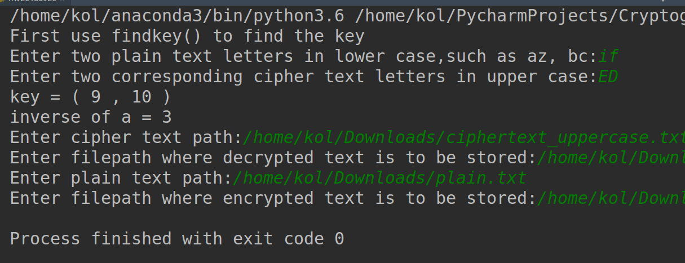

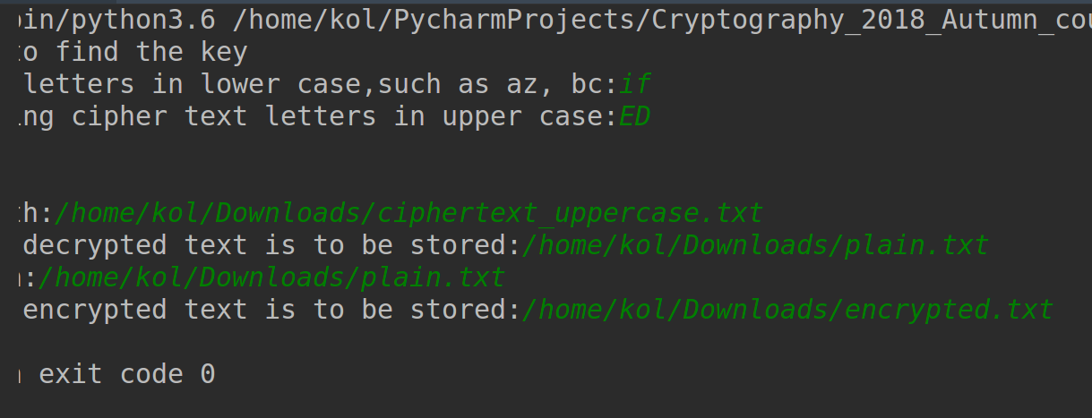
Source code in toupper.py:

filepath_in = input('Enter input filepath:')
filepath_out = input('Enter output filepath')
f_read = open(filepath_in, 'r')
f_write = open(filepath_out, 'w')

for line in f_read.readlines():
for letter in line:
if letter.islower():
letter = letter.upper()
f_write.write(letter)

Source code in Question1.py:
# plain text is in lower case
# cipher text is in upper case

class AffineCipher:
"""
encryption and decryption on affine cipher
"""

def __init__(self):
self._a, self._b, self._inverse_a = 0, 0, 0
print('First use findkey() to find the key')

# find greatest common divisor
def gcd(self, m, n):
return m if not n else self.gcd(n, m % n)

# find the key (a, b)
def findkey(self):
m = list(input('Enter two plain text letters in lower case,such as az, bc:'))
c = list(input('Enter two corresponding cipher text letters in upper case:'))
for i in (0, 1):
m[i] = ord(m[i]) - ord('a')
c[i] = ord(c[i]) - ord('A')

for a in range(1, 26):
if self.gcd(26, a) != 1:
continue
if (a*(m[0] - m[1])) % 26 == (c[0] - c[1]) % 26:
b = [0, 0]
for i in (0, 1):
b[i] = (c[i] - a*m[i]) % 26
if b[0] == b[1]:
break

self._a, self._b = a, b[0]
for inverse_a in range(1, 26):
if (inverse_a * a) % 26 == 1:
break
self._inverse_a = inverse_a
print('key = (', a, ',', b[0], ')')
print('inverse of a =', inverse_a)
return a, b[0], inverse_a

def encryption(self):
plain_text_path = input('Enter plain text path:')
try:
f = open(plain_text_path, 'r')
except IOError:
print('cannot open', plain_text_path)

cipher_text_path = input('Enter filepath where encrypted text is to be stored:')
try:
out = open(cipher_text_path, 'w')
except IOError:
print('cannot write to', cipher_text_path)

for line in f.readlines():
for letter in line:
if letter.islower():
cipher_char = chr(ord('A') + (self._a * (ord(letter) - ord('a')) + self._b) % 26)
out.write(str(cipher_char))
else:
out.write(str(letter))

def decryption(self):
cipher_text_path = input('Enter cipher text path:')
try:
f = open(cipher_text_path, 'r')
except IOError:
print('cannot open', cipher_text_path)
plain_text_path = input('Enter filepath where decrypted text is to be stored:')
try:
out = open(plain_text_path, 'w')
except IOError:
print('cannot open', plain_text_path)

for line in f.readlines():
for letter in line:
if letter.isupper():
plain_char = chr(ord('a') + (self._inverse_a * (ord(letter) - ord('A') - self._b)) % 26)
out.write(str(plain_char))

if __name__ == "__main__":
cipher = AffineCipher()
cipher.findkey()
cipher.decryption()
cipher.encryption()

