BAS ON-BOARD AUTONOMOUS HAR SYSTEM
System Design: Orientation-Agnostic HAR + Digital Twin + Multi-Agent Validation
Instructor Brief — Proposed Architecture

1. Problem & Objective
The proposed system is an offline, on-board AI assistant for microgravity experiments on the Bharatiya Antariksh Station (BAS). It continuously analyzes fixed-camera video, understands astronaut–object interactions, identifies the current experimental step, and validates the procedure without depending on continuous ground support.
- Recognize astronaut activities and hand–object interactions from local video.
- Track the astronaut in an orientation-agnostic 3D payload-rack coordinate frame.
- Maintain a live Digital Twin representing the astronaut, objects, rack and experiment state.
- Validate the prescribed sequence using a deterministic Finite State Machine (FSM).
- Use multiple specialized agents for perception, twin synchronization, reasoning, guidance and logging.
- Provide local voice guidance/alerts and lightweight structured telemetry.

2. Design Principles
Principle | Design Choice | Why it matters
Edge-first | Local inference on Jetson Orin NX / spaceflight compute | Reduces dependence on bandwidth and ground availability.
Orientation-agnostic | 3D HMR + fixed payload-rack frame | Astronauts can work in arbitrary/inverted orientations.
Safety by design | FSM remains deterministic | LLM/agents cannot directly decide procedural validity.
State-aware | Digital Twin | Maintains a consistent view of the whole experiment.
Modular AI | Specialized agents | Each agent has a clear responsibility and can be independently tested.
The thesis describes fixed-camera local processing, orientation-agnostic 3D HMR, HOI-based validation, deterministic FSM logic, offline TTS, and edge deployment. The Digital Twin + explicit multi-agent orchestration are presented here as the integrated system-design layer.

3. MAIN SYSTEM DESIGN
FIXED PAYLOAD CAMERA
Local video stream
↓
1. EDGE VIDEO PIPELINE
Frame capture • preprocessing • temporal buffering
↓
OBJECT PERCEPTION  YOLOv8-nano  • Object class  • Bounding box  • Color | 3D HUMAN PERCEPTION  Orientation-agnostic HMR  • 3D joints  • Body/hand pose  • Rack-relative coordinates | TEMPORAL PERCEPTION  AdaSpot + lightweight HAR  • Active RoI  • Action sequence  • Event timing

↓
2. PERCEPTION FUSION + HAND–OBJECT INTERACTION
Fuse object location, 3D hand position, distance/contact and temporal evidence
↓
3. DIGITAL TWIN ENGINE
Live virtual payload rack + astronaut + objects + current experiment state
↓
4. MULTI-AGENT ORCHESTRATOR
Coordinates specialized agents using the Digital Twin as shared state
Perception Agent  Consumes vision outputs  and updates observations. | Twin Agent  Maintains object, pose  and experiment state. | Reasoning Agent  Explains context and  supports next-step guidance. | Logging/Guidance Agent  Creates telemetry and  voice/text feedback.

↓
5. DETERMINISTIC FSM VALIDATOR
Expected procedure state ↔ observed Digital Twin state
✓ Valid • ⚠ Out-of-order • ⚠ Skipped
↓
6. OUTPUTS
Next-step guidance • Offline TTS alert • GUI • Timestamped JSONL • Local video / stream
Safety boundary: the multi-agent/LLM layer can interpret, summarize and recommend, but the FSM is the authoritative component for sequence compliance.
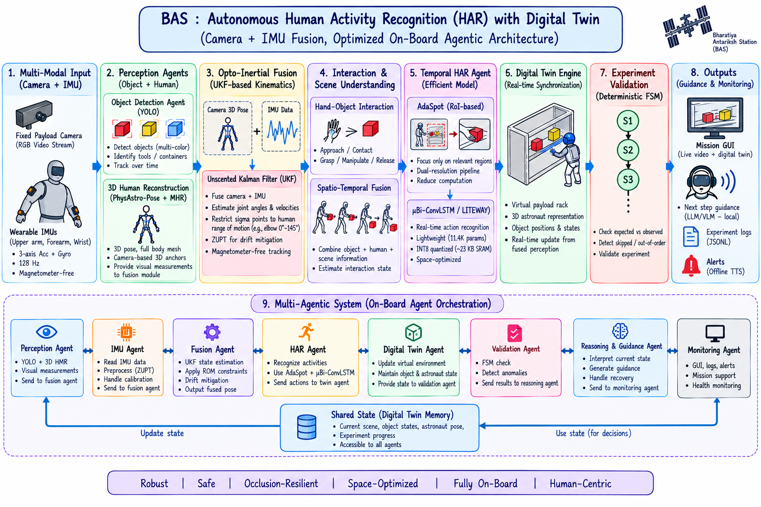
4. HOW THE SYSTEM WORKS — SIMPLE EXAMPLE
Example experiment: Open container → Extract Red Box → Extract Yellow Box. The same architecture can be adapted to other BAS payload procedures.
Step | What the AI observes | Digital Twin state | Validation / action
1. Open container | Lid movement + object context | Container = OPEN | FSM → State 1 ✓
2. Extract red | Hand approaches red box; box exits container bounds | Red = EXTRACTED | FSM → State 2 ✓
3. Extract yellow | Hand approaches yellow box; box exits bounds | Yellow = EXTRACTED | FSM → COMPLETE ✓
Wrong order | Yellow detected while red is required | Yellow = TOUCHED/HELD | FSM → ERROR + voice alert

5. Core AI Modules
Object Detection: Customized YOLOv8-nano, INT8/TensorRT for local inference; detects experiment-specific objects and supports color-aware identification.
3D Human Reconstruction: Orientation-agnostic HMR with a fixed payload-rack coordinate frame; PhysAstro-Pose concepts such as COC, S-PLR and URCF improve robustness to floating/inverted postures.
Computational Saliency: AdaSpot-style low-resolution context + active high-resolution RoI processing to reduce unnecessary computation.
Temporal HAR: Lightweight temporal modeling such as μBi-ConvLSTM/LITEWAY can be evaluated for edge deployment; the final model should be selected from measured latency/accuracy.
Hand–Object Interaction: Combines 3D hand joints, object boxes and spatial/temporal thresholds to infer grasp, extraction and manipulation events.
FSM Validator: Encodes allowed experiment transitions and requires persistent evidence before committing a state change, reducing false alerts.

6. Edge & Software Deployment
- Development prototype: PC + Python + Blender/Three.js Digital Twin + webcam/video input.
- Edge target: NVIDIA Jetson Orin NX for vision/HMR workloads; the thesis specifies a 10–25 W operating envelope for the module.
- Safety-critical validation/logging should remain isolated from probabilistic AI services; the thesis proposes partitioning perception and deterministic functions.
- GUI: live video, 3D twin/skeleton, current step, alerts and diagnostics.
- Telemetry: log only structured events, timestamps, state and outcomes instead of relying on continuous raw-video transmission.

