Given user opens browser  


When user navigates to "https://the-internet.herokuapp.com/"  
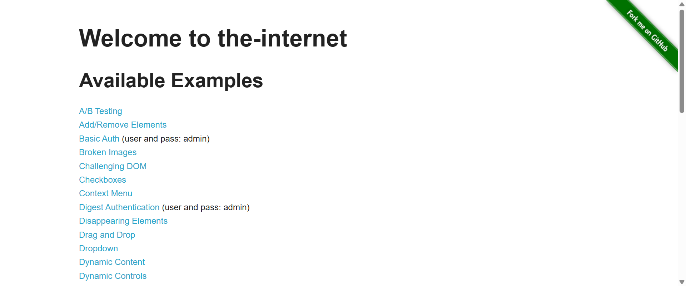

Then title should contain "The Internet"  
