**Coincidence measurement using NaI(Tl) detector**

Hoi Yeung Wong (Ocean Wong)

MSc Physics and Technology of Nuclear Reactors

University of Birmingham

Nuclear Laboratory experiment report (Semester 2)

**Abstract**

In this report, the characteristics of the NaI(Tl) detector was explained and explored in detail. Its timing characteristics for coincidence measurement has been

# 1. Introduction

Some γ radiations are known to be temporally and/or spatially correlated when they are emitted from the same nuclide. For example, when an electron annihilates with a positron, a pair of back-to-back γ-rays with energy Eγ = 511keV must be emitted simulatenously to conserve energy and momentum.

In the following experiment, such temporal and directional correlation will be explored using a relatively fast timing detector, sodium iodide detector, and a coincidence circuit.

To observe the temporal correlation, the circuit will be set-up in such a way that only γ’s of 511keV will be registered by the circuit, allowing us to focus on the temporal correlation only between γ’s of interest, suppressing background noise level.

The method of imaging via locating these γ’s is called Positron Emission Tomography (PET), and is extensively used in industrial and medical applications. By using the same principle as demonstrated in this experiment, the distribution of positron emitting radioactive isotopes in enclosed, otherwise inaccessible volumes can be mapped. Therefore it is important to understand how the coincidence performance varies wrt. angle of detector and source arrangement.

Additionally, since PET relies on scintillators, (NaI and BiGe), it is beneficial to understand the characteristics of scintillator detector’s response, especially in the vicinity of the 511keV range, as well as the timing characteristics of it. [11]

**2. Theory**

**2.1 Nuclear physics of coincidence measurements**

**2.1.1 Positron annihilation reactions**

The classic case of correlated emission of γ is the emission of two back-to-back 511keV γ’s when an electron is annihilated. Take the following example:

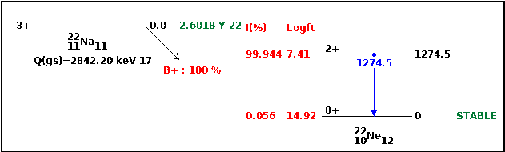

 (The 22Ne* decay by the emission of a high energy γ which is not of interest here.)

This reaction has a ground-state-to-ground-state Q value of 2842.2 keV, 1274.5keV stays in the 22Ne* nucleus 99.940% of the time as it stays in the excited state and decays away later by the emission of a γ corresponding to this energy.

Most of the kinetic energy of this β+ reaction (2842.2 -1274.5 =1567.7 keV) is given to the neutrino due to its small mass. On average the positron carries away K.E.= 215.54 keV, though it can carry away 545.67 keV (the endpoint energy).

The positron then loses all its energy in the material near its parent nuclide via Coulomb interactions with the nearby electrons. When it comes to a rest, it annihilates with an electron. By conservation of mass energy and momentum, two back-to-back γ’s, each with Eγ= mec2=511keV is emitted as a result of their annihilation.

The probability of finding a second 511keV γ from the same decay at a direction and angle and time, when the direction and time of emission of the first 511keV γ is known, is



where θ is the angle the second γ’s path makes with the first’s,

Δt is the the time difference between the first γ and the second γ’s emission,

δ(x) is the Dirac Delta function over x.

These probability distributions are trivial to understand and not plotted here.

**2.1.2 Temporal correlation of successive decays**

As an extension of the case above, another case of a temporally correlated distribution is the separated by deay through one or multiple intermediate energy levels Ni with decay constant λi, expressed as the following (ignoring decay across multiple intermediate states, Ni → Ni+j for j>1)

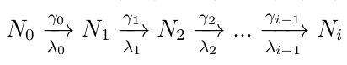

This problem can be formulated as the Bateman’s equation, the full solution of which will not be included here.

In the case of only one intermediate nuclear energy level between the start and end energy levels, the equation simplifies greatly, and the emission probability of the second γ is evaluated as:



For example, in the decay of 44Ti,

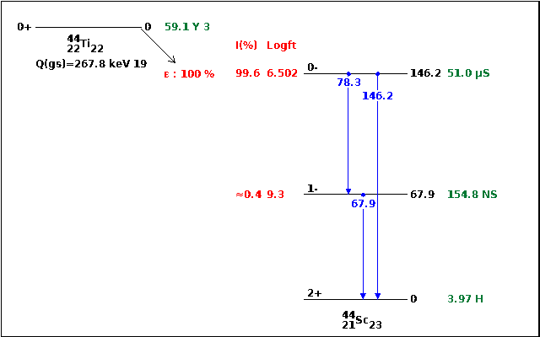

The time difference between detection of γ1 and γ2 is Δt, Where γ1 is the transition from Jπ = 0- to 1-, with Eγ=78.3keV, and γ2 is the transition from Jπ = 1- to2+ , with Eγ = 67.9keV.

**2.1.3 Angular correlatoin of successive decay**

Transitions between nuclear states involves changes to the angular momentum of the nucleus, leading to preferential emission of γ’s in certain polar angles. However, without a strong magnetic field to align the nuclei, all m-states are degenerate, so only an isotropic distribution of nuclear radiation will be measured in the lab frame[7].

But is not true in case of successive decays (γ1, γ2). For a coincidenc circuit where the start pulse is triggered by the detection of γ1 at a fixed direction, and the stop pulse triggerd by the detection of γ2 at angle θ to that direction, the nuclide has to have been already aligned in a particular direction. In other words, the coincidence circuit have effectively selectively sampled a population of nuclides with non-degenerate m-state, so an anisotropic distribution of γ2 emission, manifested as an anisotropic angular distribution of count rate as recorded by the coincidence circuit, will be observed.

However, the current application of such coincidence measurement technique are limited, so it is not carried out for this particular lab report.

**2.2 Detector operation**

**2.2.1 Scintillation**

The detection of γ starts with its interaction with the NaI (Sodium Iodide) crystal:

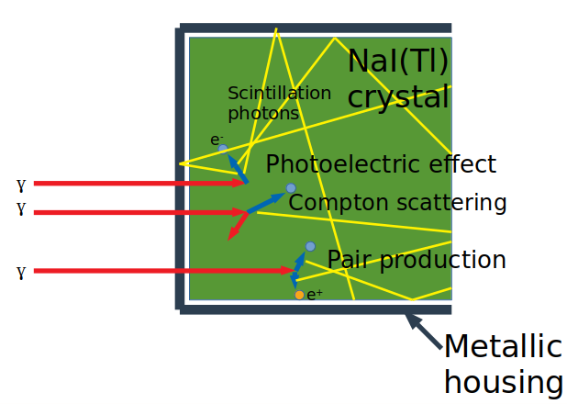

Figure 1: γ deposits its energy into the crystal via the photoelectric effect, Compton scattering, and pair production. The electrons deposit energy in the material to form of electron-hole pairs, which in turn de-excite to emit scintillation photons (yellow). It is connected to the photocathode of a PMT to the right.

After the γ is transmitted through the housing, it has a high probability of being scattered/absorbed by the NaI crystal. This is due to the high atomic number of Iodine in the Sodium Iodide, leading to a high microscopic cross section σpe of absorption of the γ due to photoelectric effect.

The photoelectric effect refers to the phenomena where the atom absorbs a γ of Eγ and liberates an electron with energy Eγ – Eb ≈Eγ where EB is the binding energy required to excite the electron out of its orbital into the conduction band (or exciton band) of the lattice.

The other two competing mechanisms for scattering/absorbing the γ are Compton scattering and pair production.

Compton scattering is an elastic scattering process where part of the energy of the γ is transferred to an atomic electron as the kinetic energy of the electron. The fraction of energy deposited by this process is



, where θ is the angle the γ is scattered through, mec2 is the electron mass expressed in terms of energy. This shows that the maximum fraction achievable (at θ=π) will still be significantly smaller than unity (since Eγ/mec2 <10 for most γ rays of interest). Therefore a Compton scattering event will not reflect the full energy Eγ of the γ.

The last of the three main mechanisms of γ interaction with matter is pair production. When the γ interacts with the electric field in the vicinity of a nucleus, the energy of the photon Eγ can be used to produce an electron-positron pair, annihilating the γ in the process. Due to the conservation of mass-energy, the condition Eγ > 2mec2 must be fulfilled for this reaction to occur as two particles each with mass me are produced.

The energy recorded after a pair production event occurs may be smaller than Eγ by mec2 or 2 mec2 because the positron (created from the original γ’s energy Eγ) will annihilate with another electron in the detecting medium, releasing two back-to-back γ’s each with mec2=511keV. If both are re-captured by the detecting medium (via the photoelectric effect), then all of Eγ will be re-captured in the detecting medium with no loss; but if one or both of the 511keV γ’s are lost, then their corresponding energies will be deducted from Eγ.

In all of the above cases, the energetic electron created travels through the lattice to deposit its energy via successive collisions, exciting other electrons bound in the NaI crystal’s ions, until all its energy is lost.

In each collision, the electron gives away an amount of energy ≥ band gap energy for NaI = 5.8eV. The resulting electron-hole pairs then de-excites preferentially through the activator sites. For the case of NaI(Tl) crystals, these sites are the Thallium cations, where the electron level lies in the forbidden band. The presence of Tl as an activator is key to the large light yield of NaI(Tl). However, it is worth noting that the light yield per keV is energy-dependent, as this helps to explain the result of the investigation in section 3.2.

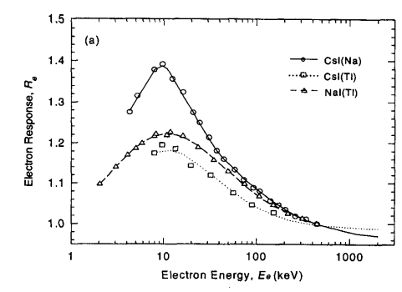

Figure 2: The normalized differential light yield from NaI(Tl) crystal fluctuates with energy. Extracted from Knoll [1]

Additionally, light emission from inorganic scintillators have a long decay time (decay lifetime = 230ns for NaI (Tl))[1]. This leads to a long tail associated with each pulse in the signal created after a γ is absorbed, leading to high deadtime between signal detection.[3]

The NaI crystal is transparent to the light emitted (in the visible/UV range of frequencies) by the mechanism described. This is because these photons has lower energy (longer wavelength) than required to excite an electron from the forbidden band into the conduction band of the NaI. Therefore these photons can travel through the crystal and eventually be collected by a photocathode after reflection, refraction and transmission.

The 3”x3” (diameter ⨉ height) cylindrical NaI crystal is canned in a metallic material and hermatically sealed. This is done for three reason: to protect the hygroscopic NaI from degrading upon contact with water vapour; to minimize trespass of ambient light which will otherwise form a background noise; and to act as a specular reflector to redirect light back into the crystal towards the photocathode.

The NaI crystal are manufactured in two forms: single crystal and polycrystalline. Crystallized from a melt of NaI with 0.1% TlI (atomic fraction) addition, the ingot are subsequently machined into cylindrical form. [4]

**2.2.2 Multiplication into signal**

To convert these photons (of the order of tens of thousands of them) into an electrical signal, a photomultiplier tube (PMT) is used.

The crystal is coupled to the photocathode via optical grease to increase the transmission rate. The photons then travels through a thin semi-transparent photocathode, likely made of a Negative Electron Affinity (NEA) material such as strongly Zn doped GaP (p-type semiconductor) coated with a Cs layer to lower the vacuum potential below the conduction band in the bulk of the material. The vacuum potential is fixed relative to the conduction and valence energy bands’ levels at the surface of the material, so the Cs coating allows electrons in the conduction band in the bulk to easily diffuse outside of the surface[3]. Photoelectrons are liberated from this layer of material into a vacuum, and are accelerated towards the first dynode by a fraction of the applied voltage Vapp. The distance between the photocathode and the first dynode is significantly larger than that between the first and second dynode. This is done so to ensure that there will be minimum spread in the transit time of the electrons, so that a sharp peak will be observed on the amplifier down the line. Additional electrodes are also used to shape the electric field between the photocathode and the first dynode for more precise transit time. Mu-metal is also used to shield the PMT from the magnetic field of the earth to minimize disturbance to the trajectory of these electrons.

Due to thermionic electron emission, the photocathode also leaks electrons spontaneously even when its average thermal energy kBT (T= temperature of the photocathode material, kB = Boltzmann constant) is much less than its work function. This thermionic emission forms the dark current, which contributes a significant level of background noise, and limits the energy resolution of the detector.

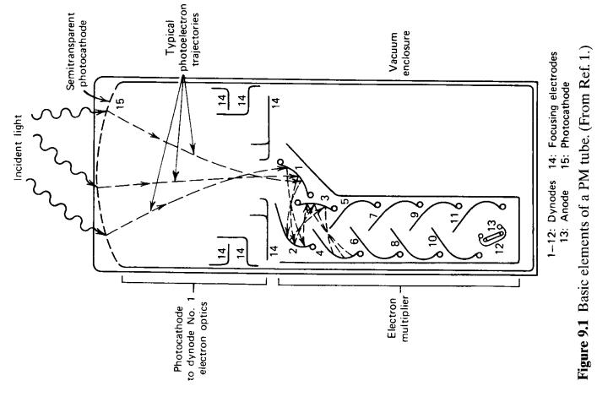

Figure 3: schematic of the internal structure of a PMT, showing the main features: photocathode, electric field shaping electrodes, dynodes. (From [5])

Electrons are accelerated down the series of dynodes by the increasingly positive electric potential on each dynode. The fast electrons impinging on each dynode releases more electrons from the dynode, multiplying the number of electron in the signal pulse by a factor which monotonically increase wrt. incident electron energy on the dynode. The dynode is usually made from BeO, MgO or Cs3Sb[2]. The voltage increase between each dynode is a constant fracton of the applied voltage Vapp /N where N is the number of dynode; this division of voltage is carried out by a specially designed voltage divider.

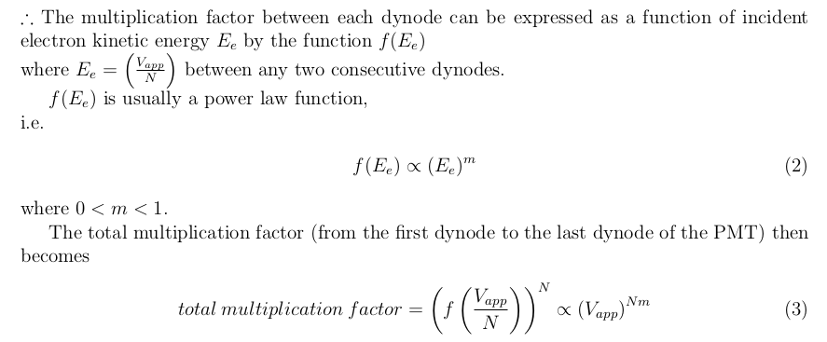 This power law relationship is clearly observed in the figures below:

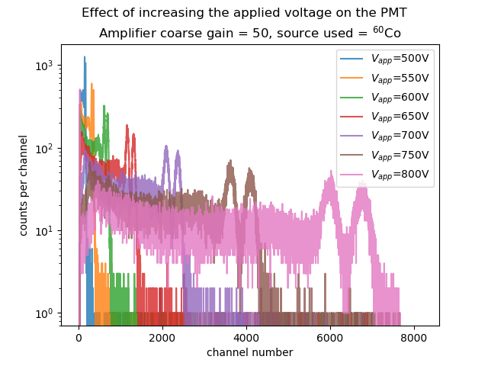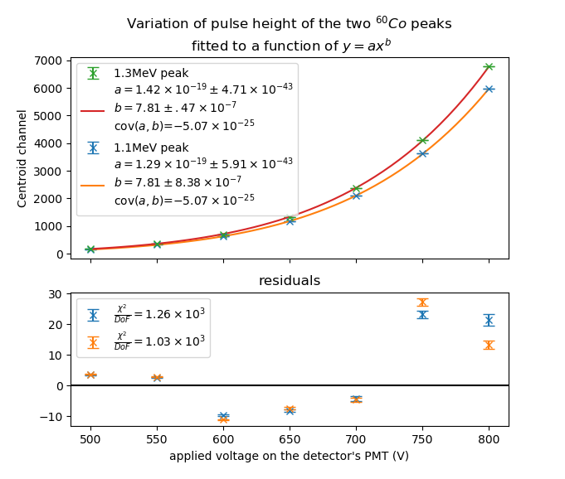

Figure 4a: The variation of the spectrum of 60Co wrt. increasing applied voltage, acquired using an MCA with 8192 channels.

Figure 4b: The variation of mean pulse height (represented by as the centroid channel number) fitted to a power law relationship wrt. applied voltage

Both of the fits above give the same precise result of exponent b=7.81 in fit equation of

y(centroid channel number) = a(Vapp)b

with extremely small error.

Therefore we may deduce that there are N ≥ 8 dynodes in the PMT, such that the

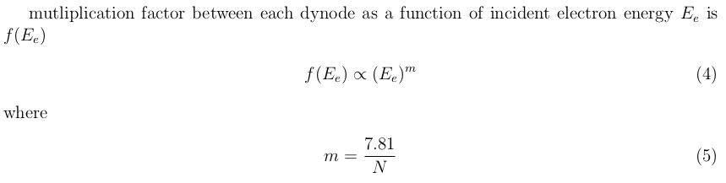

The fitting program used to generate these results does not take into account error on the x-axis (Vapp), which may explain the poor χ2 of the fit, as a small perturbation in x value leads to a very large perturbation in y value due to the power law relationship. The fact that the residuals of both peaks lie on the same side of the fit curve for *every* voltage is further evidence that this may be the case, because this can only be explained by the actual applied voltage being smaller/larger, leading to both data points under-/overshooting the fit curve together respectively; and cannot be explained by random error.

Another explanation for the poor goodness of fit includes the function f(Ee) itself being non-linear and doesn’t adhere to the multiplication factor function f(Ee)∝(Ee)m assumption, leading to a smaller than expected multiplication factor f(Ee) in the 600V ≤Vapp≤ 700V range. Further investigation will be requried if one wishes to understand if this is the case, which lies beyond the scope of this experiment.

**3. Set-up and methodology**

**3.1 Pulse detection**

The arrival of the electrons onto the final dynode forms a current, which is detected as a signal pulse outputted by the PMT. This signal is sent to the main amplifier to be shaped, so that further processing can be done (see figure below).

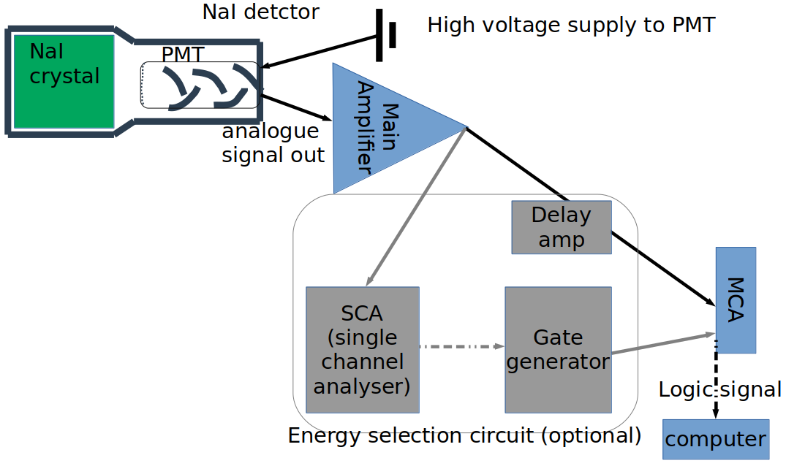

Figure 5: Circuit diagram for acquiring a energy spectrum. All arrows represent coaxial cables. The grey parts are not necessary when energy selection is not involved, so can be bypassed when acquiring the full energy spectrum, analyszing and recording all pulses outputted by the Main Amplifier, indiscriminant of the pulse height.

The main amplifier removes the long exponential decay tail that follows each pulse using a differentiating circuit (RC circuit acting as a high pass filter); and then convert the pulse into a more symmetrical, Gaussian shaped peak using an integrating circuit (CR circuit acting as a low pass filter) by smoothing the rising edge. These two filters also remove background noise of high and low frequencies.

To maximize timing resolution of the detection circuit set-up, the shaping time of the main amplifier (determined by the characteristic decay time of the RC and CR circuits) is set to the minimum value achievable, 0.5μs. This comes at the cost of reduced energy resolution and non-linear scaling of the spectrum, as signal pulses will experience a greater degree of ballistic deficit. But for this experiment, where energy of all incoming radiation are known and well tabulated, this does not present any major issues; and since shaping time = 0.5μs> decay time of scintillation light τ = 230ns, the degredation in energy resolution will be acceptably small.

If an energy selection circuit is added, then a positive voltage will be sent to the MCA’s “gate” port when a signal of interest is detected, prompting the MCA to accept and analyze that pulse.

The single channel analyser (SCA) detects pulses with peaks that falls within a user-defined range (named upper and lower window level), and sends a logic signal to the gate to indicate the presence of such a pulse when it does arise. For TTL convention, 5V and 0V represents 1’s and 0’s in binary, indicating the presence and absence of a pulse of interest respectively. Note that if a unipolar signal is inputed into the SCA, then the 5V TTL signal will be outputted when the trailing edge of the input pulse crosses the lower window level from above. The time when this crossing of the lower window occurs is offset from the maximum of the pulse by a short time Δt , where Δt is dependent on the pulse height. This variation in Δt is called the amplitude-time walk, and will lead to a decrement timing resolution of the coincidence circuit proportional to the size of the SCA window. To eliminate amplitude-time walk, the SCA instead analyses the bipolar output of the Main Amplifier.

The SCA’s 5V TTL signal triggers the gate generator, which generates a rectangular positive voltage pulse called the gate, with user-defined amplitude and duration. The amplitude of the gate is immaterial, as long as it is non-zero, the MCA will be able to register the gate as “open”; but the duration must be long enough to cover all of the signal pulse of interest, as well as allow room for amplitude-time walk if there are any. In a high dose rate environment, it is desirable to not extend the gate any further than that to avoid including noise that can arise after the pulse of interest. For this experiment, the gate duration was chosen to be ~6μs.

A delay amplifier must be used to delay the analogue signal outputted by the amplifier if the energy selection circuit is used. This is because the process described above involving the SCA+gate generator will open the gate with a small delay *after* the pulse of interest has passed. The original signal must be delayed by the same amount of time in order for the MCA to process this pulse.

Decision of the gate duration and delay amplifier delay time can be made while viewing the signal from the gate generator’s output and the delay amplifier simultaneously on an oscilloscope.

MCA (multi-channel analyser), which is a form of an ADC (analogue-digital converter), converts analogue signal into digital data packets, which is then sent to the computer via a USB b connection. For a 12Mbit/s USB connection transmitting as data packets of 16 bits, on average each data packet transmission (containing pulse height information of a single count) can be done within 1.3μs; but a bigger limiting factor on the maximum count rate recordable by the MCA is the conversion time: the successive approximation ADC (SA-ADC) in the MCA requires up to 2μs to convert the analogue pulse into a digital data packet [6]. When the SA-ADC is busy, no new pulses can be processed.

Therefore when carrying out any experiment, one must be aware that the recorded count rates will be discounted when pulses from the detector arrive too frequently, due to the limitation posed by the deadtime of the detector and the deadtime of the ADC. It is preferable to keep the deadtime shown on the computer program to <5%. When the energy selection circuit (SCA + gate) is applied and connected to the gate port, the background pulses that are not of interest will not be processed by the ADC, reduing the ADC’s deadtime; but the actual spectrum may still be degraded by pile-up of consecutive events occuring in the detector, leading to lowered energy resolution and noisier background.

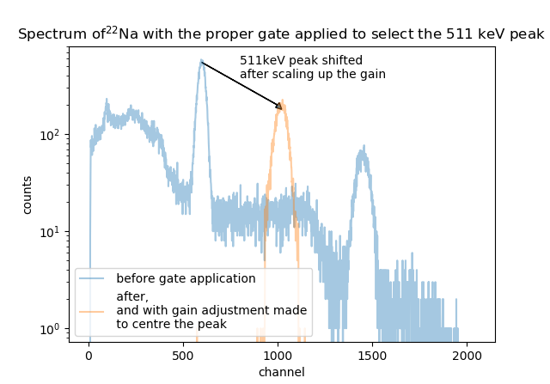

Figure 6: The energy spectrum of 22Na acquired before and after the energy selection circuit was incoperated. Note the counts per channel decreased despite being recorded over the same amount of time, because the gain was increased, so the counts were spread more channels.

Using the circuit described above, the effect of adjusting the window levels on the SCA can be observed on the spectrum displayed on the computer in real time. By adjusting the SCA window levels so that only the Gaussian peak of the 511 keV is observed, the orange spectrum in Figure 6 is obtained. This shows only γ with Eγ=511keV will trigger the SCA.

It is useful to know that a Gaussian distribution appears as a parabolic distribution on a log y plot. This mathematical fact becomes apparent when examining the mathematical expression for Gaussian distribuions.

**3.2 Coincidence**

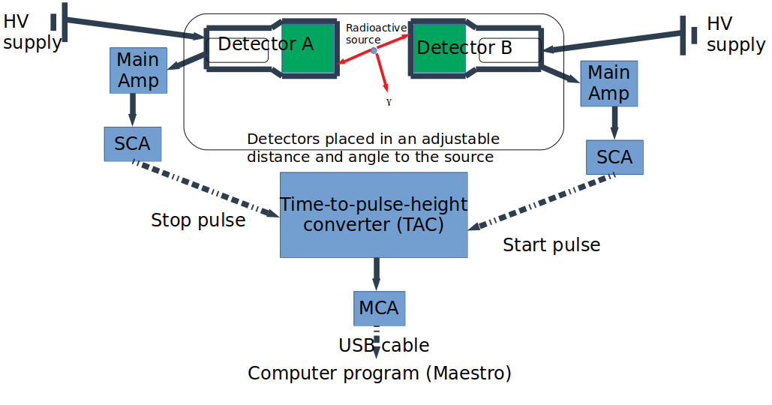

Figure 7: Circuit diagram for measuring emission time difference between two γ’s of known energies.

The time to pulse height converter has the following response:

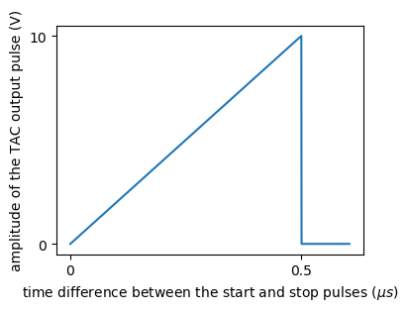

Figure 8: Height of pulse generated by the TAC wrt. increasing time delay between the start and stop pulse inputted into the time delay. The full range voltage and full range time difference of the TAC has been chosen as 10V and 0.5μs respectively.

The TAC charges up its capacitor at a constant rate as soon as a “start pulse” is received, then discharges it when a “stop pulse” is received, generating a pulse with an amplitude proportional to the time difference between the start and stop pulses. If no stop pulse is received after the full range time (set to be 0.5μs in this experiment), the TAC resets, and will not be triggered until another start pulse is received.

In an ideal coincidence circuit, if the start and stop pulses are detected at a constant time difference of Δt0 apart, then a sharp peak will be observed on the TAC pulse height spectrum displayed on the computer, indicating that all pulses from the TAC arrives with the same pulse height (representing the same time difference between pulse the start and stop pulses). However, due to various sources of random errors including electrical noises, variation in impedance in the cables, variation in scintillation photon’s arrival time at the PMT, and the variation of electrons transit time across the PMT, the difference will deviate from Δt0  by a random amount. By the central limit theorem, a Gaussian distribution will be observed instead on the TAC spectrum.

**3.2.1 Positron annahilation reactions and successive γ emissions**

If this circuit is used to investigate coincidence of two γ’s emitted simultaneously, e.g. when investigating electron-positron annihilations, detector A and B will detect a pulse at the same time. After adding on the effect of random fluctuations, the stop pulse will arrive later than the start pulse in only half the cases. Thus only the right half of the Gaussian peak mentioned in the paragraph above will be observed on the pulse height spectrum. To increase the count rate observed, one can *deliberately* introduce a systematic error by delaying the pulse from the SCA of detector A, shifting the centroid of the Gaussian peak to the right by a known amount, improving the counting statistics of the experiment.

The TAC spectrum can then be algebraically represented as:

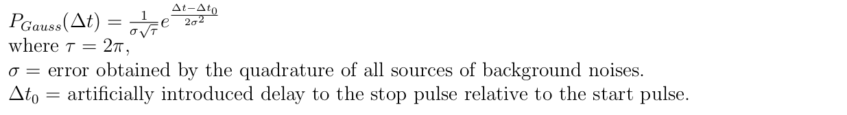

The coincidence measurement circuit above can also be used to examine changes in the TAC spectrum wrt. changes to the detection geometry. For example, increase in distance between detector A and the positron-electron annihilation source should delay the stop pulse, shifting the Gaussian peak further to the right. But in this experiment, the distance of both detectors from the source has been kept constant and equal, so no changes to the centroid location was observed, as was expected, and no further investigation into that was carried out.

If the two γ’s of interest are not emitted simultaneouly, but rather with a variable delay as explained in Section 2.1.2, then a different shape will be observed on the TAC spectrum. Consider the following decay of Titanium,



The 44Sc* is the 2nd excited state of Scandium nucleus (Jπ=0-) (see Section 2.1.2), emitting a γ1 of Eγ=78.3keV to decay to the 1st excited state; and then emitting a γ2 of Eγ=67.9keV to decay to the ground state.

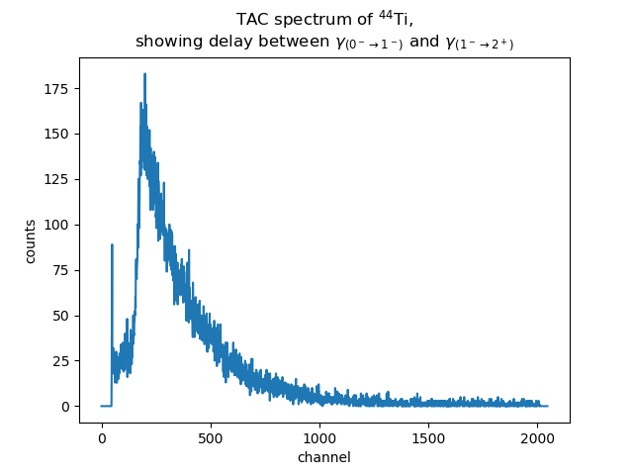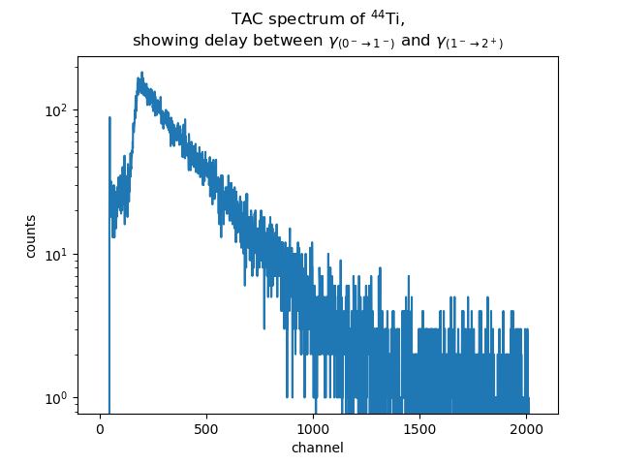

Figure 9: The TAC spectrum of the coincidence of the two main decay radiations of 44Ti in a) linear and b) log scale. Note the straight line with constant slope n the log scale plot, which corresponds to the exponential decay of the intermediate state 1- of 44Sc.

The spectrum obained can be interpreted as the convolution of the two probability distributions:

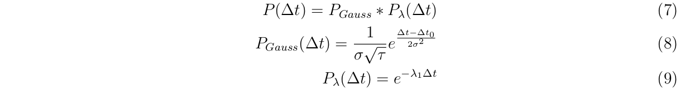

The decay curve has decay constant λ=154.8ns equal to the decay life time of the intermediate nuclear energy level.

Deconvolution can be performed on the above spectrum to find out the length of the decay life time of the intermediate nuclear level. This can be done by Laplace transform of the spectrum, dividing it by the gaussian peak’s laplace transform; or by function fitting (i.e. finding the best fit parameters for the Gaussian peak’s width and exponential decay lifetime that will give a function that resemble the TAC spectrum the most after their convolution.)

In Figure 7, where the detectors are placed in an adjustable distance and angle to the source, the set-up is more clearly sketched below:

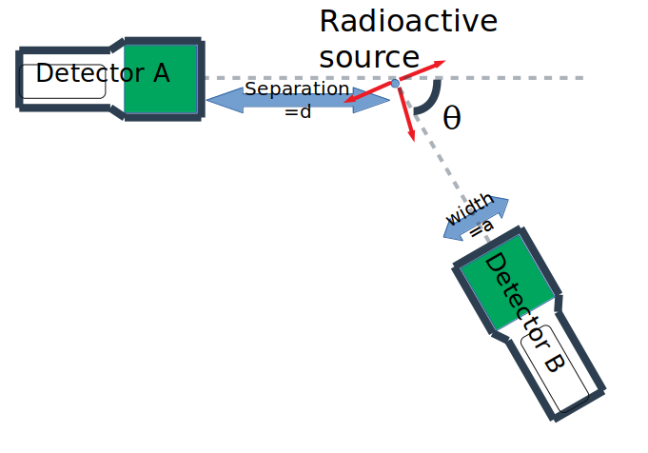

Figure 10: The close up of the geometry of the detector set-up used.

Due to the finite size of the detector (diameter of NaI crystal = a = 3” = 7.62cm), the angular distribution of coincidence count rate will deviate from the expectation of δ(θ-π) as explained in section 3, to be a peak of finite height and width.

A detailed derivation, as well as the result, will be presented in section 5.

**3.2.3 Compton Scattering**

Another application of the coincidence circuit is to investigate the energy distribution after a Compton scattering event:

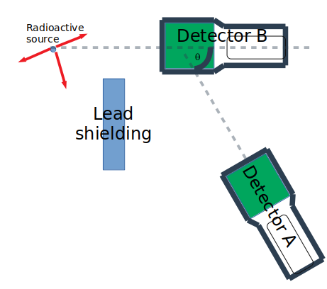

Figure 11: The set-up for measuring the energy of Compton scattered γ’s. Detector B is triggered by a Compton scattering event, and Detector A is triggered by a γ with the complement energy.

A Compton scattering event in Detector B deposits a fraction of energy 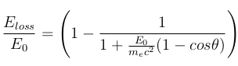.

The fraction energy left in the Compton scattered γ is , where θ is the angle that the γ is scattered through. Detector A is set-up to be triggered a γ with Eγ equal to this fraction of the original γ’s energy E0. The lead shielding is used to collimate the beam partially so that no full energy γ with energy E0 directly arrives at detector A without first Compton scattering off detector B.

These two equations can then be verified using the coincidence measurement circuit (Figure 7) and the set-up in Figure 11.

**4. Detector characteristics measurement**

First, in order to to properly operate the detector, The following section explores the characteristics of an NaI detector using the set-up described in section 3.1.

**4.1 Energy resolution**

The detector’s ability to differentiate between neighbouring peaks decreases as the energy of the peaks increase.

This can be quantified by the quantity R, where R(E)= FWHM(E)/E is a function of energy E (which is in turn a function of channel number) of the incoming γ. Where FWHM is the full width half maximum of the photopeak with the specified energy.

R(E) is expected to roughly ∝ 1/√(E) for an NaI detector. This is due to large statistical noise of the PMT, because the pulse height is strongly dependent on the small number of electrons arriviaing at the first dynode, creating a FWHM partially proportional to the square root of the number of electrons arriving at the first dynode, which in turn is proportional to the number of scintillation photons, which in turn is (almost linearly (see Figure 2)) proportional to the energy of the incoming radiation.

However, other contributions, such as dark current through the PMT, is energy independent, and contribute a constant component to the FWHM. Therefore, the expected expression for FWHM is



By measuring the FWHM (in terms of number of channels) of various photopeaks of known energy at a fixed gain and voltage, and converting that into FWHM(E) using the calibration equation in section 4.4, the following is obtained:

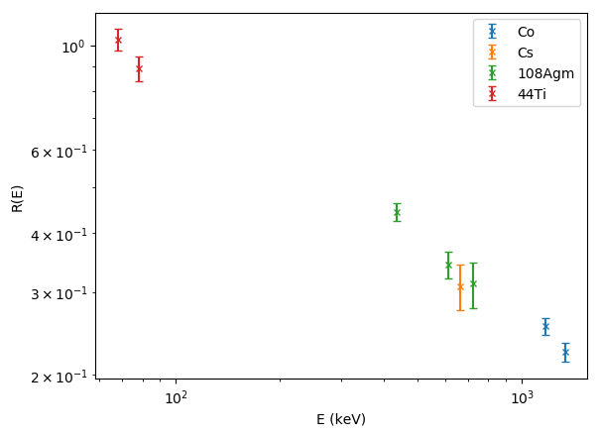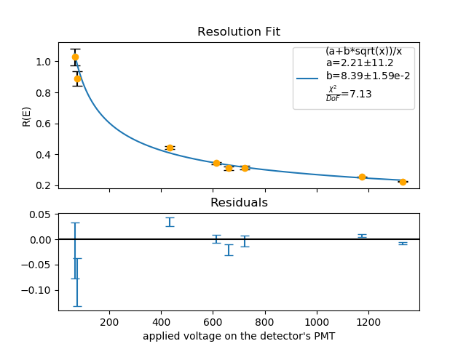

Figure 12: The resolution R(E) data obtained from four calibration sources, a) plotted on a log scale/ b) fitted on a linear scale.

The inverse relationship with (E)2 is apparent on the log-log plot (Figure 12a), and is quantified concretely using the fit in Figure 12b.

Comparing the two fit parameters against each other, the FWHM is dominated by the energy dependent component b= 8.39±0.0159 keV1/2 , which is much larger than the energy independent constant component a=2.21±11.2 keV when multiplied onto √(E). This agrees with the expectation that the FWHM arises mainly due to statistical noise of number of electrons arriving at the first dynode, thus mainly proportional to √E, thus R(E) is proportional to 1/√(E).

The R(E)∝1/√(E) trend implies that the energy resolution is better at higher energy; and peaks at lower energy are more difficult to be resolved from one another. Therefore, when setting up the coincidence circuit, more noise is expected to pass through the window discriminator and be mis-counted as signal pulses at low energy than at high energy.

**4.2 Efficiency**

Since detectors are only capable of measuring the energy of γ’s which has interacted with the detector (i.e. via scattering or absorption), but some γ’s incident on on the detector may be transmitted through the detectoing medium without interaction, the efficiency of the detector is always >100%.

Inorganic scintillators such as NaI(Tl) detectors relies on the interaction of :gamma; with the detector crystal to deposit its energy, which is then re-emitted by the crystal as photons of much lower energy.

The γ’s deposit energy into the detector crystal via the three main effects mentioned in section 2.2.1: the photoelectric effect, Compton Scattering, or pair production. The dominant mechanism is different for different energy ,and the cross-section of each of these interactions is also energy dependent. Therefore, the efficiency of the detector at detecting incident γ’s is also dependent. The latter two mechanisms (Compton scattering and pair production) are prone to depositing less than the full energy into the crystal. This is because Compton scattering allows the scatterered off photon to escape the detecting medium (the energy lost by the photon to the detecting medium (NaI crystal) then forms the Compton continuum); While pair production allows one or both of the 511keV γ’s created after the positron has lost all its kinetic energy and annihilates with a rest e⁻ to escape, the remaining energy deposited into the detector forms the single/double escape peak.

Therefore, the ratio



is also an energy dependent quantity, as the fraction of γ’s interacting with the detecting mediu by the photoelectric effect decreases wrt. increasing incident energy.

A hgih efficiency at the energy of interest is desirable for completing the measurements in a reasonable frame of time and have a high signal : noise ratio.

NaI has a high effective atomic mass



so it has a high cross-section for photoelectric effect, whose cross-section varies as σ ∝ Z4-5; thus it has a high efficiency.

The absolute efficiency of the detector set-up is defined as



Since the detector will be kept at a constant distance away from the source throughout the experiment, (2.95cm), we are only interested in the absolute efficiency of the set-up, at the photopeak energy range.

By measuring the counts received from sources of known activites and energy, one can find the efficiencies of the NaI detector at that energy by the following formulae:

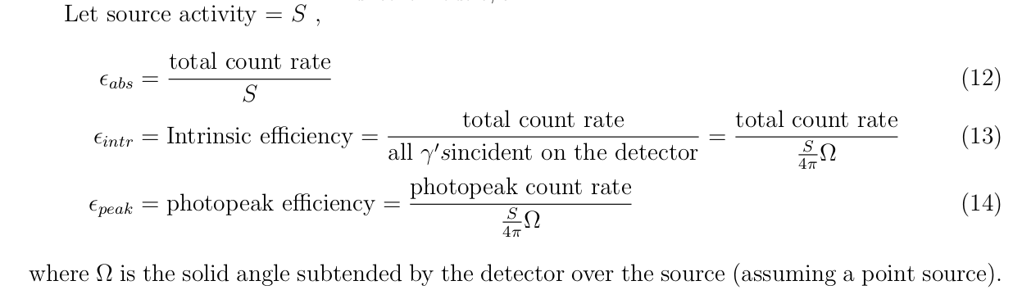

The fraction of γ’s which are able to trigger the start and stop of the coincidence circuit is then equal to (εabsr) since only the pulses whose amplitude that falls within the SCA’s window(the photopeak energy range) will trigger the SCA.

When performing the coincidence measurement, it is desirable to keep this factor (εabsr) as high as possible (close to unity) so to maximize the count rate.

This means that when investigating the coinicidence of γ of a particular energy, if the r=εpeak/εintr, an energy and detecting medium material dependent property, is low, then εabs should be increased by moving the detectors closer to the source to compensate; or, alternatively, use a detector with higher efficiency (e.g. larger detector crystal or a detecting medium with higher Z) to increase the count rate, making the experiment less time-consuming.

The efficiency of the detector is expect to vary as follows:

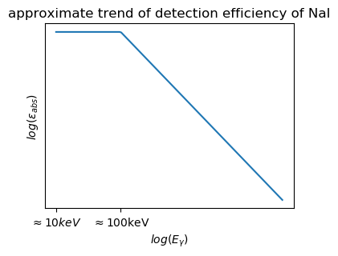

Figure 13: expected trend of variation in absolute efficiency of an NaI detector in log scale, reproduced from Knoll [8]

This is because at low energy (~10 keV, above the X-ray absorption edges of Na and I), the photoelectric (pe) cross-section is large; so the rate of reaction per cm of material travelled through by the γ is high, i.e.

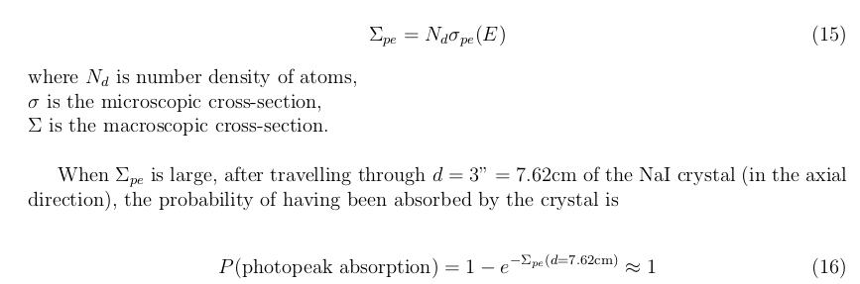

where the photopeak absorption refers to events where γ is recorded as its full energy via photoelectric interaction.

However, as the energy increase, photons starts to be able to be able to escape the detector without being absorbed/scatterd, P(photopeak absorption) starts to deviate from unity, such that the photoelectric effect’s cross section starts to decreas as E-3, while the at the same time, Compton scattering microscopic cross section increases, competing to reduce the number of photopeak counts. It is this energy dependent region that we are interested in.

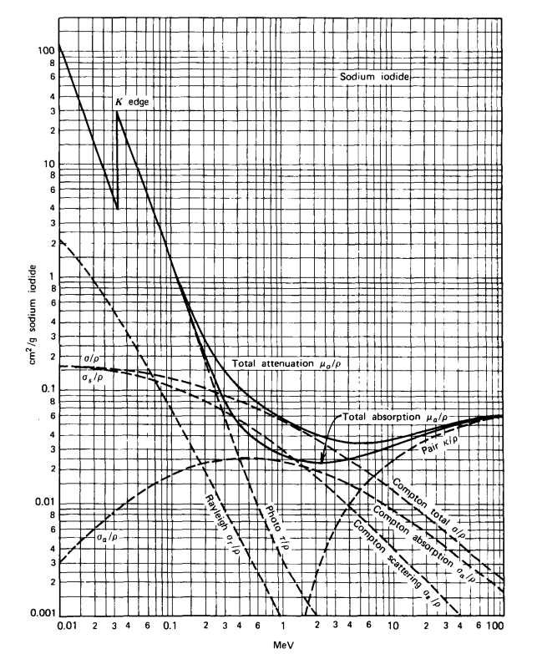

Figure 14: The variation of mass attenuation coefficient of NaI (≈Σ/ρ where ρ=density).

Note the steep drop off of contribution from the photoelectric effect, after which Compton scattering dominates [9]

This leads to an inverse relatiosnhip wrt. E below:

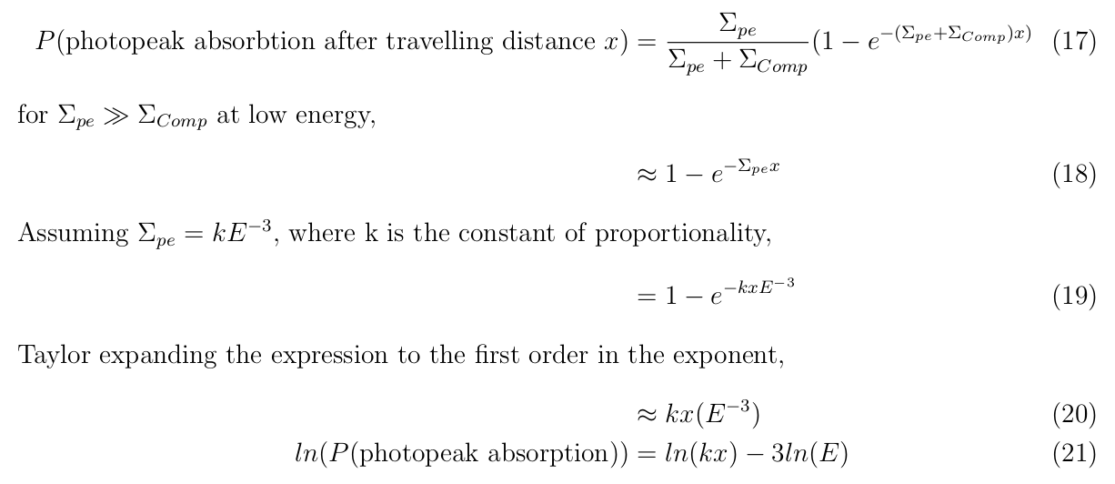But in reality, the pair production effect contribution to the photopeak absorption as well at high enough energy (Eγ>1022keV), leading to a much shallower slope, the magnitude of which <|-3| predicted above, i.e. σ deson’t drop off as fast wrt. E. See the following plots:

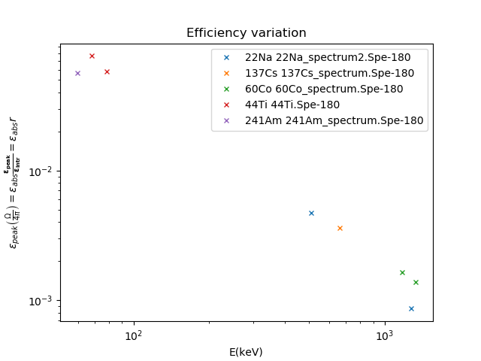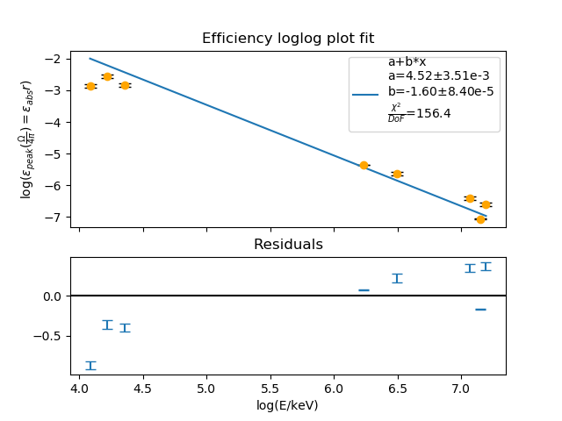

Figure 15: a)Plot and b)fit of Efficiency of a NaI detector. An inverse relationship wrt. energy is observed. The error bars displayed on 15b are too small, likely due to the fitting program Buffit underestimating errors associated with them.

Note that anomalous data points from 133Ba were removed (See Appendix)

All data points are assumed to be situated in the energy dependent region of Figure 13.

The quantity being plotted here (εabsr) should follow the same trend as that in Figure 13 assuming that a nuclear data point should be visible. This plot supports the prediction of

“log( P(photopeak absorption) ) linearly decreases with log(energy)”

made above; a haphazardly fitted line in Figure 15 gives a slope of -1.60 , far from the value of -3 expected at the low energy limit. This is likely because of the contribution to the photopeak by pair production, bending the curve back up at the high E end.

**4.3 Timing resolution**

The timing resolution of the coincidence circuit set-up can be measured by a simutaneous pair of γ, emitted back-to-back. Repeating this measurement of Δt will give the timing precision of this circuit, quantified by the standard deviation σ of the time difference measured as introduced by noises from various sources.

Therefore positron annihilation γ’s (2 back-to-back γ’s of 511keV emitted simultaneously) was chosen for this purpose. This is generated by the 22Na decay into 22Ne, by the reaction



described in section 2.1.1.

Note the background count rate for 511keV γ’s is too low to cause any counts to be recorded when the 22Na is absent. See the appendix for such plot of background (BG) coincidence rate when the source is removed.

Using the procedure described in section 3.2.1, the following TAC spectrum is obtained. The pulse height (x-axis) represents the time difference between the stop and start pulse.

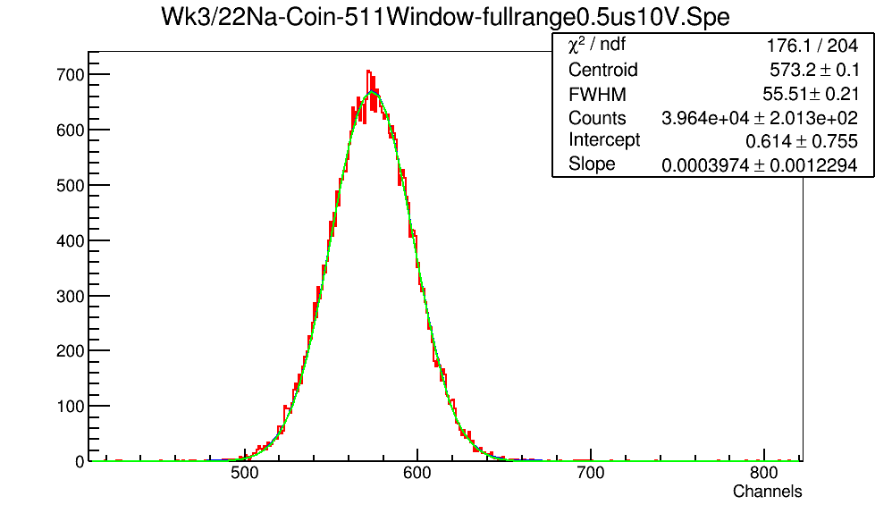

Figure 16: TAC spectrum of coincidence of 511keV γ’s from 22Na decay;

acquired using a full range voltage = 10 V, full range time = 0.5 μs, acquired over 300s;

the stop pulse (from detector A) is delayed by 0.2μs more than the start pulse.

The green lines are the components of best fit functions guessed by Buffit [10]

The detectors were placed at θ=0, i.e. in a syemmetrical collinear geometry, sepearated from the source by d=2.95cm each, as stated in section 3.2.1

The non-zero width of the gaussian peak above arises from random fluctuation in elecrical noises, and detector scintillation time variation as explained in section 3.2.1. The standard devation σ is formed from the quadrature of all sources of random error (i): 

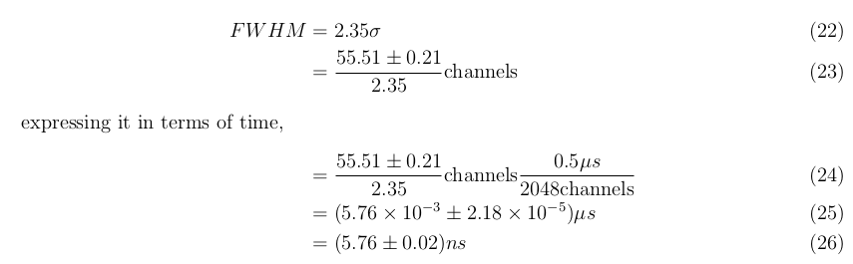

which is an excellent timing resolution, considering that the scintillation pulse in NaI itself has a characteristic decay lifetime of 230ns.

**4.4 Calibration equation**

In cases where γ’s of uncertain energies sources needs to have their energy determined, calibration of the NaI detector is required to convert the channel number on the spectra into γ energy values.

The following section demonstrates how this can be done, despite the fact that there isn't need for such an operation in this experiment where all sources has very well documented energies. This method is applicable to any nuclear radiation detectors with a reasonably linear energy-pulse height conversion equation.

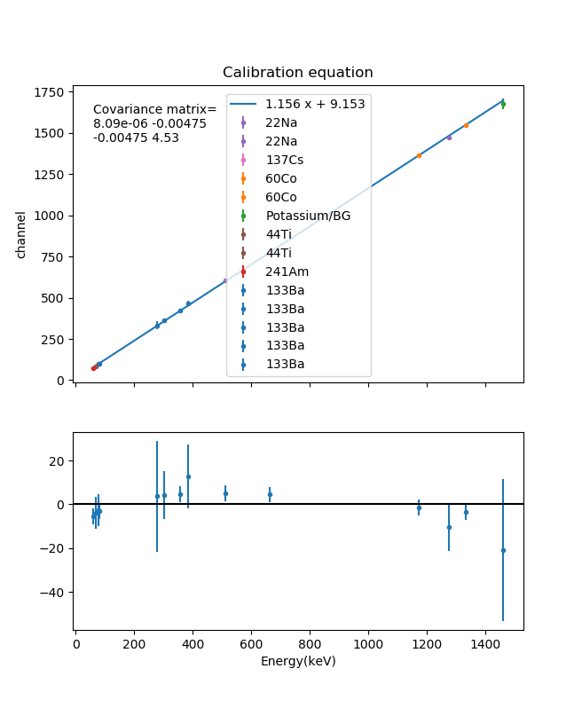

Figure 17: Calibration plot

The centroid channel number and its associated error are found, either manually or by a fitting program like Buffit [10]. These are assigned as the y-values and error on y-values of the data points respectively; while the corresponding, known Eγ of each peak is assigned as the x value. Linear regression is performed on this set of x-y data to find the best fit line’s slope and intercept (m,c) and its associated errors (σm, σc) from the covariance matrix,

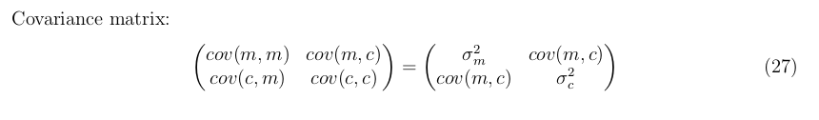

So that when a unidentified peak of centroid value y1 and associated error on centroid value dy1 is observed, the energy x1 and the associated error on energy dx1 can be found using the following equations:



Precaution: The calibration parameters are dependent on the applied voltage, as well as gain on the amplifier. For applications where energy of the incident γ isn’t already known, one must ensure that calibration is done for every new session, because a minor voltage drift will still lead to a big difference in the calibration equation.

**5. Results of coincidence measurements**

The following section demonstrates the use of two NaI detectors for coincidence measurement using the set-up described in section 3.2.

**5.1 Angular distribution of positron annihiliation**

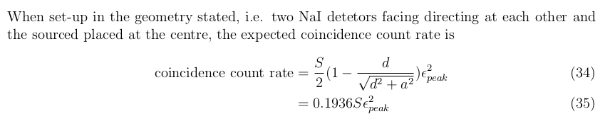

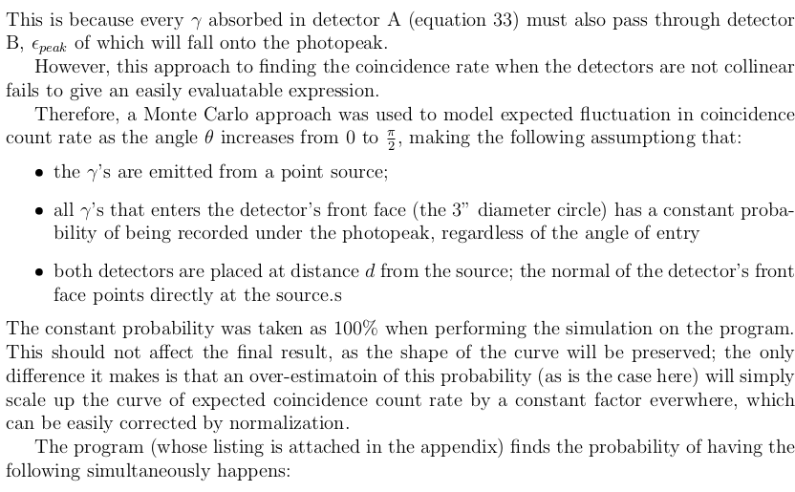



The program written calculates a datapoint from 200000 trials, where each angle from θ=0° - 90° at interval of 1°

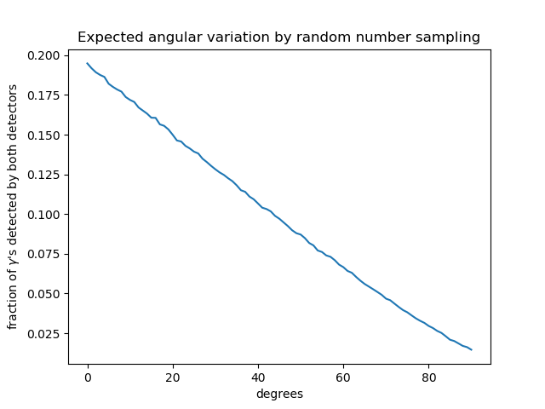

Figure 18: Expected angular variation of coincidence count rate generated by the aforementioned Monte Carlo code using the value separation from the source d=2.95 cm, plotted in a linear graph.

Figure 18 shows a surprisingly linear trend (with a region that deviates from linearity at θ>70°.

A more intuitive method of representing this data is to use an polar plot:

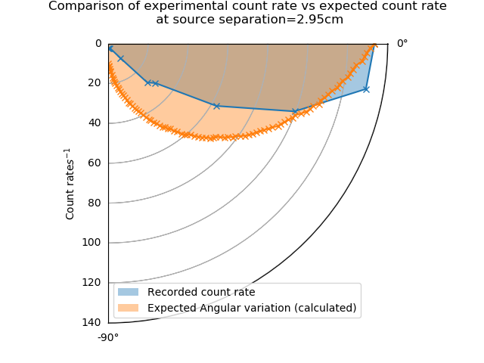

Figure 19: The actual coincidence count rate contrasted with the expected count rate given by the Monte Carlo program, the latter is normalized to have it’s maximum value match that of the former’s.

We can see an over-estimation of coincidence count rate when θ is small, and vice versa.

This is likely due to the program not taking into account the volume of the detector: at small θ, only γ that grazes detector B are excluded by increase in θ. In reality these grazing incidents are rarely detected by B in the first place; thus excluding them does not lead to significant decrease in coincidence count rate. The program doesn’t take into account the angle at which it enters either detector, and assigns equal weights (instead of a reduced weight) to γ’s that makes a larger angle with the normal of the detector B’s front face.

It is also worth noting that the program does not take into account the thickness of the detector housing, and simply assumes that the NaI crystal starts at exactly d=2.95cm away from the source.

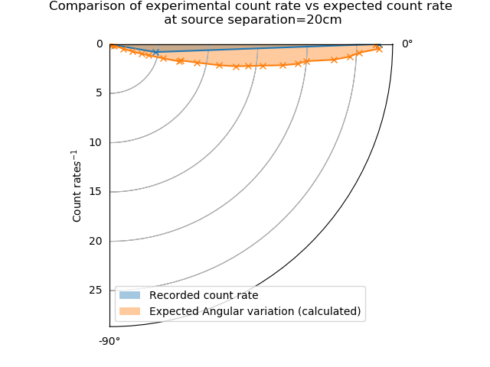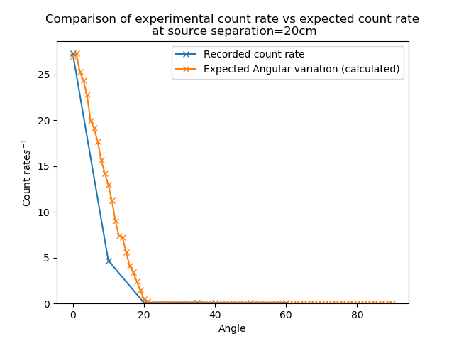

Figure 20: Repeat of the experiment above, but at separation d=20cm

This discrepancy is less prominent; but an overestimation is seen instead this time.

The count rate drops to zero when the two detectors’s solid angles no longer overlap antipodally, as expected, verifying that the 511keV photons were in deed emitted in a back-to-back manner.

**6. Extra: Further application of convolution**

In the section 3.2, the mathematical concept of convolution was mentioned, and its inverse operation (deconvolution) was applied for obtaining the decay life time of Sc.

Another useful application of convolution in the context of nuclear spectra is to smooth out the spectrum by acting as a sliding average:

For example, given the following data d and stencil s

d= [ 11 6 15 8 7 19 2 8 12]

s= [ 0.1 0.2 0.4 0.2 0.1]

s*d= 0.1 [ 11 6 15 8 7 19 2 8 12 0 0 0 0]

+0.2 [ 0 11 6 15 8 7 19 2 8 12 0 0 0]

+0.4 [ 0 0 11 6 15 8 7 19 2 8 12 0 0]

+0.2 [ 0 0 0 11 6 15 8 7 19 2 8 12 0]

+0.1 [ 0 0 0 0 11 6 15 8 7 19 2 8 12]

where d has length N=9 elements,

s has length M=5 elements,

s*d has length N+M-1=13 elements

after removing the first and last  elements from s*d, a sliding average of length N is obtained.

Applying the assumption that nearby counts could’ve very well fallen onto nearby channels anyways, we can perform convolution on the spectrum using the stencil, and obtain a spectrum that still closely resembles the expected spectrum.

For example, after applying this convolution operation, the following spectrum is smoothened:

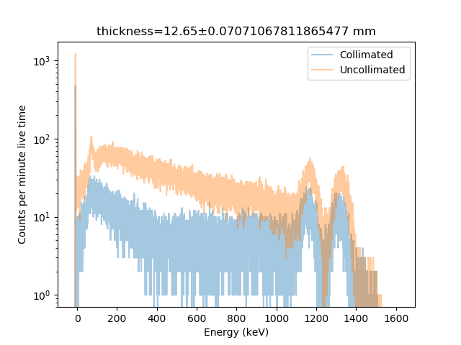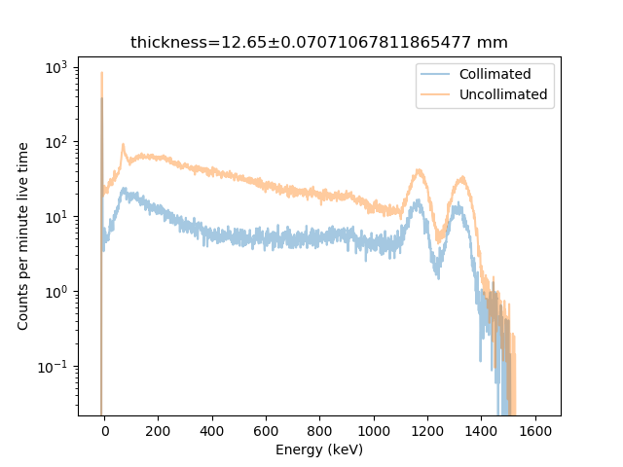

Figure 21: A sample spectrum (showing attentuation of 60Co radiation by iron plates) a)before and b)after convolution with a Gaussian distribution stencil. A shift of both centroids to the left was made apparent after performing this convolution to “tidy” the spectrum.

The stencil were chosen to fulfill the following two conditions:

1. The numerical values on it sums to 1.

2. It is distributed in a Gaussian manner (symmetrically).

After that, the width of this Gaussian peak and the stencil itself were varied to find the minimum width of the stencil and the standard deviation (σ) of the Gaussian peak that still gives a reasonably smoothened spectrum.

For the spectrum above, the width of the stencil was chosen as 11 element wide; and the Gaussian was chosen to have a σ=3.00 channels, thus s= [0.03548293, 0.05850147, 0.08630959, 0.1139453, 0.13461047, 0.14230046, 0.13461047, 0.1139453, 0.08630959, 0.05850147, 0.03548293]

This operation has the effect of filling in local dips and flattening out local peaks at the expense of counts of nearby channels.

It creates a less noisy spectrum, so that the approximate centroid can be visually estimated, enabling easier data analysis, minimizing human error/confusion when attempting to identify peaks from a noisy, low count spectrum. This may be useful in conditions were data acquisition time were limited, so the quality of the data is not ideal.

However, this method should not be applied when trying to find the information about the peaks (count rate under the peak, centroid positions and Full-width Half Maximum) to the highest possible accuracy, because it reduces the information content of the spectrum by “blurring” the counts of nearby channels together. This technique also reduces the differential non-linearity on the spectrum, therefore reducing the χ2 value when fitting the peak of interest against a Gaussian+linear-background model, causing the errors of the fitting parameters to be underestimated. In the worse case scenario, this will also hide smaller peaks with maximum value (measured in count per channel) comparable to the background count per channel.

Despite its lack of application for further statistical analysis use, it improves the visual appeal and allows easier intuitive analysis by visual examination of the spectrum alone, as demonstrated in Figure 21.

**6. Conclusion**

In this report, the method of scintillation detector detection of γ’s is explained, along with the underlying physics; and it’s characteristics were explored. It’s efficiency and resolution variatoin wrt. energy of γ were examined, giving trends of R∝1/√E, and shown that ε decreases wrt. E.

R(E) = a+b√(E)/E, where a=2.21±11.2 keV, b=8.39±0.0159 keV1/2;

ϵ =ea Eb , where a=4.52 ± 3.51 ⨉ 10-3, b=-1.60±8.4 ⨉ 10-5;

A multiplication factor b for multiplication of total number of electrons was determined to be related to the applied voltage by ∝ Vapp , where b= 7.81 ± 8.38 ⨉ 10-7

The set-up for γ energy spectrum acquisition when searching for the correct threshold voltages to isloate the 511keVγ energy was explained. The calibration equation obtained was

m=1.156 ± 0.003, c = 9.15 ± 2.13 where y=mx+c, y = channel number, x = energy of γ

The coincidence circuit was also explained in detail. The timing resolution of it was investigated in the context of positron annihilation, giving a σ = 5.76±0.02ns, excellent compared to the 230ns decay time of scintillation pulse in NaI.

The angular variation in coincidence count rate were recorded, and compared against a calculated expectatin value.

_______________________________________________________________

In this report, the physics of positron annihilation and successive decays in nuclides were discussed, and the operational principle of scintillation detector was reviewed, which were used to explain how its characteristics arises. These include the R∝1/√E trend observed in the energy resolution, and the generally decreasing trend of the efficiency ε(E), which is more difficult to quantify.

These characterstics were measured on a 3”x3” NaI(Tl) detector.

The electron multiplication factor as a function of applied voltage Vapp is determined as

a= 1.29 ⨉ 10-19 ± 5.91⨉10-43, b=7.81 ± 8.38 ⨉ 10-7;

when fitted to the function of a*Vappb

When operating at Vapp = 800V and a gain of 50,

the R(E) was shown to follow

a=2.21±11.2 keV, b=8.39±0.0159 keV1/2;

when fitted to the function R(E) = a+b√(E)/E;

and ε(E) were shown to follow

a=4.52 ± 3.51 ⨉ 10-3, b=-1.60±8.4 ⨉ 10-5;

when fitted to the function ϵ =ea Eb

though the ε(E) fit was poor because the fit model does not fully describe the actual physics. A much more complicated model taking into account more nuclear physics interactions will be required to fully describe the efficiency variation wrt. energy.

The timing resolution for coincidence measurement of 511keV γ’s from positron annihilation with electrons were found as σ=5.76±0.02ns, which is excellent compared to the 230ns decay lifetime of of the scintillation photon flux from the detector.

The set-up of a coincidence circuit for measuring positron annihilation γ’s was explained in detail, stating the function of each component, and the modification necessary to use the same circuit for investigating other previously explained nuclear phyiscs phenomena were also explained. These phenomena includes Compton scattering and successive decays.

A preliminary set-up was used to find the correct window levels to set on the SCA in the coincidence circuit. This circuit was also explained in detail, the calibration was demonstrated, yielding coefficients as follows

m=1.156 ± 0.003, c = 9.15 ± 2.13

for the linear fit equation y=mx+c where y = channel number, x = energy of γ

The equation for error propergation through the calibration was also stated.

The expected angular variation in count rate were calculated using a Python program (attached in the Listings section of the Appendices), and compared against the data acquired, showing that they roughly match up. The discrepancy between the two were explained in terms of the assumption used to generate the code. Regardless, the back-to-back nature of positron annihilation was verified.

Additionally, a technique for smoothening spectra was detailed; and its limitation stated.

The results above gives us a better insight into the nuclear physics, detction technique, and limitations of positron annihilation measurements from a top-down perspective.

Equipped with this understanding, one can make better choices about the detector set-up, detector choices, etc. in regards to positron annihilation, and scintillator detectors usage in general, in the future.

**7. References**

[1]

[2]

[3]

[4]

[5]

[6]

[7]

[8]

[9]

[10]

[11]