**NaI(Tl) detector**

Hoi Yeung Wong (Ocean Wong)

MSc Physics and Technology of Nuclear Reactors

University of Birmingham

Nuclear Laboratory experiment report (Semester 2)

**Abstract**

# 1. Introduction

Some γ radiations are known to be temporally and/or spatially correlated when they are emitted from the same nuclide. For example, when an electron annihilates with a positron, a pair of back-to-back γ-rays with energy Eγ = 511keV must be emitted simulatenously to conserve energy and momentum.

In the following experiment, such temporal and directional correlation will be explored using a relatively fast timing detector, sodium iodide detector, and a coincidence circuit.

To observe the temporal correlation, the circuit will be set-up in such a way that only γ’s of 511keV will be registered by the circuit, allowing us to focus on the temporal correlation only between γ’s of interest, suppressing background noise level.

<positron annilhilation can be done using this technique>

<therefore it is useful to understand the response of the detector wrt. Angular variation>

**2. Theory**

**2.1 Detector and circuit**

**2.1.1 Scintillation**

The detection of γ starts with its interaction with the NaI crystal:

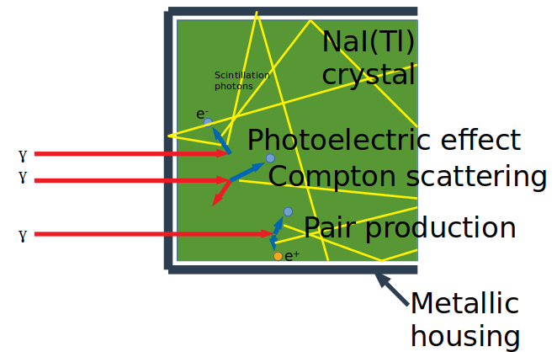

Figure 1: γ deposits its energy into the crystal via the photoelectric effect, Compton scattering, and pair production. The electrons deposit energy in the material to form of electron-hole pairs, which in turn de-excite to emit scintillation photons (yellow). It is connected to the photocathode of a PMT to the right.

After the γ is transmitted through the housing, it has a high probability of being scattered/absorbed by the NaI crystal. This is due to the high atomic number of Iodine in the Sodium Iodide, leading to a high microscopic cross section σpe of absorption of the γ due to photoelectric effect.

The photoelectric effect refers to the phenomena where the atom absorbs a γ of Eγ and liberates an electron with energy Eγ – Eb ≈Eγ where EB is the binding energy required to excite the electron out of its orbital into the conduction band (or exciton band) of the lattice.

The other two competing mechanisms for scattering/absorbing the γ are Compton scattering and pair production.

Compton scattering is an elastic scattering process where part of the energy of the γ is transferred to an atomic electron as the kinetic energy of the electron. The fraction of energy deposited by this process is



, where θ is the angle the γ is scattered through, mec2 is the electron mass expressed in terms of energy. This shows that the maximum fraction achievable (at θ=π) will still be significantly smaller than unity (since Eγ/mec2 <10 for most γ rays of interest). Therefore a Compton scattering event will not reflect the full energy Eγ of the γ.

The last of the three main mechanisms of γ interaction with matter is pair production. When the γ interacts with the electric field in the vicinity of a nucleus, the energy of the photon Eγ can be used to produce an electron-positron pair, annihilating the γ in the process. Due to the conservation of mass-energy, the condition Eγ > 2mec2 must be fulfilled for this reaction to occur as two particles each with mass me are produced.

The energy recorded after a pair production event occurs may be smaller than Eγ by mec2 or 2 mec2 because the positron (created from the original γ’s energy Eγ) will annihilate with another electron in the detecting medium, releasing two back-to-back γ’s each with mec2=511keV. If both are re-captured by the detecting medium (via the photoelectric effect), then all of Eγ will be re-captured in the detecting medium with no loss; but if one or both of the 511keV γ’s are lost, then their corresponding energies will be deducted from Eγ.

In all of the above cases, the energetic electron created travels through the lattice to deposit its energy via successive collisions, exciting other electrons bound in the NaI crystal’s ions, until all its energy is lost. The resulting electron-hole pairs then de-excites preferentially through the activator sites. For the case of NaI(Tl) crystals, these sites are the Thallium cations, where the electron level lies in the forbidden band. The presence of Tl as an activator is key to the large light yield of NaI(Tl). However, it is worth noting that the light yield per keV is energy-dependent, as this helps to explain the result of the investigation in section 3.2.

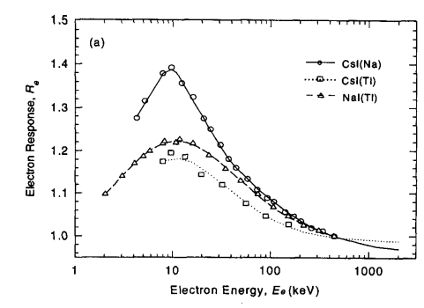

Figure 2: The normalized differential light yield from NaI(Tl) crystal fluctuates with energy. Extracted from Knoll [1]

Additionally, light emission from inorganic scintillators have a long decay time (decay lifetime = 230ns for NaI (Tl))[1]. This leads to a long tail associated with each pulse in the signal created after a γ is absorbed, leading to high deadtime between signal detection.[3]

The NaI crystal is transparent to the light emitted (in the visible/UV range of frequencies) by the mechanism described. This is because these photons has lower energy (longer wavelength) than required to excite an electron from the forbidden band into the conduction band of the NaI. Therefore these photons can travel through the crystal and eventually be collected by a photocathode after reflection, refraction and transmission.

The 3”x3” (diameter ⨉ height) cylindrical NaI crystal is canned in a metallic material and hermatically sealed. This is done for three reason: to protect the hygroscopic NaI from degrading upon contact with water vapour; to minimize trespass of ambient light which will otherwise form a background noise; and to act as a specular reflector to redirect light back into the crystal towards the photocathode.

The NaI crystal are manufactured in two forms: single crystal and polycrystalline. Crystallized from a melt of NaI with 0.1% TlI (atomic fraction) addition, the ingot are subsequently machined into cylindrical form. [4]

**2.1.2 Multiplication into signal**

To convert these photons (of the order of tens of thousands of them) into an electrical signal, a photomultiplier tube (PMT) is used.

The crystal is coupled to the photocathode via optical grease to increase the transmission rate. The photons then travels through a thin semi-transparent photocathode, likely made of a Negative Electron Affinity (NEA) material such as strongly Zn doped GaP (p-type semiconductor) coated with a Cs layer to lower the vacuum potential below the conduction band in the bulk of the material. The vacuum potential is fixed relative to the conduction and valence energy bands’ levels at the surface of the material, so the Cs coating allows electrons in the conduction band in the bulk to easily diffuse outside of the surface[3]. Photoelectrons are liberated from this layer of material into a vacuum, and are accelerated towards the first dynode by a fraction of the applied voltage Vapp. The distance between the photocathode and the first dynode is significantly larger than that between the first and second dynode. This is done so to ensure that there will be minimum spread in the transit time of the electrons, so that a sharp peak will be observed on the amplifier down the line. Additional electrodes are also used to shape the electric field between the photocathode and the first dynode for more precise transit time. Mu-metal is also used to shield the PMT from the magnetic field of the earth to minimize disturbance to the trajectory of these electrons.

Due to thermionic electron emission, the photocathode also leaks electrons spontaneously even when its average thermal energy kBT (T= temperature of the photocathode material, kB = Boltzmann constant) is much less than its work function. This thermionic emission forms the dark current, which contributes a significant level of background noise, and limits the energy resolution of the detector.

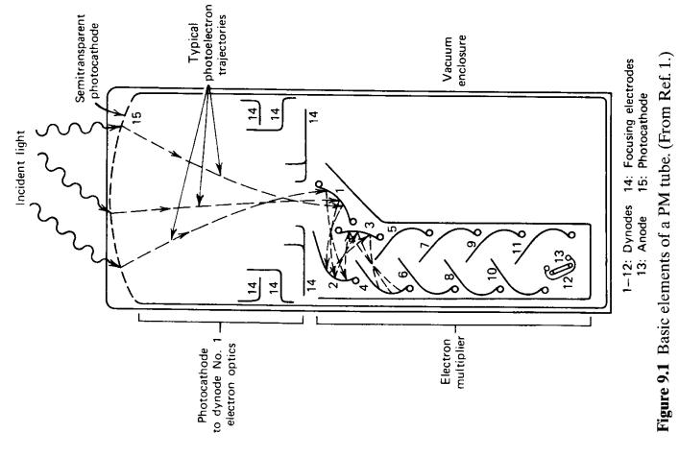

Figure 3: schematic of the internal structure of a PMT, showing the main features: photocathode, electric field shaping electrodes, dynodes. (From [5])

Electrons are accelerated down the series of dynodes by the increasingly positive electric potential on each dynode. The fast electrons impinging on each dynode releases more electrons from the dynode, multiplying the number of electron in the signal pulse by a factor which monotonically increase wrt. incident electron energy on the dynode. The dynode is usually made from BeO, MgO or Cs3Sb[2]. The voltage increase between each dynode is a constant fracton of the applied voltage Vapp /N where N is the number of dynode; this division of voltage is carried out by a specially designed voltage divider.

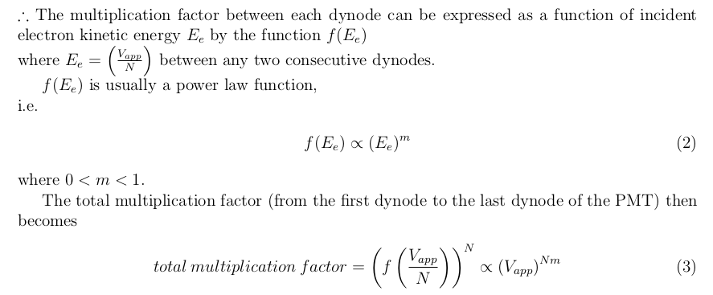 This power law relationship is clearly observed in the figures below:

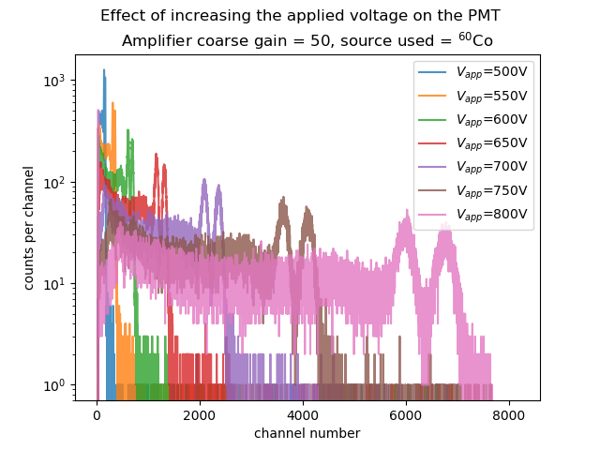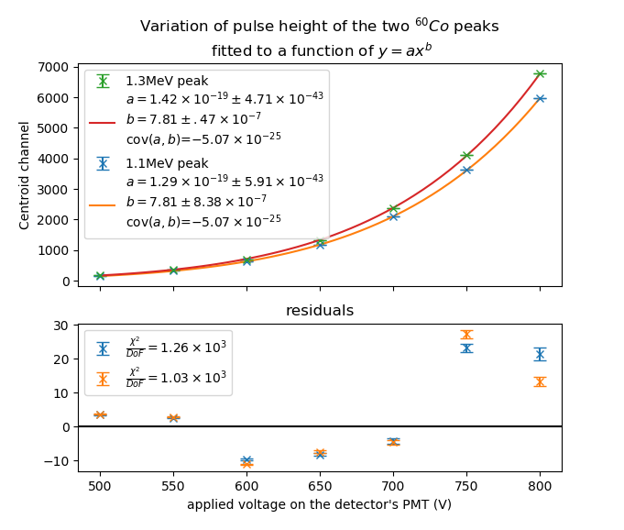

Figure 4a: The variation of the spectrum of 60Co wrt. increasing applied voltage, acquired using an MCA with 8192 channels.

Figure 4b: The variation of mean pulse height (represented by as the centroid channel number) fitted to a power law relationship wrt. applied voltage

Both of the fits above give the same precise result of exponent b=7.81 in fit equation of

y(centroid channel number) = a(Vapp)b

with extremely small error.

Therefore we may deduce that there are N ≥ 8 plates in the PMT, such that the

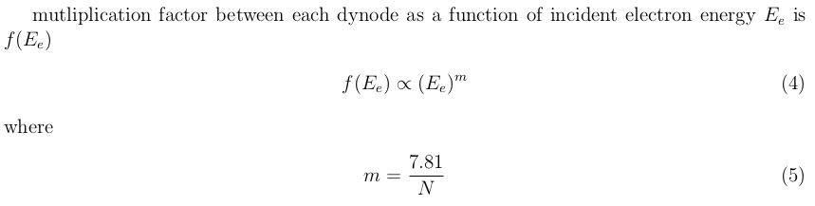

The fitting program used to generate these results does not take into account error on the x-axis (Vapp), which may explain the poor χ2 of the fit, as a small perturbation in x value leads to a very large perturbation in y value due to the power law relationship. The fact that the residuals of both peaks lie on the same side of the fit curve for *every* voltage is further evidence that this may be the case, because this can only be explained by the actual applied voltage being smaller/larger, leading to both data points under-/overshooting the fit curve together respectively; and cannot be explained by random error.

Another explanation for the poor goodness of fit includes the function f(Ee) itself being non-linear and doesn’t adhere to the multiplication factor function f(Ee)∝(Ee)m assumption, leading to a smaller than expected multiplication factor f(Ee) in the 600V ≤Vapp≤ 700V range. Further investigation will be requried if one wishes to understand if this is the case, which lies beyond the scope of this experiment.

**2.1.3 Pulse detection**

The arrival of the electrons onto the final dynode forms a current, which is detected as a signal pulse outputted by the PMT. This signal is sent to the main amplifier to be shaped, so that further processing can be done (see figure below).

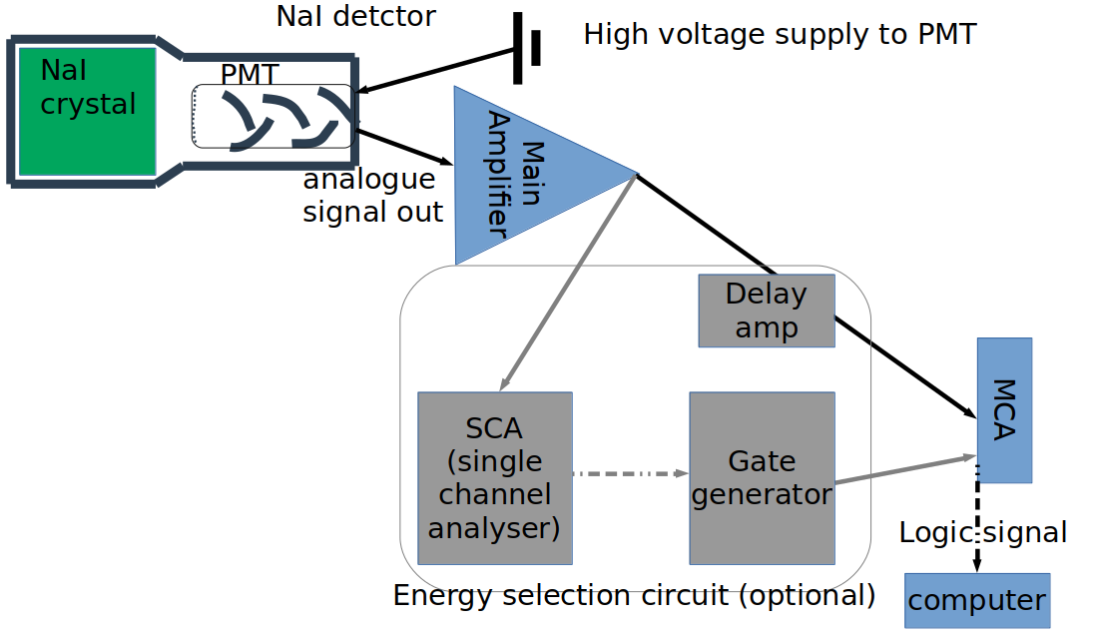

Figure 5: Circuit diagram for acquiring a energy spectrum. The grey parts are not necessary when energy selection is not involved, so can be bypassed when acquiring the full energy spectrum, analyszing and recording all pulses outputted by the Main Amplifier, indiscriminant of the pulse height.

The main amplifier removes the long exponential decay tail that follows each pulse using a differentiating circuit (RC circuit acting as a high pass filter); and then convert the pulse into a more symmetrical, gaussian shaped peak using an integrating circuit (CR circuit acting as a low pass filter) by smoothing the rising edge. These two filters also remove background noise of high and low frequencies.

To maximize timing resolution of the detection circuit set-up, the shaping time of the main amplifier (determined by the characteristic decay time of the RC and CR circuits) is set to the minimum value achievable, 0.5μs. This comes at the cost of reduced energy resolution and non-linear scaling of the spectrum, as signal pulses will experience a greater degree of ballistic deficit. But for this experiment, where energy of all incoming radiation are known and well tabulated, this does not present any major issues; and since shaping time = 0.5μs> decay time of scintillation light τ = 230ns, the degredation in energy resolution will be acceptably small.

If an energy selection circuit is added, then a positive voltage will be sent to the MCA’s “gate” port when a signal of interest is detected, prompting the MCA to accept and analyze that pulse.

The single channel analyser (SCA) detects pulses with peaks that falls within a user-defined range (named upper and lower window level), and sends a logic signal to the gate to indicate the presence of such a pulse when it does arise. For TTL convention, 5V and 0V represents 1’s and 0’s in binary, indicating the presence and absence of a pulse of interest respectively. Note that if a unipolar signal is inputed into the SCA, then the 5V TTL signal will be outputted when the trailing edge of the input pulse crosses the lower window level from above. The time when this crossing of the lower window occurs is offset from the maximum of the pulse by a short time Δt , where Δt is dependent on the pulse height. This variation in Δt is called the amplitude-time walk, and will lead to a decrement timing resolution of the coincidence circuit proportional to the size of the SCA window. To eliminate amplitude-time walk, the SCA instead analyses the bipolar output of the Main Amplifier.

The SCA’s 5V TTL signal triggers the gate generator, which generates a rectangular positive voltage pulse called the gate, with user-defined amplitude and duration. The amplitude of the gate is immaterial, as long as it is non-zero, the MCA will be able to register the gate as “open”; but the duration must be long enough to cover all of the signal pulse of interest, as well as allow room for amplitude-time walk if there are any. In a high dose rate environment, it is desirable to not extend the gate any further than that to avoid including noise that can arise after the pulse of interest. For this experiment, the gate duration was chosen to be ~6μs.

A delay amplifier must be used to delay the analogue signal outputted by the amplifier if the energy selection circuit is used. This is because the process described above involving the SCA+gate generator will open the gate with a small delay *after* the pulse of interest has passed. The original signal must be delayed by the same amount of time in order for the MCA to process this pulse.

Decision of the gate duration and delay amplifier delay time can be made while viewing the signal from the gate generator’s output and the delay amplifier simultaneously on an oscilloscope.

MCA (multi-channel analyser), which is a form of an ADC (analogue-digital converter), converts analogue signal into digital data packets, which is then sent to the computer via a USB b connection. For a 12Mbit/s USB connection transmitting as data packets of 16 bits, on average each data packet transmission (containing pulse height information of a single count) can be done within 1.3μs; but a bigger limiting factor on the maximum count rate recordable by the MCA is the conversion time: the successive approximation ADC (SA-ADC) in the MCA requires up to 2μs to convert the analogue pulse into a digital data packet [6]. When the SA-ADC is busy, no new pulses can be processed.

Therefore when carrying out any experiment, one must be aware that the recorded count rates will be discounted when pulses from the detector arrive too frequently, due to the limitation posed by the deadtime of the detector and the deadtime of the ADC. It is preferable to keep the deadtime shown on the computer program to <5%. When the energy selection circuit (SCA + gate) is applied and connected to the gate port, the background pulses that are not of interest will not be processed by the ADC, reduing the ADC’s deadtime; but the actual spectrum may still be degraded by pile-up of consecutive events occuring in the detector, leading to lowered energy resolution and noisier background.

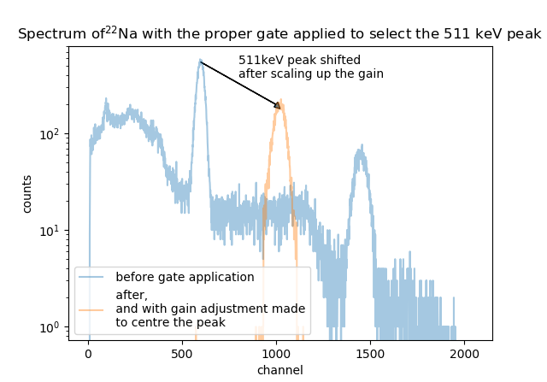

**2.1.4 Coincidence**

Time-to-pulse-height conversion: operating principle

What this allows us to tell

(State the alternative method where the Compton scattered photon can be measured instead in a collimated beam of electron incident on the 1st detector instead)

**2.2 Nuclear physics**

Positron annihilation: must be back to back

<insert radial plot>

Example of successive decay (60Co and 44Ti)

Successive decay: instead of a sharp peak we get a smooth angular distribution, and have a time decay

<insert radial plot>

<Insert decay scheme>

**3. Detector characteristics measurement**

**3.1 Energy resolution**

<insert result table + plot>

**3.2 Efficiency**

<insert result table + plot>

**3.3 Timing resolution**

<insert result table + plot>

Refer to section 4, where

**3.4 Calibration equation**

In cases where energy of unknown sources needs to be found, a calibration of the detector is required to convert the channel number on the spectra into γ energy values.

The following section demonstrate how this is done, despite the fact that there isn't need for such an operation in this experiment where all sources has very well documented energies.

Precautions: if one wishes to replicate the following results, must:

Ensure that calibration is done for every new session, because a minor voltage drift will still lead to a big difference in the calibration equation.

**4. Coincidence measurement**

Insert circuit diagram

**4.1 Calibration of the coincidence circuit**

Explain why the χ^2 is bad, and what has been done to fix it.

Note the gain settings at well, and why the gain setting was made so.

**4.2 Angular distribution of positron annihiliation**

Insert radial plot

Derive theory, "knowing that the two gammas will be emitted back-to-back

Treat everything else as constant

Compare result with theory

Explain why it’s better.

**4.3 Further application of the coincidence measurement technique**

Explain why deconvolution is necessary

<insert deconv'able graph>

State how this can be done; but no further analysis was done because of time constraint, and because it wasn’t the main focus of the experiment.

**5. Further application of the convolution technique**

In the previous section, the mathematical concept of convolution was mentioned, and its reverse operation (deconvolution) was relied up on for obtaining the decay life time of an isotope.

Another useful application of convolution in the context of nuclear spectra is to smooth out the by acting as a sliding average:

Insert test spectrum

Insert stencil

Insert extended convolution spectrum

Insert clipped convolution spectrum

Applying the assumption that nearby counts could’ve very well fallen onto nearby channels anyways, we can perform convolution on the spectrum using the stencil, and obtain a spectrum that still closely resembles the expected spectrum.

When applying this convolution operation, the following spectrum is obtained:

The stencil were chosen to fulfill the following two conditions:

1. The numerical values on it sums to 1.

2. It is distributed in a Gaussian manner (symmetrically).

After that, the width of this Gaussian peak and the stencil itself were varied to find the minimum width of the stencil and the standard deviation (σ) of the Gaussian peak that still gives a reasonably smoothened spectrum.

For the spectrum above, the width of the stencil was chosen as 9 element wide; and the Gaussian was chosen to have a σ=3.00.

This operation has the advantage of smoothing out the spectrum: local dips will be filled up, while local peaks will be flattened.

It creates a less noisy spectrum, so that the approximate centroid can be visually estimated, enabling easier data analysis, minimizing human error/confusion when attempting to identify peaks from a noisy, low count spectrum.

However, this method should not be applied when trying to find the information about the peaks (count rate under the peak, centroid positions and Full-width Half Maximum) to the highest possible accuracy, because it reduces the information content of the spectrum by “blurring” the counts of nearby channels together. This technique also reduces the differential non-linearity on the spectrum, reducing the χ2 value when fitting the peak of interest against a Gaussian+linear-background model, potentially causing the errors to be underestimated. In the worse case scenario, this will also hide smaller peaks with maximum value (measured in count per channel) comparable to the background count per channel.

**6. Conclusion**

State the significance of the results

State what has been verified,

State how these techniques can be applied in the field

Stat what can be done to improve the resolutions etc.

e.g. shorter wires

**7. References**