Draft Zero

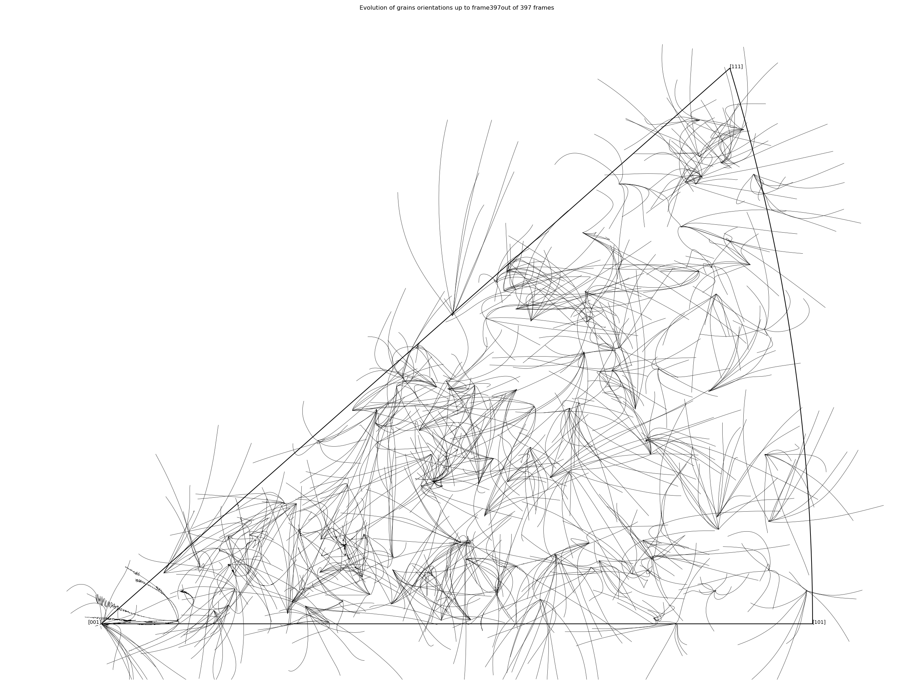
./All/GrainOrientationEvolution_ToFrame397.OfAllGaussPoints.png
This contains (124) all grains times 8 gauss points per grain;
So there are five methods that we’ve used:
1. Graphical average:
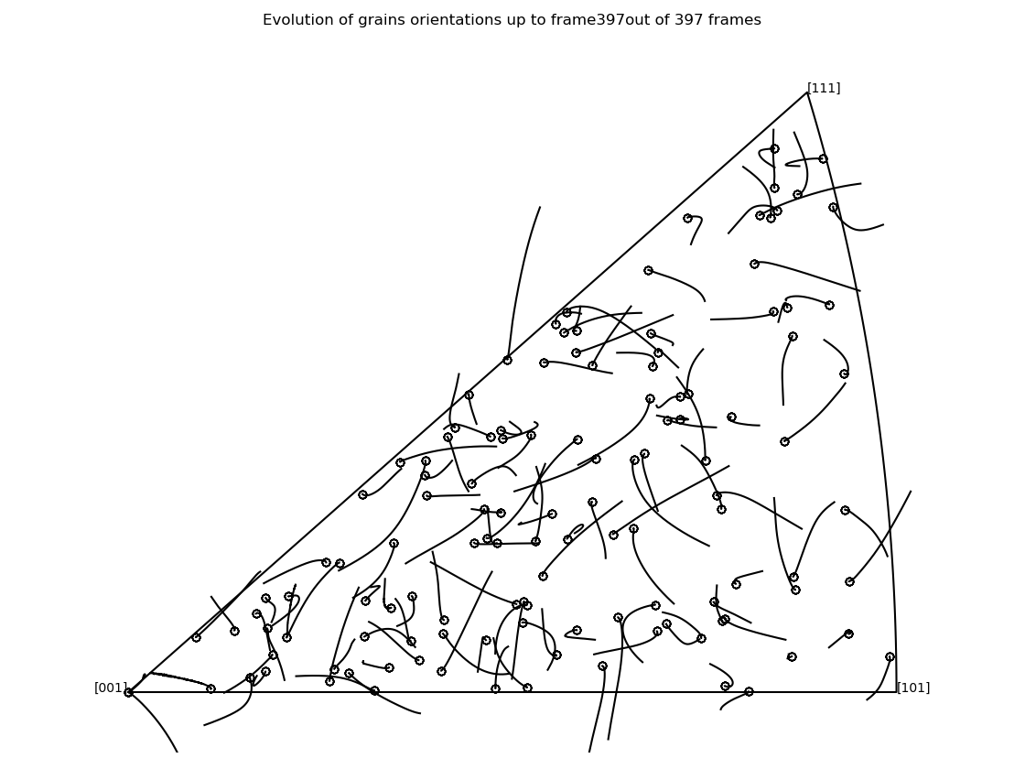
./All/GrainOrientationEvolution_ToFrame397graphicalAverage.png

Plots the dot at the mean x-coordinate and mean y-coodinate.
Advantage:
Gives no discontinuity; all paths traced out by grains are smooth lines.
Disadvantage:
No real physical/mathematical basis to carry out such averaging operation
Does not take into account for the tan 𝜃/2 distortion when points are mapped onto a pole figure
2. Sum of Eigenmatrix
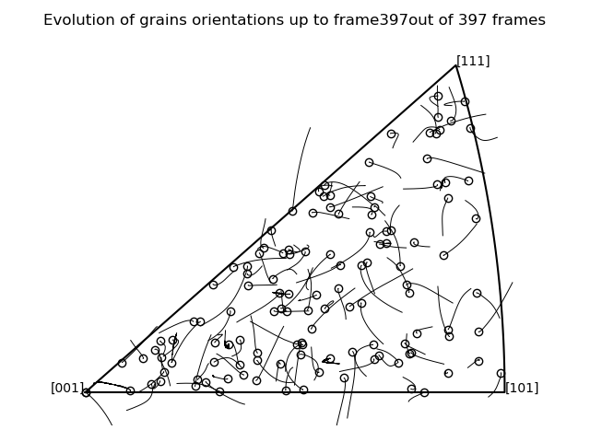
./CorrectAveraging/GrainOrientationEvolution_ToFrame397misorientationMinimizationAverage_small.png
Code:
def averageQuat(qList):
matrix = np.zeros([4,4])
for q in qList:
Matrix += outerProduct(q,q)
EigenVal, EigenMat= np.linalg.eig(Matrix)
average = EigenMat.T[np.argmax(EigenVal)]
return average*np.sign(average[0])
#In the report, we’ll have to include all this as LaTeX maths as well

Advantage:
Mathematically accurate
Is the only method to give (nearly always) continuous misorientation value:

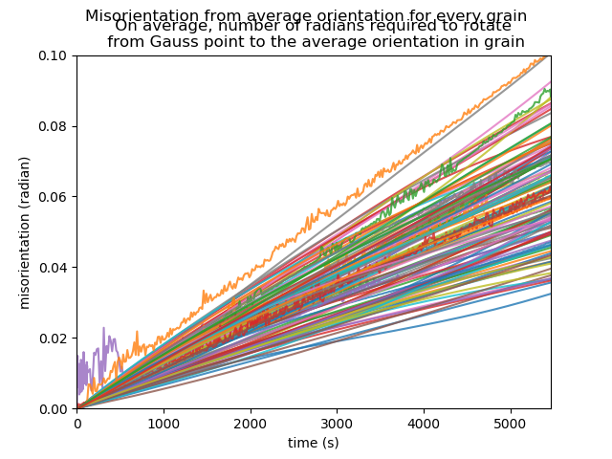
/home/oceanw/Documents/Computing/Python_testing/GroupStudies/Scatter/CorrectAverage/DeviationFromCorrectAverage.png
The seven lines above where the misorientation values does not vary smoothly against time are the grains with indices (34, 51, 61, 72,87,103,113). They are also identified as the seven anomalous grains with fluctuating path on the inverse pole figure.

Disadvantage:
Will sometimes generate complex-valued index for the quaternion (which is mathematically invalid) and cause ComplexWarning when turning the quaternion into a rotational matrix;
(but once the imaginary part of these indices are discarded this still gives a useful result.)
Still, some grains’ paths are observed with minor fluctuation (see next page)
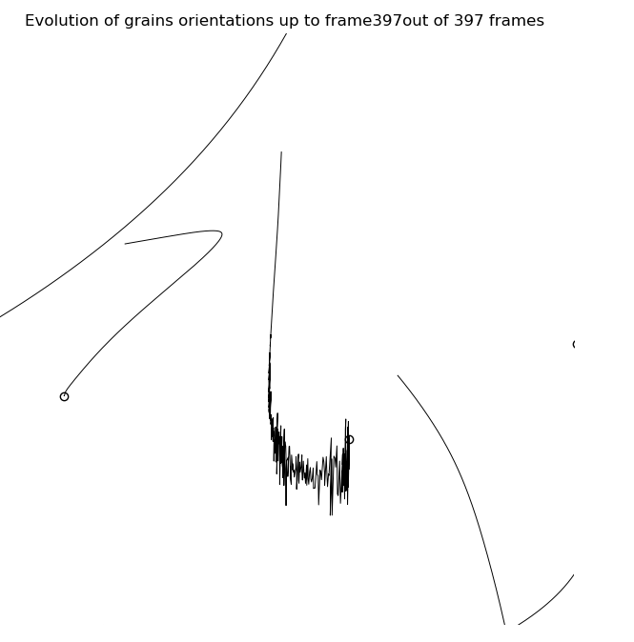
./CorrectAveraging/Enlarged.png
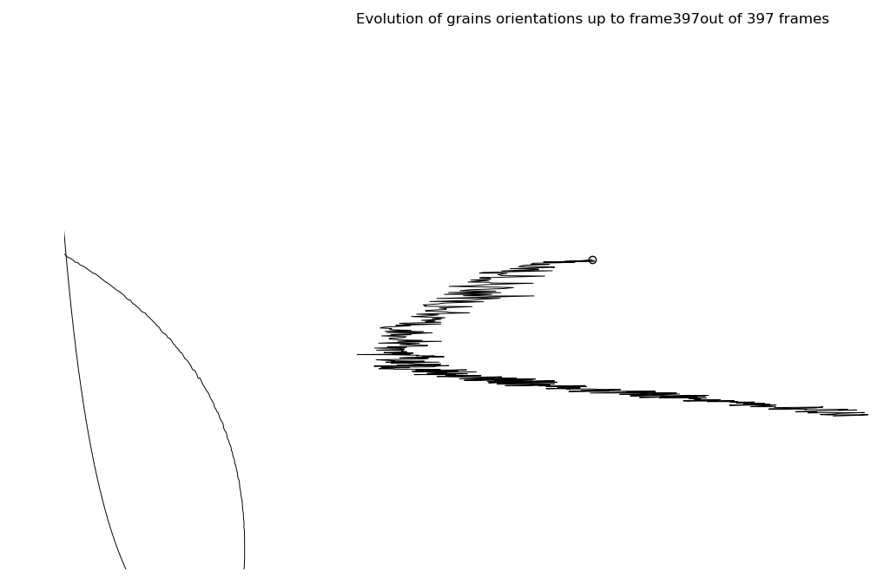
./CorrectAveraging/Enlarged2.png
3. Median method
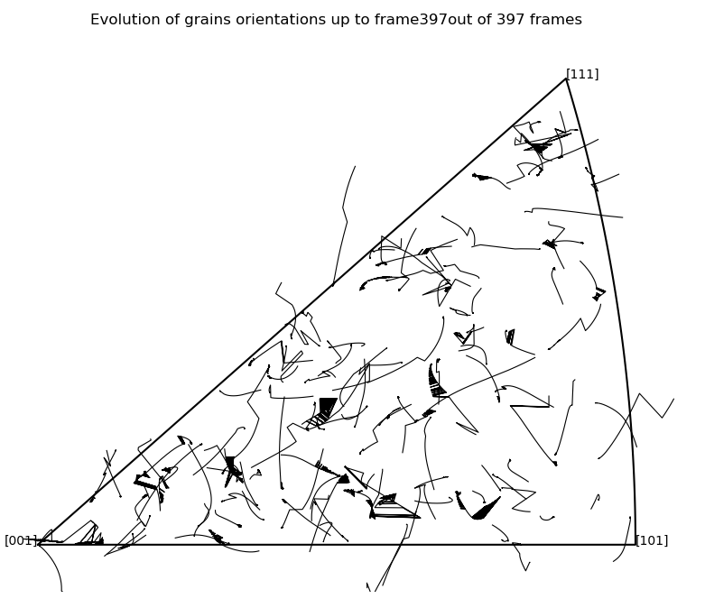
./Median/medianMethodEnd.png

Advantage:
Always works for any number of Gauss points. Simple to implement once a subprogram for finding misorientation has been written.
No large discontinuous jumps across from one inverse pole figure sector another.

Disadvantage:
Instability at low scatter as it jumps between quaternions that are close in the quaternion space.
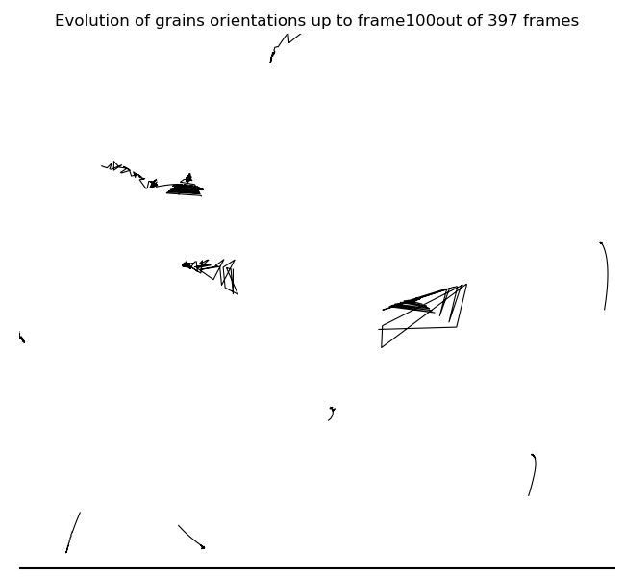./Median/medianMethodProblem.png
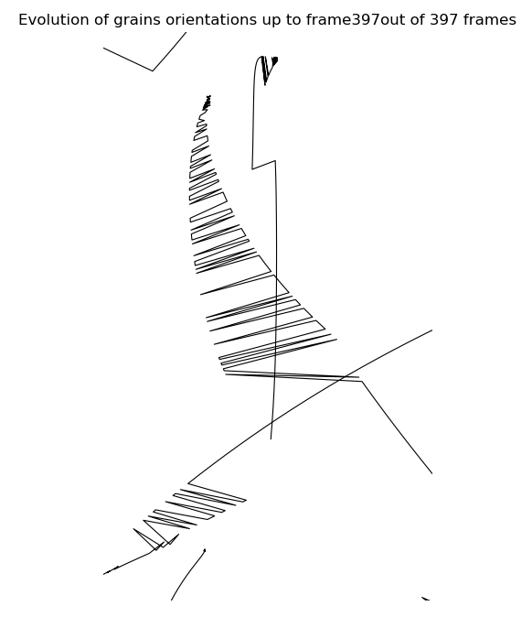./Median/medianMethodEndProblem.png
The width of this zig zag path will decrease if there’s a higher number of Gauss points per grain; but there is no guarantee that it will disappear.
4. Minimize angle
Iteratively find the particular quaternion that has the minimal misorientation angle from every other Gauss point’s quaternion.
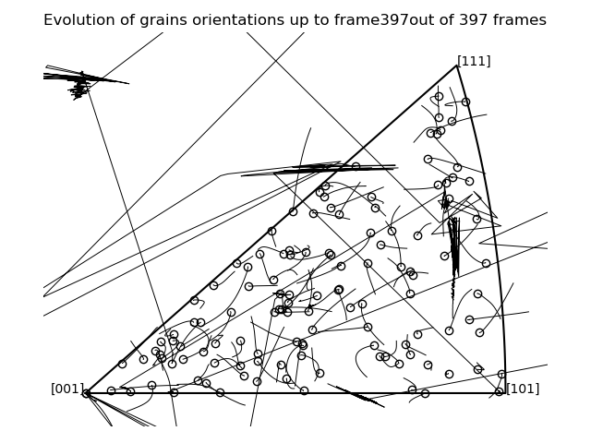
./MinimizeAngle/GrainOrientationEvolution_ToFrame397misorientationMinimizationAverage_small.png

Advantage:
Can be used to demonstrate the principle.
Disadvantage:
Very time consuming, therefore this method is NOT recommended:
computing time (Each frame takes around 1 minute to solve.)
programming time (require manually removing anomalous grains)
See the photo below for the result after removing the discontinuity:
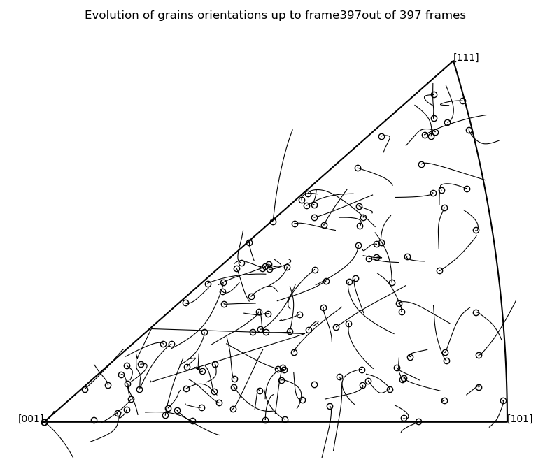
./MinimizeAngle/GrainOrientationEvolution_ToFrame397DiscontinuityRemoved.png
5. Normalized Sum
Add up all quaternions, and then divide the result by it’s own length.
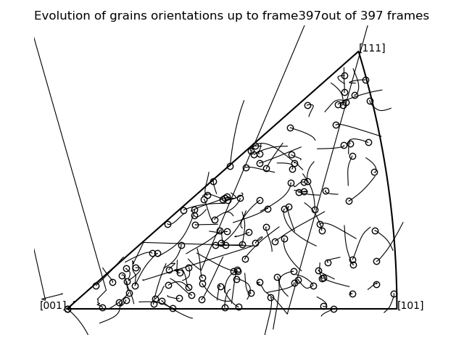
./RenormalizedMean/GrainOrientationEvolution_ToFrame397.png

Advantage:
Easy to implement
Short computing time
Always give a real result without fault.
Disadvantage:
No mathematical basis
Some discontinuity may be generated, needs to be manually removed:
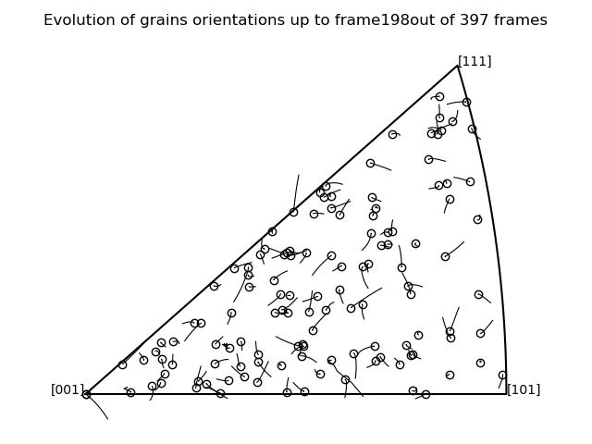
./RenormalizedMean/GrainOrientationEvolution_ToFrame198.png

