An experiment of drifting wave buoy
with long trailing rope

Tetsuya UWAI
Japan Meteorological Agency
uwai@met.kishou.go.jp
buoyunit@hq.kishou.go.jp

Abstract
The Japan Meteorological Agency has been deploying the drifting wave buoys in the seas around Japan since June, 2000.
Each buoy has the battery for 6 months three-hourly observations.
In the small seas such as the Sea of Japan and the East China Sea, the buoys tend to drift out of the target area in short period by wind/current.
So we equipped a buoy with the rope which reaches the seabed on trial, and deployed it in the shallow water of the East China Sea (about 200m or shallower in most of the area).
The drift speed of the buoy was significantly slow without spoiling its capability for observation in comparison with another buoy which was not attached a rope.

Introduction -- background –
JMA has been operating drifting wave buoys since June, 2000, in the seas around Japan (Picture). About 30 wave buoys have been deployed since then. Figure 1 shows the paths of 17 buoys which worked in 2001.
Their mission is to monitor severe weather conditions for prevention of meteorological disasters. Usually, the buoy works every three hours, and the data are transmitted to the JMA via ORBCOMM satellites. In case wave height is higher than the threshold, that is usually set to 3 meters, it changes to hourly observation automatically. We can send a command to choose hourly or three-hourly observation.

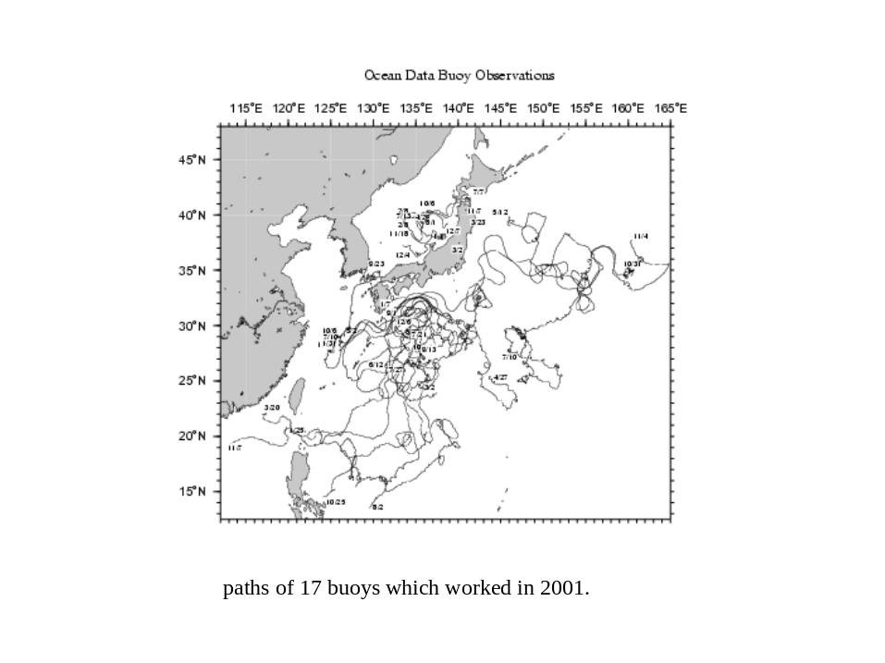
Figure 1: Paths of 17 buoys which worked in 2001.

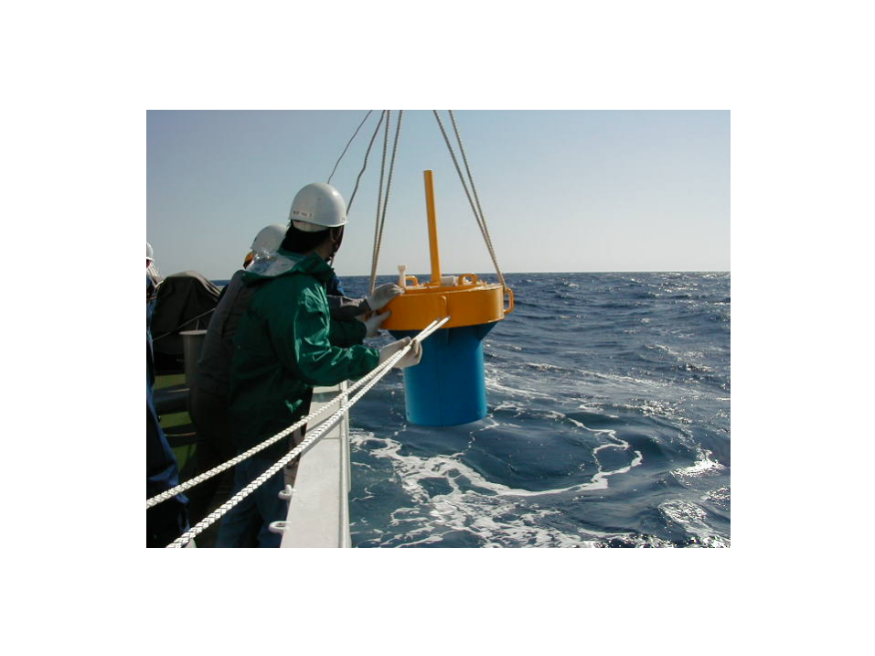
Picture: Drifting wave buoy.

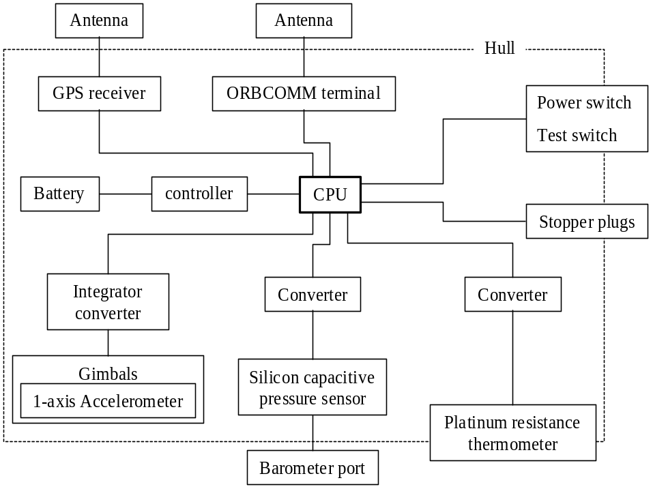
Figure 2: Buoy construction chart.
Each buoy is equipped with batteries for 6 months duration, when it continues 3-hourly observation. The powers are independently supplied for the observation sensors, the telecommunication equipment and the CPU.
Usually, the battery for the sensors runs down first, after about 2100 observations. Then, the power for telecommunication remains by 700 more times. After that, the report contains only the position and time. Total number of reports from a buoy amounts to around 2800 (Figure 3).
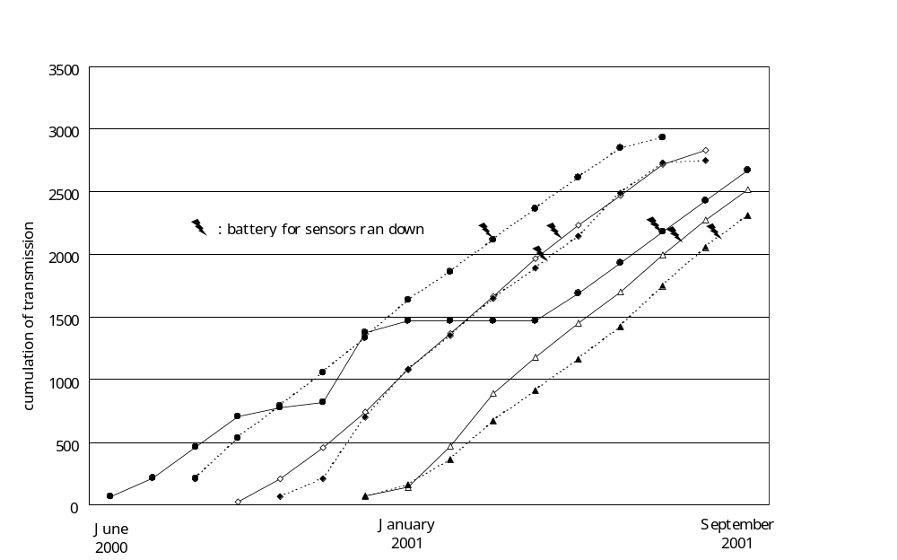Figure 3: Cumulation of transmission from 6 buoys.

There is another problem. In the small seas such as the Sea of Japan or the East China Sea, the buoys tend to land on shore or drift out of the target area in a relatively short period (3 - 13 weeks) by wind or current (Figure 4).
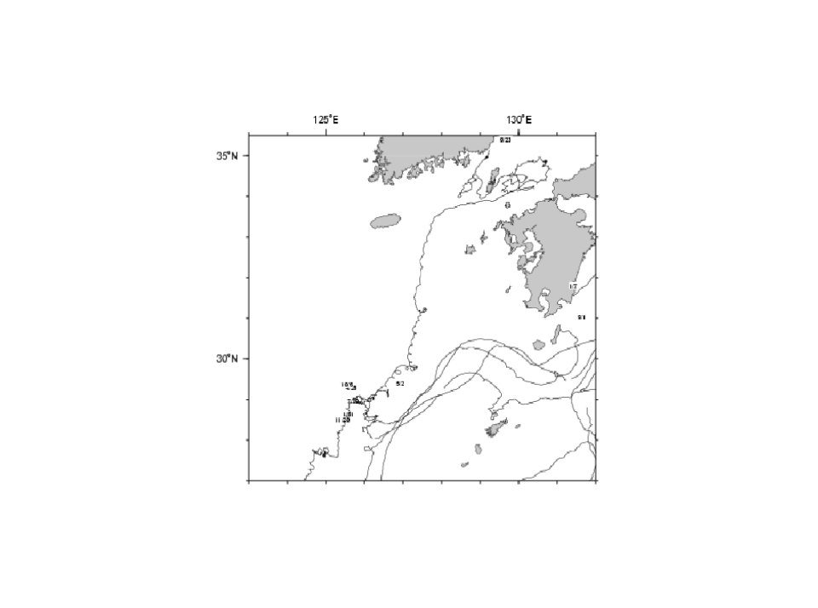
Figure 4: Paths of buoys which were deployed in the East China Sea.

Experiment

Aim
We planned an experiment to keep buoy position within the target area as long period as possible. In this experiment, we used the present drifting wave buoy without any reconstruction. It’s necessary to devise a system which can be easily deployed from our research vessels.
Considering these points, we started this experiment to attach a long trailing rope to the buoy.

Test field
As the test field, we chose the East China Sea. The depth is shallow and the current is weak at the point where we have repeatedly deployed this type of buoys. This point is the northwest end of our research vessel’s routine oceanographic observation line. There is a deep trough in the southeast side of this area. Strong Kuroshio current is flowing along the Southwest Islands of Japan (Nanseishoto).
We are interested in how long we can extend the period.

Design concept
We designed the system as follows,
- To give a certain holding power to resist the current or wind stress to some extent.
- To allow to be dragged by rapid (strong) current.
Under the strong current, too heavy weight may draw the hull underwater because of its small buoyancy.
- Not to sink
- Not to lose observation capabilities
Even when it moves into deep water area.
- Not to disturb wave observation.

Materials
- Rope :150m : 12kg (underwater)
- long enough to reach the seabed
- Iron chain & shackles : 9kg (underwater)
- as weight. no anchor
- to trail at shallow water
- not to hold the bottom soil too strong
- Floats : 21kg buoyancy
- for neutral total buoyancy to keep drifting at deep water
- and to sink with buoy hull by command

These parts are connected so as not to affect the vertical motion of the buoy hull (Figure 5). All loads under water are supported with the larger two floats.

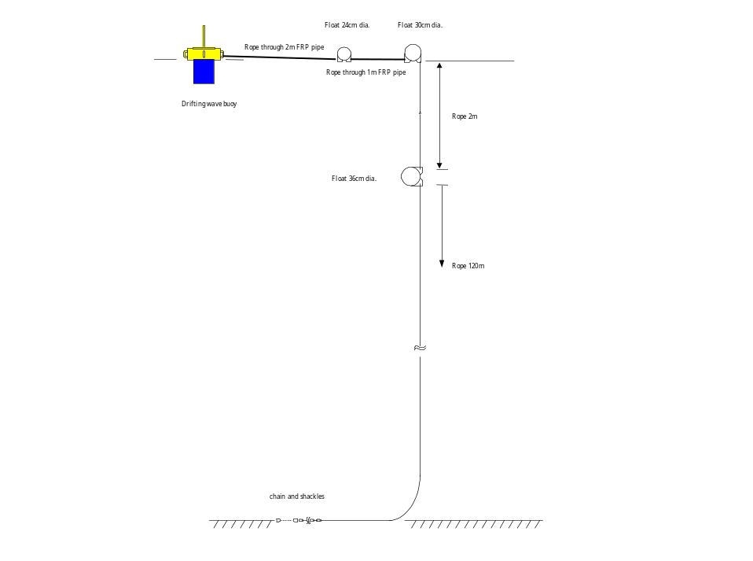
Figure 5: Connection of ropes, chains and floats.

Deployment
The buoy was deployed on July 10, 2002, attached with the 150m rope.
Another buoy of the same type as this, but without rope, was deployed simultaneously near by.

Result
The observations showed a good coincidence when the two were near (Figures 6, 7).
As for the comparison buoy, the communication became intermittent only eight days after deployment, and cut off later, unfortunately. The cause is unknown (Figure 8).
The distance between the two buoys was shorter than 20 nautical miles in the first seven days.
The speed of the buoy with rope was clearly slower compared with the comparison buoy (Figure 9).
Three weeks after, the buoy moved to deeper area. Although the rope must have been lifted off the seabed, the buoy continued observation normally. And it observed a maximum of 14.2m high wave caused by a typhoon.
Further, the buoy drifted into shallow area again 6 weeks after the deployment. While drifting in shallow area, the drift speed was slow in general.

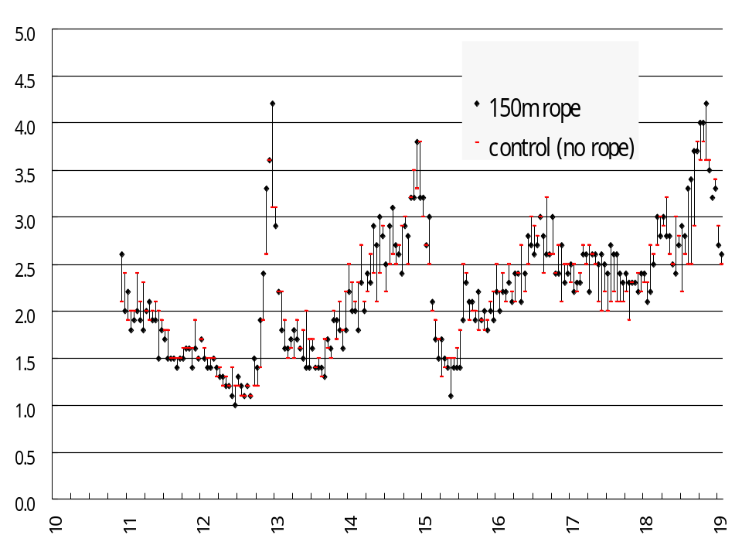
Figure 6: Comparison of wave height.

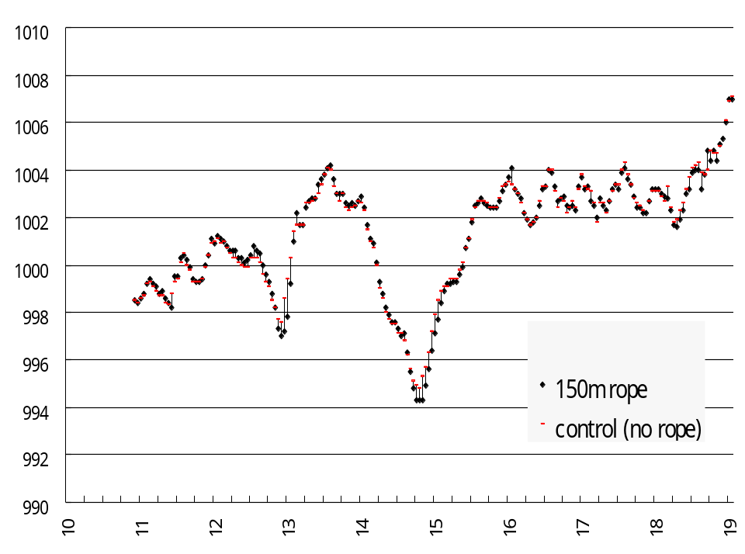
Figure 7: Comparison of air pressure.

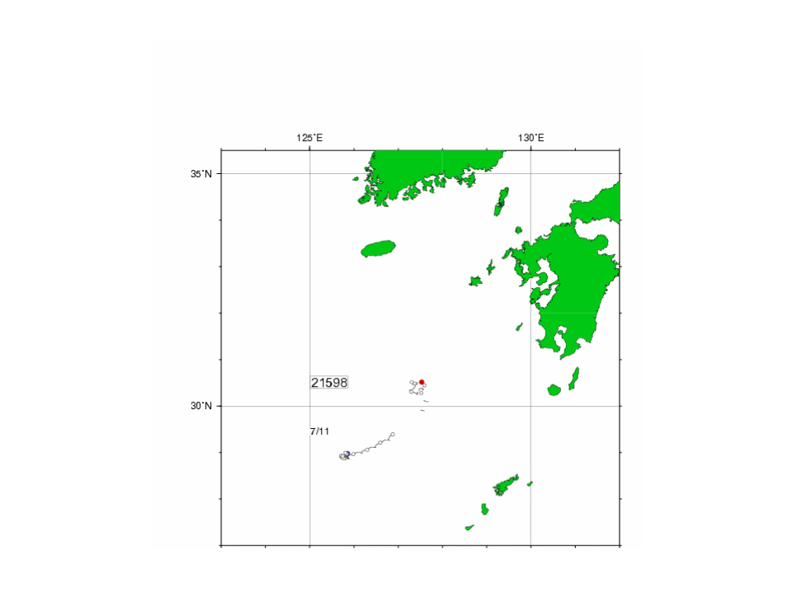
Figure 8: Path of the buoy without rope. The open circle denotes the position at 00h UTC on each day.
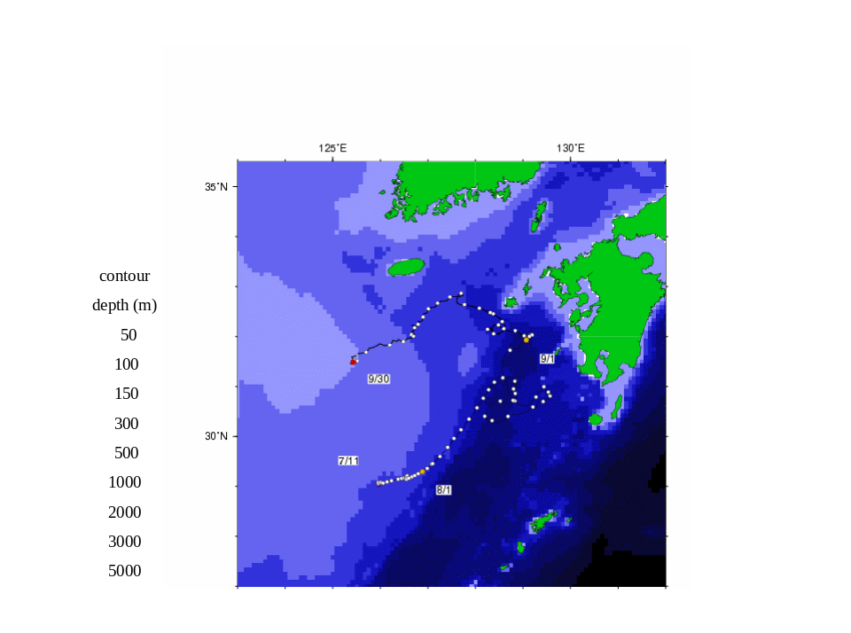
Figure 9: Path of the buoy with long trailing rope.

Conclusions and future works
This experiment was considerably successful though it was under some limited conditions.
As a measure for the present, it is required that this system should be improved so that it may hardly be moved at least three-month or so. And it is necessary to improve to apply it for deeper sea or stronger current.
As a permanent measure, we need to develop the optimal system for each deployment point, with due consideration for the wind, current, wave, bottom soils, etc.

Link
http://www.data.kishou.go.jp/marine/buoy/index.html

