First Results using Iridium Satellite Modems for Buoy Applications

David Meldrum and Duncan Mercer
Scottish Association for Marine Science

Oban PA37 1QA, Scotland

Abstract

The Iridium satellite communications system, with its true global 24-hour real-time coverage, has long been a focus of interest for ocean data applications. The enhanced data throughput and two-way communications alone are particularly attractive. However, unlike message-forwarding systems such as Argos and Orbcomm, Iridium also permits real-time interaction with the remote platform, effectively an on-line session with a remote computer, allowing reprogramming, flexible file handling and sophisticated diagnostics. In this paper, based on the presentation given to the DBCP XVIII Scientific and Technical Workshop, we report our early experience with first-generation Iridium modems, made available to us through the U.S. Argos Program office.

Discussion

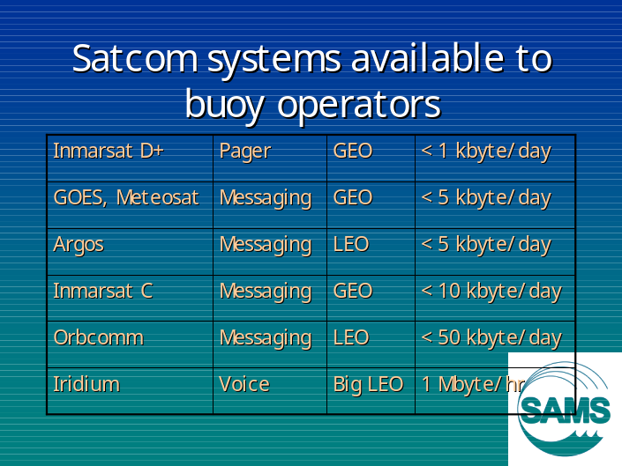
Figure 1. The principal satellite communication systems available to buoy operators, their prime function, orbit type and practicable data rates.

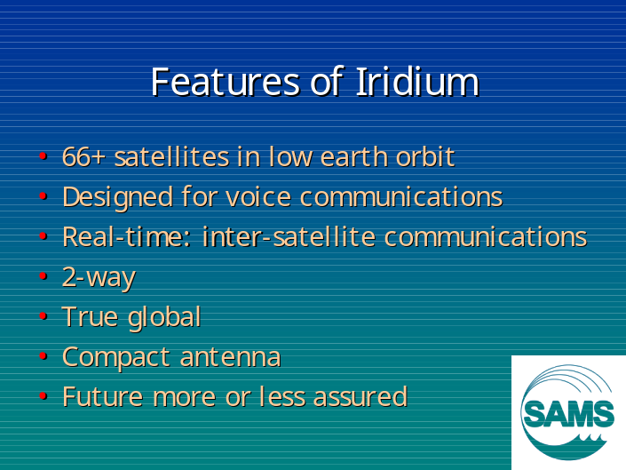
Figure 2. A key feature of Iridium is that it is true-global, true-real-time, thus permitting on-line interaction with a mobile anywhere in the world.

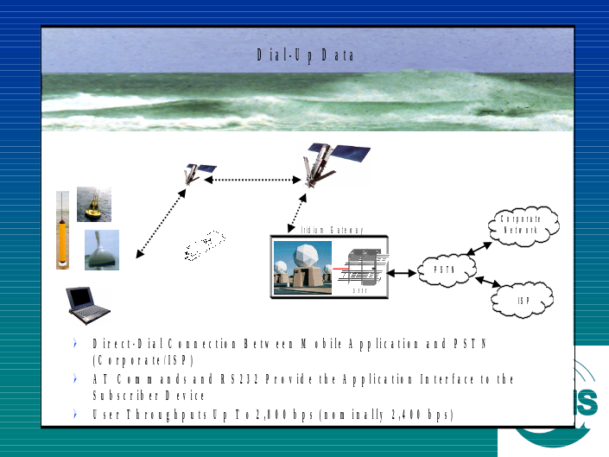
Figure 3. Our initial evaluation of the system configured it in a rather primitive way, as a simple dial-up service using conventional analogue modems. (Figure courtesy of Steve Piotrowicz, NOAA)

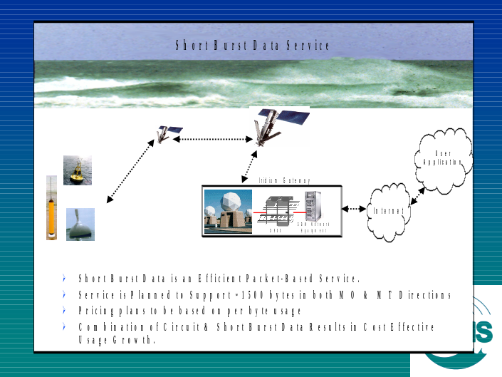
Figure 4. The next stage will be to use the digital Short Burst Data service as soon as it is implemented. This should significantly reduce the connect time, and thus the financial and energy costs. (Figure courtesy of Steve Piotrowicz, NOAA)

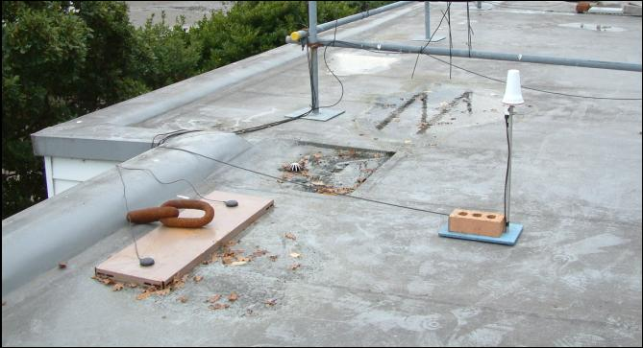
Figure 5. Iridium operates at a much higher frequency (1.5 GHz) than many of the alternative systems. This permits the use of much smaller antennae, three of which are shown circled in this photograph.
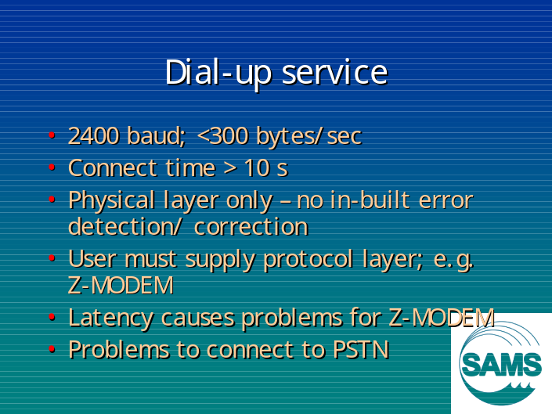
Figure 7. Some features of the dial-up service. The rather long time (>10 s) to establish the call means that this connection mode is not ideal for the transfer of small amounts of data.
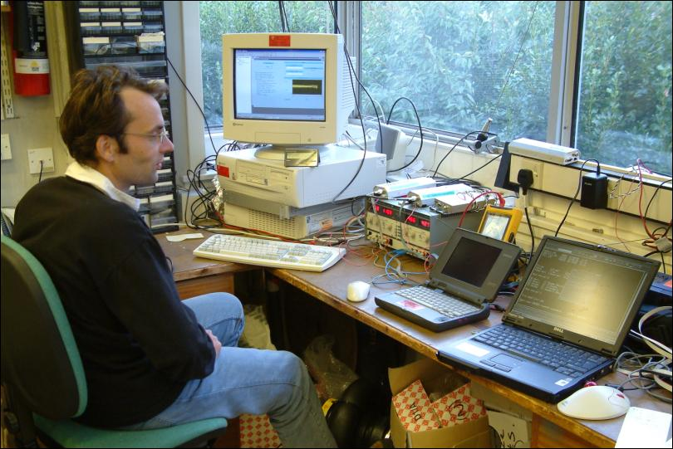
Figure 6. Two Iridium modems lie on top of the power supply in the centre of the picture. Part of our evaluation included the measurement of the energy consumed during file transfers between the two modems.
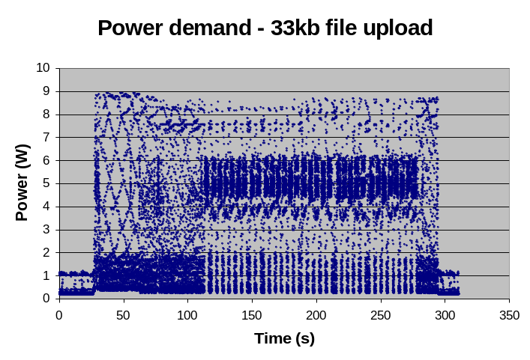
Figure 8. Power demand as a function of time during a 33 kbyte file transfer.

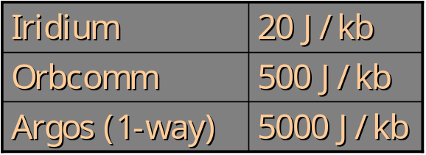
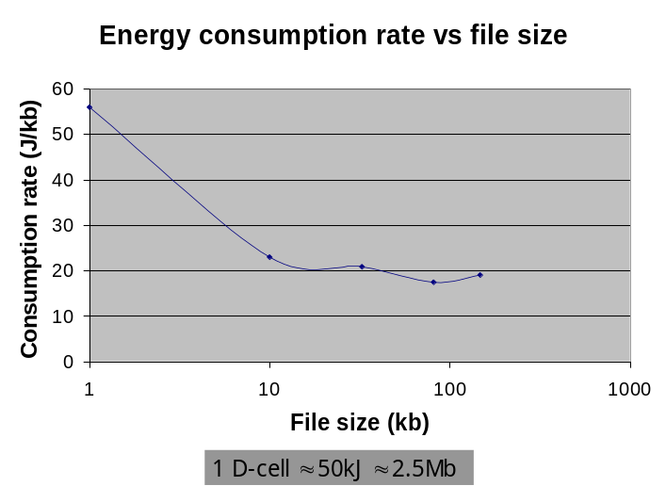
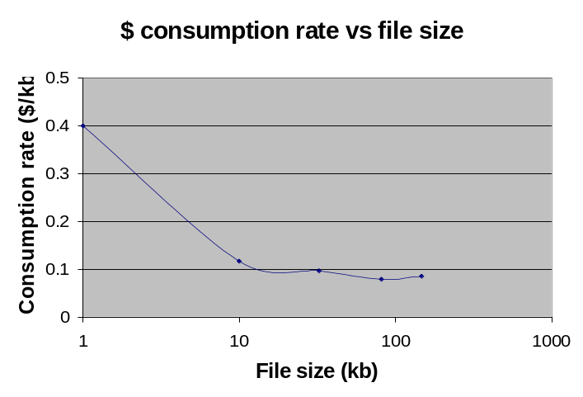
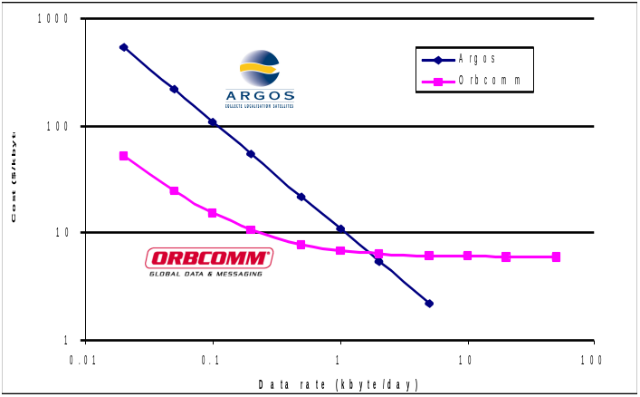
Figure 10. Specific energy consumption rates (joules per kilobyte) for three commonly used satellite communication systems. The Argos figure will improve following the implementation of Argos 2-way in 2003.
Figure 9. Because of the call set-up overhead, energy efficiency improves with larger file sizes. Note that kb = kilobyte in this and other charts.
Figure 11. The airtime costs of operating Iridium fall to about 10 cents per kilobyte for file transfers greater than 10 kilobyte.
Figure 12. Comparable costs for other systems are typically several dollars per kilobyte.

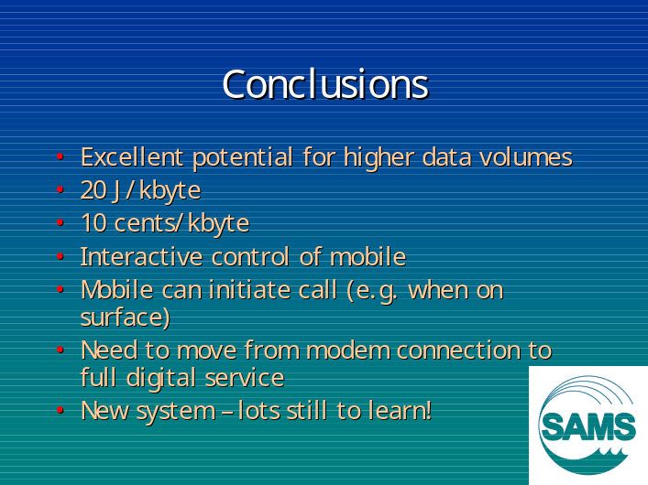
Figure 13. The principal conclusions of this initial phase of our study. We will now move on to evaluate the fully digital Short Burst Data service.
Acknowledgements

We particularly thank Steve Piotrowicz of NOAA and Ngoc Hoang of NAL Research for the opportunity to participate in this study.

