The Performance of Minimet Wind Drifters in Hurricane Fabian

William Scuba and Peter Niiler
Scripps Institution of Oceanography
La Jolla, California, U.S.A.

1. Abstract

Since 1988 wind drifters have been deployed in the tropical Atlantic in regions where hurricanes tend to develop in strength or approach landfall. Projection of winds from NCEP reanalysis on these drifters has revealed that no wind drifter south of 30N has experienced winds in excess of 27m/sec. Operational air deployment packages were developed and tested on land for potential ocean deployment of Minimet drifters by C-130J aircraft. On September 3, 2003, eleven Minimet drifters were successfully deployed at a distance about 18 hours in front of the projected path of a category-4 hurricane, Fabian, in the vicinity of 25N, 65W. The sea surface temperature (SST), pressure, wind direction and drift data during the hurricane passage over these Minimets is reviewed. Based on this unique, but limited data set, recommendations are made for continued research and operational deployments of Minimet drifters into hurricanes from operational C-130 aircraft.

2. Introduction

This work describes the air deployment scheme used to drop 16 drifting buoys in the path of hurricane Fabian, in the tropical Atlantic Ocean, and examines the data received from these drifters. In total, wind speed and direction, SST, atmospheric pressure, and drifter position were recorded.

Through June, 2003, approximately 133 wind drifters have been deployed in the world’s oceans. However, projection of winds from NCEP reanalysis on these drifters has revealed that no wind drifter south of 30N has experienced winds in excess of 27ms⁻¹. In order to get accurate wind data from the interior of a hurricane, a method was needed to assure that wind drifters were in the path of the hurricane.

This paper describes an air deployment scheme used to deliver the wind drifters into the path of the hurricane, the results of the drop, and a preliminary analysis of the data received from the drifters.

3. Drifter and Air Deployment Package

The drifters used in the experiment were Minimet drifting buoys designed by Pacific Gyre (Figure 1) which include a barometer, thermistor, submergence sensor, wind speed sensor - hydrophone/ambient noise sensor -, and wind direction sensor - compass and wind vane.

The air deployment package consisted of a 100 cm x 100 cm x 100 cm cardboard box containing 2 Minimet drifters stacked one on top of the other. Each drifter was individually packaged in its own cardboard box (Figure 2). The outer box only had 5 sides and acted as a sleeve, sliding over the two drifter boxes and holding them in place. A slit was cut down one side of the outer box to allow for easy deployment once the package was in the water. This slit was held together with water soluble paper tape which dissolved and fell away once wet. A third cardboard box inside the drifter box contained the drogue. This box had a hole cut in the top to allow room for the cable attaching the drogue to the drifter. The entire package was designed so the outer box came apart first allowing the two inner drifter boxes to separate from each other before they came apart. The whole box structure sat on top of a specially designed wooden pallet (Figure 3). Blocks of wood around the corners of the top of the pallet kept the box from moving during the air deployment. When the parachute initially opens after the package has been pushed out the plane, there can be a large sideways force on the box. The wooden bars and the straps running up all four sides of the box are designed to keep the box from coming off the pallet.

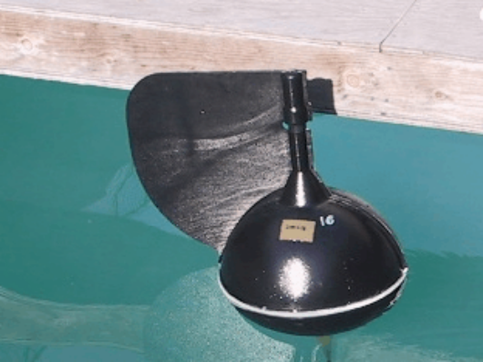
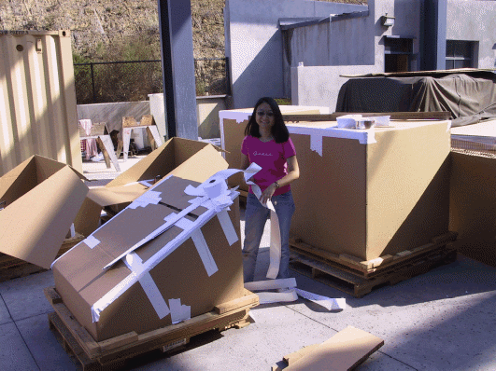

Figure 1: Minimet drifter

The straps attach on top of the box to the parachute and underneath the pallet using salt blocks. There is a hole on each side of the pallet which the straps pass through. There is a loop at the end of the strap inside of which a 7.5 cm x 1.75 cm x 1.75 cm salt block is placed (Figure 4). This salt block prevents the strap from pulling back through the hole when the parachute is deployed and then dissolves when it contacts the water, releasing the parachute. The time it takes for a drifter to be floating free of its packaging is approximately 2 hours from time the package contacts the water. The parachute used is a C-9 military personnel chute.

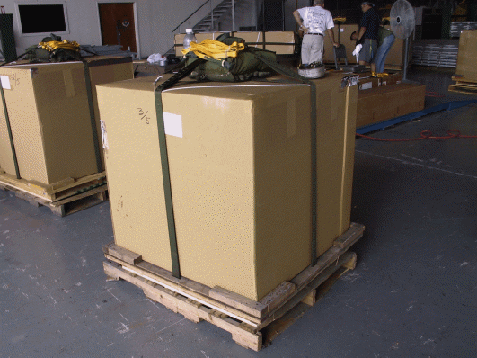
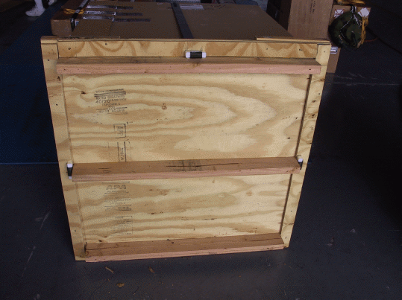

Figure 3: Box containing 2 Minimet drifters on top of pallet. Wooden deployment pallet is sitting on top of a shipping pallet that is removed before deployment.
Figure 4: Under side of deployment pallet with bottom plywood removed.

Before the experiment took place, eight test drops were made by the Air Force’s 53rd Weather Reconnaissance Squadron at Keesler Air Force Base. Dummy systems were made up which did not contain drifters, but weights placed to mimic the weight distribution of the drifters. Six of the eight packages deployed as expected, one had a parachute that inverted, but landed safely and one had a weight come loose and fly out the side of the box upon parachute deployment.

4. Hurricane Drop

Sixteen Minimet drifters in eight air deployment packages were shipped to Keesler Air Force Base on September 2nd, 2003. On September 3rd, 2003 a Category 4 Hurricane called Fabian was being tracked in the Atlantic east of Cuba. The go ahead was given by the Air Force and the eight packages were loaded on a C-130J aircraft. The packages were deployed in a two line array approximately 18 hours in front of the projected path of Fabian (Figure 5). They were deployed at an altitude between 300 m and 400 m and between 20:00 and 24:00 local time. The ground wind speed at the time of deployment was between 17 ms⁻¹ and 22 ms⁻¹ and the wave height was approximately 7 m.

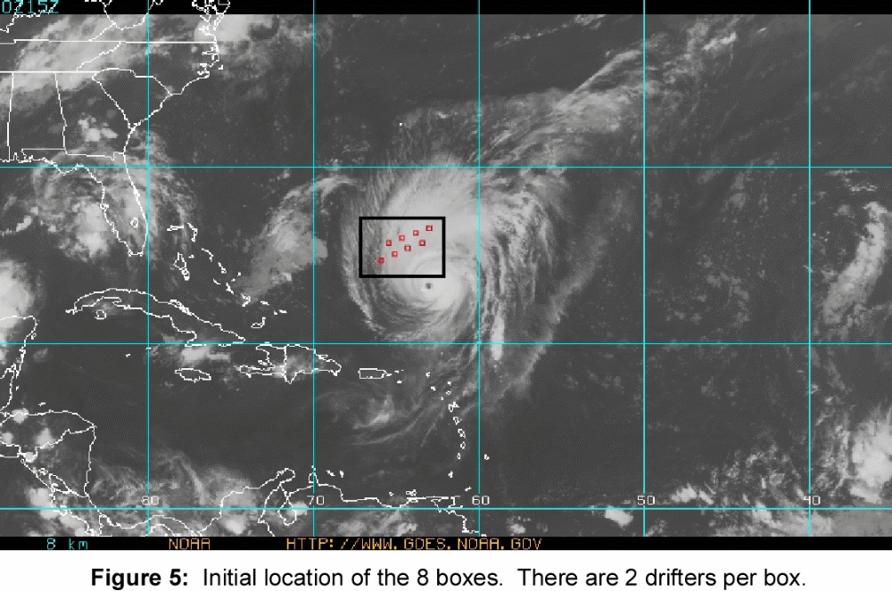

Five of the drifters did not transmit any data after the air drop. Three more stopped transmitting data before the complete passage of the hurricane (~36 hours). The remaining eight drifters provided data through the entire hurricane. The path of the hurricane was such that it passed directly over the active drifters (Figure 6). Two of the drifters came within 50 km of the hurricane center.

Less than 2 weeks later the 8 drifters that survived the deployment drifted into the path of hurricane Isabel (Figure 7), for which data was also collected.

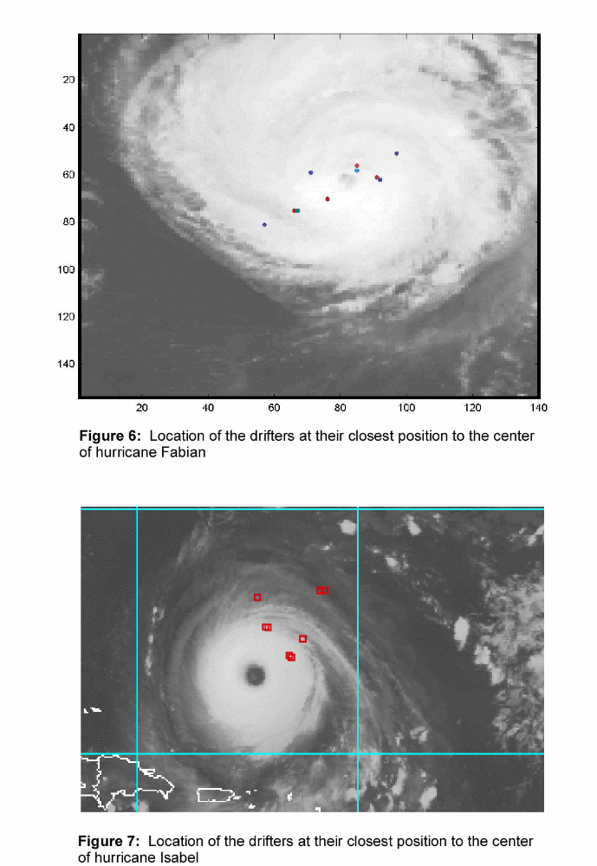

There are several possible explanations for the failure of the first eight drifters. One explanation is the harsh conditions they were deployed in – the high wind speed and wave height. High winds create a large horizontal velocity of the drifter deployment package as it parachutes toward to water. The deceleration caused by the drifter package contacting the water can cause the two drifters to bump into each other or into the wooden pallet with sufficient force to damage the internal electronics of the drifter and stop them from either gathering data or being able to transmit that data to a satellite. Large rolling waves may exaggerate this effect. A second explanation is that several of the boxes were damaged during shipping to Keesler Air Force Base by being stacked on top of each other. These boxes were repaired, but they still might not have had sufficient integrity to survive the air drop. Four of the boxes sustained some damage during shipping and only 3 out of the 8 drifters in those boxes survived through the hurricane. For the undamaged boxes, 5 out of the 8 drifters survived through the hurricane.

5. Results

Analysis of the drifter wind direction data revealed the expected cyclonic motion of the hurricane winds (Figure 8). The average wind direction relative to the distance from the center of the hurricane (Figure 9) shows that between 100 km and 300 km the wind direction has a small component pointing toward the center of the hurricane. A much larger directional component is pointing toward the center of the hurricane for distances from 300 km to 500 km. For distances from 35 km to 100 km the wind direction has a component pointing away from the center of the hurricane.

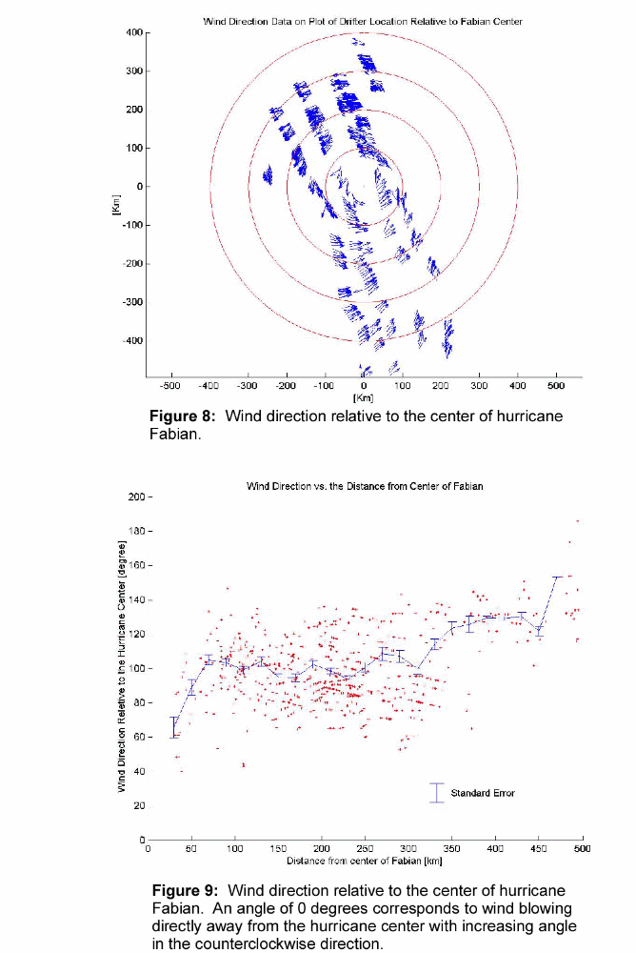

The air pressure at sea level, measured by the drifters, decreases together with the distance from the center of the hurricane (Figure 10). Measurements of the air pressure in the eye of the hurricane by the Air Force 53rd Weather Reconnaissance Squadron put the air pressure at the eye between 939 mBar and 944 mBar. The pressure measured by a drifter was 943 mBar at 33 km from the hurricane center. From this data it appears as though one of the drifting buoys passed through the eye of the hurricane.

The SST as the hurricane passed over the drifters measured between 26.5 and 28.5 degrees Centigrade (Figure 11). After the passage of the hurricane, the temperature warmed to between 27.5 and 30 degrees Centigrade over the next 7 days. There are periodic fluctuations in the temperature due to surface heating of the water by the sun.

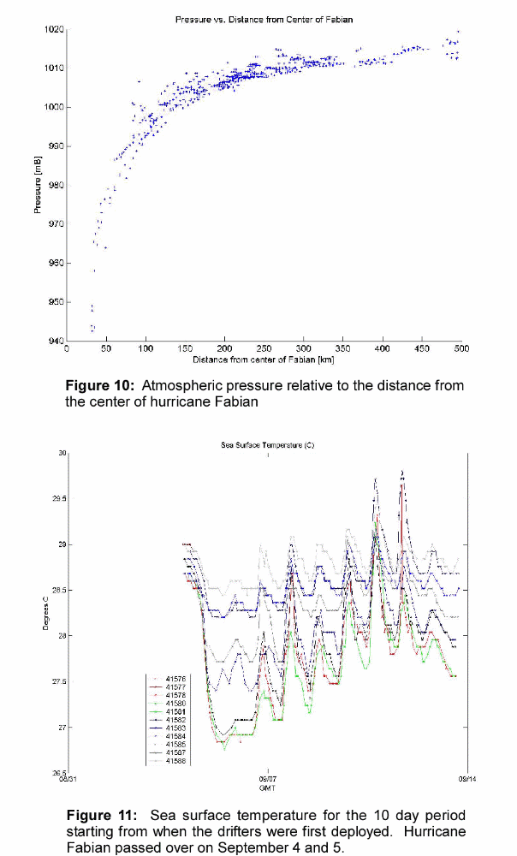

6. Conclusions

Measurements of hurricane wind direction, wind speed, SST, atmospheric pressure and surface currents were obtained by deploying 16 Minimet drifting buoys in front of a hurricane. Eight of the 16 drifters transmitted data throughout the entire time they were in the hurricane. The data shows that:
1. The atmospheric pressure decreases from ~1010 mBar on the outside of the hurricane to ~940 mBar within 50 km of the center
2. SST is between 26.5 and 28.5 degrees Centigrade in the hurricane and increases to between 27.5 to 30 degrees Centigrade over the 7 days after the passage of the hurricane.
3. The expected cyclonic motion of the hurricane winds is measured. At distances from 100 km to 500 km there is a component of the wind direction pointing toward the center of the hurricane

This experiment demonstrates that the air deployment of Minimet drifters in front of a hurricane provides an excellent means of obtaining meteorological data.

To increase survivability of the instruments, the drifters should be deployed in wind condition of less than 13 ms⁻¹ and further steps should be taken to assure the boxes are not stacked or damaged during shipping.

7. Acknowledgements

We acknowledge and thank Luca Centurioni, John Lee, Euna Lee, Andy Sybrandy and Chris Martin for their help in putting together the Minimet drifters and packaging them. Luca Centurioni, Andy Sybrandy and John Lee are further acknowledged for their insightful suggestions on analyzing and presenting the data.

8. References

Niiler, P.P., Evolution of the SVP Drifter Design and the Global Drifter Program Future, Presentation at DBCP Conference, Angra dos Reis, Brazil, 2003

