Using Surface Drifters and Remote Sensing Images to Observe Currents and Mesoscale Activity Offshore Brazil: an Environmental Perspective

Ronald Buss de Souza and Alexandre Pereira Cabral
Oceansat-PEG S/A, 26 Av. Rio Branco, 1st Floor, 20090-001
Rio de Janeiro, RJ, Brazil
ronald@oceansat.com.br

1. Introduction
This paper presents a general view on the utilization of data from surface drifters and remote sensing satellites for environmental applications in the offshore oil production sites located at the Campos Basin area (Figure 1) , Rio de Janeiro State, Brazil. The utilization of such data for continuously monitoring the currents and mesoscale processes at the oil production regions in Brazil is very important for various reasons: (1) remote sensing techniques offer a general, synoptic view of the sea surface difficult to be achieved by other techniques; (2) the intense thermal gradients occurring at the Campos Basin region between Brazil Current (BC) waters and adjacent coastal waters are easily observed by Advanced Very High Resolution Radiometer (AVHRR) and other sensors used to estimate the sea surface temperature (SST); (3) these thermal gradients are use to identify and monitor the Cabo Frio upwelling, the eddy activity and the presence of coastal waters at the Campos Basin region.

Nevertheless, the sole utilization of AVHRR or other sources of SST imagery at the area are not sufficient for studying the kinematics of the BC and its associated phenomena. In this case, current meter data and drifting buoys can be used as a complement for providing data for monitoring purposes. The problem is that in Brazil current meter data are very scarce. Current meter data are neither consistently collected on a long period basis nor the moorings well spread over large areas including the coastal waters. Lagrangian data, however, are easily obtained for many reasons: (1) the WOCE compatible drifters are fairly cheap, (2) the Brazilian industry is able to build them, (3) many deployment programs have been implemented since WOCE in the 1990s, and the drifters are easily deployed from any ship.

Souza (2000) has studied the mesoscale surface processes in the Southwestern Atlantic Ocean by means of satellite images and Lagrangian data from the Brazilian counterpart to WOCE. The author suggested that the combination of Lagrangian and satellite data is very productive when analyzing surface processes in the ocean, especially at regions with strong thermal gradients such as the Brazil-Malvinas Confluence Zone (BMC). The study of mesoscale structures such as eddies, for instance, can be greatly improved by combining satellite imagery to Lagrangian velocity (and temperature) data. Souza (2000), however, have not applied his results towards a proper monitoring scheme of eddies or other mesoscale structures at the BMC or in the coast of Brazil. His findings, though, were consolidated by Souza and Robinson (2003) who described a newly named Brazilian Coastal Current at the Brazilian Continental Shelf. This current, formed in the BMC region, flows opposite to the BC flow (SW to NE, contrary to the BC flow) and can eventually reach the Campos Basin area in extreme cases. In the present paper, the utilization of satellite images in combination with Lagrangian data is proposed as a efficient mechanism for monitoring the Campos Basin oil production site offshore Rio de Janeiro Sate, Brazil. Although surely other methods of monitoring such as modeling can be useful, the paper focuses in the satellite and Lagrangian data because they are simple, efficient and ready-to-use data already available at the present in Brazil.

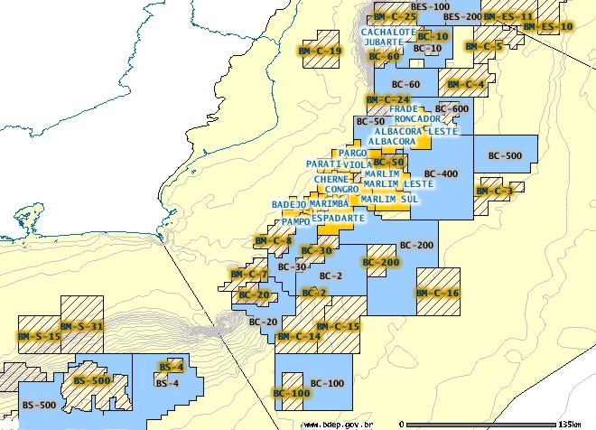
RIO DE JANEIR JAjJANEIROJANEIRO
CABO FRIO

Figure 1. The Campos Basin oil exploration site in Brazil, including the oil concession blocks (e.g. BC-100) and main oil fields (e.g. PAMPO, ALBACORA, etc). Source: BDEP/ANP, Brazil.

2. The Campos Basin oil exploration site
The Campos Basin area is located in a very singular site of the Brazilian coast, where the coastline abruptly changes orientation from NE-SW to E-W. Flowing along the continental shelf break, the western boundary current BC is forced, by vorticity constraints, to change its main flow direction as well. This causes extreme instabilities and makes the region a place of constant eddy formation. The eddies are often observed in the satellite images, being cold core ones resulted of the interaction of the BC with costal, frequently upwelled waters. The wind regime is dominated by the trade winds blowing from NE. The wind stress acts causing the most well-know upwelling regime in Brazilian waters at Cabo Frio, Rio de Janeiro State.
The Campos Basin are is also located at the geographical limit of the atmospheric frontal systems coming from the south (Figure 2). This cause intense atmospheric coverage sometimes, changes in the predominant wind direction, change in the surface currents by Ekman effect and high wave patterns. All these effects are important for the oil exploration industry in the region owing to operational concerns. The continuous changes in the upper layer environment at this region have environmental impacts yet to be assessed.

The environmental monitoring of the Campos Basin area is important due to several reasons. One reason is that the area is by far the largest oil production maritime site in Brazil, extracting at the present 1.07 million barrels a day (more than 80 % of the Brazilian oil production). By 2005, a production of 1.6 million barrels a day is predicted. Another reason for monitoring the area is the environmental legislation. Since the mid 1990s, when the Brazilian oil extraction market was open to foreign companies, the environmental legislation is getting tougher and very heavy fines are being applied in case is environmental accidents. The seismic, drilling and production activities are monitored and the licensing for oil exploration depends upon the Brazilian government’s environmental agency IBAMA.

3. Variability of the meteorological and oceanographic parameters at Campos Basin
The climatology of the atmospheric systems in South America is described in Nimer (1989). The author reports the presence of two semi-stationary anticyclonic systems over the Pacific and Atlantic oceans. The Atlantic system is stronger in wintertime, when atmospheric pressures can reach 1024 mbar. In winter, this high pressure system reaches lower latitudes. At the center of South America a low pressure system occurs centered at the Argentinean Chaco region. Polar anticyclonic systems are often generated at higher latitudes. Traveling northwards with polar air mass, these system cause a discontinuity zone with the tropical high systems, tending to converge winds. When the polar masses travel above the sea, the front tends to absorb heat and humidity causing rain along its path (Figure 2). In general, however, in the absence of the atmospheric fronts coming from the south, the presence of the Atlantic and Pacific anticyclonic systems cause the winds to blow from NE to SW in the Campos Basin area as seen on Figure 3.

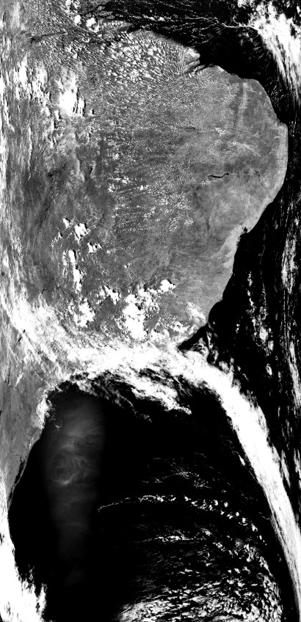

Figure 2. AVHRR image taken in 10 December 2003. The atmospheric front originated in the south of the South American continent is stationary over the Campos Basin area.

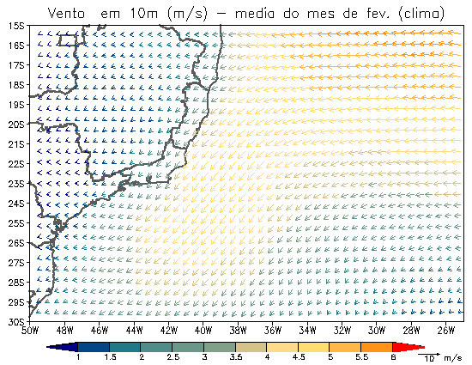 | 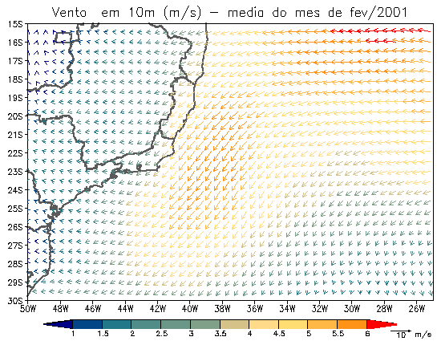
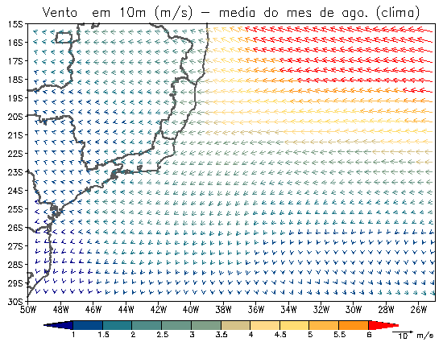 | 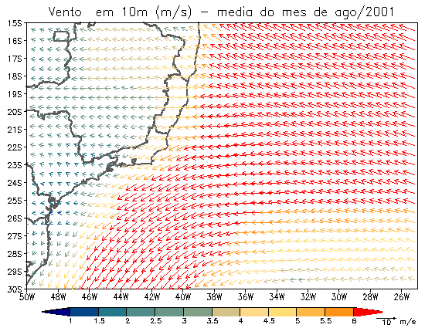

Figure 3. The wind regime at Campos Basin from NCEP reanalysis data. Climatological mean (left) and actual winds in 2001 (right) for February (summer, upper panels) and August (winter, lower panels).

The oceanographic conditions in Campos Basin are regulated by the dominance of the BC which is the western boundary current of the South Atlantic anticyclones gyre. Geostrophic and current meter BC estimates showed the current flowing in the NE-SW direction with average speeds of varying from 30 cm/s to about 70 cm/s (Signorini, 1976; Reid, 1989; Peterson and Stramma, 1991).

In the Campos Basin, owing to instabilities caused both by winds and by the bottom and coastal topography, BC abruptly changes direction producing mesoscale eddies. The presence of these eddies and the processes of interaction with the coastal waters are easily noticed by satellite images. Figure 4 show examples of cold-core, cyclonic eddies generated at Campos Basin area by the interaction of the BC with the coastal waters at the region. Schmid et al. (1995) reported diameters greater than 100 km for these structures which could reach depths of about 400 m. Other authors like Signorini (1976), Lorenzzetti et al. (1994) and Souza (2000), for example, reported the presence of both cyclonic and anticyclonic eddies in the Campos Basin area.

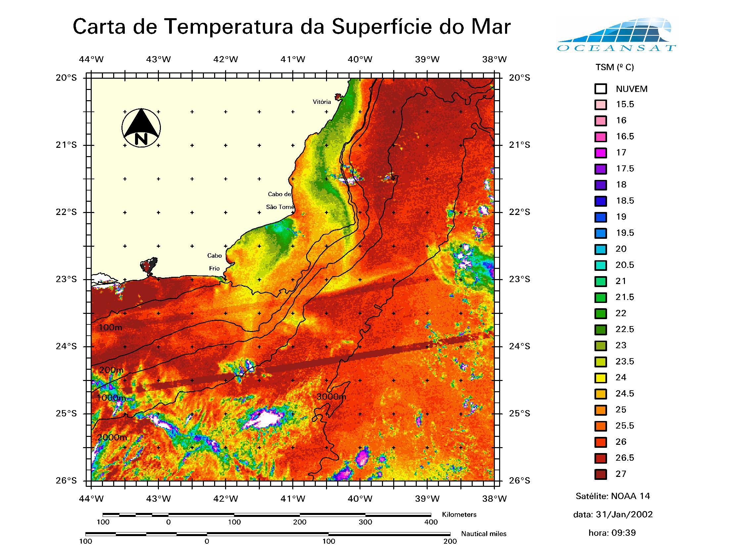
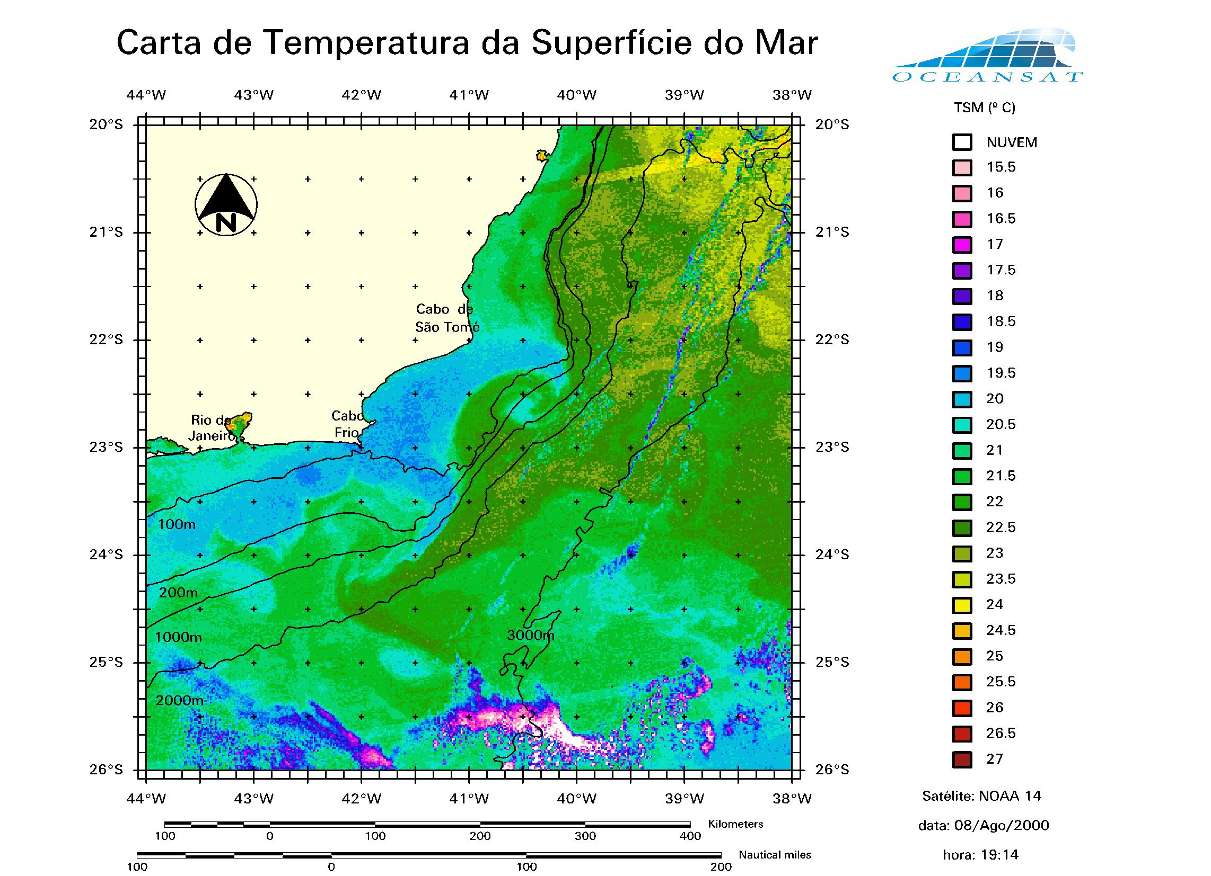
31-01-2002
08-08-2000

Figure 4. AVHRR SST images of the Campos Basin region showing the formation and presence of Brazil Current eddies.

4. Monitoring the environment
The assessment of the physical characteristics of the BC and its associated meanders and eddies at the Campos Basin area is important because they change the mean velocity (speed and direction) of the BC. That causes the circulation regime of the area to differ drastically from the expected current in the region, with consequences in the environment and in the planning of the offshore operations.

As mentioned before, AVHRR images on their own, although giving important information on the SST fields and associated structures, provides no information on the kinematics of the BC or associated eddies or meanders. Souza (2000) has demonstrated that AVHRR images used in conjunction with Lagrangian data provides new and useful information for monitoring proposes in the Southwestern Atlantic Ocean (SWA). Following Souza (2000), the lack of in situ current data in the area is a major limiting factor for better understanding the dynamics of the SWA.

Since the WOCE and, more recently, the establishment of the National Buoy Program (PNBoia) in Brazil, many WOCE-standard, low cost drifters (LCDs) have been deployed in the Brazilian coast to study the BC. This paper is the first to take advantage of the PNBoia data for helping on the monitoring of the Campos Basin area together with satellite data.

Figure 5 shows examples of drifter trajectories along the Brazilian coast including the Campos Basin area. The LCDs were deployed between 2000 and 2002 north of the Campos Basin. Trajectories vary from stable, low-perturbed tracks representing the expected BC flow in the area to turbulent flows presenting large loops related to the BC eddies. The BC velocities computed from the drifter trajectories can be treated individually as made by Souza (2000) and Souza and Robinson (2003) or considering geographical areas (boxes) were spatial averages are considered. In the last case seasonal or multi-temporal averages can be computed. PNBoia results computed for geographical boxes were presented by Assireu (2003).

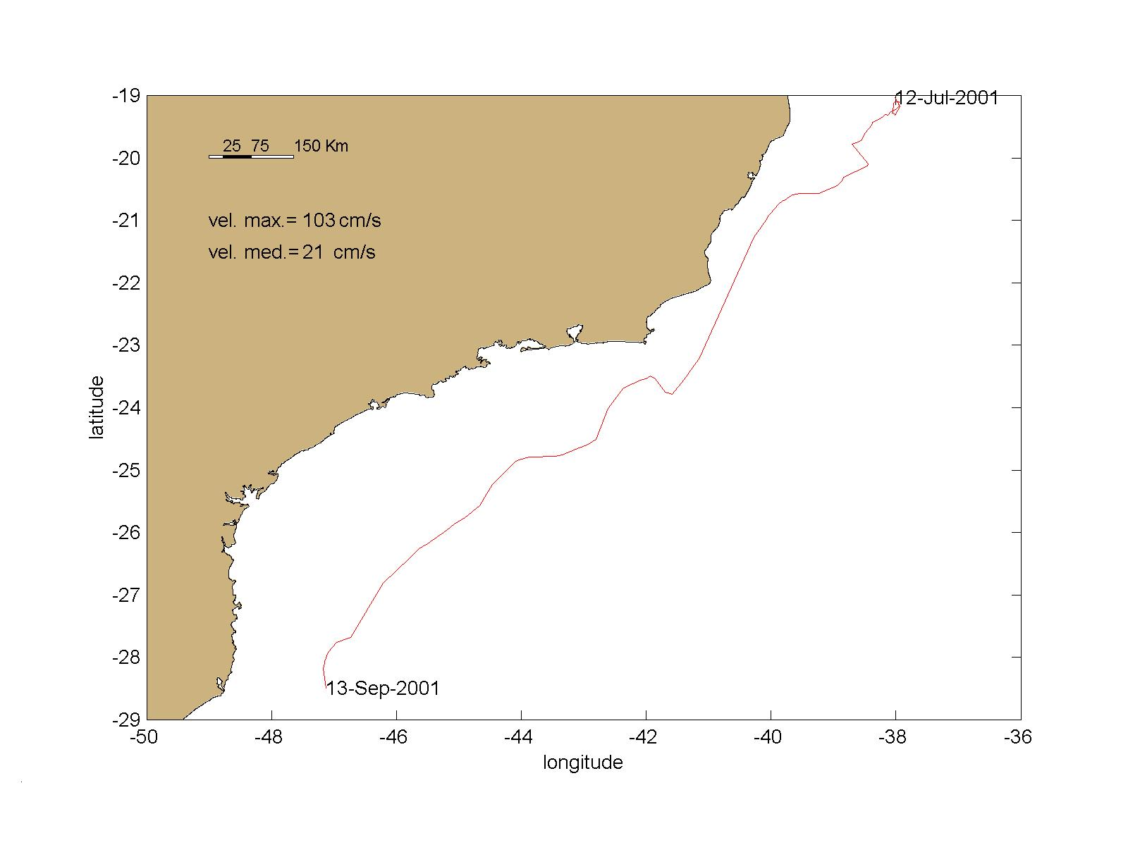 | 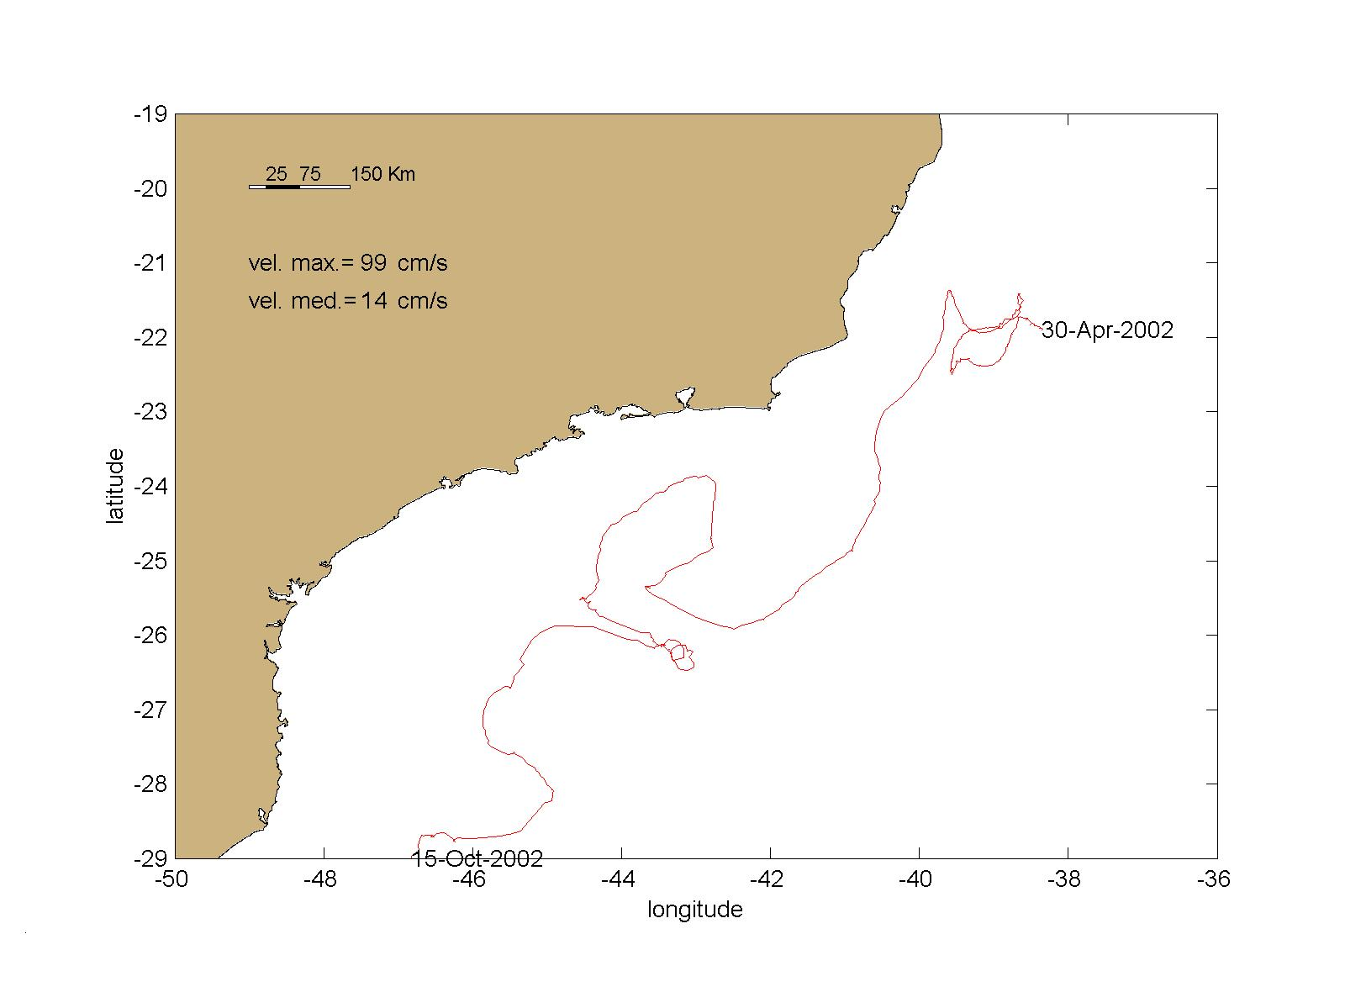
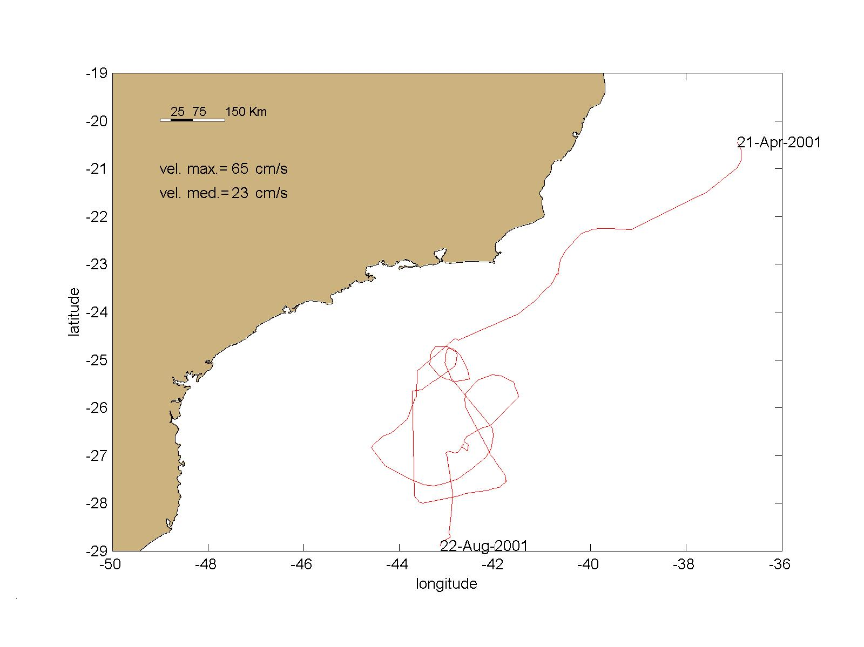 | 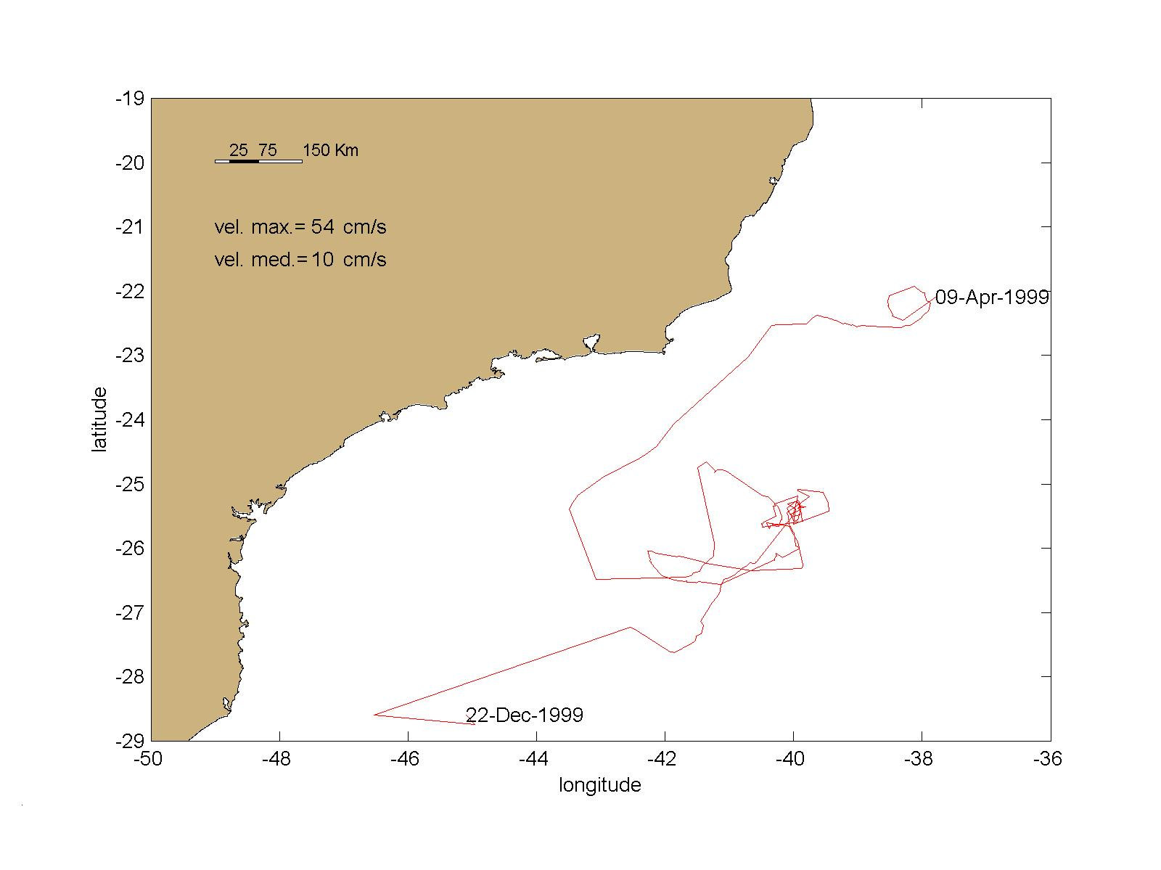

Figure 5. Individual trajectories of some LCDs from the Brazilian Buoy Program along the Campos Basin area.

Mean velocities for the BC computed individually from the PNBoia LCD trajectories varied from 7 cm/s to 23 cm/s towards SW. Generally, slower velocities are associated with meandering currents and associated loops. Assireu (2003) computed mean velocities for 8 distinct boxes (about 2º x 2º) located from 20ºS to 35ºS in the SWA. The author found velocities of about 2 cm/s to 22 cm/s.

The velocity estimates described here are currently being used by OCEANSAT/PEG for helping on the monitoring of eddies and meanders at the Campos Basin. Previous work made at the company using 225 AVHRR SST images had demonstrated that during the period of July 1999 to June 2000 (one year), 36 eddies were identified in the Campos Basin area. Eddies were about 50 km to 80 km in diameter lasting 7 days to 13 days in the area. Extreme values for eddies life time in the region was close to 65 days. As Garfield (1990) had pointed out, most eddies tended to be transported with the BC towards SW, but some eddies traveled opposite to the BC flow.

OCEANSAT/PEG is currently using data from many other sensors for monitoring the Campos Basin area. TOPEX/Poseidon (and recently, Jason) data is used both to generate sea surface height anomaly charts in the area and geostrophic velocity maps for the BC. Chlorophyll maps are derived from the Moderate Resolution Imaging Spectroradiometer (MODIS) sensor. SST maps are also produced from the Tropical Rainforest Measurement Mission (TRMM) Microwave Imager (TMI). TMI data, although providing coarse resolution in comparison to the AVHRR sensor, has proved very useful because SSTs can be estimated even under cloudy (not rainy) conditions. Long period time series can be used to compute climatologies and derive SST anomalies. The SST anomaly maps, as the one seen on Figure 6, are proving very useful to add information about dipole configurations of some Campos Basin eddies. Dipoles are not yet described in the literature for the Campos Basin eddies. The evidence of their existence adds up complexity to the dynamics of the Campos Basin region.

5. The P-36 platform accident
One example of successfully integrating oceanographic data for the environmental monitoring at the Campos Basin region was the unfortunate accident of the Petrobras P-36 oil extraction platform. The P-36 was the largest oil platform in the world and suddenly, after a series of large explosions in 15 March 2001, it sunk in the Campos Basin area were it was operating. As very few in situ data was available and, owing to the very accident, new field campaigns were not possible because of safety concerns, satellite data were used to monitor the SST fields in the area as a proxy for the currents occurring there.

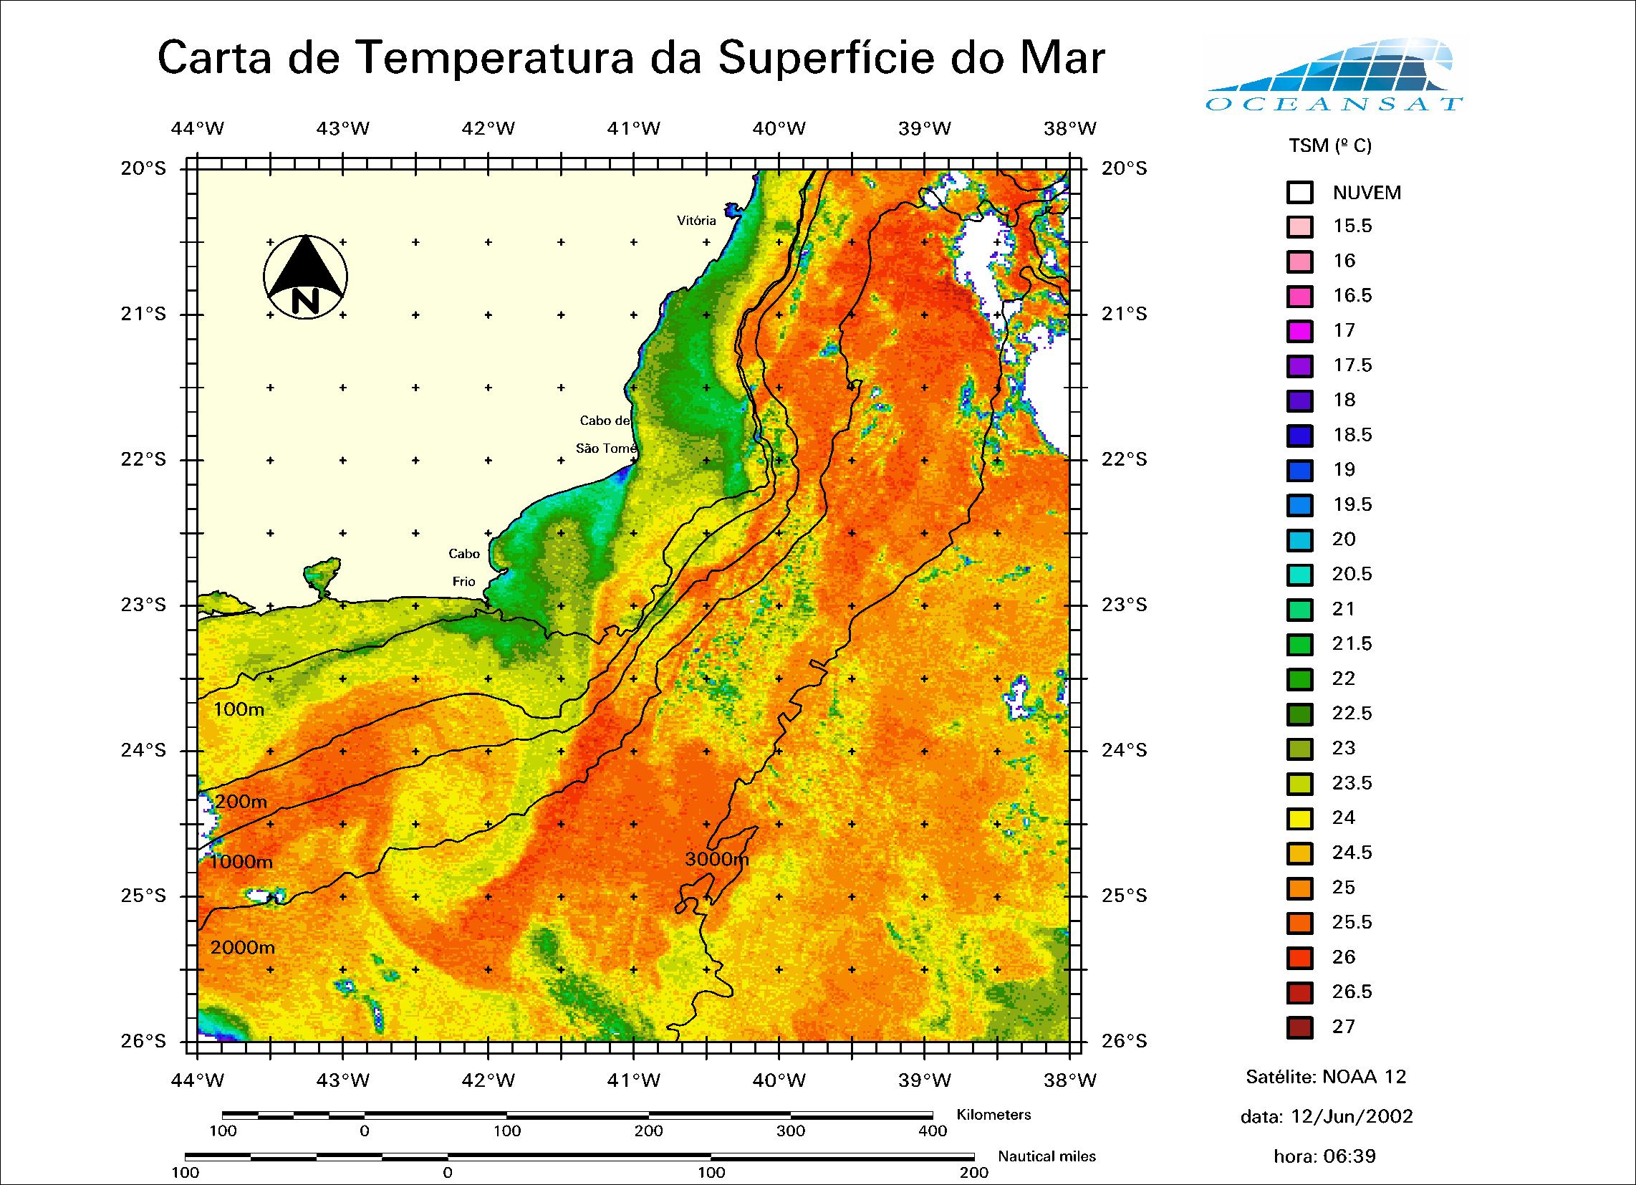
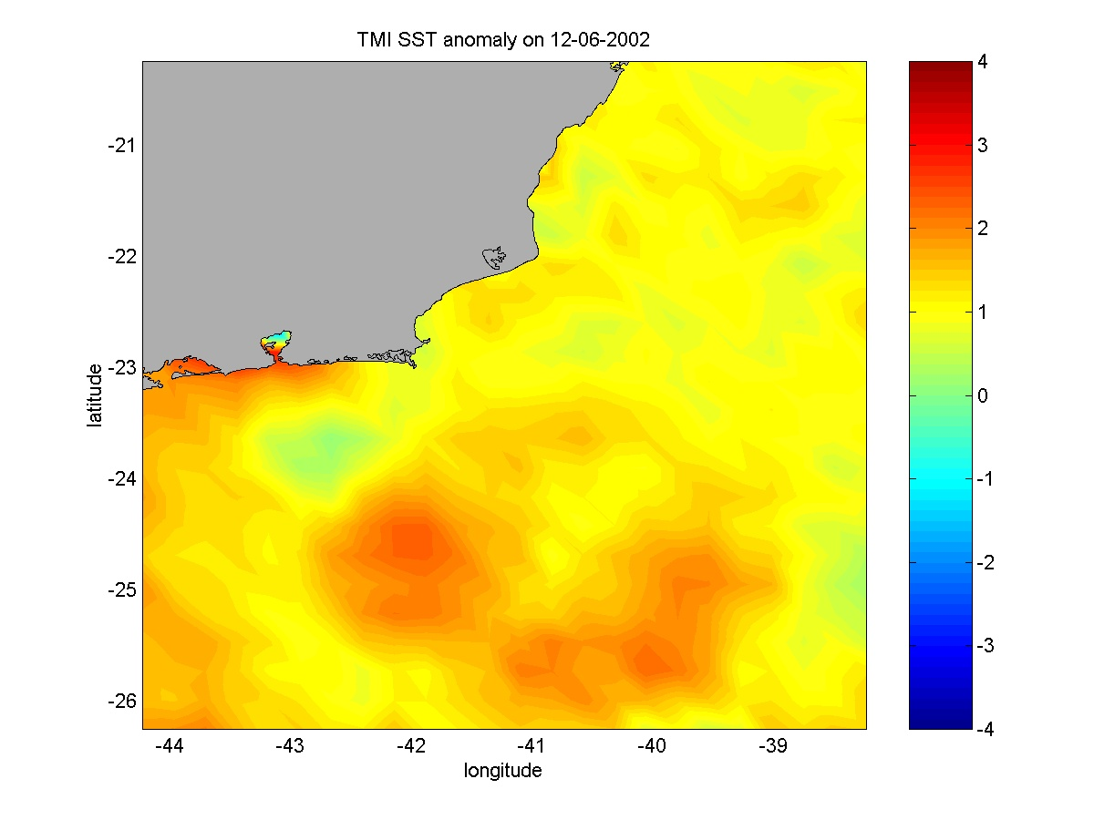

Figure 6. AVHRR SST (left) and TMI SST anomaly maps for the Campos Basin area in 12 June 2002.

Figure 7 shows that when the P-36 sunk, the location of the platform was coincident with the position of a cold tongue of costal waters caught by the BC during a cyclonic eddy formation. Daily series of AVHRR images taken from before the accident were used to show that the surface waters movement at the P-36 location were driving the crude oil towards the open ocean and not towards the coast. Because of that, the accident was considered of small impact. Radar images were acquired after the accident to evaluate the dispersion of the oil spill also demonstrated the tendency of the oil spill to spread towards the open sea.

6. Conclusions
Main conclusions drawn from this paper are:
• The continuous monitoring of the Campos Basin area offer the possibility of a better planning for the offshore activity and diminishes the possibility of structural and environmental accidents;
• SST fields monitoring and surface drifter trajectories, when used in combination, can offer a very feasible option for analysing the surface current fields at the Campos Basin area;
• Other sources of data, although not very consistent in terms of time series, are always welcome to help on a better environmental analysis especially in accident events.

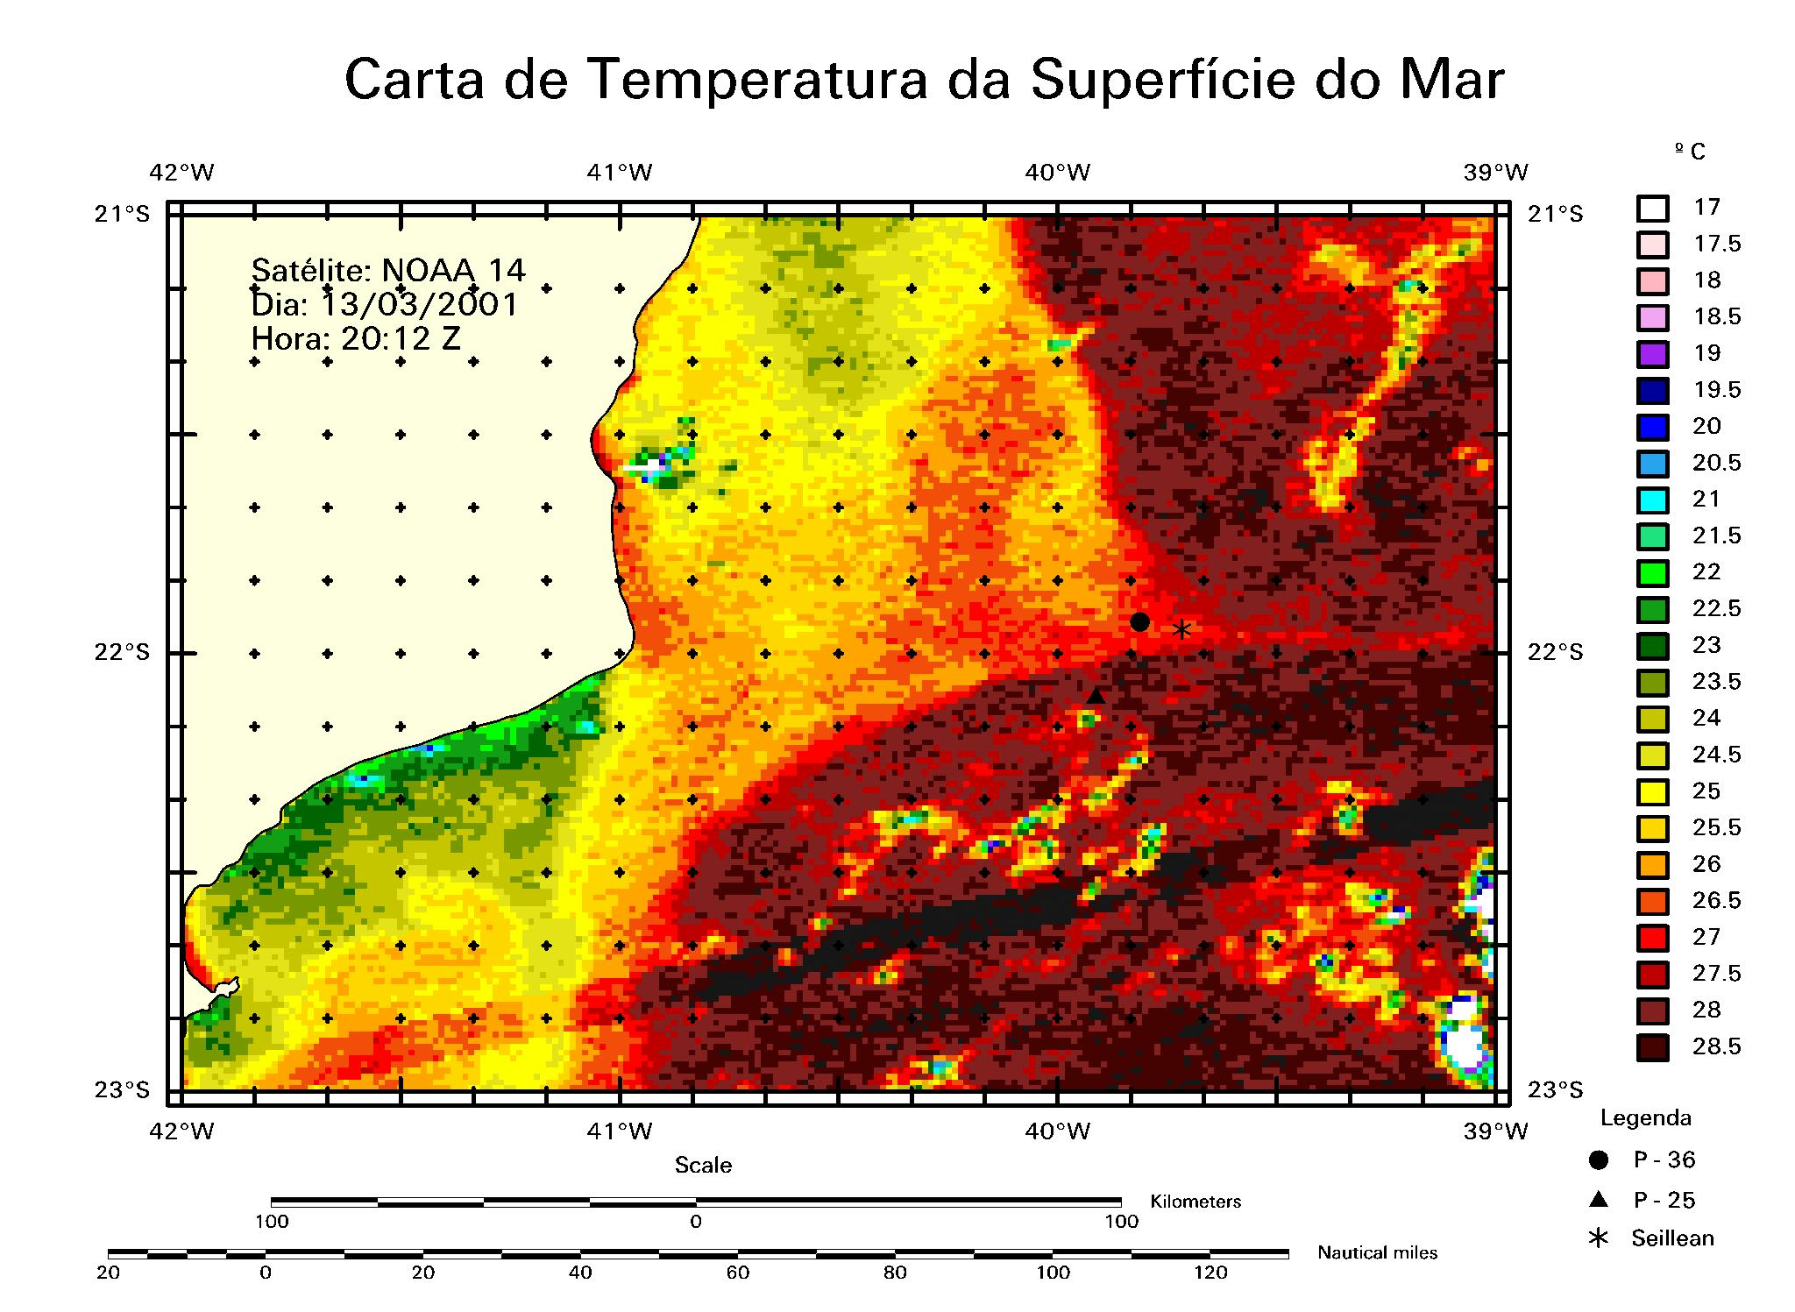
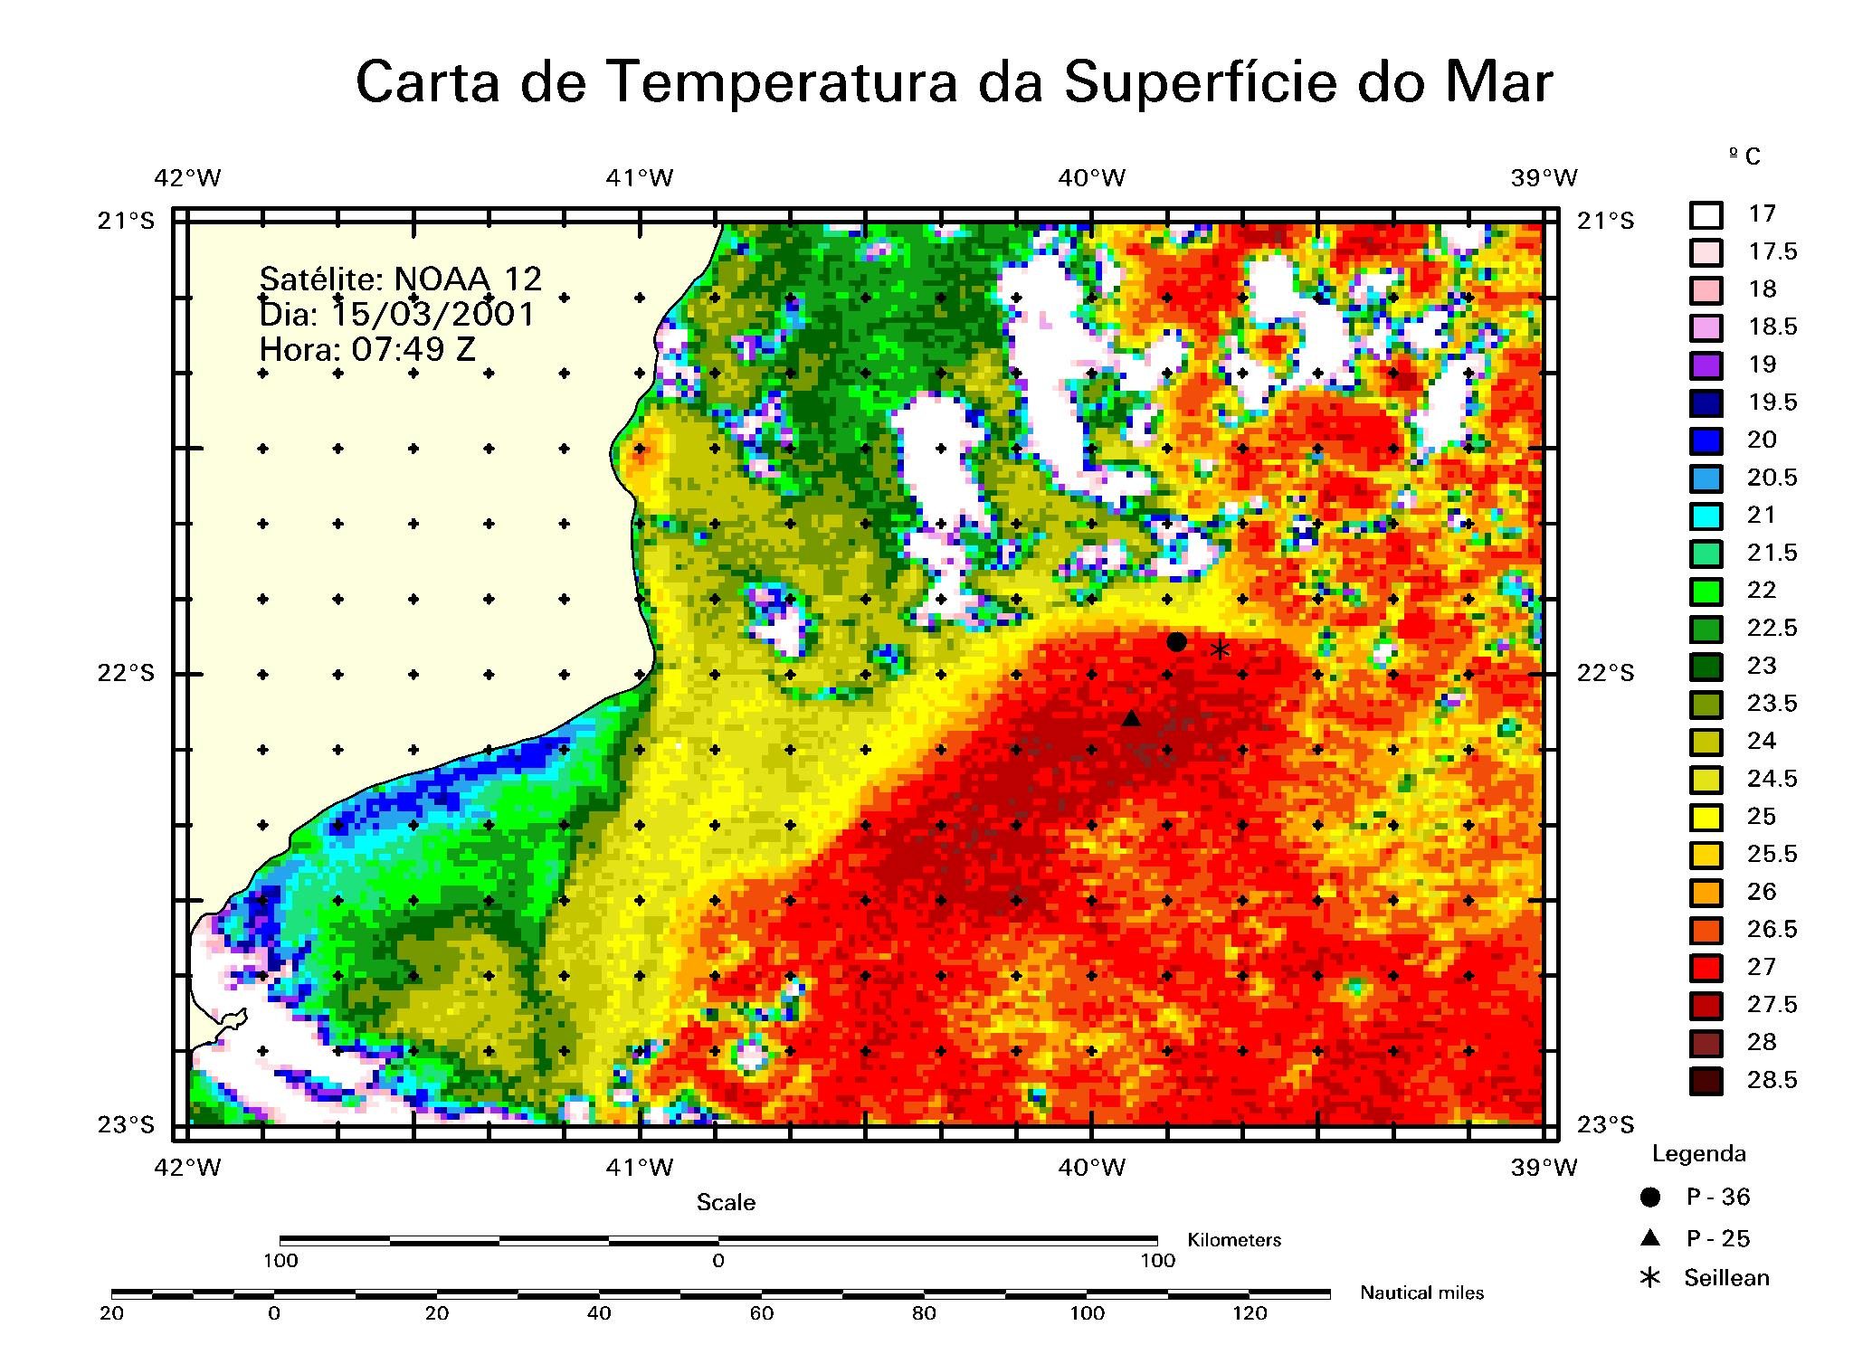

Figure 7. AVHRR SST maps at the Campos Basin in 13 and 15 March 2001. The P-36 location is shown in green. The cold tongue of coastal waters transported the oil spill towards the open sea.

References.
Assireu, A.T. 2003. Estudo das características cinemáticas e dinâmicas das águas de superfície do Atlântico Sul Ocidental a partir de derivadores rastreados por satélite. Doctoral thesis. Instituto Oceanográfico da Universidade de São Paulo, IOUSP, Brazil, 154pp.
Garfield, N. 1990. The Brazil Current at subtropical latitudes. Ph.D. thesis. University of Rhode Island, Rhode Island, USA, 121pp.
Lorenzzetti, J. A.; Stevenson, M. R.; Silva Jr., C. L.; Souza, R. B. 1994. Behaviour of a semi-permanent eddy as observed from AVHRR images and WOCE drifters. In: Abstracts from the Symposium: The South Atlantic – present and past circulation. Bremen, Germany, 15-19 August 1994. Berichte, Fachbereich Geowissenschaften, Universitat Bremen, n 52, p 83-84.
Nimer, E. 1989. Climatologia do Brasil. 2 ed. IBGE. Departamento de Recursos Naturais e Estudos Ambientais. Rio de Janeiro. 422 p.
Peterson, R.G., Stramma, L. 1991. Upper-level circulation in the South Atlantic Ocean. Progess in Oceanography, 26:1-73.

Reid, J. L. 1989. On the total geostrophic circulation of the South Atlantic Ocean: flow patterns, tracers and transports. Progress in Oceanography, 23:149-244.
Schmid, C.; Schäfer, H.; Podestá, G.; Zenk, W., 1995. The Vitória Eddy and its relation to the Brazil Current. J. Phys. Oceanogr., 25(11): 2532-2546.
Signorini, S. R. 1976. Contribuição ao estudo da circulação e do transporte de volume da Corrente do Brasil entre o Cabo de São Tomé e a Baía de Guanabara. Boletim Instituto. Oceanografico da Universidade de. São Paulo, 25:157-220.
Souza, R.B. 2000. Satellite and Lagrangian observations of mesoscale surface processes in the Southwestern Atlantic Ocean. Ph.D. thesis. University of Southampton, Southampton, UK. 239pp.
Souza, R.B.; Robinson, I.S. Lagrangian and satellite observations of the Brazilian Coastal Current. Continental Shelf Research (in press).

