Summary of Drifter Data Products

Available on the Web

Mayra C. Pazos

Drifter Data Assembly Center
NOAA/AOML
Miami, Florida. USA
E-mail: Mayra.Pazos@noaa.gov
www.aoml.noaa.gov/phod/dac/dacdata.html

Abstract

A description of the data products currently available on the Data Assembly Center (DAC) web site (www.aoml.noaa.gov/phod/dac/dacdata.html) and the history of their development. The near real-time products will be compared to the delayed mode, scientifically quality controlled data updates, including the Global Drifter Array Maps, Monthly trajectories, SST anomalies, GDC deployments, Annual and Seasonal Mean estimates by seasons (graphs and data files), the Hurricane Array, drifter animations and pertinent web links.

You can go to the Drifter Data Products web page from the AOML main page, or going directly to the DAC web page.

From the AOML main page:
WWW.AOML.NOAA.GOV > Data Sets > GOOS Center > Global Drifter Center > The Drifting Buoy Data Assembly Center.

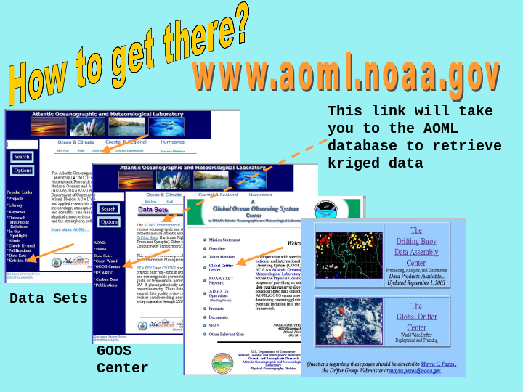Or directly to: WWW.AOML.NOAA.GOV/phod/dac/dacdata.html
The first part of the page is dedicated to the Hurricane Drifter Array that is launched every year at the beginning of the hurricane season in the Atlantic Ocean, to provide data in real time to help in the forecast and prediction of hurricanes. You can find information, status tables on the drifters and their sensors, drifter tracks and links to download drifter data in near real time from the GTS, as well as hurricane tracks and data.

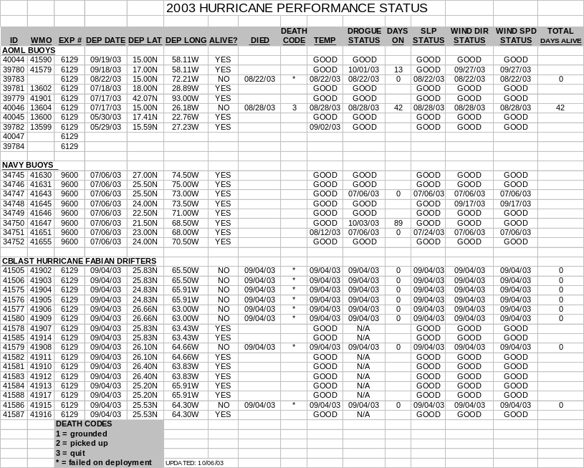

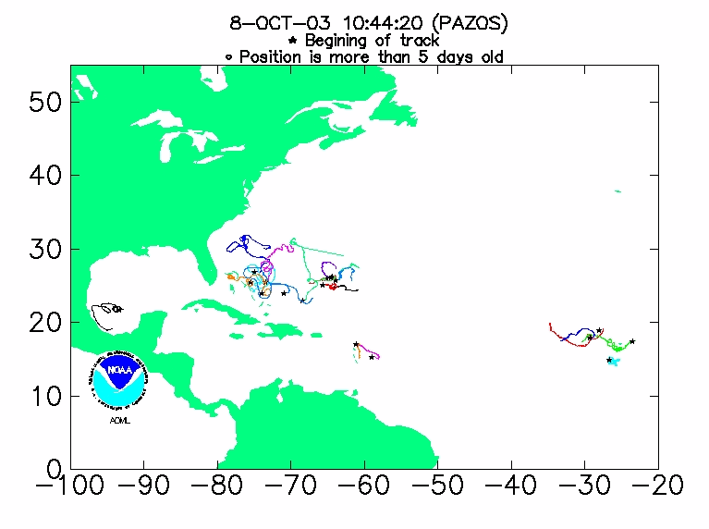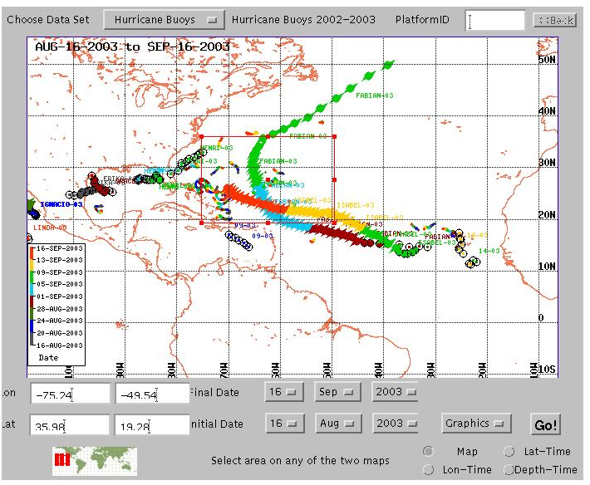

The next section of the web page consists of maps updated once a week showing movements of the currents in 7 different basins, the status of the global drifter array and SST anomalies. The last map of each month is kept and can be retrieved from any month and year starting from 1995.

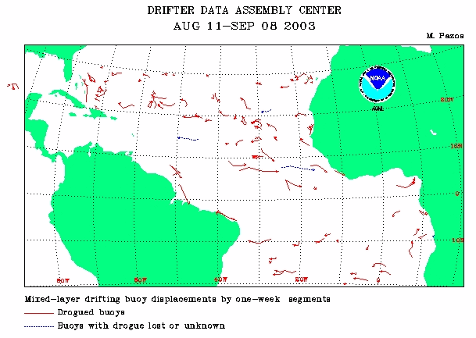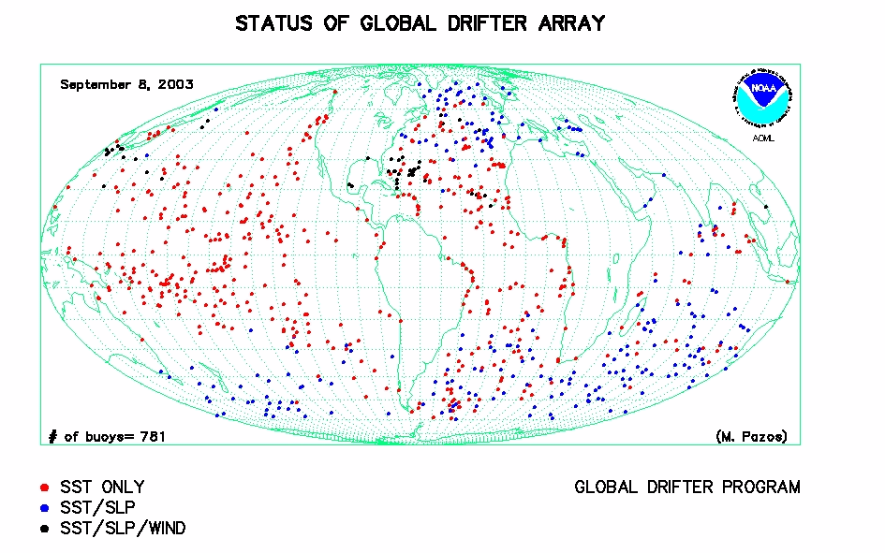

The annual and seasonal mean velocity estimates, variances about the mean velocity estimates, and contour plots indicating the number of points in each bin, are updated
once a year from all data available in the database in each basin since 1979. The drogued only, quality controlled and interpolated data to 6-hour intervals are used. The latitude, longitude, u, v are averaged at five day intervals and grouped into five degree by five degree bins. The data files can be downloaded from the page.

The last section of the page is dedicated to the retrieval of the kriged interpolated drifter data using a browser. You can choose from an interactive GUI, a region, and/or a period of time, also, you can choose to only download drogued data, or all data. If it is a short file, you can use the browser to save the downloaded file. If a large area or time period has been requested, you will be notified by e-mail where to download the file using FTP. In this section you can also download near real time data from the GTS, or go to the MEDS web page to download raw or quality controlled non- interpolated data.

Other products and links in this section include: Drifter animations: currents and SST, monthly drifter SST and current anomalies map, number of buoys in 5⁰x5⁰ bins from GTS, and drifter bibliography research papers.



