Trials of the Iridium Dial-Up and Short Burst Data Services

David Meldrum, Duncan Mercer and Oli Peppe
Scottish Association for Marine Science
Dunstaffnage Marine Laboratory
Oban PA37 1QA, Scotland
tel: +44 1631 559000 fax: +44 1631 559001
dtm@sams.ac.uk

Abstract - Further experience has been gathered in the use of Iridium modems in a number of polar applications. This has confirmed that the system is capable of efficiently transferring files of several tens of kilobytes in a conventional dial-up modem configuration. The costs, both in financial and energetic terms, are at least an order of magnitude better than for other polar-capable systems. More recently, trials have been conducted using the Short Burst Data service, which allows transmission of data packets of up to 2 kilobytes in a manner equivalent to cellular phone text messaging. This should reduce the energy penalty associated with establishing a call circuit in dial-up mode, and further improve the efficiency of the system, particularly for smaller file sizes of a few kilobytes. The results of these trials will be reported.
TABLE 1

SATELLITE SYSTEMS OF POSSIBLE INTEREST TO DATA BUOY OPERATORS
SystemOriginal FunctionOrbit TypeAchievable data rateInmarsat D+PagerGEO< 1 kbyte/dayGOES, MeteosatMessagingGEO< 5 kbyte/dayArgosMessagingLEO< 5 kbyte/dayInmarsat CMessagingGEO< 10 kbyte/dayOrbcommMessagingLEO< 50 kbyte/dayIridiumVoiceBig LEO~1 Mbyte/hr

I. INTRODUCTION

Last year we presented a paper [1] describing some initial results from laboratory tests of modems using the Iridium satellite system (Figure 1). These tests, enabled by the generous provision of prototype modems and airtime by the US Argo Program Office, were part of a general effort at the Scottish Association for Marine Science (SAMS) to develop remote platforms and associated satellite communication systems for oceanographic and polar research [2, 3]. The positive results, as well as enabling a new methodology in interactive control of remote experiments, have been disseminated to other potential users of satellite communication systems via the DBCP website and other publications [4]. Table 1 summarises our findings with regard to suitable systems for buoy operators.
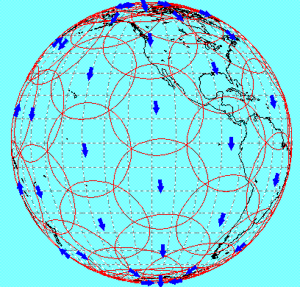
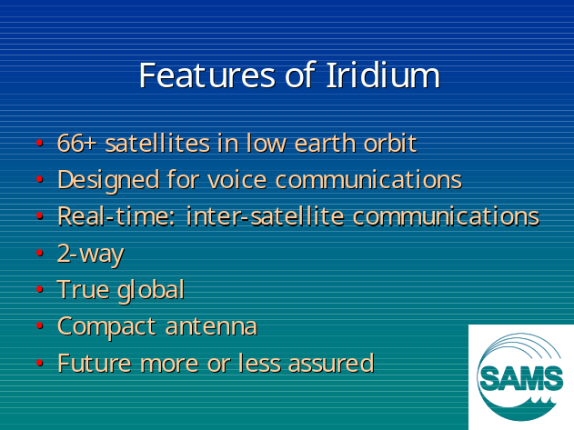
Figure 1. Some salient features of the Iridium satellite system. The large number of satellites in the constellation assures continuity of inter-satellite links and obviates the need for an extensive ground station network.
II. DATA OVER IRIDIUM

As this system was originally conceived for global telephony, it is truly 2-way in real time, permitting the operator to perform on-line software upgrades and diagnostics with his mobiles, as well as more traditional data telemetry tasks. Additionally, it is one of the very few systems to offer true polar coverage (Argos is one of the others), and the 1.5GHz communications frequency permits the use of a compact low profile antenna. In addition to laboratory tests of the system, we have now deployed Iridium equipped platforms in the Arctic using both the Dial-Up and Short Burst Data (SBD) modes of access. Whereas the former is analogous to a conventional modem connection via a telephone line, the latter is more akin to the short message service (SMS), or text messaging, available to cellular phone users.

A. The Dial-Up Service

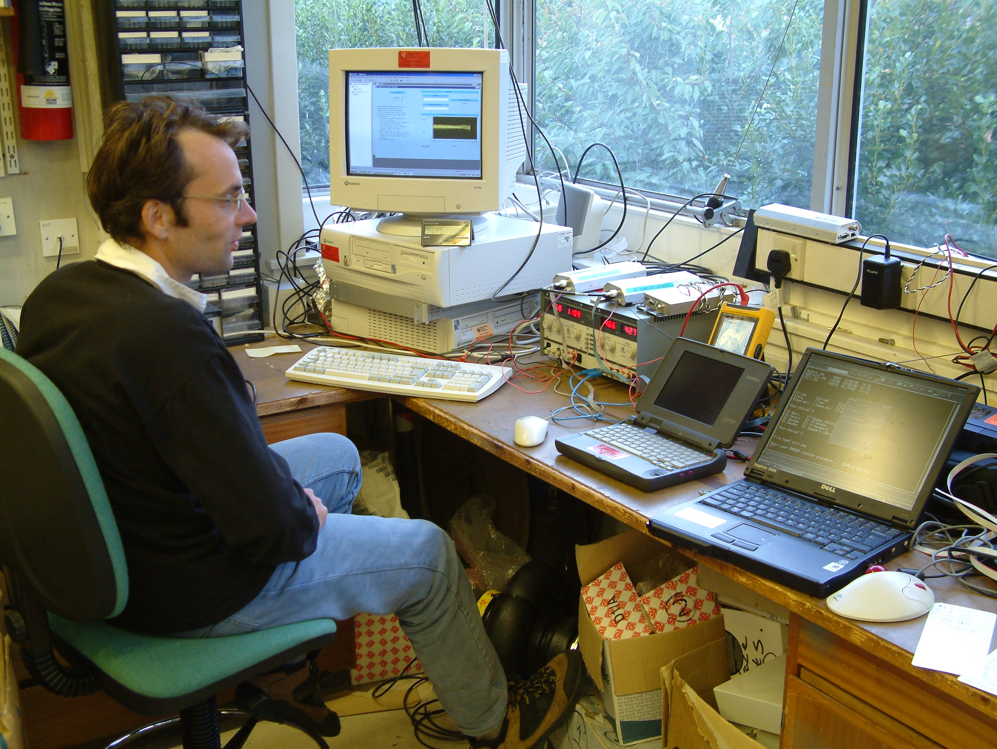
This was the first data service available to Iridium users, and functions in a similar manner to a conventional dial-up modem connection over a fixed telephone line (Figure 2). The similarity is not complete, however, as the available modems are integrated with the Iridium RF unit, in effect a re-worked Iridium 9500 or 9505 mobile phone. One result is that the over-the-air data connection rate is fixed at 2400 baud, whereas current generation stand-alone telephone modems are capable of much higher rates over standard voice circuits. We intend to perform tests to see if it is possible to achieve higher rates using stand-alone modems in the near future.
Figure 4. Laboratory tests of a pair of Iridium modems (visible as small boxes on top of the power supply in the centre of the image). The PC was used to log file transfer time and energy consumption.

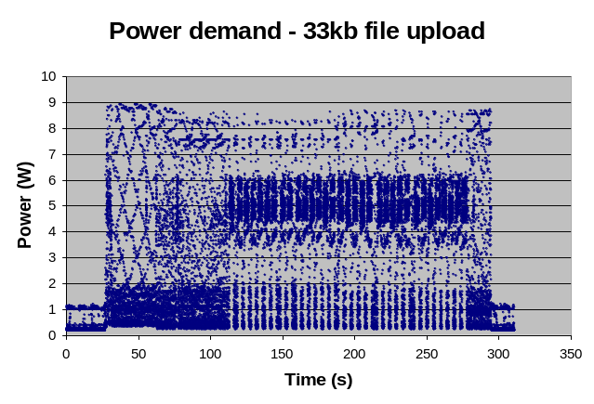
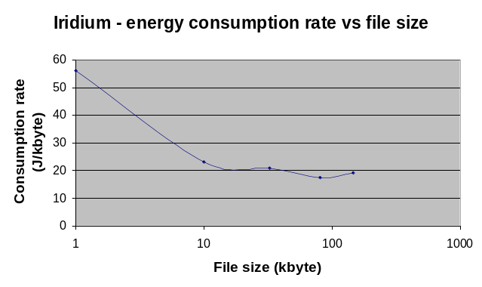
Our tests concentrated on placing calls and initiating file transfers between two Iridium modems. The modems were connected to laptops running a simple Bulletin Board Server (BBS), allowing basic functions such as file listing, e-mail, on-line chat and file transfer (Figure 3). Z-MODEM was used as the file transfer protocol, as it implements packet retries in the event of error. Nonetheless, we did experience several occasions when file transfer failed, particularly for larger file sizes (>100 kbyte), and a much more robust protocol would need to be developed to allow dial-up to be used for data transfer to and from autonomous platforms.
Figure 5. Modem power demands during a dial-up file session during which a 33 kbyte file was transferred.
Figure 6. Dial-up energy consumption rate as a function of file transfer size. The call connection overhead is significant for smaller file sizes.
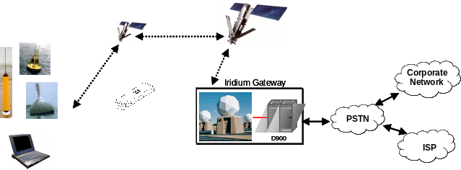
Initial tests were conducted in the laboratory, allowing file transfer time and energy consumption to be logged (Figure 4) for a range of file sizes (Figures 5 and 6). Further tests were conducted with one mobile in the Arctic Ocean, to evaluate the concept of using Iridium for data telemetry and control in polar regions, where geostationary satellite coverage is unavailable (Figure 7). Figure 7 was in fact transferred from the Arctic via Iridium as a JPEG file.
Figure 2. A schematic representation of the Iridium Dial-Up service (courtesy of Steve Piotrowicz, NOAA). The modems, based on the 9500 and 9505 Iridium phones, implement a subset of the Hayes AT command set. Typical throughput is 2400 baud.
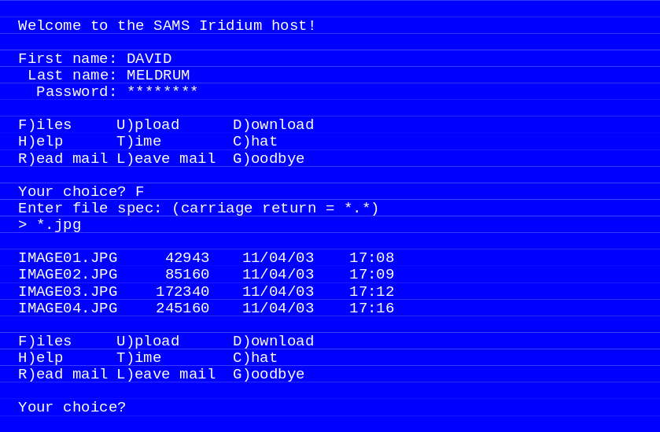
Figure 3. Part of an online session to our Iridium BBS host. File transfers are supported in both upload (to mobile) and download (from mobile) directions.
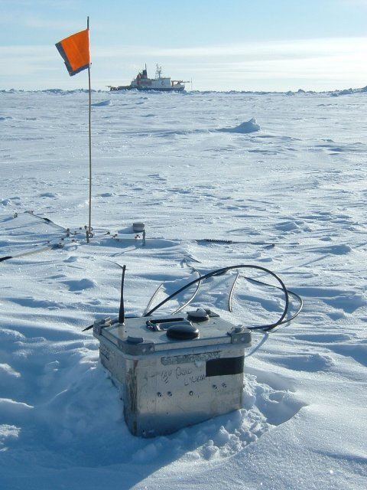
Figure 7. An Iridium-equipped strainmeter station in the Arctic Ocean, with the German research vessel Polarstern in the background. The image was sent back to the laboratory over an Iridium dial-up link.

B. The Short Burst Data (SBD) Service

In this mode of use, the mobile does not initiate a call to a distant station, but transfers packets of data to and from the Iridium system under a simple handshaking protocol, using an extended AT command set (Figure 8). Packet size is approximately 2 kbyte in either direction, and error checking and packet retransmission are transparent to the user. Messages are transferred to and from the user as conventional e-mails attachments, with each mobile having a unique mail ID. Curiously, this ID is not linked to its ‘personality’ as described in the SIM card, but to the modem’s IMEI or unique serial number. An example of a mobile-originated e-mail is shown in Figure 9.

The system also generates a rather crude position for the mobile (Figure 10), which is also passed to the user in the body of the e-mail, along with an error-estimate in km. The locations are too poor to be of much use for scientific purposes, but are clearly used in the charging algorithm, which disadvantages mobiles located outside North America. The user is charged on the basis of data volume at roughly $1.20 per kbyte for North American mobiles and $2.40 per kbyte elsewhere.

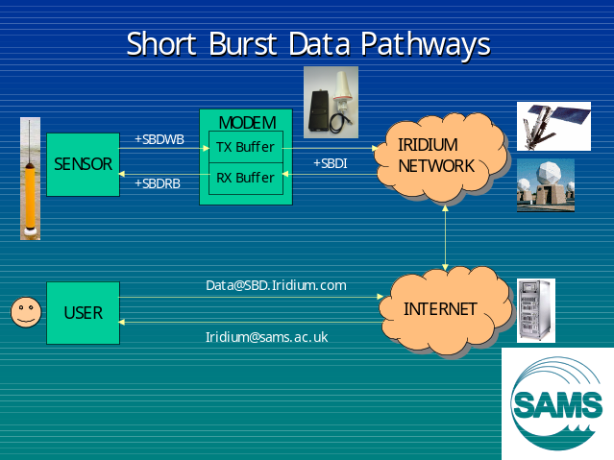
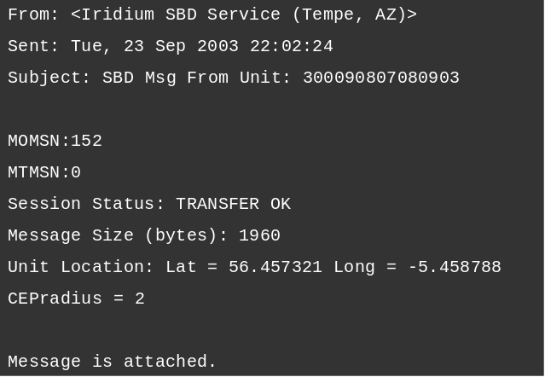
Figure 8. A summary of SBD data pathways, AT commands and mailbox addresses. Messages sent to the mobile are queued by the system until explicitly requested by the mobile.
Figure 9. The body of a mobile-originated (MO) e-mail as received by the user. Data are included as an attachment. Note the system-computed location, with an estimated accuracy of 2 km in this case.

III. CONCLUSIONS

An overall comparison of the costs of Dial-Up and SBD in terms of both energy and cash are given in Figures 11 and 12, and an intercomparison with other systems is summarised in Table 2.

It is clear that Iridium is much more energy efficient than competing systems such as Argos and Orbcomm. In part this is due to the handshaking protocol employed, but also is probably also a result of the high-gain spot-beam antennae fitted to the Iridium satellites which reduces the mobile transmit power needed for a given bandwidth. What is slightly surprising is that Iridium SBD is no more energy efficient than Iridium Dial-Up, both consuming about 20 J/kbyte. However, our experience is that SBD is much easier to implement and potentially much more rugged, particularly when dealing with autonomous platforms.

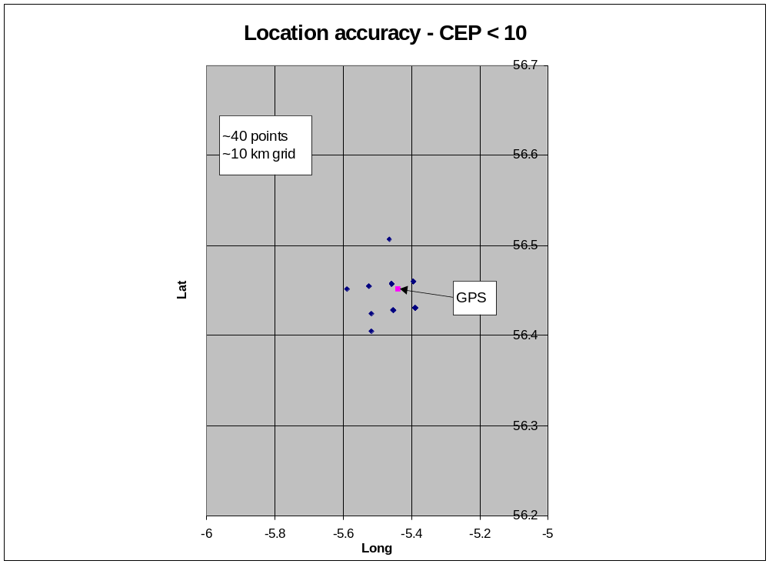
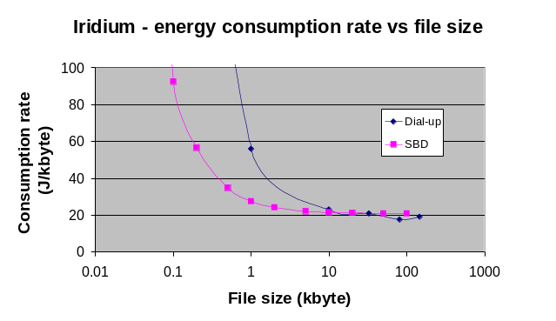
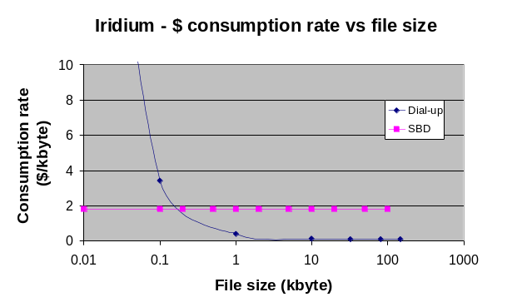
Figure 10. A set of Iridium-computed locations compared to GPS. Estimated errors (CEP) are frequently quoted much higher than 10 km. There is clearly an inherent quantisation of location solutions, as many of the solutions plot directly on top of each other.
Figure 11. A comparison of the energy consumption of Dial-Up and SBD data transfers. Both systems level out at about 20 J/kbyte.
Figure 12. A comparison of the cash costs of Dial-Up and SBD data transfers. Dial-Up is much less costly for file transfers of more than a few hundred bytes.
TABLE 2

ENERGY COSTS OF SATELLITE SYSTEMS
SystemOriginal FunctionOrbit TypeEnergy ConsumptionArgosMessagingLEO~5000 J/kbyteOrbcommMessagingLEO~500 J/kbyteIridiumVoiceBig LEO~20 J/kbyte
IV. ACKNOWLEDGEMENTS

We gratefully acknowledge the support of the UK Natural Environment Research Council, the Alfred Wegener Institute and Steve Piotrowicz of NOAA.

V. REFERENCES

1. Meldrum, D T and Mercer, D J L, 2003. First results using Iridium satellite modems for buoy applications. In: Proceedings of the DBCP Scientific and Technical Workshop, Martinique, October 2002. Data Buoy Co-operation Panel Technical Document No 22, (CD-ROM). WMO, Geneva.

2. Meldrum, D, Cromey, C, Doble, M, Mercer, D and Peppe, O, 2003. New developments in the remote measurement of currents and waves at the Scottish Association for Marine Science. In: Proceedings of the 7th IEEE/OES Conference on Current Measurement Technology, San Diego. (CD-ROM), pp 271-276. IEEE.

3. Meldrum, D T, Mercer, D J L , Peppe, O C and Doble, M J, 2002. Results from Orbcomm ice buoy deployments. In: Proceedings of the DBCP Scientific and Technical Workshop, Perth, Australia, Oct 2001. Data Buoy Co-operation Panel Technical Document No 21 (CD-ROM). WMO, Geneva.

4. Meldrum, D, Peppe, O and Mercer, D, 2001. Developments in satellite communication systems - an update for October 2001. In: Final Report of the 17th Session of the Data Buoy Co-operation Panel, pp 85-95. WMO, Geneva.

