EUROPEAN GROUP ON OCEAN STATIONS (EGOS)

1 THE MANAGEMENT COMMITTEE OF EGOS
The Management Committee met once in 2004:

- The summer meeting was hosted by the Icelandic Meteorological Office in Reykjavik during 29 and 30 June 2004. A report on the conclusions and recommendations of this meeting is in EGOS Tech. Doc. No. 284. Representatives from DBCP and EUCOS attended this meeting.

2 Membership of EGOS
No members have formally indicated any changes in their membership. At present the number of EGOS members is 10. The status of the EGOS membership is summarised in Table 1.

Table 1 The membership of EGOS as of 31December 2004.

Country | Organisation | Member of Committee (MoC)
Denmark | Danmarks Meteorologiske Institutt | Erik Bødtker
France | Météo-France | Pierre Blouch
Iceland | Veðurstofa Íslands | Hreinn Hjartarson
Ireland | Met Éireann | Evelyn Murphy
Federal Republic of Germany | Deutscher Wetterdienst | Reinhard Zöllner
The Netherlands | Koninklijk Nederlands Meteorologisch Instituut | Frank Grooters
Norway | Meteorologisk Institutt | Kjell Hegg
Spain | Instiuto Nacional de Meteorologia  Puertos del Estado | Enrique Fanjul
Sweden | Sveriges Meteorologiska och Hydrologiska Institut | Erik Liljas
United Kingdom | Met Office | Sarah North

3 Financial matters
The EGOS Common Fund is based on voluntary contributions, mainly to cover the service of the Technical Secretariat. WMO handles the EGOS Common Fund on behalf of the EGOS Management Committee.

Calls for national contributions for 2004 were issued by WMO.

On behalf of the EGOS Management Committee WMO established a contract with Christian Michelsen Research AS (CMR) in Bergen, for the continued service of the EGOS Technical Secretariat for 2004.

As for 31 December the balance of the common fund was 10 447 GBP. The statement of account is found in Annex 3. Deutscher Wetterdienst contributes to the work of EGOS through a bilateral contract with CMR.

4 The EGOS Technical Secretariat
The Technical Secretariat has continued its functions according to the Terms of Reference and the instructions given by the Management Committee and on the basis of the contract.

The contract for the Technical Secretariat is a contract between WMO and CMR, and all main secretariat functions lie with Christian Michelsen Research, Norway, represented by Anne A. Hageberg.

At the December MC meeting in Paris December 2003 the Committee entrusted CMR to continue the Technical Secretariat in 2004, but decided to not renew the contract for 2005 due to dissolution of EGOS early 2005.

The Technical Secretary has continued to report and monitor the activities in the EGOS drifting buoy programme, following the established routines. The status of the operating buoys has been closely monitored and reported in close co-operation with the Technical Co-Ordinator. The duties of the Technical Secretary include:

- Preparation for meetings, including preparing and issuing the relevant documents and reports.
- Provision of advice and technical assistance to participants in the EGOS programmes as directed by the Management Committee.
- Act as the focal point for information on EGOS programmes and their status.
- Undertake any urgent GTS related matters in the absence of the Technical Co-ordinator.
- Reporting to the Management Committee on the progress of programs and the results of missions carried out.
- Maintain the EGOS drifting buoy meta database.
- Preparation and publication of the EGOS Monthly reports.
- Preparation and publication of the EGOS Annual report, and intersessional reports, e.g. for DBCP.

Reports
The following EGOS reports and documents have been completed in 2004:

- The EGOS Annual report for 2003. A draft version was revised by the Management Committee during the Winter Meeting in December 2003, and subsequently amended and issued as Tech. Doc. No. 273.

- The report on the EGOS meeting in Paris December 2003 (EGOS Tech. Doc No 277), and on the EGOS Meeting in Reykjavik 2004 (EGOS Tech. Doc. No. 284).

- Intersessional report on EGOS for the DBCP meeting in 2004 (Tech Doc No 285). Tech Doc No 287 is a summary of this Intersessional Report that was also made for the DBCP meeting.

- Monthly reports on the status of the EGOS programme during 2004. These reports describe the operational status of the programme, the performance of the buoys and the data quality based on statistics provided by Météo-France.

All reports published later than December 1999 are available on pdf format on Internet at www.cmr.no/conmar/egos. Some older reports are also available. All reports except drafts are open.

5 The Technical Co-Ordinator of EGOS
The Technical Co-ordinator is in charge of the technical and operational activities of contributors to EGOS programmes. He will be appointed by the committee from Parties to the programme, normally on an annual basis.

The duties of the Technical Co-ordinator include making proposals for the deployment strategies, to co-ordinate the deployments of all available drifting buoys, and to arrange for the insertion of their data onto the GTS. The Technical Co-Ordinator shall, where appropriate, make arrangements for changes of the status of drifting buoys reporting on the GTS, with the agreement of the contributor.

The Technical Co-Ordinator also provides monthly statistics and status tables of buoy performance for inclusion in the EGOS monthly report.

The Technical Co-ordinator may make proposals for new ODAS programmes to meet requirements for marine meteorological and oceanographic data and make proposals on scientific, engineering and operational matters relating to ODAS programmes. He or she may co-ordinate the exchange of information on these matters.

The Technical Co-ordinator reports to the Management Committee of EGOS.

6 LIAISON WITH INTERNATIONAL ORGANISATIONS
EGOS maintain a close co-operation with international organisations working in the same field.

WMO and IOC
WMO manages the EGOS Common Fund and financial matters on behalf of the EGOS Management Committee. In 2004 Teruko Manabe took over after Peter Dexter as contact person for EGOS. Within IOC Boram Lee has been EGOS’ contact during year 2004. IOC was represented by Etienne Charpentier at the summer meeting in Reykjavik 2004.

DBCP
Report from DBCP has been represented at the EGOS meeting in Reykjavik summer 2004 by DBCP’s Technical Co-Ordinator Etienne Charpentier.

EUCOS
EUCOS was represented by its Surface Marine Programme Manager, Pierre Blouch, and Programme Manager, Jim Caughey, at the summer meeting in Reykjavik 2004.

Environment Canada
Environment Canada was not represented at the EGOS Summer Meeting in Reykjavik 2004.

US National Data Buoy Center (NDBC)
NDBC was not represented at the EGOS Summer Meeting in Reykjavik 2004.

International Meetings
EGOS was represented by Frank Grooters at the DBCP meeting in India October 2004.

Reports on EGOS were presented at these meeting by the EGOS representative (EGOS Tech. Doc. No 285 (long version) and 287 (short version)).

7 EGOS DRIFTING BUOYS

7.1 Development of the operational programme
Deployment Strategy
What has significantly influenced on EGOS deployment strategies 2004 is the coordination of buoy deployments with the EUCOS’ Observation System Experiment (OSE). The EUCOS Surface Marine Network has performed a Network Design Study based on the OSE, which suggests how to improve the Numerical Weather Prediction (NWP) for Europe. To identify sensitive areas for NWP models, extensive deployments have been performed west of Portugal in summer time (in 2003) and south of Greenland during winter 2003/2004. This deployment strategy has continued throughout 2004 and is reflected in Figure 1 a) and b) which show that the highest deployment rate in EGOS South occurred in the period February to May. But during June to November more buoys were seeded into EGOS North.

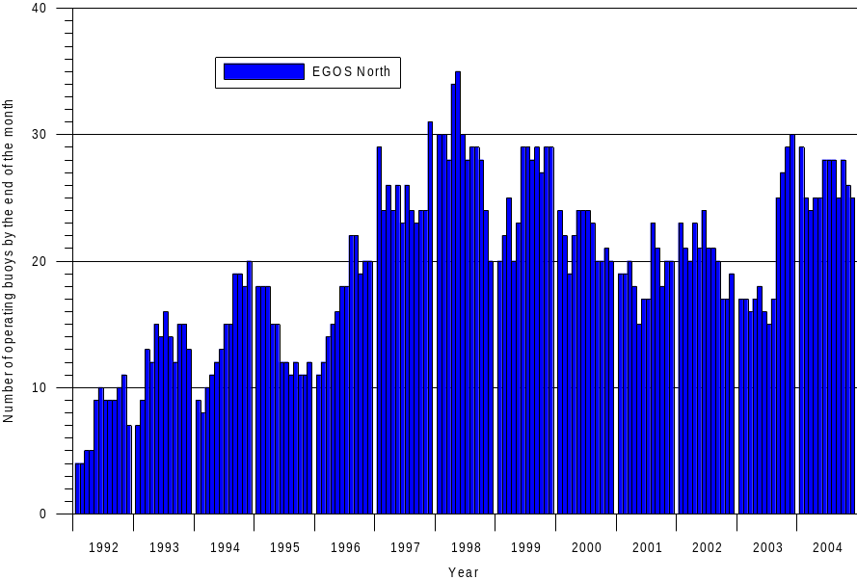

Figure 1 a) The number of drifting buoys operating in EGOS North 1992-2004. The North label refers to where the buoy was originally deployed, and not to where the buoy is at any given time.

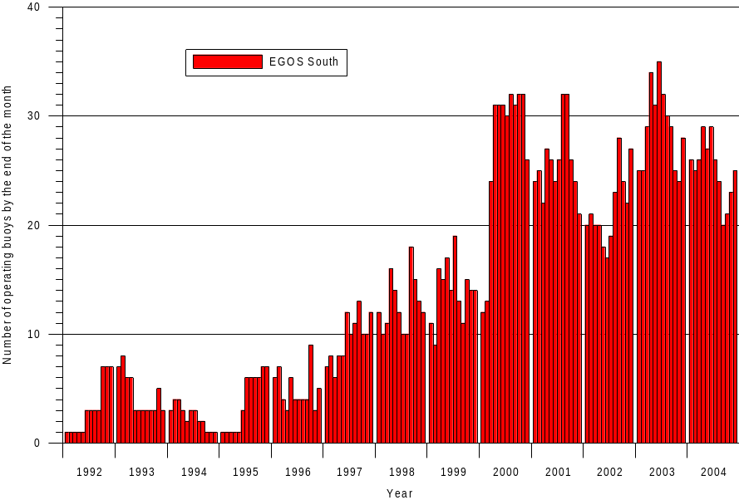
Figure 1 b) The number of drifting buoys operating in EGOS South during 1992-2004. The South label refers to where the buoy was originally deployed, and not to where the buoy is at any given time.

Deployments have been carried out on shipping routes from UK, France, Iceland and Norway to US or South America. No air deployments have been carried out during 2004.

Historical review
The fact that France began contributing buoys to the Programme in 1997 is reflected in the increased number of buoys. The large number of buoys deployed during the FASTEX experiment in January 1997 gave a total of 36 operational buoys by the end of January 1997. The number of operational drifting buoys reached a second maximum of 43 in December the same year. The high number of operational drifting buoys continued during 1998, with a maximum of 50 buoys in April 1998. This figure remained the largest number of operational drifting buoys ever in the EGOS history until May and June 2000, when the number of operational buoys reached 55. Due to deployment strategy there was an enhanced deployment of buoys in EGOS South to fill in the gaps in year 2000 and we see this as a dramatic increase in EGOS South. In 2000 the average number of drifting buoys operating in EGOS was 49, the highest number ever in the history of EGOS. The activity level has decreased in 2001, with an average of 45 drifting buoys. This decrease has continued into 2002 with 42 drifting buoys in average. Spring 2003 was the start of deployment of drifting buoys by EUCOS contributing to an increase of in average 49 operating drifting buoys. The numbers of operational drifting buoys stayed high during the first part of 2004, but decreased during the second part resulting in an average of 52 buoys. The minimum number of operational drifting buoys by the end of each month in the 2004 was 49 and maximum was 57.

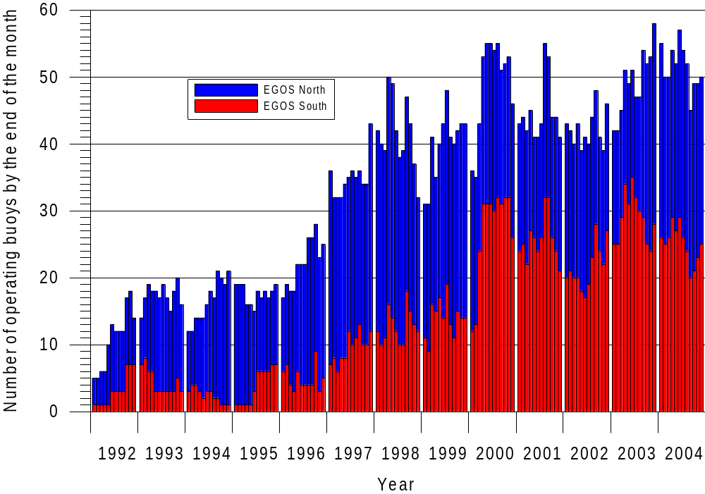

Figure 2 The number of operational EGOS drifting buoys by the end of each month 1992-2004. The South/North label refers to where the buoy was originally deployed, and not to where the buoy is at any given time.

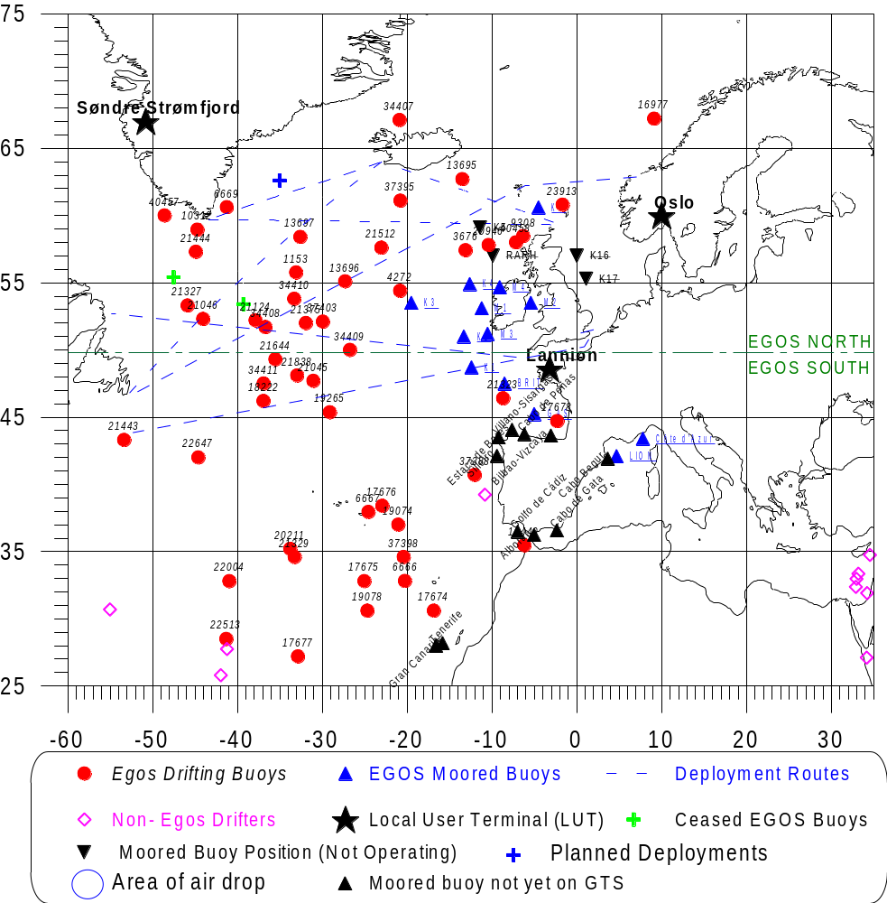

Figure 3 Distribution of EGOS buoys at 31 December 2003.

As of 31 December 2003, a total of 58 drifting buoys were operating in EGOS, 30 in EGOS North and 28 in EGOS South (figure 3). At this time typically 8-10 none-EGOS drifters are seen.

One year later, as of 31 December 2004, the number of operational buoys is lower, 50, 25 in EGOS North and 25 in EGOS South (figure 4). The number of none-EGOS drifters is also reduced to typically 2-4 drifters.

The number of none-EGOS drifters is typically around four, operating north of the southern boundary of the EGOS area of interest (30 ºN) in 2004.

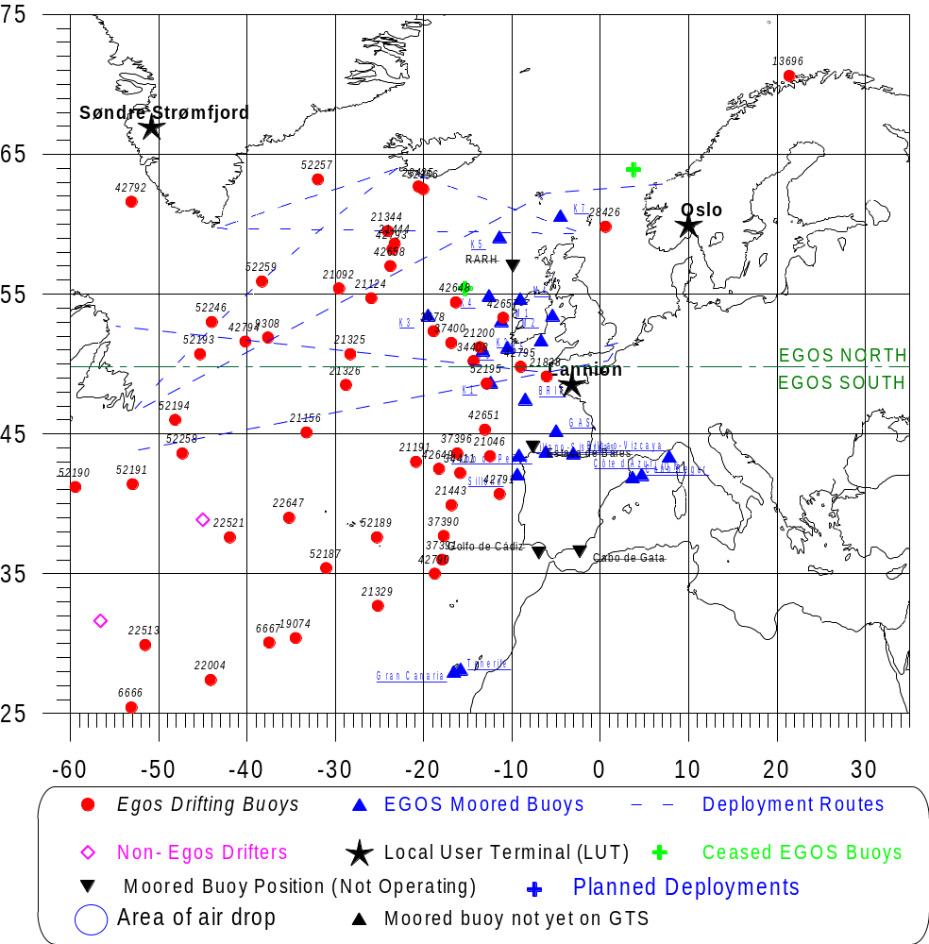
Figure 4 Distribution of EGOS buoys at 31 December 2004.

7.2 Deployment of new buoys
Drifting buoys are supplied by most EGOS members. Most members supply 1 to 2 buoys per year. Met Office, UK, and Météo-France were the largest contributors in 2004, with respectively 14 and 25 deployments. Pre-deployment testing and deployment of buoys in EGOS is organised through Met Office in UK, the Icelandic Meteorological Office in Reykjavik, CMR in Bergen, and Météo-France in Brest, depending of which buoy is being deployed.

A total number of 43 drifting buoys were deployed in EGOS in 2004 (table 1).

Table 1 The number of buoys deployments per year since 1996.

Year | No of buoys deployed
1996 | 22
1997 | 53
1998 | 50
1999 | 71
2000 | 57
2001 | 41
2002 | 52
2003 | 73
2004 | 43

Of the 43 these were either ConMar buoys (# 4), Metocean FGGE type buoys (# 0), Marisonde buoys (# 0), SVP-B type buoys (# 39) or CMOD drifters (# 0). 3 of the SVP-B buoys had wind sensors (SVP-BW), and 2 had salinity sensor (SVP-BS). All of the ConMar buoys had a GPS receiver. See table 2 for details.
1999 2000
Early failures
The number of SVP-B failures was 19 % in 1998, 29 % in 1999 and 24 % in 2000. In 2001 this improved dramatically. Of at total of 28 SVP-Bs deployed, only 1 suffered an early failure, or 4 %. The good results continued into 2002 as only 1 of 42 SVP-Bs failed, 2 %. In 2003 this changed as 11 of the 61 or 18 % of the SVP-Bs suffered early failure. In 2004 this improved as only 4 of 43 or 9 % suffered early failure.

Table 2 List of all EGOS drifting buoys deployed in 2004.

WMO | ARGOS | Owner | Buoy | Deployed from | Deployment date | Programme | Stopped | Ending cause | Operational lifetime [days]
65599 | 28426 | GE | C/B-GPS | Norway | 04.01.2004 | EGOS
44625 | 21344 | UK | SVP-B | Iceland | 10.02.2004 | EGOS
44547 | 42793 | FR | SVP-B | Iceland | 08.03.2004 | EGOS
44548 | 42795 | FR | SVP-B | Iceland | 09.03.2004 | EGOS |  | Failed | 4
62575 | 42655 | FR | SVP-BS | France | 26.03.2004 | EGOS | 3.26.2004 | Failed | 0
62576 | 42656 | FR | SVP-BS | France | 26.03.2004 | EGOS | 7.4.2004 | Recovered | 100
62694 | 21200 | UK | SVP-B | UK | 04.04.2004 | EGOS
44627 | 21191 | UK | SVP-B | UK | 06.04.2004 | EGOS
41601 | 21156 | UK | SVP-B | US | 12.04.2004 | EGOS
62556 | 42790 | FR | SVP-B | France | 13.04.2004 | EGOS
62557 | 42791 | FR | SVP-B | France | 13.04.2004 | EGOS
64608 | 21086 | UK | SVP-B | Iceland | 18.04.2004 | EGOS
62558 | 37390 | FR | SVP-B | France | 24.04.2004 | EGOS
62559 | 37391 | FR | SVP-B | France | 25.04.2004 | EGOS |  | Failed | 61
65600 | 3677 | NO | C/B-GPS | Norway | 16.05.2004 | EGOS
62565 | 42657 | FR | SVP-BW | France | 07.06.2004 | EGOS
62563 | 42648 | FR | SVP-B | France | 08.06.2004 | EGOS
62566 | 42658 | FR | SVP-BW | France | 09.06.2004 | EGOS
62562 | 37400 | FR | SVP-B | France | 22.06.2004 | EGOS
62561 | 37397 | FR | SVP-B | France | 24.06.2004 | EGOS | 11.14.2004 | Faded | 142
62564 | 42649 | FR | SVP-B | France | 26.06.2004 | EGOS
64524 | 42792 | FR | SVP-B | Iceland | 28.06.2004 | EGOS
62560 | 37396 | FR | SVP-B | France | 28.06.2004 | EGOS
44549 | 42794 | FR | SVP-B | Iceland | 29.06.2004 | EGOS
 | 21142 | UK | SVP-B | UK | 11.07.2004 | EGOS | 7.11.2004 | Failed | 1
44629 | 21147 | UK | SVP-B | UK | 12.07.2004 | EGOS | 10.29.2004 | Failed | 33
44721 | 52246 | UK | SVP-B | Iceland | 24.08.2004 | EGOS
44779 | 3678 | NO | C/B-GPS | Norway | 10.10.2004 | EGOS
44775 | 9308 | GE | C/B-GPS | Norway | 11.10.2004 | EGOS
64609 | 52257 | UK | SVP-B | Iceland | 16.10.2004 | EGOS
44723 | 52259 | UK | SVP-B | Iceland | 17.10.2004 | EGOS
44722 | 52258 | UK | SVP-B | Iceland | 19.10.2004 | EGOS
64610 | 52256 | UK | SVP-B | Iceland | 28.10.2004 | EGOS
62510 | 52189 | FR | SVP-B | France | 10.11.2004 | EGOS
13534 | 52187 | FR | SVP-B | France | 11.11.2004 | EGOS
44550 | 52193 | FR | SVP-B | France | 14.11.2004 | EGOS
44601 | 52194 | FR | SVP-B | France | 15.11.2004 | EGOS
62511 | 52195 | FR | SVP-BW | France | 24.11.2004 | EGOS
62512 | 42651 | FR | SVP-B | France | 25.11.2004 | EGOS
44608 | 52191 | FR | SVP-B | France | 07.12.2004 | EGOS
44607 | 52190 | FR | SVP-B | France | 08.12.2004 | EGOS
44725 | 21183 | UK | SVP-B | UK | 16.12.2004 | EGOS
44724 | 21179 | UK | SVP-B | UK | 17.12.2004 | EGOS | 12.19.2004 | Failed | 2

7.3 Operational lifetime statistics
51 EGOS-buoys ceased to operate in 2004 (table 4). This includes buoys that completely failed to transmit due to technical failure or battery exhaustion, buoys with air pressure sensor failure and buoys that ran ashore. 1 FGGE and 1 SVP-B style drifters were voluntarily recovered (early recovery) and 2 FGGE and 1 SVP-B style drifters were picked up by e.g. fishermen. 5 SVP-Bs suffered an early failure (table 3).

Table 3 Average operational lifetime for the two main types of buoys used in EGOS, the SVP-B and the FGGE style. Lifetime excluded early failures: lifetime is calculated on all buoy except those who failed within 30 days after the date the buoy was put on GTS. Lifetime excluded early recoveries: lifetime is calculated on all buoys except those who are recovered on purpose. Redeployed buoy, buoys that has been picked up or run ashore and is deployed again without service, is included in all statistics.

Model | 2003 |  | 2004 |  | Change
 | Number | Lifetime | Number | Lifetime
All buoys | 54 | 276 | 51 | 389 | 113
All buoys excluded early recoveries  (average lifetime) | 53 | 280 | 49 | 399 | 119
All buoys excluded early failures | 43 | 346 | 46 | 426 | 80
All buoys excluded early failures and recoveries | 42 | 353 | 44 | 438 | 85
FGGE | 5 | 246 | 9 | 315 | 69
FGGE excluded early recoveries | 4 | 283 | 8 | 330 | 47
SVP-B | 43 | 280 | 42 | 405 | 125
SVP-B excluded early failures | 32 | 353 | 37 | 458 | 105

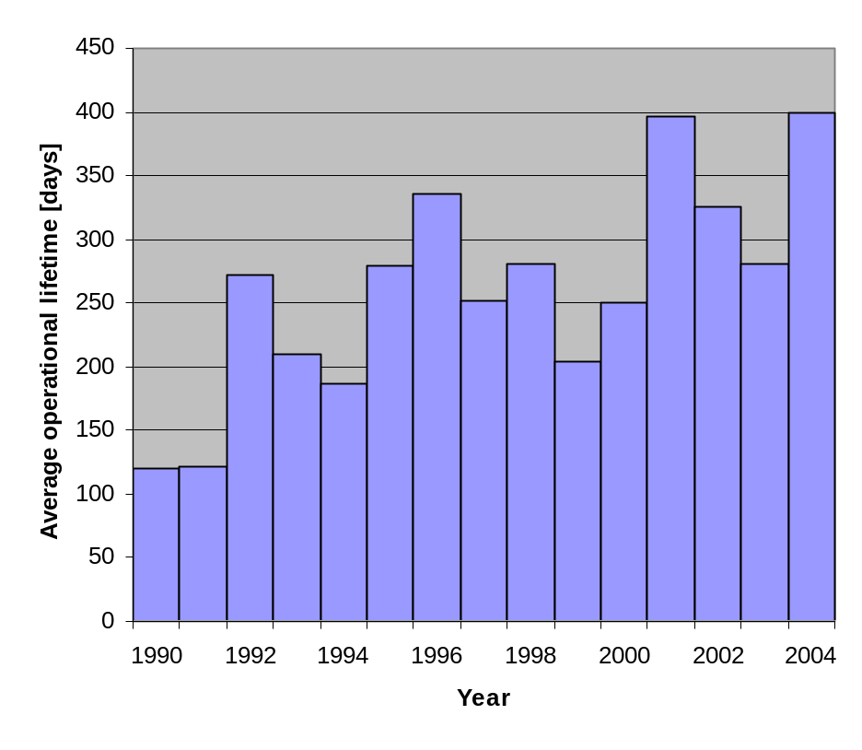The lifetime of all buoys that ceased to operate in 2004 is compared to the previous years in figure 5, which also shows the development of annual average lifetimes for EGOS drifting buoys since 1990. The average lifetime for the drifting buoys that ceased to operate in 2004 was 399 days, taking all except the early recoveries to be the most representative. This is the highest average lifetime of drifting buoys within the context of EGOS.
1998 1999 2000

Figure 5 Average operational lifetimes of EGOS drifting buoys 1990-2004.

Development of the operational lifetime
The decrease in the operational lifetime since 1996 is due to the increasing relative number of SVP-B drifters. For 1999 the 7 CMOD drifters contributes to the rather low figure. The CMOD drifters have a nominal lifetime of about 3 months. The average lifetime of the EGOS SVP-B drifters that ceased to operate has varied from 140-429 days since 1997. The power saving DBCP-MX format combined with a general technical improvement and increased deployments in EGOS South has led to a huge improvement in the lifetime for the SVP-Bs. For 2004 the average lifetime of the SVP-Bs is 405 days (table 3). This is an improvement by 125 days since the previous year. The main reason for this is that less buoys suffered early failure (see Chapter 7.2 and Figure 6).

The average lifetime for the FGGE style buoys that ceased to operate has varied from 283-464 days since 1997. For 2004 the average lifetime was 330 days (early recoveries are excluded). This is an improvement of 47 days compared to 2003. Because of the low number of FGGE style buoys these numbers are just an indication with significant uncertainty. As seen in table 4 55 % of the FGGE style buoys end their lifetime by running ashore, were picked up by ships both deliberately and not on purpose (fished for money). This is 40 % more than for the SVP-B style buoys. The difference is caused by the drogue (slows down the wind drift), deployment area (most of the FGGE drifts in the northern area with more wind drift and stronger currents) and possible also the visibility (the FGGE is larger and brighter in colour: easier to see and have a larger chance to get picked up by a fisherman).

For 2004 the average lifetime of all drifting buoys is 399 days (table 3). This is an improvement by 119 days since the previous year. The main reason for this is that less buoys suffered early failure (see Chapter 7.2 and Figure 6). Also the increase in the operational lifetime may also be due to a climatological effect. The tendency for the buoys to run aground has decreased compared to previous years (figure 6).

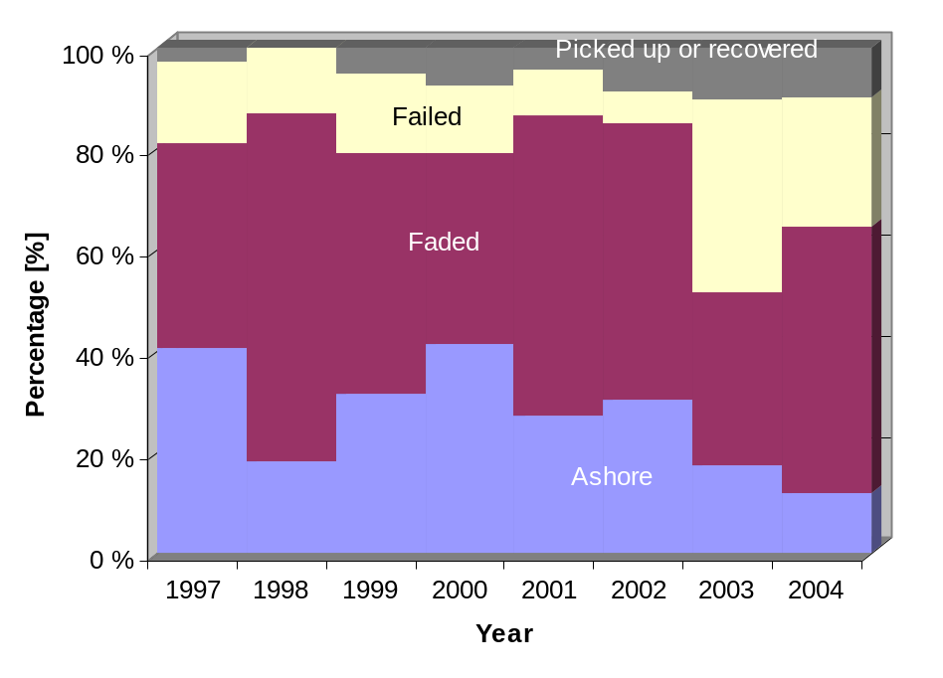
Figure 6 The cause of failure for all drifting buoys since 1997.

The trajectories of the EGOS drifting buoys for the 2004 are shown in figure 7a and 7b. Compared to the trajectories in 2003 this year there is a large area north of the Azores with very little buoy activity.

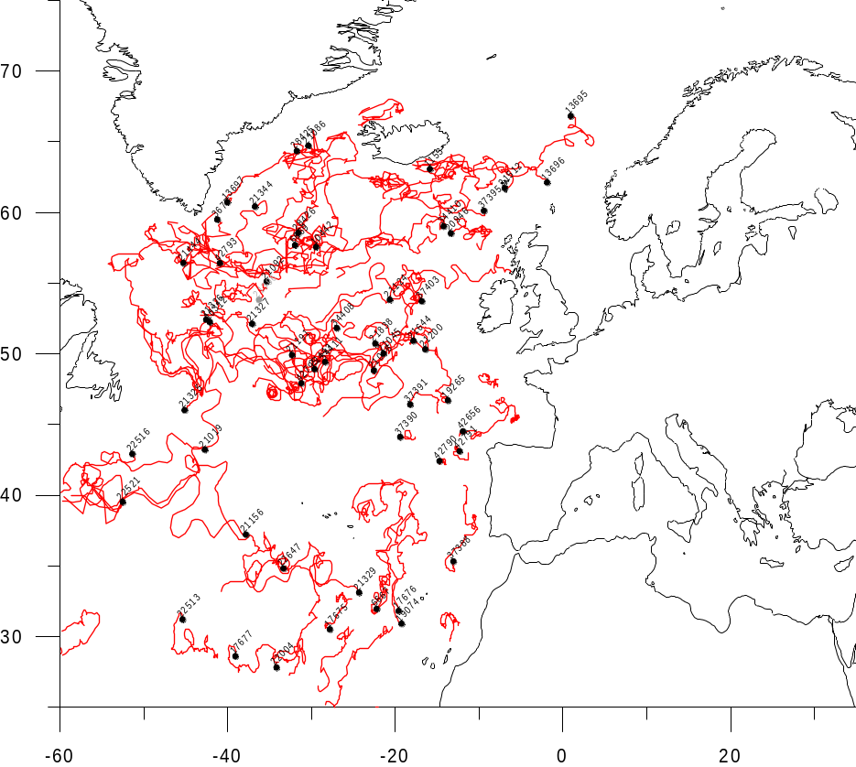
Figure 7a Trajectories of EGOS Drifting buoys 1 January to 24 June 2004.

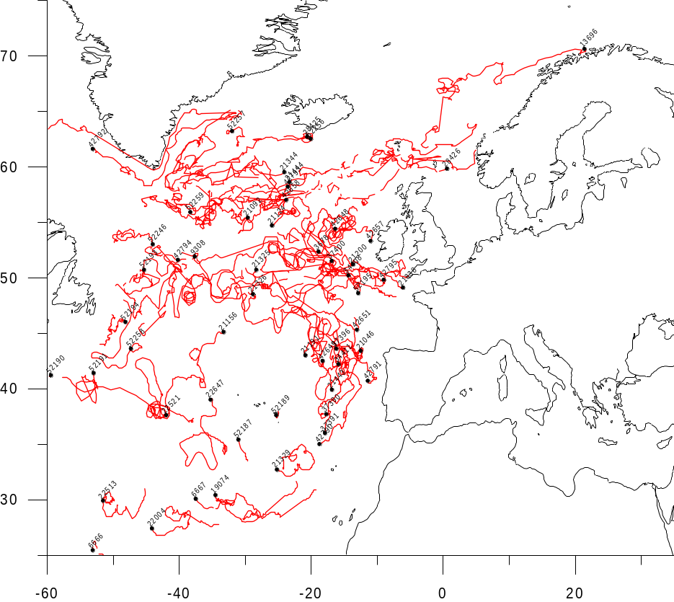

Figure 7b Trajectories of EGOS Drifting buoys 25 June to 31 December 2004.
Table 4 EGOS drifting buoys that ceased to operate in 2004.

WMO | ARGOS | Owner | Buoy | Deployment date | Stopped | Ending cause | Operational lifetime | Comment
62575 | 42655 | FR | SVP-BS | 26.03.2004 | 26.03.2004 | Failed | 0 | Failed a few hours after dep
 | 21142 | UK | SVP-B | 11.07.2004 | 11.07.2004 | Failed | 1
44724 | 21179 | UK | SVP-B | 17.12.2004 | 19.12.2004 | Failed | 2
62696 | 18222 | UK | SVP-B | 27.05.2003 | 04.02.2004 | Faded | 11 | Is redeployed
44604 | 34410 | FR | SVP-B | 05.03.2003 | 13.12.2004 | Ashore | 19 | Drogue Lost, AP failed
44629 | 21147 | UK | SVP-B | 12.07.2004 | 29.10.2004 | Failed | 33 | AP failed 15.08.2004
44772 | 10442 | GE | C/B-GPS | 28.12.2003 | 14.10.2004 | Failed | 99 | AP failed 6 Apr 2004
62576 | 42656 | FR | SVP-BS | 26.03.2004 | 04.07.2004 | Recovered | 100 | Salinity failed 13 May 2004, SST failed 24 May 2004
62598 | 3676 | NO | C/S-GPS | 23.09.2003 | 29.01.2004 | Ashore | 128
13532 | 37393 | FR | SVP-B | 27.12.2003 | 13.05.2004 | Faded | 136
62561 | 37397 | FR | SVP-B | 24.06.2004 | 14.11.2004 | Faded | 142
44770 | 4272 | GE | C/B-GPS | 24.09.2003 | 26.02.2004 | Pickup | 154
62554 | 37388 | FR | SVP-B | 16.04.2003 | 13.07.2004 | Failed | 190 | AP failed 24.10.2003
64523 | 34407 | FR | SVP-B | 17.08.2003 | 25.03.2004 | Failed | 193 | Drogue Lost 7.02.2004, AP failed 1.03.2004
62574 | 13014 | FR | MS-GT | 13.10.2003 | 27.04.2004 | Recovered | 197 | Recovered by BSAD Ailette by 47.9N and 7.9W
44762 | 21396 | UK | SVP-B | 29.09.2003 | 14.06.2004 | Failed | 206 | On GTS from 30 Sep to 7 Oct 2003, then no location from 7 Oct to 27 Nov, then no loc from June 14 2004
62802 | 19078 | UK | SVP-B | 08.03.2003 | 21.04.2004 | Faded | 247 | Ap failed 5.11.2003
65598 | 6669 | GE | C/B-GPS | 19.11.2003 | 06.10.2004 | Failed | 299 | AP failed
44621 | 40457 | NL | SVP-B | 28.04.2003 | 08.03.2004 | Faded | 315
13533 | 37394 | FR | SVP-B | 29.12.2003 | 11.11.2004 | Faded | 317
13531 | 37392 | FR | SVP-B | 28.12.2003 | 18.11.2004 | Faded | 325
44765 | 21019 | UK | SVP-B | 15.10.2003 | 09.09.2004 | Faded | 328 | Drogue lost
44771 | 19265 | GE | C/B-GPS | 24.09.2003 | 27.08.2004 | Failed | 337
44605 | 34409 | FR | SVP-B | 28.04.2003 | 10.05.2004 | Ashore | 377
44546 | 21644 | UK | SVP-BW | 22.09.2003 | 04.10.2004 | Faded | 378
65597 | 10312 | IR | C/B-GPS | 09.10.2003 | 25.10.2004 | Faded | 381
62552 | 37398 | FR | SVP-B | 17.04.2003 | 11.05.2004 | Faded | 390 | Drogue Lost 9 May
44774 | 10440 | GE | C/B-GPS | 12.12.2002 | 12.01.2004 | Ashore | 396 | Fix GPS pos since 31 Dec 2003
62804 | 21323 | UK | SVP-B | 08.03.2003 | 18.04.2004 | Faded | 405
44747 | 21045 | UK | SVP-B | 30.09.2003 | 19.11.2004 | Pickup | 416
44761 | 21327 | UK | SVP-B | 31.10.2003 | 24.12.2004 | Faded | 420
44626 | 22516 | UK | SVP-B | 10.06.2003 | 15.09.2004 | Faded | 463 | Unreliable SST data since 1.02.2004
62551 | 17676 | FR | SVP-B | 16.04.2003 | 24.08.2004 | Failed | 467 | Drogue Lost on 23.02.2004, AP failed 26.07.2004
62519 | 17678 | FR | SVP-B | 29.09.2002 | 14.01.2004 | Ashore | 471 | Drogue lost
44551 | 37403 | FR | SVP-BW | 06.06.2003 | 03.11.2004 | Faded | 512 | Prototype, wrong data WD/WS since 2 July 2004
62513 | 17674 | FR | SVP-B | 20.09.2002 | 20.02.2004 | Faded | 515 | SST data failed 10.09.2003
62515 | 17190 | FR | SVP-B | 14.09.2002 | 10.05.2004 | Ashore | 602 | Drogue lost, Drifted out of the EUCOS area 16 April (data still good)
44608 | 20211 | UK | SVP-B | 12.08.2002 | 19.04.2004 | Faded | 616
62711 | 21375 | UK | SVP-BW | 08.04.2002 | 13.01.2004 | Failed | 641 | Data wind failed 15 September
44767 | 16977 | UK | SVP-B | 11.04.2002 | 19.01.2004 | Failed | 648 | No positioning
44614 | 13697 | UK | SVP-B | 22.12.2002 | 24.10.2004 | Faded | 671 | Drogue lost
44613 | 13696 | UK | SVP-B | 20.12.2002 | 25.12.2004 | Faded | 687 | AP stopped 9.11.2004
44606 | 19893 | UK | SVP-B | 12.08.2002 | 30.06.2004 | Faded | 688 | Drogue lost
44603 | 37395 | FR | SVP-B | 03.02.2003 | 26.12.2004 | Faded | 691 | SST stopped 29.12.2003
44611 | 13695 | UK | SVP-B | 24.09.2002 | 06.09.2004 | Faded | 710 | Drogue lost
62517 | 17677 | FR | SVP-B | 11.09.2002 | 29.08.2004 | Faded | 717 | Drogue lost
62514 | 17675 | FR | SVP-B | 21.09.2002 | 18.09.2004 | Faded | 726 | Drogue Lost
62712 | 21512 | UK | SVP-B | 27.08.2002 | 31.08.2004 | Faded | 735 | Drogue lost
44609 | 20946 | UK | SVP-B | 12.08.2002 | 17.08.2004 | Faded | 736
44764 | 23913 | UK | SVP-B | 15.02.2002 | 02.03.2004 | Faded | 746 | Drogue lost
44780 | 1153 | IR | C/B-GPS | 16.03.2002 | 09.07.2004 | Pickup | 843 | Deployed before planned when washed over board in a storm. SST sensor damaged.

Drogue losses
Concerning the loss of drogue for SVP-B drifter the situation looks about the same compared to last year. This is an important issue, since the wind measurements of the SVP-B rely on an attached drogue. As of 31 December 2004, a total of 43 SVP-Bs were operating in EGOS. 6 (14 %) had lost the drogue. Compared to 2003 this is an improvement by 12 %. The chances of still having the drogue attached after one year is small. Figure 8 may be interpreted very simple, the probability of loosing the drogue increases with age.
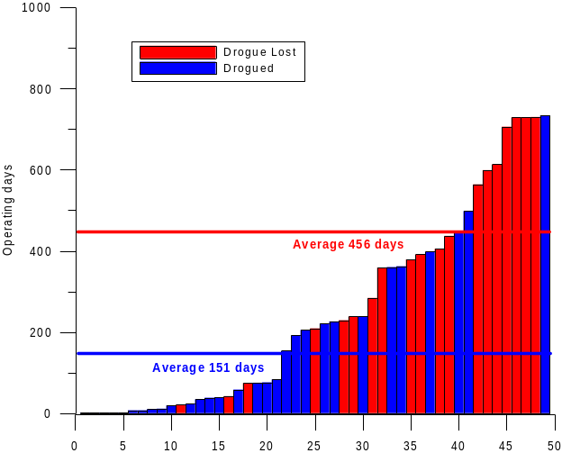
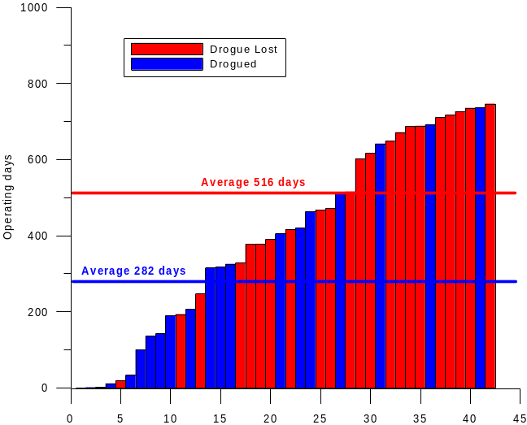
Figure 8 The lifetime of the SVP-Bs that had their drogue attached by the end of their lifetime, compared to those who lost it in 2004 (left) and 2003 (right).

8 EGOS Moored Buoys
Met Office presently operates seven moored buoys in the EGOS programme. The K1–K5, K7 and the RAHR buoy. The ‘Brittany’ and the ‘Gascogne’ buoy are operated jointly by Météo-France and Met Office. M1-M4 are operated by the Irish Marine Institute, as a part of a collaborative venture between Met Office, Met Éireann, Irish Marine Institute and The Irish Department of Communications, Marine and Natural Resources. Météo-France operates the LION and the Côte d’Azur buoys. Puertos del Estado, Spain, operates 12 moored buoys. Data from these buoys are not yet on GTS. The Irish mooring M4 was back in operation by 2 June 2004. A new Irish buoy, M5, was successfully deployed on the 16 October 2004. The GTS data transmission of the Spanish moored buoys started on 13 December 2004. The reports are in BUFR code. As of 31 December 2004 23 of 29 EGOS moored buoys are operational and all of these reports data on the GTS.

Table 5 Status of EGOS Moored buoys 31 December 2004.

Name | WMO No. | Position | Operating | Data reporting to GTS*
K 1 | 62029 | 48.7 N, 12.4 W | Yes | Yes
K 2 | 62081 | 51.0 N, 13.3 W | Yes | Yes
K 3 | 62108 | 53.5 N, 19.5 W | Yes | Yes
K 4 | 62105 | 54.9 N, 12.6 W | Yes | Yes
K 5 | 64045 | 59.0 N, 11.4 W | Yes | Yes
K 7 | 64046 | 60.7 N, 5.2 W | Yes | Yes
RARH | 62106 | 57.0 N, 9.9 W | No | Yes
Brittany | 62163 | 47.5 N, 8.5 W | Yes | Yes
GAS | 62001 | 45.2 N, 5.0 W | Yes | Yes
Côte d’Azur | 61001 | 43.4 N, 7.8 E | Yes | Yes
Lion | 61002 | 42.1 N, 4.7 E | Yes | Yes
M1 | 62090 | 53.1 N, 11.2 W | Yes | Yes
M2 | 62091 | 53.5 N, 5.4 W | Yes | Yes
M3 | 62092 | 51.2 N, 10.5 W | Yes | Yes
M4 | 62093 | 54.67 N, 9.07 W | Yes | Yes
Bilbao-Vizcaya | 62024 | 43.63 N, 3.04 W | No | Yes
Cabo de Peñas | 62025 | 43.73 N, 6.17 W | Yes | Yes
Estaca de Bares | 62082 | 44.06 N, 7.62 W | Yes | Yes
Villano-Sisargas | 62083 | 43.49 N, 9.21 W | Yes | Yes
Silleiro | 62084 | 42.12 N, 9.40 W | Yes | Yes
Golfo de Cádiz | 62085 | 36.48 N, 6.96 W | No | Yes
Alborán | 61199 | 36.24 N, 5.03 W | No | Yes
Cabo de Gata | 61198 | 36.57 N, 2.34 W | No | Yes
Valencia | 61281 | 39.47 N, 0.27 W | Yes | Yes
Tarragona | 61280 | 40.77 N, 1.47 E | Yes | Yes
Cabo Begur | 61196 | 41.91 N, 3.65 E | Yes | Yes
Mahón | 61197 | 39.73 N, 4.42 E | Yes | Yes
Gran Canaria | 13130 | 28.19 N, 15.81 W | No | Yes
Tenerife | 13131 | 28.00 N, 16.58 W | Yes | Yes
*when the buoy is operating

ANNEX 1 List of Acronyms
Acronym | Full name
ALIP | Argos Large International Programme
AOML | Atlantic Oceanographic and Meteorological Laboratory (US)
ARGO | Array for Real-time Geostrophic Oceanography
AP | Air Pressure
AT | Air Temperature
BGSF | Local User Terminal, Søndre Strømfjord
BOOS | Baltic Operational Oceanographic System
CGC | Co-ordinating Group of the COSNA
CLS | Collecte Localisation Satellite
CMM (1) | Centre de Meteorologie Marine in Brest
CMM (2) | Commission of Marine Meteorology (formerly)
CMOD | Compact Meteorological and Oceanographic Drifter
CMR | Christian Michelsen Research
COSNA | Composite Observation System for the North Atlantic
COST43 | Co-Ordination in Science and Technical Research, Action 43 (formerly)
DBCP | Data Buoy Co-operation Panel
ECMWF | European Center for Medium Range Weather Forecasting
EGOS | European Group on Ocean Stations.
ENMI | Local User Terminal, Oslo
EPSHOM | Etablissement Principal du Service Hydrographique et Oceanographique de la Marine (FR)
EUCOS | Eumetnet Composite Observing System
EUMETNET | European Meteorological Network
EUROGOOS | European Global Ocean Observing System
FASTEX | Fronts and Atlantic Storm Track Experiment
FGGE | First GARP Global Experiment
GARP | Global Atmospheric Research Programme
GBP | Great Britain Pound
GCOS | Global Climate Observing System
GDP | Global Drifter Programme
GODAE | Global Ocean Data Assimilation Experiment
GOOS | Global Ocean Observing System
GTS | Global Telecommunication System
IABP | International Arctic Buoy Programme
IBPIO | International Buoy Programme for the Indian Ocean
IGOSS | Integrated Global Ocean Services System
IMO | Icelandic Meteorological Office.
IOC | Intergovernmental Oceanographic Commission
ISABP | International South Atlantic Buoy Programme
JCOMM | Joint Technical Commission for Oceanography and Marine Meteorology (FR)
JTA | Joint Tariff Agreement (with Argos)
KNMI | Royal Netherlands Meteorological Institute
LFPW | ICAO location indicator for GTS Regional Telecommunication Hub of Toulouse (Météo France). (Data processed via the Argos French Global Processing Centre of Toulouse are inserted on GTS by Météo France using LFPW location indicator in GTS bulletin headers.)
LUT | Local User Terminal
MEDS | Marine Environmental Data Service (Canada)
METEOSAT | European geostationary meteorological satellite
NAVOCEANO | Naval Oceanographic Office (US)
NCEP | National Centre for Environmental Prediction
NDBC | National Data Buoy Center (US)
NOAA | National Oceanic and Atmospheric Administration (USA)
ODAS | Ocean Data Acquisition System
PGC | Principal GTS Co-Ordinator
PTT | Platform Terminal Transmitter
QC | Quality Control
SAI | Service Argos, INC
SST | Sea Surface Temperature
TAO | Tropical Atmosphere Ocean Array
TOGA | Tropical Ocean and the Global Atmosphere
WMO | World Meteorological Organisation
WWW | World Weather Watch or World Wide Web

ANNEX 2 list of buoy types used by egos

SVP-B style SVP-B Surface Velocity Programme – Barometer Drifter. Small Spherical drogue carrying buoy.
Barometer type (May vary): Low-precision barometer type AIR SB-2A or Vaisala PTB-100.
Does not provide air temperature. Nominal lifetime: 1 year
SVP-BW As above, but fitted with acoustic wind speed sensor and a fixed vane for wind direction
measurements
SVP-BS As above, but with Salinity (i.e. conductivity) sensor

FGGE style MO MetOcean Buoy- Also Called TOGA or FGGE type. Large, aluminium hull, high precision
barometer, type Paroscientific or medium precision type Solartron. Measures all parameters
including wind speed and direction where indicated in the ff and dd column. Nominal
lifetime: 2 years or more.
C/S ConMar buoy. Large, Glass Fibre Reinforced hull. High precision barometer, type
Paroscientific. Measures
all parameters, except wind. Nominal Lifetime: 2 years or more.
C/S-GPS As above, but with GPS positioning.
C/B ConMar buoy. As above but with medium precision Solartron barometer
C/B-GPS As above, but with GPS positioning. PTT repetition interval 200 or 90 seconds.
MS Marisonde buoy. Medium size, polyethylene hull, medium precision barometer type Vaisala
PT201A or Air DB-2A. Nominal lifetime 1 year.
MS-Gt As above for MS, but fitted with thermistor chain.
MS-Gi Marisonde Gi (Interaction measurements) measures Air Pressure, Sea Surface Temperature,
Wind Direction, wind speed, Air Temperature.
MS-G As above, but fitted with a vane for wind direction measurements

Others CMOD Compact Meteorological and Oceanographic Drifter. Small, cylindrical aluminium hull with
gas inflated flotation collar on top Diameter of flotation collar is 36 cm.. 43 cm telescopic
mast on top carrying AT sensor and air inlet. Total length 134 cm, low precision barometer.
Measures AT, SST and AP and TZ

Annex 3 Statement of Account 2004

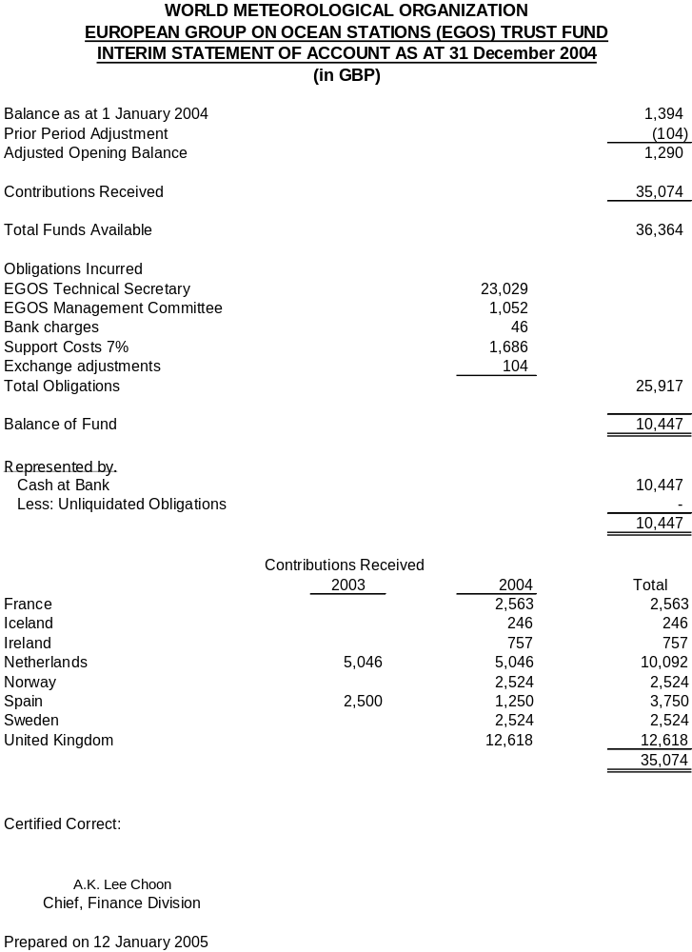

In this context, the word operational is used for a buoy transmitting useable air pressure data on GTS.
Early failure: failure within 30 days after the buoy started transmitting onto GTS

