Site: Abaco
Position: 26.5 º N 76 º W
Categories: observatory, physical

Short description:
- 3 mooring Sites: A: 26 30' N, 76 51' W
B: 26 30' N, 76 30' W
E: 26 30' N, 72 00' W
- measured variables: temperature, salinity, currents

Scientific rationale:
The moored time series observations at Abaco are intended to serve three primary purposes for climate variability studies:
1. Monitoring of the DWBC for watermass and transport signatures related to changes in the strengths and regions of high latitude water mass formation in the North Atlantic.
2. Providing the western boundary endpoint of a subtropical MOC/heat flux monitoring array designed to measure the thermohaline overturning circualtion at 26.5 N and the time varying meridional heat transport.
3. Monitoring the intensity of the Antilles current as an index (together with the Florida Current) of interannual variability in the strength of the subtropical gyre.

Groups / P.I.s /labs /countries involved / responsible:
RSMAS, Univ. of Miami, USA (W. Johns, L. Beal)
NOAA/AOML, USA (M. Baringer)
collaboration: U.K. RAPID (S. Cunningham, J. Marotzke, H, Bryden)

Status:
- operating
- Funded for 4 years, starting January 2004

Technology:
- full water column temp./salinity/currents, discrete moored sensors
- telemetry beginning from Abaco site "E" in January 2005.

Data policy: data public once processed

Data management: no comments

Societal value / Users / customers: no comments

Role in the integrated global observing system:
Atlantic basin MOC/MHT time series observations at 26.5 N

Contact Person: William Johns (RSMAS, Miami)

Links / Web-sites: -

Compiled/updated by: William Johns (RSMAS, Miami); March 2005

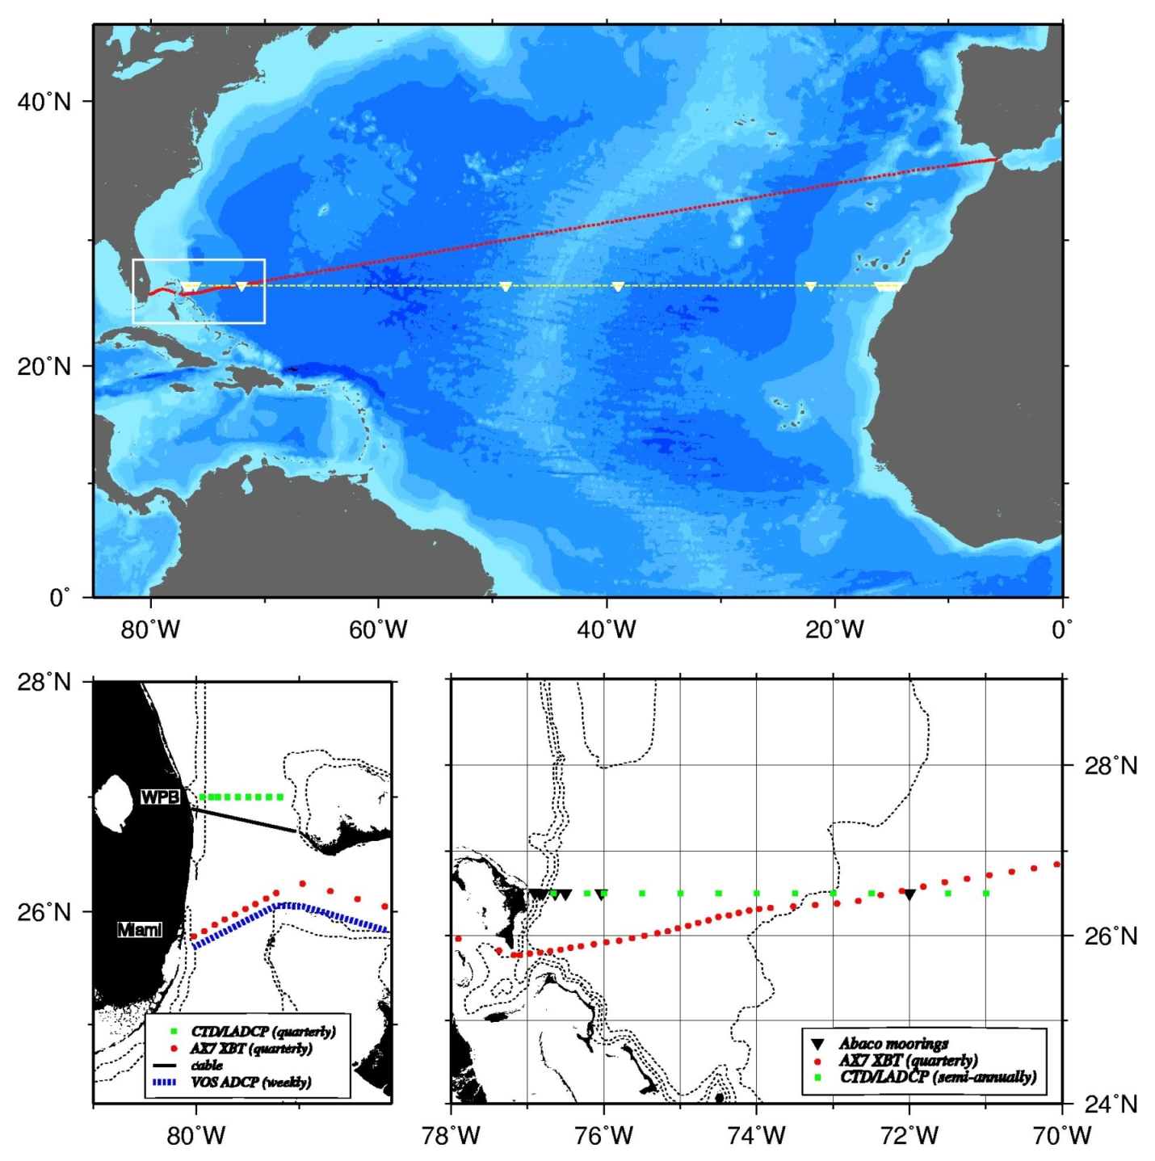

Figure 1
Summary of the proposed observation system for MOC/MHT monitoring in the subtropical North Atlantic. The components are:
(a) a trans-basin moored array with clusters at the eastern and western boundaries and Mid-Atlantic Ridge,
(b) transbasin and western boundary repeat hydrographic sections,
(c) Florida Current monitoring by submarine cable, weekly VOS ADCP sections, and quarterly CTD/LADCP sections, and
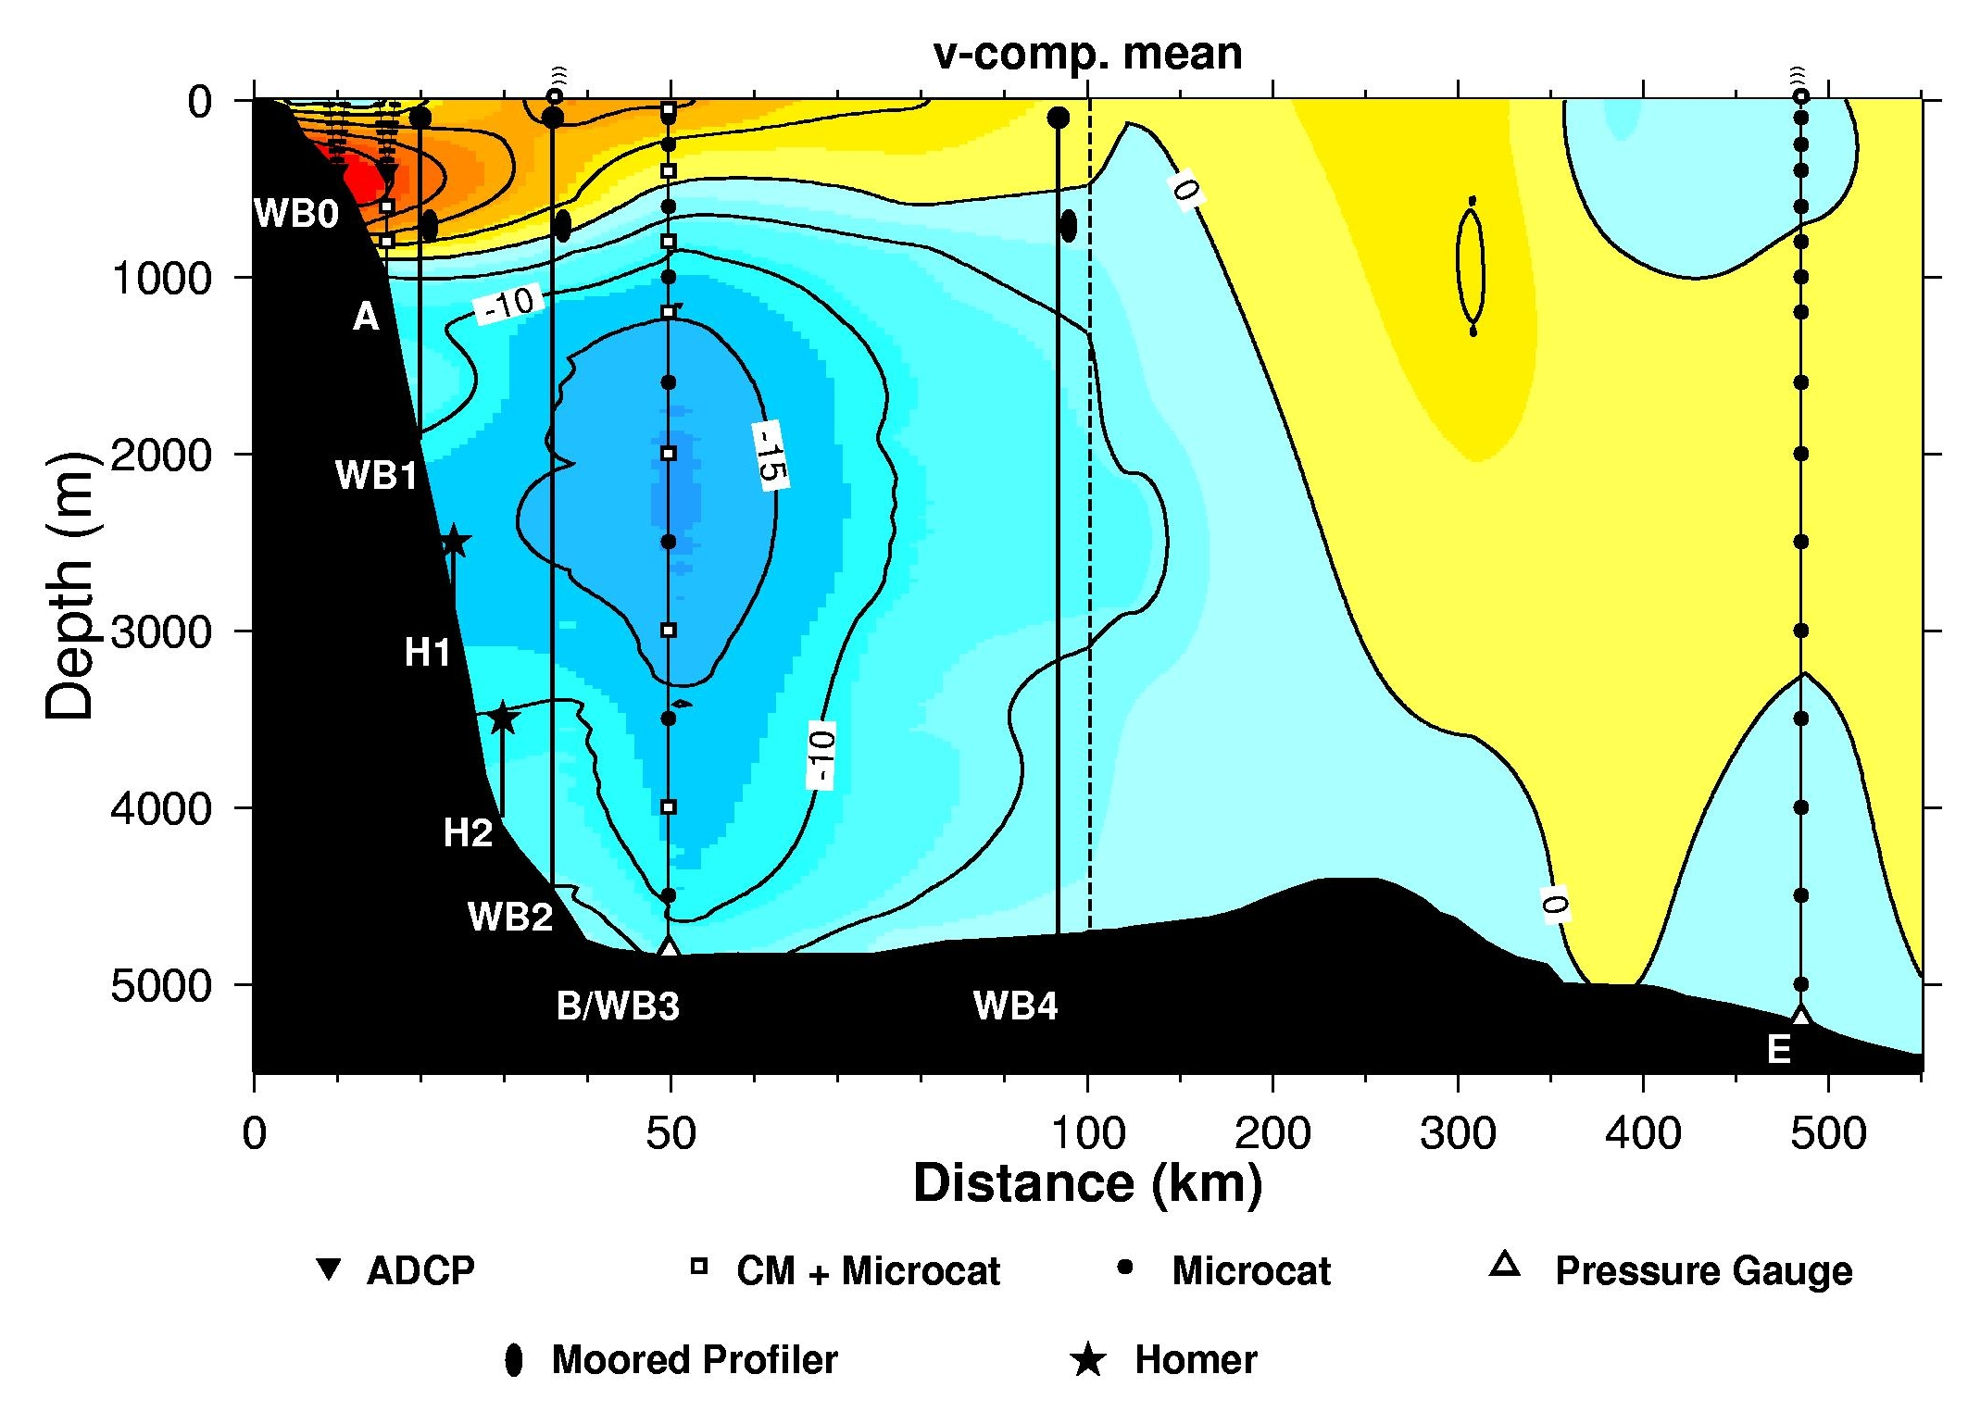
(d) quarterly high-resolution VOS XBT sections from Gibraltar to Miami.

Figure 2 The joint UK/US western boundary array off Abaco, Bahamas, superimposed on the long-term mean meridional flow structure derived from previous observations (Lee et al., 1996); note that the scale on the x-axis is blown up shoreward of 100 km.

