Site: BATS / Station S
Position: 32N 65W
Categories:
- operating
- Observatory, Air-Sea Flux reference site, Atmospheric Transport Studies
- Physical, meteorological, biogeochemical, geophysical, biological/ecological

Safety distance for ship operations:
BATS is a geographical position and therefore there are no restrictions on safe distances for operations. However, we ask that anyone doing research at the BATS site inform the BATS science team (Michael Lomas, mlomas@bbsr.edu; or Rod Johnson, rod@bbsr.edu) prior to conducting research.
Short description:
- 2 oceanographic stations located in the subtropical North Atlantic southeast of Bermuda
- Hydrostation “S” (located at 31º 50’N 64º 19’W) was started in 1954
- BATS program (located at 32º 10’N 64º 30’W) was started in October 1988 with a broader focus on the biogeochemistry and hydrograohy of the Sargasso Sea ecosystem
- Variables measured :
- continuous CTD-related measurements of pressure, temperature, conductivity, dissolved oxygen, and fluorescence
- dissolved oxygen, dissolved inorganic carbon (DIC), total alkalinity, salinity
- total organic carbon (TOC) and nitrogen (TON)
- inorganic nutrients (nitrate + nitrite, soluble reactive phosphate (SRP), and silicic acid)
- particulate organic carbon (POC), nitrogen (PON), and silica (PSi)
- phytoplankton pigments and primary productivity
- particulate organic carbon sediment flux
- bacterial abundance and productivity
- zooplankton abundance

Scientific rationale:
Long-term time series are a powerful tool for investigating ocean biogeochemistry and its effects on the carbon cycle. The seasonal and interannual dynamics of carbon and nutrient cycles in the upper ocean determine the productivity of ecosystems, the net exchange of carbon dioxide between the atmosphere and the ocean, and the distribution of many elements in the sea. Understanding the overall elemental cycle requires that we understand each of its component processes, and the interplay between physical forcing and biological response. Both oceanographic time-series provide improved understanding of the functioning of the Sargasso Sea ecosystem over a range of timescales, from daily to decadal. As a platform for time-series science, these programs actively seek and support external research programs to the best extent of our capabilities.

Groups / P.I.s /labs /countries involved / responsible:
Over the course of their history, BATS and Hydrostation “S” have been successful due to the active participation and interest of the numerous scientists and technicians who have been directly involved in their management and execution. Both of these time-series studies have also thrived due to the extensive ancillary collaborations that have built upon the time-series framework. These collaborations have been both multidisciplinary and multinational, and the reader is directed to http://www.bbsr.edu/cintoo/bats/bats.html to get complete details about these programs and related activities or http://bats.bbsr.edu to access our data.

Status:
Hydrostation S and BATS are operating and currently maintained with National Science Foundation support, including support for BBSR’s UNOLS registered research vessel Weatherbird II that samples the site at bi-weekly to monthly intervals. BATS has recently been funded through 2008 and Hydrostation S through 2006.

Technology:
- The Weatherbird II has a through the hull mounted ADCP, and a complete CTD package (General Oceanics SBE-32) for profile sampling to 4200m.
- High-quality DIC data is achieved using a highly precise SOMMA-coulometer system, dissolved oxygen by UV endpoint titrations, and total alkalinity by potentiometric titration Salinity samples are analyzed on a Guideline model 8400A Autosal Salinometer.
- Samples for total organic carbon (TOC) and nitrogen (TON) are analyzed via high-temperature combustion, samples for nitrate+nitrite, soluble reactive phosphate (SRP), and silicic acid are analyzed on an Alpkem Flow Solution IV, and compared to several commercially available certified standards, Ocean Scientific International and Wako Chemical.
- POC/PON samples are analyzed with a Control Equipment Corporation (CEC) 240-XA Elemental Analyzer, which is standardized on each run using acetanilide as a reference. PSi samples are analyzed by Dr. Dave Nelson at Oregon State University, but separate funding is being sought to transfer this methodological expertise to BBSR. Phytoplankton pigment samples are analyzed by both standard fluorometric and high performance liquid chromatography (HPLC) techniques. Pigments are analyzed with a Spectra-Physics model SP8800 liquid chromatograph calibrated with pigment standards obtained from VKI.
- Primary production is measured by the uptake of ¹⁴C in dawn to dusk in situ incubations. Sediment flux rates are determined from surface tethered MultiPIT arrays. Zooplankton swimmers are removed manually with fine forceps as the filters are examined at 250-500 x magnification. Total mass flux is determined gravimetrically and the carbon and nitrogen content of a subsample is determined with a CHN analyzer.
- Bacteria abundance is measured by direct counts of DAPI and bacterial production is estimated using a modified version of the {³H-Methyl}-thymidine (³H-TdR) technique.
- Zooplankton are collected with a 1m ² rectangular, 202µm mesh net.

Data policy:
All data collected under the auspices of the Hydrostation S and BATS time-series programs are publicly available following QA/QC procedures. This usually results in a 3-4 month lag from time of collection and data are placed on the web as they are processed. We encourage you to visit http://bats.bbsr.edu and use our data extraction tools to examine the data.

Data management:
At this time there are no plans to go to real time processing and distribution. The data management structure will however evolve over time based upon comments from the broader user community. Comments can be submitted through out data extraction pages.

Societal value / Users / customers:
A prominent aspect of these time-series programs is the rapid availability of the scientific data through a web-based interface. These web interfaces provide extensive knowledge about both the program and the underlying rationale for conducting the science, which increases both the exposure and value to the community at-large. Both the real-time and delayed-mode availability of this data to other non-academic users such as climate policy-makers and forecasters, fisheries managers, and other outreach and educational agencies will be fundamental to their continued success as well. The BATS data set is commonly used as a basis for many educational courses and learning activities.

Role in the integrated global observing system:
With nearly 5 decades of interdisciplinary research conducted at these two time-series sites (as well as numerous other ancillary programs), our level of understanding of the Sargasso Sea ecosystem is quite extensive. The BATS program in particular (in addition to HOT) have been the “crown jewels” in the collective U.S. JGOFS crown and consequently can serve to provide extensive amounts of expertise and experience to developing time-series programs. This expertise comes both in the form of operational oceanography as well as intellectual assimilation of data streams.

Contact Person: For further information about BATS, data or possible collaboration on research cruises contact either Mike Lomas (mlomas@bbsr.edu) or Rod Johnson (rod@bbsr.edu)

Links / Web-sites:
Please see more information about BATS at http://www.bbsr.edu/cintoo/bats/bats.html and the data extraction engine at http://bats.bbsr.edu

compiled/ updated by: Michael Lomas, January 2005
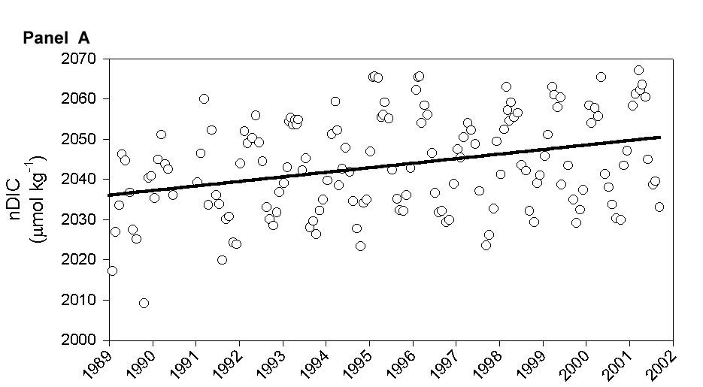
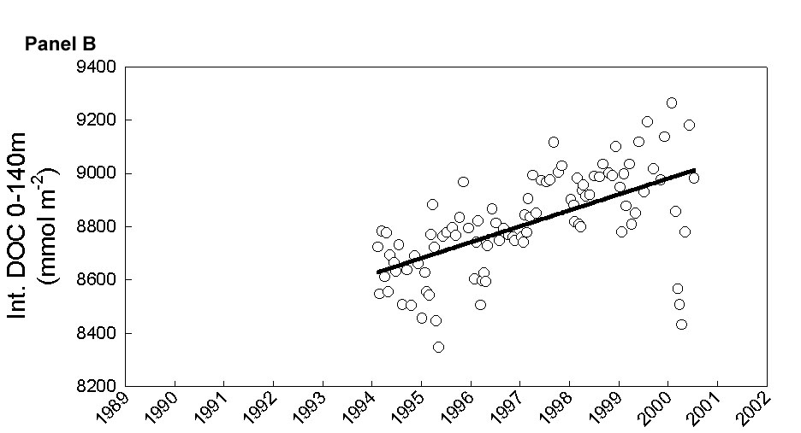
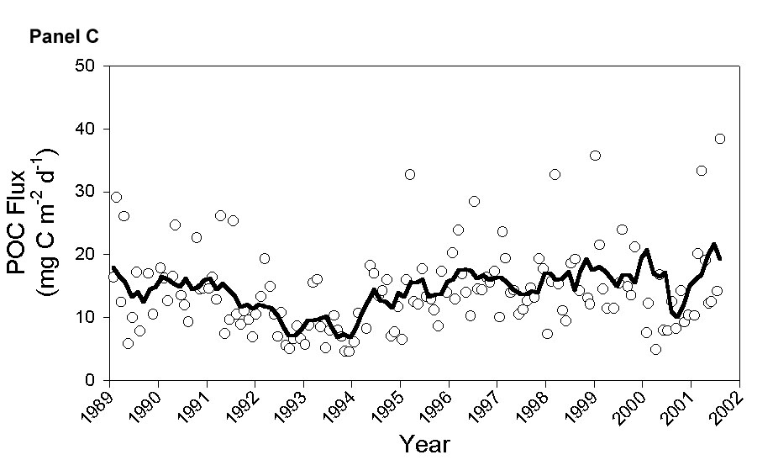

Figure:
The 13-year record of carbon system parameters in the Sargasso Sea has provided us with information on a variety of temporal scales. Salinity-normalized DIC (nDIC; Panel A) and DOC (Panel B) concentrations in the surface ocean show a clear seasonal pattern with annual minima in the summertime. This seasonal pattern is overlaid by a low frequency, multiyear increase that translates into a 1% increase in DIC and a 5% increase in DOC over the length of the BATS program. (Panel C) The particle flux from the surface ocean (measured at 300m) shows a different trend with a hint at a cyclic oscillation between periods of lower flux (e.g. 1992-1994) and higher flux (e.g. 1989 – 1991 and 1995 –1998).

