Site: Bermuda Testbed Mooring (BTM) program
Position: 31deg 43’N, 64deg 10’W (Nominal Position)
Categories: observatory; physical, meteorological, biogeochemical, ecological

Safety distance for ship operations: 5 nautical miles
Short description:
- 1 interdisciplinary autonomously sampling mooring located about 80 km southeast of Bermuda in about 4600m depth waters
- The variables measured are generally summarized in Figure 1 and on the OPL website and are generally made within the upper 200 m for most variables, though measurements of temperature and salinity are often made at greater depths. These include meteorological variables (solar insolation, spectral radiation, wind speed and direction, air and sea surface temperature, barometric pressure, relative humidity), horizontal currents (uplooking ADCP, 3m vertical bins), temperature, salinity, photosynthetic available radiation, spectral and hyperspectral inherent and apparent optical properties (IOPs and AOPs), and chlorophyll fluorescence. Investigators using the BTM have also done measurements of macro- and micronutrients (water samplers), dissolved oxygen, carbon dioxide, primary production (using 14C and a water sampler), atmospheric aerosols, and zooplankton using acoustic backscatter data. Most meteorological, physical, and optical measurements are made at intervals of about 5-15 min and discrete water sampling is done on roughly weekly intervals. Vertical resolution is dependent on measurement (e.g., temperature on order of 10 m or less).
- The BTM began in June 1994. BTM recoveries and redeployments have been done at intervals of approximately 3 - 6 months (presently, 6-month turnarounds are done).

Scientific rationale:
The BTM captures a broad dynamic range of oceanic variability (minutes to years), enabling new insights into high frequency and episodic phenomena while also providing long-term (climate-scale) and contextual, complementary information for other observations at the BTM/BATS/OFP sites, for evaluation of undersampling/aliasing effects, and for developing and testing models.
Some of the highlight results to date include:
- Data obtained during passages of cold-core eddies and other mesoscale features have been used to estimate their roles in affecting new production, biogeochemical cycling, and carbon flux to the deep ocean. One feature contained the highest Chl a observed during 15 years of BATS sampling. Another warm mesoscale feature recently analyzed in detail by Maureen Conte (WHOI) and our group, shows especially large and coincident particle flux in nearby sediment traps.
- The dynamics of the upper ocean have been observed during transient re-stratification events and during hurricanes and other intense storms. These unique observations have been documented in several BTM observational and modeling publications. A recent paper has compared the Hurricane Felix data set with simulations using four different mixed layer models designed to predict the thermodynamical and dynamical response of the upper ocean to hurricane forcing.
- BTM papers have provided new insights into bio-optical variability on short (minutes to day) time scales and associated with solar elevation and Raman scattering effects. Ongoing work focuses on the relation of in situ and remotely sensed ocean color parameters (e.g., water-leaving radiance).
- New sensors and systems have been tested by U.S. and international groups. These include new measurements of pCO2, dissolved oxygen, nitrate, trace elements, several spectral inherent and apparent optical properties, ¹⁴C for primary production, and currents.

Groups / P.I.s /labs /countries involved / responsible:
Lead PI is Tommy Dickey (UCSB). Dan Frye has been a co-PI since the inception of the BTM in 1994. The BTM and/or BTM data has/have been used by about 100 investigators. Several countries have participated (e.g., Southampton Oceanographic Centre of the UK has done Autosub work in the vicinity of the BTM site).

Status:
- operating since June 2004
- Funding support has come from the U.S. National Science Foundation, Office of Naval Research, National Aeronautics and Space Administation, and the National Ocean Partnership Program
- Funding cycle is 3-5 years per proposal and a renewal proposal directed to NSF is due in 2006.

Technology:
- The BTM uses autonomous sampling sensors and systems (see Figure 1)
- Meteorological and buoy position data are telemetered in near real-time.
- Autonomous profile measurements have been done on an experimental basis by WHOI investigators (John Toole and Dan Frye)
- New technologies for sensors and data telemetry are commonly tested from the BTM.

Data policy:
Meteorological and buoy position data are telemetered in near real-time. Other data that must be retrieved from in situ systems at present are made available following recovery of the mooring and processing of data – typically within a few months at maximum.

Data are freely available to the public.

Data management:
- Complementary satellite data and some imagery are included on the OPL website.
- Subsets of BTM data are routinely collected and distributed in near real-time (e.g., meteorological data and position of the buoy). Past experiments have included telemetry of several other in situ variables. It is anticipated that real-time telemetry will be used for additional interdisciplinanry variables in the future.
- BTM investigators are participating in a pilot OceanSITES data management program (contact is Songnian Jiang, songnian.jiang@opl.ucsb.edu)

Societal value / Users / customers:
The Bermuda Testbed Mooring is used for several purposes at present:
- Testing of oceanographic instrumentation
- Scientific studies
- Calibration and validation of satellite sensors
- Development and testing of interdisciplinary ocean models
Other users could include:
- Weather services (i.e., hurricane prediction and warning)
- Tsunami warning system in North Atlantic Ocean

Role in the integrated global observing system:
BTM serves or can serve several global ocean observing system goals:
- Pilot mooring for testing of new ocean instrumentation
- Studies of air-sea interaction, upper ocean dynamics, biogeochemistry, upper ocean ecology, extreme and episodic events including hurricanes and eddies, climate change
- Calibration and validation of ocean satellites
- Data for use in data assimilation models and for formulating and testing of a variety of interdisciplinary ocean models

Contact Person:
Tommy D. Dickey or Derek Manov
Ocean Physics Laboratory
University of California, Santa Barbara
6487 Calle Real, Suite A
Santa Barbara, CA 93117
Phone: 805 893-7354
FAX: 805 967-5704
Email: tommy.dickey@opl.ucsb.edu ( Derek.manov@opl.ucsb.edu )
Website: www.opl.ucsb.edu

Links / Web-sites:
http://www.opl.ucsb.edu
or contact Tommy Dickey at tommy.dickey@opl.ucsb.edu

provided/ updated by: Tommy Dickey, January 2005

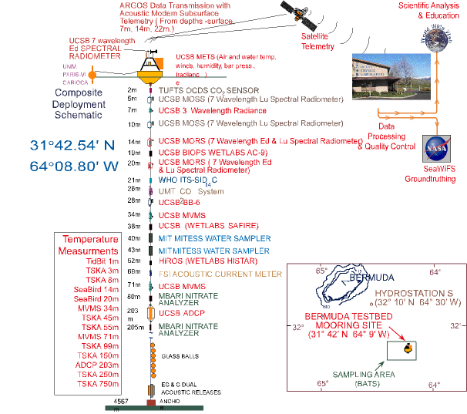

Figure 1
Mooring diagram for the Bermuda Testbed Mooring

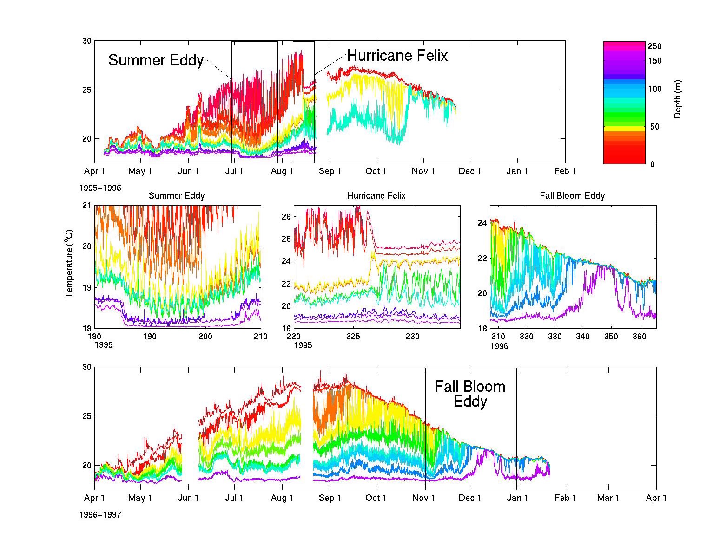

Figure 2
Time series of temperature obtained during BTM deployments. Some of the processes observed by the BTM include mesoscale eddies and upper ocean response to hurricanes.

