Site: Barents Sea Array
Position: 72-74N, 20E
Categories: Transport, physical

Short description:
- 5 moorings plus 2 bottom ADCPs
- Variables measured: Currents, T and S
- Start date of the timeseries, service interval: 1997, serviced every year

Scientific rationale: Monitoring the heat transport of the Atlantic Inflow to the Barents Sea.

Groups / P.I.s /labs /countries involved / responsible: H.Loeng (IMR, Norway)

Status:
- operating till 2006 under ASOF-EC(N) project (EU funded)
- planned to continue but funding not secured yet

Technology:
5 moorings plus 2 bottom ADCPs (current meters and T and S sensors)

Data policy:
recent collected data are under the EC data policy and also will be subjected to the recently released CLIVAR data policy: http://www.clivar.org/data/data_policy.htm

Data management:
ASOF is forming a data management task team and the details of the ASOF data management will be defined this year. The general idea is to follow the CLIVAR data management.

Societal value / Users / customers:

Role in the integrated global observing system: Monitoring MOC

Contact Person: H. Loeng (harald.loeng@imr.no)

Links / Web-sites for Project information:
http://www.awi-bremerhaven.de/Research/IntCoop/Oce/ASOF/index.htm

compiled by: Roberta Boscolo, March 2005

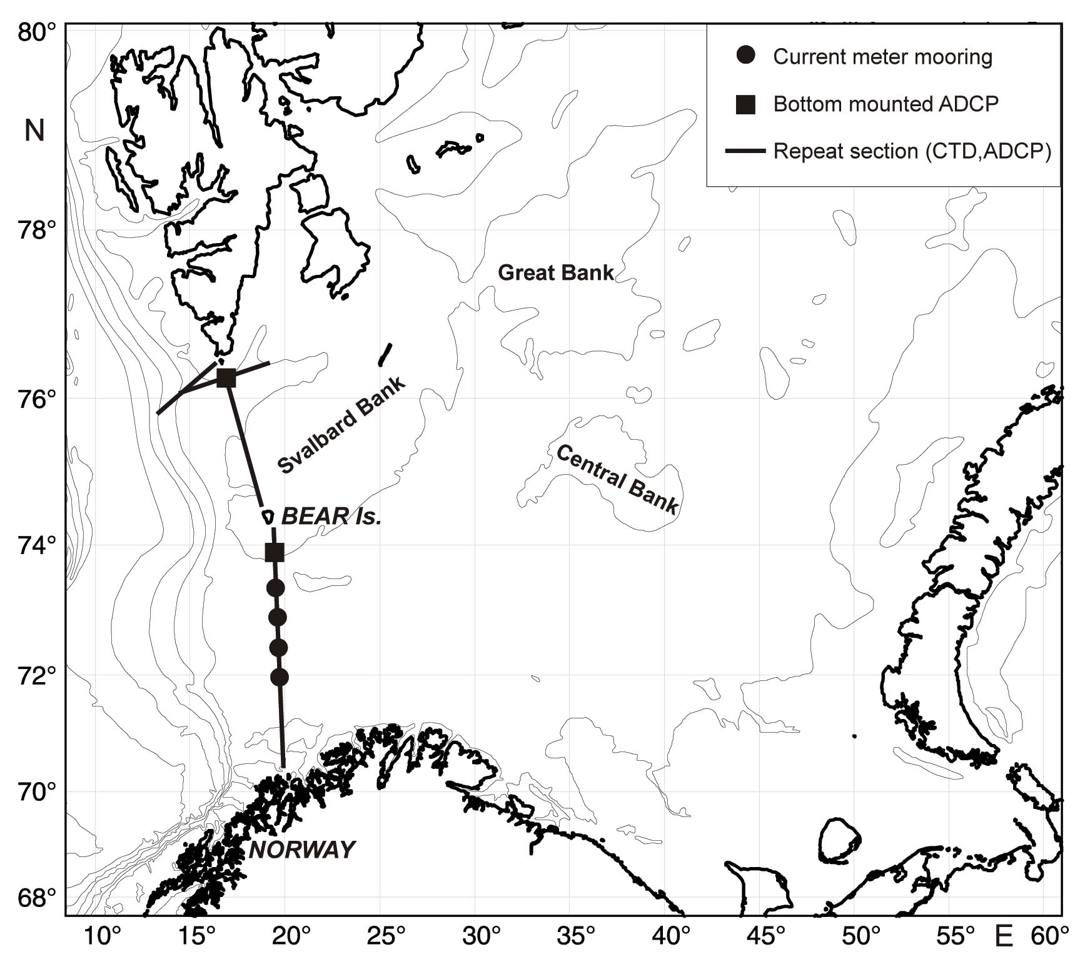

Figure 1 The Barents Sea array.

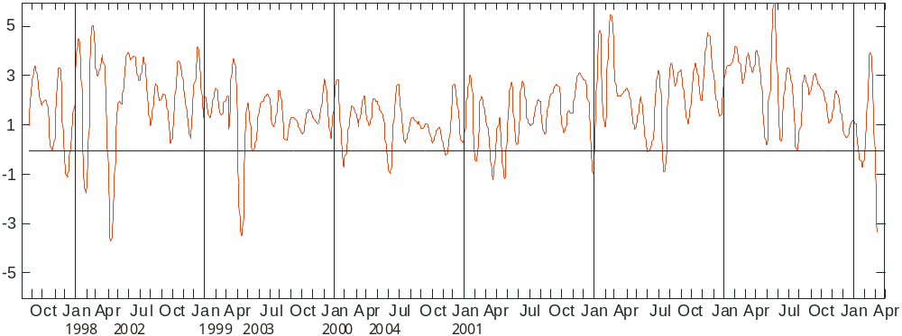

Figure 2 Volume transport of Atlantic Water 1997-2004

