Site: CIS, Central Irminger Sea
Position: 59°40’N, 039°40’W, 2780 m
Categories: Geostrophic mooring; measurement of physical and biogeochemical parameters

Safety distance for ship operations: 10 nm (17’’ telemetry buoy at the surface)
Short description:
- Number of stations / moorings: 1 mooring
- Variables measured:
Variable | Depth / m | Sampling rate / s | Near real time data transmission | Remarks
Temperature, Conductivity | 10, 40, 90, 140, 200, 300, 400, 550, 850, 1000 |  | Yes | MicroCat; partly with pressure sensor
Fluorescence | 40 |  | Yes | WetLab
CO₂ | 40 |  | Yes | SAMI
Nutrients | 40 |  | Yes | NASE
Temperature,  Conductivity | 1245, 1495 |  | No | MicroCat; partly with pressure sensor
Current, temperature | 1000, 2325 | 7200 | No | RCM8
Current profiles (upward) | 150 – surface |  | No | RDI  WH ADCP 300 kHz
Currentprofiles (downward) | 150 - 800 |  | No | RDI  Long ranger ADCP, 75 kHz
- Start date of the timeseries: August 2002
- service interval: annual

Scientific rationale:
Physical: The site is located in the center of the Irminger Sea gyre in a region of minimum stratification, i.e. within the gyre, convection will reach its maximum depth (about 800 m). Presently, little is known about the interannual variability of deep mixing and water mass formation. The site is expected to be representative of the eastern part of the subpolar gyre. Since this is in the area of NAO (North Atlantic Oscillation) activity, impacts on the physical processes are expected and can be studied. Also, the station forms a dynamic height pair with site PAP in the Porcupine Abyssal Plain for monitoring the northeastward branch of the North Atlantic Current entering the polar seas.
CO2: The subpolar gyre is one of the global maxima of CO2 uptake of the ocean, and timeseries observations in this region are important for quantifying the sequestration and its variability. This is possible by combined measurements of physical variables and CO2 partial pressure.
Biological: The subpolar gyre is probably one of the ocean regions with a rather simple food chain, and the zooplankton community is dominated by a single species (Calanus Finmarchicus). There are interesting research questions about this important species and its relevance for the fisheries in the region (redfish), as well as physical/climatic forcing of these. Being in the middle of a gyre, away from boundaries, the hope is that the system is reasonably 1-D and mooring timeseries can be more easily interpreted.

Groups / P.I.s /labs /countries responsible / involved:
- IFM-GEOMAR, Kiel, Germany (Johannes Karstensen (jkarstensen@ifm-geomar.de), D.Wallace, T.J. Mueller)
- MRI, Reykjavik, Iceland (H.Valdimarsson, A.Gislason, J.Olafson)
- SIO, La Jolla, CA, USA (U. Send);
- ICCM, Telde de Gran Canaria, Spain (O.Ilinas, Maria Villagarcia)
- NOC, Southampton, U.K. (R.Lampitt)

Status:
- Operational since 2002
- Funded for 2002-2007 through EU projects ANIMATE and MERSEA, with physical (CTD,ADCP) sensors, pCO2, fluorescence, nutrients;

Technology:
- moored sensors
- near real time satellite telemetry for physical parameters, pCO₂, fluorescence and nutrients as prototype being tested
- CTD/rosette casts during mooring services
- Glider planned for tests in 2006 / 2007

Data policy:
- real-time data: public
- delayed mode data: public 6 months after acqusition; use for publications in agreement with PI only.

Data management:
- Satellite data collection system (present, future): prototype testing phase
- Real-time data distribution system: GTS via CORIOLIS (France)
- Delayed mode data distribution system: NOC format; in part OceanSITES format
- Metadata scheme: NOC format; in part OceanSITES format

Societal value / Users / customers:
Improved understanding and forecasts of water mass formation in the thermohaline circulation system. Quantification of North Atlantic contribution to CO2 sequestration. Improved understanding of ecosystem response to climatic forcing, ultimately with appliation to fisheries.

Role in the integrated global observing system:
CIS will form a node in the dynamic height pairing network for the North Atlantic; it is an essential element of a North Atlantic CO2 monitoring system.

Contact Person:
- for enquiry about addition of instrumentation or sensors to the site or for possible ancillary measurements during cruises to the site: Johannes Karstensen, IFM-GEOMAR, Kiel, Germany, jkarstensen@ifm-geomar.de.
- for information about the site or data : jkarstensen@ifm-geomar.de.

Links / Web-sites:
- for Project information : http://www.noc.soton.ac.uk/animate/data/cis/cisdescription.php
or http://www.mersea.eu.org/Insitu-Obs/3-Insitu-Timeseries-Atl-Status-CIS.html
- for data access: http://www.noc.soton.ac.uk/animate/data/cis/cisdata.php
or ftp://ftp.noc.soton.ac.uk/pub/animate/animate_data/

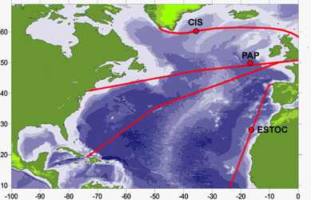 | Figure 1 (left): Positions of Atlantic moorings maintained under MERSEA. The red lines indicate commercial shipping routes where Volunteer Observing Ships (VOS) take measurements of Carbon Dioxide and nutrients in surface waters.  Figure 2 (bottom): timeserie of salinity (left) and potential temperature (right)
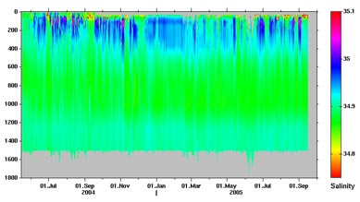 | 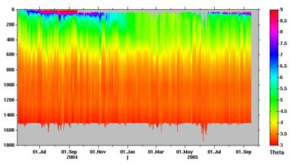

Compiled by: J. Karstensen, T. J. Müller (Feb. 2006)

