Site: CB-Site, Cape Blanc
Position: 21º17’N 020°48’W
Categories: operating; Observatory; physical, dust input, bio-geochemical, bio-mass, trace-elements

Short description:
- 2 sediment trap moorings, maintenance 1 time a year,
CB (Cape Blanc) mooring ; 21°17N 020°48W
CBi (Cape Blanc interior); 20°45N 018°42W
- Reactivated times-series station, long-term funded via the national DFG research center “Ocean Margins”, RCOM

Scientific rationale:
The CB site is dealing with studies comparing the seasonality of particle sedimentation in the most productive area off northwest Africa (Cape Blanc region) to other nearby JGOFS North Atlantic study sites. Additionally, a focus is set on interannual variations of organic carbon, alkenone export fluxes and surface chlorophyll derived from SeaWIFS satellite imagery.

Groups / P.I.s /labs /countries involved / responsible:
G. Fischer and G. Meinecke (GeoB, MARUM, Bremen)

Status:
Operational, long-term funded via German Research Foundation, DFG (RCOM)

Technology:
Sediment trap mooring without telemetry

Data policy:
- delayed mode data: public via PANGEA and WDC MARE

Data management:
Policy of WDC MARE and PANGEA Data base
http://www.pangea.de
http://www.wdc-mare.org

Societal value / Users / customers:
- / -

Role in the integrated global observing system:
- / -

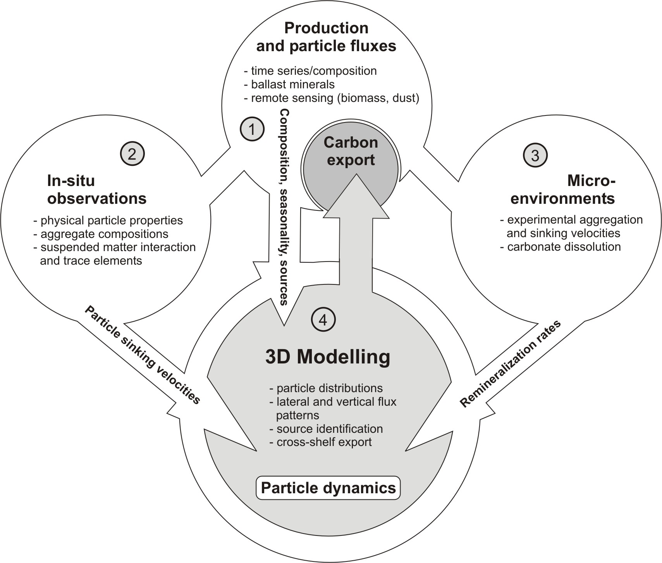
Contact Person:
- Dr. Gerhard Fischer, Dept. of Geosciences, Univ. Bremen,
++49 421 218 3588, gerhard.fischer@allgeo.uni-bremen.de
- Dr. Gerrit Meinecke, MARUM, Univ. Bremen, Germany,
++49 421 218 65600, gmeinecke@marum.de

Links / Web-sites:
http://www.rcom-bremen.de

compiled by: Gerrit Meinecke, March 2005

Figure:
Combined working program around the Cape Blanc mooring site activities.

