Site: Tropical Eastern North Atlantic Time-Series Observatory (TENATSO)
Position: 17.4 N, 24.5 W (Cape Verde)
Categories:
- Planned Observatory: physical, biological, meteorological, biogeochemical, atmospheric chemistry, possibly geophysical
- Atmospheric Site to be located on Sao Vicente Island (approx. 16.8N 24.9W)

Safety distance for ship operations: Unknown
Short description:
- 1 ocean station, 1 atmospheric station on land
- Variables measured :
- CTD stations quasi-monthly with small research vessel based in Mindelo:
T,S, oxygen, nutrients, inorganic and organic carbon parameters (DIC, Alkalinity, TOC), Chlorophyll, Plankton sampling, Maybe zooplankton sampling
- Mooring: measurements of T, S, O2, pCO2, current meters (ANIMATE-type frequency), maybe sediment traps
- Start date of the timeseries, service interval:
- Attempt to start May/June 2006
- Service interval for moorings initially 6 months; subsequently yearly

Scientific rationale:
Long-term observation is fundamental to understanding of global changes in air quality, atmospheric oxidation capacity, and climate. Such changes impact marine ecosystems and the atmosphere is, in turn, influenced by ocean physical and biogeochemical processes. Many impacts and feedbacks are focussed in the Tropics. TENATSO will initialize ground- and ocean-based observations in the tropical Eastern North Atlantic Ocean region, specifically at Sao Vicente, Cape Verde (16oN, 24oW). The tropical Eastern North Atlantic is ‘data poor’ but plays a key role in atmosphere-ocean interactions of climate-related and biogeochemical parameters including greenhouse gases. Being ‘downwind’ of an area of high primary productivity (the Mauritanian upwelling), the Observatory will provide unique information on links between upwelling and atmospheric composition changes. The location is also ideal for climate studies and for investigating impacts of dust on the marine ecosystem. Operation of the site involves transfer of technology to Cape Verde: a small West African developing country with an enormous economic zone and strong ties to Europe and North America. TENATSO will establish linked atmospheric and ocean stations. The atmospheric station will measure meteorological parameters, greenhouse gases, short-lived gaseous species, and aerosols. The data will be integrated into the Global Atmospheric Watch (GAW) program of the World Meteorological Organization. The ocean site will include a mooring equipped for temperature, salinity, ocean current and oxygen measurements and will also be incorporated into international observing programs. The site will be visited regularly with Cape Verde’s research vessel, to collect samples for physical and biogeochemical parameters. The Observatory will be a resource for national and international programs and is considered part of a broader initiative to establish a Science Logistics Centre in Cape Verde. An outreach program will promote the Observatory at major conferences and with international research organizations.

Groups / P.I.s /labs /countries involved / responsible:
IFM-GEOMAR, Kiel, Germany (Douglas Wallace, Martin Visbeck, Arne Körtzinger)
INDP, Cape Verde (Oscar Melicio)
INMG, Cape Verde (Jose Pimenta Lima)
University of York, UK (Lucy Carpenter)
Max-Planck Institut für Biogeochemie, Jena, Germany (Martin Heimann)
Institut für Troposphärenforschung, Leipzig, Germany (Hartmut Hermann)
plus others!

Status:
- Very active planning underway; some initial funds available
- Seek to initiate during 2006
- Funding for basic atmospheric observations more or less available (UK SOLAS; and institutional funds of the Max-Planck Institut in Jena)
Funding for Ocean Site establishment being sought from German SOLAS and the Volkswagen Foundation. Some support from UK SOLAS also possible.
Technology:
- Moored and ship-based sensors
- initially probably no real-time telemetry
- Profile measurements with CTD profiler, likely Seabird (needs to be purchased). Maybe with trace metal free sampling equipment.

Data policy:
Data available in delayed mode. Details not yet clear.

Data management:
Data collection system, metadata scheme (including collection, distribution mean, format), etc. has to be worked out.

Societal value / Users / customers:
Key thing is that this site is in a developing country. Our aim is to train and employ local scientists to operate the site logistics. The Observatory is also aimed at attracting international scientists to visit Cape Verde to conduct their research.
Role in the integrated global observing system:
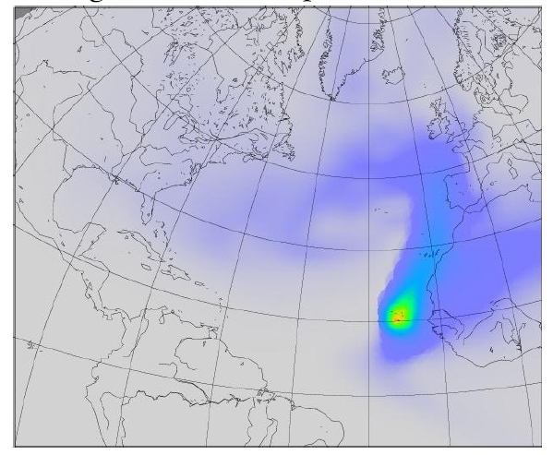
This site plays a key role because of its location for climate and for carbon as well as biological observing systems.
Contact Person:
- Initial Contact for Ocean Site:
Douglas Wallace, IFM-GEOMAR Kiel
- for Atmospheric Site:
Martin Heimann (Jena) for trace gases
Lucy Carpenter (York) for short-lived species

Links / Web-sites for Project information :
http://www.bgc-jena.mpg.de/bgc-systems/projects/cape_verde/index.shtml

provided by: Douglas Wallace, February 2005
Figure 1
Results of a 'footprint analysis' for the proposed monitoring site in Cape Verde. The site can potentially sample air masses that originate over the mid-Atlantic, over the Mauritanian Upwelling, Europe and North Africa and central Africa.
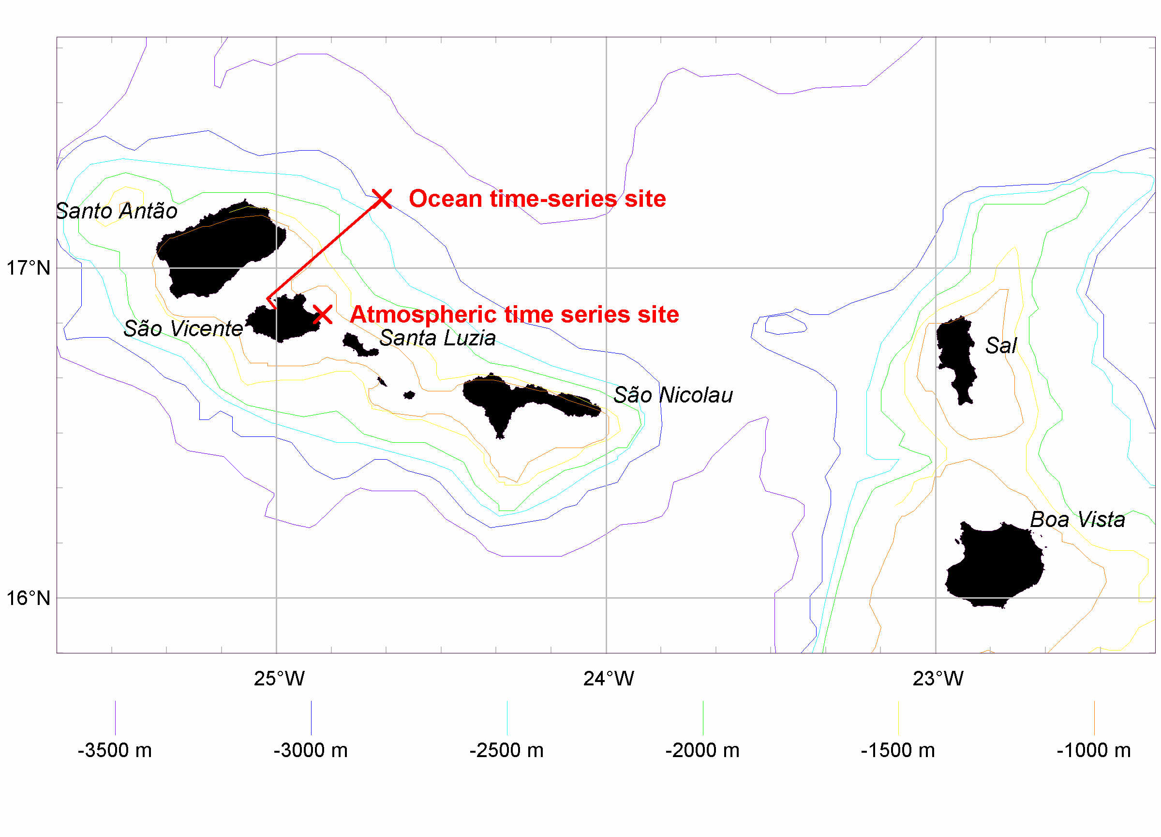
Figure 2
Proposed location of the ocean time-series site approx. 50 nm northeast of Mindelo, São Vicente.

