Site: Cretan Sea, E1-M3A (Mediterranean Moored Multi-sensor Array, Buoy #1 of Eastern Basin)
Position: 35º 39.676' N 24º 59.132' E
Categories: Mulit-parametric (meteorological, physical, biochemical) moored observatory (0-500m)

Safety distance for ship operations: 1000m
Short description:
- Number of moorings: The E1-M3A system is composed by a central mooring (line 1) and two peripherals (line 2 & 3). For more detailed information see technology.
- Variables measured:
- Measurements in the water column:
 | 40m | 65m | 90m | 115m | 150m | 250m | 350m | 500m
Temperature | X | X | X | X | X | X | X | X
Salinity | X | X | X | X | X | X | X | X
Light Attenuation | X | X | X | X
Dissolved Oxygen | X | X | X | X
Chlorophyll-a | X | X | X | X
PAR | X | X | X | X
Nutrients (Nitrate) |  | X
Current speed / direction | 0-500 m profile
- Measurements at air-sea interface: air temperature, relative humidity, atmospheric pressure, wind speed and direction wave parameters
- Sampling rate: 3 hours
- Start date of the timeseries, service interval:
Current deployment: 20 June 2004, Service every 3-6 months
Previous (pilot) deployment: January 2000 to March 2001

Scientific rationale:
The M3A was designed as an open-ocean monitoring system that can provide continuous information for physical parameters in the upper thermocline, bio-chemical parameters in the euphotic zone and air-sea interaction parameters at the sea-surface level. The overall concept of the system follows the experience of the TAO - TRITON arrays of the equatorial pacific, but makes a step forward with the introduction of bio-chemical measurements.

The M3A array has been developed for the needs of the Mediterranean Forecasting System (MFS, an initiative of the Mediterranean Task Team of EuroGOOS) through a number of European research projects (1998-2005). The long term goal of MFS is to develop an operational ocean monitoring and forecasting system for the Mediterranean Sea with forecasting capability up to the primary production. The system is now merged with other European efforts to develop a Global Ocean Monitoring and Forecasting capacity through the MERSEA project. The M3A products are used for the development, calibration and validation of physical and ecological models in the Mediterranean Sea. The prototype system E1-M3A operates in the south Aegean Sea (Eastern Mediterranean) since 2000 while two more systems operate since 2004: the E2-M3A in the south Adriatic Sea and the W2-M3A in the Ligurian Sea.

Groups / P.I.s /labs /countries involved / responsible:
Hellenic Centre for Marine Research
Institute of Oceanography
P.I.: Kostas Nittis (knittis@hcmr.gr )

Status:
The deployment of E1-M3A in 2004 and its operation until mid 2005 is covered by the EU-FP5 MFSTEP project; the extension of this operational phase will be funded by the EU-FP6 MERSEA project (2005-2006). For 2006-2007 an upgrade of the system has been planed (new surface buoy, new sensors, merging of mooring lines etc) through the national funded POSEIDON-II project that expands the existing monitoring and forecasting system of the Aegean Sea. Efforts are made to cover the operational costs of E1-M3A after 2007 by the national buoy program of Greece.

Technology:
The E1-M3A system is deployed in a water depth of 1030 m and is composed by a central mooring (line 1) and two peripherals (line 2 & 3).
- Mooring line 1 is the central line that hosts the surface buoy, and the sensors for physical parameters at deep layers (below 100m). Four CTDs are used at 150, 250, 350, 500m to measure temperature, conductivity and pressure (pressure at 150 & 500m only). Data are transferred to surface by a 600m inductive-modem cable. At the same depth, a hydro-acoustic modem receives the data from mooring line 2 and transfers them to the surface buoy though the umbilical. The surface buoy is hosting the meteorological and wave sensors (wind speed and direction, air temperature, atmospheric pressure, humidity, wave height and direction), plus the data storage and transmission system. Surface measurements include no SST or SSS.
- Mooring line 2 is hosting four CTD probes at 40, 65, 90 and 115m, and the nutrient (nitrate) analyser. Apart of temperature, conductivity and pressure sensors, each CTD is equipped with sensors for chlorophyll-a, turbidity, dissolved oxygen and PAR. A pressure container at 35 meters depth is hosting the computer that controls line 2, stores the data and transmits them to mooring line 1 through the hydro-acoustic modem that is attached on the flotation device above the pressure container.
- Mooring line 3 hosts an upwards looking 75kHz ADCP at 500m depth with no real-time data transmission capabilities.

Real-time telemetry through GSM and Iridium modems.

Data policy:
- real-time data: public
- delayed mode data: public after end of project

Data management:
- Satellite data collection system: GSM and Iridium. Possible use of Inmarsat-C if the system will be integrated with the POSEIDON network.
- Real-time data processing and distribution system: Every 24 hours data are transferred to IFREMER from where a sub-set is distributed to GTS. Through MERSEA project efforts will be made to comply with the OceanSITES format and standards.

Societal value / Users / customers:
In the present phase, the main users are from the scientific community (model calibration and validation, assimilation and process studies). When merged with the POSEIDON network the surface data will be combined with the operational products which are made available to the public via Interned and cellular phone services (SMS and i-mode).

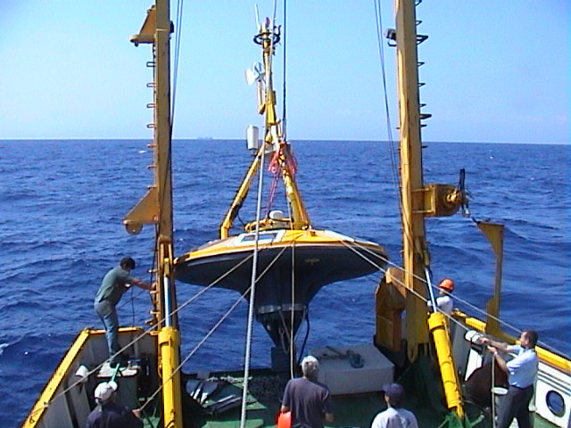
Role in the integrated global observing system:
Reference station for physical and biochemical measurements in oligotrophic seas

Contact Person:
Kostas NITTIS, knittis@hcmr.gr,
Tel: +30 22910 76400
Links / Web-sites: http://www.poseidon.ncmr.gr/M3A

provided by: Kostas Nittis, March 2005

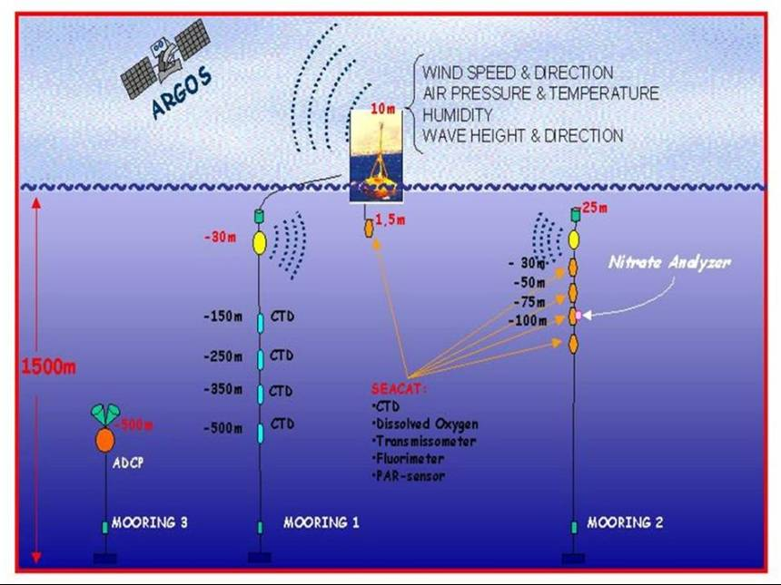 | Figure 1 Deployment of E2-M3A in the Cretan Sea from R/V Aegaeo  Figure 2  Outline of the E1-M3A system of the South Aegean Sea

