Site: DYFAMED (Dynamique des Flux Atmosphériques en Méditerranée)
Position: 43.25ºN 7.52ºE
Categories: physical, meteorological, biogeochemical observatory; (Atmospheric associated site 41°N 7.19E)
Figure 1: Map showing the location of DYFAMED
Safety distance for ship operations: see WEB site
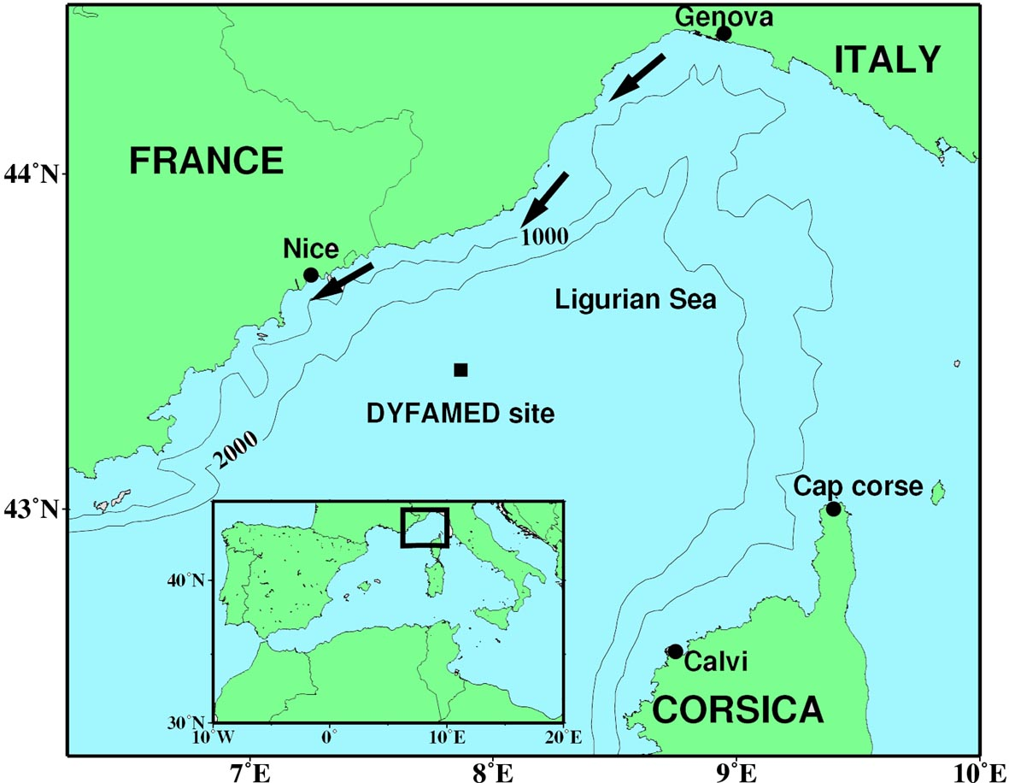
Short description:
- Two moorings are deployed on the site:
meteorological buoy “Cote d’Azur” and sediment trap mooring (traps at 200 and 100m).
- Field sampling began in 1986, pre-JGOFS, with a sediment trap mooring and atmospheric deposition survey (Cape Ferrat station) that were enhanced with a ship-based hydrology and biogeochemistry measurement program in 1991 that have continued to the present. Since 1991, monthly cruises have been conducted and most of the JGOFS core parameters (see table 1) recorded.
- The water column is 2630m depth and 22 depths are sampled in the water column each month.

Scientific rationale:
The central part of the western basin of the Mediterranean Sea constitutes a homogenous system isolated from direct coastal inputs by rivers but receive significant atmospheric input from deserts of the North Africa and from the industrialized countries bordering the Mediterranean Sea.
At this site, the seasonal succession of hydrological conditions induces production systems varying from mesotrophy in spring to oligotrophy in summer and fall.
The objectives of the DYFAMED program are as follow:
- to study the variations of hydrology and biogeochemistry at the seasonal and interannual scale
- to investigate the ecosystem response to atmospheric deposition events and to long-term environmental/climate forcing,
- to investigate and understand the ecological effects of meteorological forcing, especially the transition in community structure between spring mesotrophy and summer oligotrophy
- to estimate the air-to-sea exchange of carbon dioxide.

Groups / P.I.s /labs /countries involved / responsible:
DYFAMED is maintained by scientists from the Laboratoire d’Océanographie de Villefranche (Observatoire Océanologique de Villefranche) and of IAEA Marine Environmental Laboratory in Monaco (for sediment trap experiments).
Numerous ancillary projects and investigators take advantage of the core logistics, many of them contributing to the overall objectives of DYFAMED.
Scientific responsible :
J. C. Marty (marty@obs-vlfr.fr), Laboratoire d’Océanographie de Villefranche, Universite P. & M. Curie – CNRS – INSU, Observatoire Océanologique de Villefranche-sur-Mer, France.

Status:
- Operating
- time horizon : 30 years (?)
- Funded ; Funding is provided by INSU/CNRS.

Technology:
- moored and ship-based sensors
Approximately monthly field observations are conducted using the French R/V Téthys II which is operated by the Centre National de la Recherche Scientifique (CNRS) Institut National des Sciences de l’Univers (INSU) and home-ported in Marseilles (France). The interdisciplinary station work includes physical, chemical and biological observations and rate measurements (see Table 1). In March 1999, a meteorological buoy was deployed operated by Meteo France.

Table 1: DYFAMED Time-series station, Core Parameters

Parameter | Technique and Instrument
CTD Based Measurements (monthly since 1991)
Temperature  Salinity  Depth  Dissolved oxygen  Fluorescence | Thermistor SeaBird SBE911 plus  Conductivity sensor SeaBird SBE911 plus  Digiquartz pressure sensor SeaBird 911 plus  SeaBird Polarographic Oxygene Electrode  Chelsea Fluorometer
Discrete Measurements (monthly since 1991)
Salinity  Oxygen  Nitrates, Phosphates, Silicates  Particulate carbon  Particulate Nitrogen  Phytoplankton pigments  Bacteria  Zooplankton  Total Carbon dioxide  Alkalinity  PCO₂  Dissolved Organic Carbon  Total dissolved nitrogen | Conductivity on Guidline Autosal 8400A  Winkler titration  Alliance Inst. Autoanalyzer  High-temperature combustion Leco  High temperature combustion Leco  HPLC DAD detection  Flow cytometry  Net tows, wet & dry weights element analysis  High pre. acid titration Potentiometric detec.  High pre. acid titration Potentiometric detec  Carioca buoy  High temp. combustion oxidation  UV oxidation, Autoanalyzer
Rate Measurements (PP monthly since 1993) ; sediment traps(200 and 1000m since 1988)
Primary Production  Particle fluxes  Mass  Total Carbon  Total Nitrogen | Trace-metal clean, in situ Let GO, ¹⁴C uptake  Moored sediment traps (Technicap PPS 5)  Gravimetric analysis  High-temperature combustion Leco  High-temperature combustion Leco
Atmospheric measurements (since 1988)
Al, Na, Zn in total deposition | ICP AES
Meteorological data (operated by Météo-France) (since 1999) Real time.
Surface water and air Temperature  Wind speed and direction | Côte d’Azur Buoy

Data policy:
- delayed mode data: public for all variables listed above
- real-time data from meteorological Buoy are not public

Data management:
- Metadata scheme : informations from cruises
- Possibilities of evolution to comply with a more general JCOMM GTS scheme to be studied.

Societal value / Users / customers:
The primary societal value of DYFAMED observations is the contribution to understanding of the impacts of climate variability and anthropogenic inputs on the ecosystem and its role in the carbon cycle. DYFAMED provides a strong logistical and scientific framework for ancillary projects and development and test of new technologies (buoys CARIOCA…).

Role in the integrated global observing system:
Monitor the response at a decennal time scale of the Mediterranean sea ecosystem in reaction to climate evolution and anthropogenic inputs from industrialized areas of Europe and natural aerosols from north Africa.

Contact Person: JC Marty : marty@obs-vlfr.fr

Links / Web-sites:
- for Project information : http://www.obs-vlfr.fr/sodyf/
- for data access : http://www.obs-vlfr.fr/sodyf/

compiled by: Jean-Claude Marty, January 2005
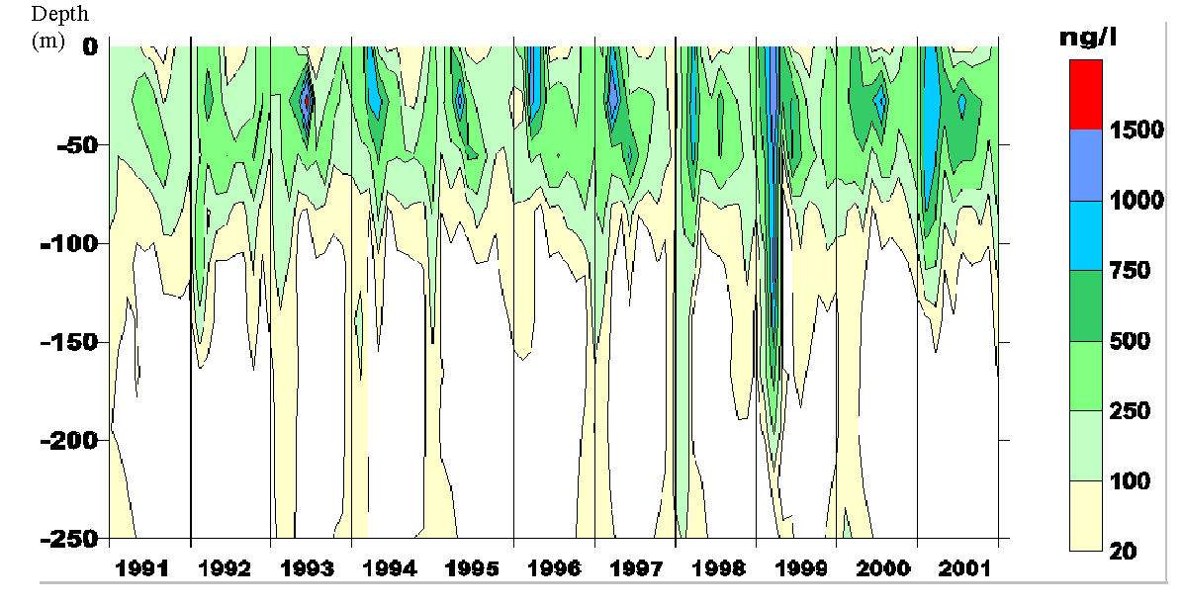
Figure 2: Time-series contour plot of chlorophyll a at the DYFAMED site (1991-2001), illustrating the increase of biomass.

