Site: Davis Strait
Position: 66º 30’ - 67º 30’ N, 54º 00’ - 62º 00’ W
Categories: operating, transport, physical

Safety distance for ship operations: 3 nm
Short description:
- number of moorings/stations and variables measured:
- 6 subsurface moorings (shallowest element at 100 m) measure:
- upper ocean currents, ice velocity and ice thickness with upward looking sonar (∆t = 5 min.) and ADCP (∆t = 30 min.) at 100 m
- C and T ( ∆t = 30 min.) at 100 m
- current, C, T (∆t = 30 min.) at 200 m or 250 m and at 500 m
- 8 trawl/iceberg-resistant bottom landers, four on each of the Greenland and Baffin shelves, measure:
- C and T (∆t = 30 min.)
- Two landers carry inductively coupled SBE Microcats in a subsurface floats at approximately 20 m. These sample at ∆t = 30 min. and log to a recorder housed in the lander.
- 3 of these landers: currents with ADCPs (∆t = 30 min.)
- 6 RAFOS sounds sources to provide navigation signals for autonomous Seagliders operating in the Strait (six broadcasts per day )
- 6 RAFOS receivers with data loggers mounted on the subsurface moorings to provide source-receiver ranges of 0 – 200 km to characterize attenuation as a function of stratification and overhead ice cover
- Acoustically navigated Seagliders will provide year-round, repeated, high-resolution hydrographic sections across the Strait
- Start date of the timeseries: first deployment September 2004
- service interval: annual servicing autumn 2005, 2006; planned final recovery autumn 2007.

Scientific rationale:
As part of coordinated domestic and international efforts to quantify the variability of fluxes connecting the Arctic and Atlantic Oceans and to understand the role played by the Arctic and sub-Arctic in steering decadal scale climate variability, we are developing an integrated observing system that will provide year-round measurements of volume, liquid freshwater and ice fluxes across Davis Strait. Fluxes through the Strait represent the net integrated Canadian Archipelago throughflow, modified by terrestrial inputs and oceanic processes during its southward transit through Baffin Bay. By the time they reach Davis Strait, Arctic waters already embody most of the transformations they undergo prior to exerting their influence on the deepwater formation sites in the Labrador Sea. This makes the Strait an ideal site for monitoring temporal and spatial variability in the critical upstream boundary condition for Labrador Sea convection. Measurements at Davis Strait will be used to study how fluctuations in the Arctic freshwater system modulate deep water formation to the south, thus influencing the associated meridional overturning circulation (MOC). By quantifying, with robust error estimates, the spatial and temporal variability of the Canadian Archipelago throughflow system at a location critical for assessing its impact on deep water formation in the North Atlantic, the observing system will make a major contribution to SEARCH and ARCSS objectives. In addition to the immediate impacts of improved estimates of freshwater inputs to the Labrador Sea, the array will provide an initial data set with which to study the relationships between Arctic freshwater system variability and large scale atmospheric fluctuations (e.g. the North Atlantic Oscillation (NAO)). The combination of emerging and existing technologies implemented in the observing system may serve as a prototype for accurate long-term monitoring of freshwater and ice fluxes in high latitude environments subject to seasonal or permanent ice cover.

Principal investigators:
Craig M. Lee, Richard Moritz and Jason I. Gobat
Applied Physics Laboratory, University of Washington, USA
Brian Petrie
Bedford Institute of Oceanography, CANADA

Status:
- first deployment September 2004, annual servicing autumn 2005, 2006
planned final recovery autumn 2007.
- funded by US National Science Foundation, Office of Polar Programs.
- Program manager: Dr. Neil Swanberg.

Technology:
- Subsurface moorings with: upward looking sonars for ice draft (with ADCPs measuring ice velocity), SBE MicroCATs and Aanderaa RCM 8
- trawl/iceberg-resistant bottom landers with SBE MicroCATs and ADCPs
- 780 Hz RAFOS sound field ensonifies the entire strait (100 – 200 km north and south)
- Autonomous Seagliders adapted to navigate under full ice cover using RAFOS sound sources. These will provide year-round, repeated, high-resolution hydrographic sections across the Strait. Gliders also provide access to the critical near-surface (< 100 m) region threatened by ice keels.
- During ice-free periods, glider data will be relayed at the conclusion of each dive by Iridium satellite telephone. The mooring do not have real-time telemetry.
- The combination of moored measurements, high-resolution glider sections and ULS/ADCP ice measurements will provide sections of absolute geostrophic velocity, T-S structure and ice thickness/motion that will be used to estimate volume and freshwater fluxes.
- Ship-based hydrography conducted during mooring cruises includes tracer measurements (e.g. nutrients, alkalinities, oxygen isotopes, trace metals, CFCs).
- Efforts are currently underway to incorporate acoustic receivers for tracking marine mammal populations, especially fin and bowhead whales.

Data policy: Delayed mode, public access. All variables.

Data management:
Will adhere to policies set by ARCSS data manager, including public release of data into forums defined by SEARCH and ASOF communities. Data will also be served from http://iop.apl.washington.edu and supplied to other systems as requested. Formats and metadata currently under consideration.

Societal value:
Physical oceanographic data will be valuable for climate studies and investigation of Arctic-subarctic interactions. Marine mammal data, with auxiliary ocean circulation and T-S measurements, will be used by the Greenlandic government to evaluate and modify whaling practices.

Role in the integrated global observing system:
Measurements at Davis Strait characterize the bulk of the freshwater exchange between the Arctic and North Atlantic west of Greenland, capturing the flow just prior to entering the Labrador Sea, after modification along its pathway. When combined with measurements at Hudson Strait, this quantifies the entire exchange through the Canadian Arctic Archipelago.

Contact Person:
Dr. Craig M. Lee
Applied Physics Laboratory
University of Washington
1013 NE 40th St
Seattle, WA 98105-6698
USA
+1-206-685-7656 (voice)
+1-206-543-6785 (fax)
craig@apl.washngton.edu
http://iop.apl.washington.edu

Web site: http://iop.apl.washington.edu

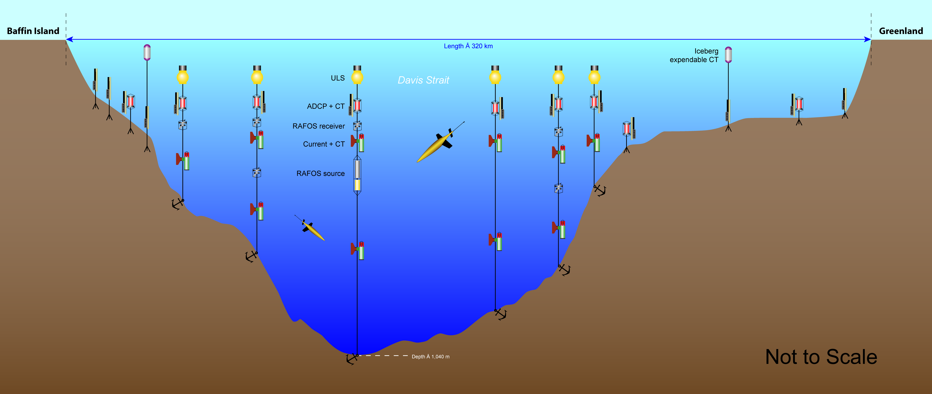
Figure 1. Cross-section Davis Strait array schematic. The Strait is approximately 300 km wide at the mooring line, with the broad Greenland shelf spanning nearly 100 km. Seagliders execute repeated sections between the 500 m isobaths along the mooring line. The five off-axis 780 Hz RAFOS sound source moorings are not depicted in this diagram.

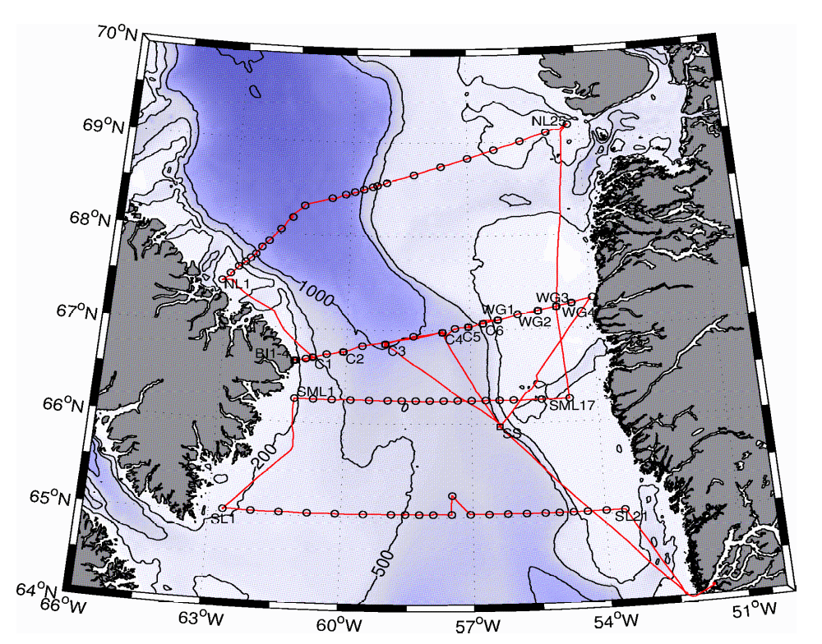
Figure 2. The Davis Strait region. Red lines mark the 2004 cruise track, with circles indicating hydrographic stations and labeled squares marking mooring sites (BI1-BI4, C1 – C6, WG1 – WG4, SS). Two RAFOS sources were deployed in 2004 (C3 and SS). Additional sources will be deployed at off-axis sites in autumn 2005. Seagliders will also begin operations in autumn 2005.

