Site: Iceland-Faroe inflow
Position: 63.3 - 62.7N, 6.1W
Categories: Transport, physical

Short description:
- 6 UL-ADCP moorings
- Variables measured: Currents, T and S
- Start date of the timeseries, service interval: 1997, every year

Scientific rationale:
Monitoring the one of the three current branches flowing from the Atlantic Ocean into the Nordic Seas. The heat transported along keeps the subarctic regions abnormally warm and by its import of salt, it helps maintain a high salinity and hence density in the surface waters as a precondition for thermohaline ventilation.

Groups / P.I.s /labs /countries responsible / involved: B. Hansen (FFL, UK)

Status:
- operating till 2006 under ASOF-EC(MOEN) project (EU funded)
- planned to continue but funding not secured yet

Technology:
6 uplooking ADCPs (currents, T and S sensors)

Data policy:
recent collected data are under the EC data policy and also will be subjected to the recently released CLIVAR data policy: http://www.clivar.org/data/data_policy.htm

Data management:
ASOF is forming a data management task team and the details of the ASOF data management will be defined this year. The general idea is to follow the CLIVAR data management.

Societal value / Users / customers:

Role in the integrated global observing system: Monitoring MOC

Contact Person: Bogi Hansen (BogiHan@frs.fo)

Links / Web-sites for Project information: http://www.bjerknes.uib.no/research/MOEN/index.html

Compiled by: Roberta Boscolo; March 2005

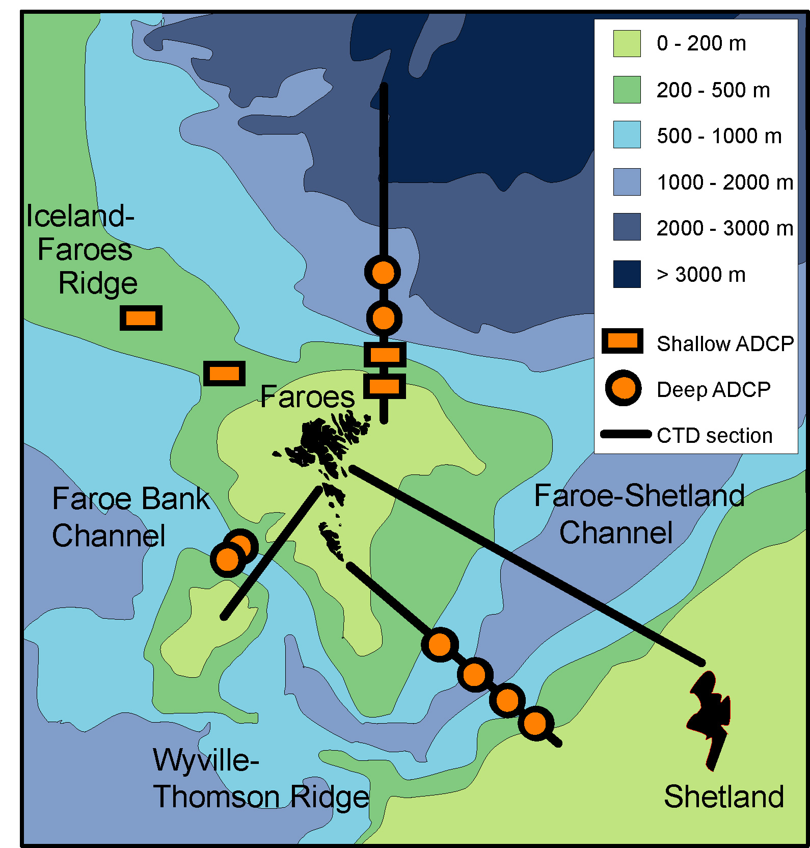 | Figure 1:  ADCP moorings presently collecting data between Iceland and Scotland
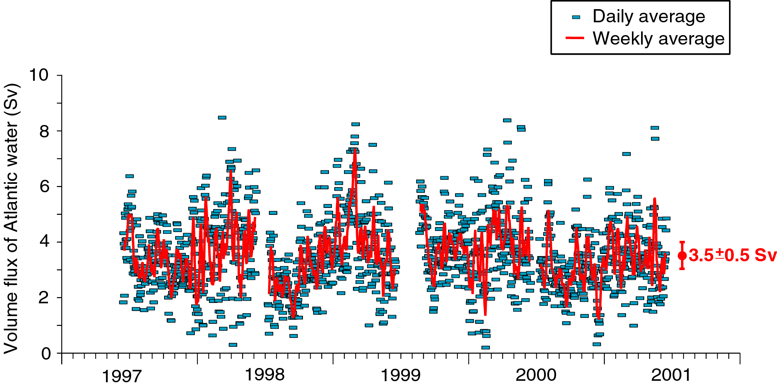
Figure 2: Iceland-Faroe Atlantic inflow volume flux

