Site: Florida Current
Position: About 27N, 79.5W
Categories: operating; transport; physical

Safety distance for ship operations: No dredging along cable path, which is marked on most charts
Short description:
- Single submarine cable spanning the Florida Straits
- Variables measured : Voltage measurements made every minute; result is transport values once per day (noon GMT).
- Start date of the timeseries, service interval: Cable observations made since 1982.

Scientific rationale:
The Florida Current is a strong oceanic current flowing northward along the eastern coast of Florida carrying warm tropical waters that eventually feed the Gulf Stream. The Florida Current represents both the western boundary current for the subtropical wind-driven gyre as well as a return pathway for the Thermohaline Overturning Cell, which consists of a slow circulation redistributing the waters of the world ocean based on sinking at the high latitudes and upwelling elsewhere. The Thermohaline Overturning Cell has been documented to have strong impacts on the global climate, and as such variations in the Florida
Current, which returns surface waters to the northern North Atlantic, represent an important climate signal to be monitored. Since 1982, NOAA has recognized the importance of long-term monitoring of the Florida Current and it has funded a project to monitor the transport variations of the current using a submarine cable and snapshot estimates made by shipboard instruments.

Groups / P.I.s /labs /countries involved / responsible:
Responsible parties: United States of America
National Oceanic and Atmospheric Administration
Atlantic Oceanographic and Meteorological Laboratory
Physical Oceanography Division
Dr. Christopher S. Meinen (currently lead Florida Current PI)
Dr. Molly O. Baringer (Western Boundary project lead PI)

Status:
- System is currently operating. A backup system is currently planned for a nearby cable.
- time horizon / long-term plans: Project is funded as part of the NOAA Observing System; to the extent possible the project will continue indefinitely.
- funding status, source of funding: NOAA provides funding for the project.

Technology:
- Project involves both a fixed submarine cable and ship-based sensors.
- Section data is collected in real time, cable data is obtained once per day.
- SST : Obtained on a limited subset of our project cruises via a flow through system. Data is not provided in real time.
- Profile measurements : On some cruises XBT and Dropsonde data are obtained, on others Lowered ADCP and CTD data are obtained.

Data policy:
- real-time data: Transport data from cable and section are public and are distributed via a web page.
- delayed mode data: Data from CTD and XBT systems are public, but are provided only upon request and are not real-time.

Data management:
- Real-time data processing and distribution system : Real-time processing is done at AOML and data are served in ASCII format via the web.
- Metadata scheme : Metadata is collected and distributed along with the data.

Societal value / Users / customers: Customers include: Climate modellers, coastal modellers, fisheries, pleasure-boaters, and Research Scientists

Role in the integrated global observing system: Represents part of the Western Boundary Time Series component of the NOAA global observing system.

Contact Person:
Dr. Christopher Meinen (305-361-4355) and/or Dr. Molly Baringer (305-361-4345).
Email addresses: Christopher.Meinen@noaa.gov ; Molly.Baringer@noaa.gov

Links / Web-sites: www.aoml.noaa.gov/phod/floridacurrent/

compiled by: Christopher Meinen (March 2005)

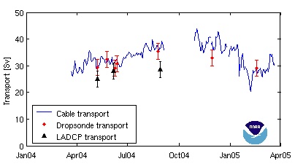 | Figure 1: Transport of the Florida Current at 27degN over the past year. Line indicates transports estimated from voltages measured on an abandoned submarine cable. Symbols indicate transport estimates from snapshot hydrographic sections using the instruments indicated in the legend; Dropsondes or Lowered Acoustic Doppler Profilers.
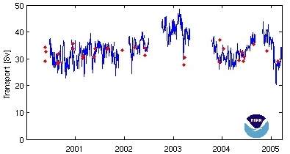 | Figure 2: Transport of the Florida Current at 27degN since 2000. Line gives transports estimated from cable voltages (three-day lowpass filtered applied), while red dots indicate transports from Dropsonde sections.

