Site: Gulf Stream
Position: 38.5N 65W
Categories: planned; Air-Sea Flux reference site; physical, meteorological

Safety distance for ship operations: 15 nautical miles
Short description:
- One surface mooring
- measured Variables:
- Surface meteorology (wind speed and direction, air temperature, sea surface temperature, sea surface salinity, relative humidity, incoming shortwave and longwave radiation, barometric pressure, and precipitation) measured every minute
- Temperature at fixed depths to 300 m, velocity at two depths near surface, salinity at three depths; internally recorded at 5 to 15 minute intervals
- Start date of the timeseries, service interval: First deployed November 2005; service November 2006; recovered November 2007

Scientific rationale:
The prime motivation for deploying a surface mooring capable of making accurate measurements of air-sea fluxes at the Gulf Stream flux reference site is that this is an area of intense air-sea interaction which remains poorly quantified in both observational and numerical model analyses. The strong air-sea temperature and humidity differences that occur over the Gulf Stream drive some of the global ocean's largest net heat losses to the atmosphere making this a key region in the coupled ocean-atmosphere system. Accurate in-situ observations of the air-sea exchanges are being made in support of a CLIVAR process study to examine the formation of 18°C mode water.

Groups / P.I.s /labs /countries involved / responsible:
The Gulf Stream surface mooring will be deployed by Dr. Robert Weller and the Upper Ocean Processes Group of the Woods Hole Oceanographic Institution, Woods Hole, MA, USA with support from the National Foundation. Dr. James Edson, U. Connecticutt, will install turbulent flux sensors on the surface buoy.

Status:
- Deployment planned for November 2005, recover and redeploy November 2006, recover November 2007.
- Long-term plans are to proposed this is a long-term Ocean Reference Station.
- November 2005 to November 2007 funded by the U.S. NSF.

Technology:
- Surface mooring.
- Telemetry of hourly averaged surface meteorology via Service Argos.
- Telemetered SST data comes from 1 m depth.
- Oceanographic instruments are internally recording point instruments.

Data policy:
- Real-time data: hourly surface meteorology available in near real time via website once deployed.
- Delayed mode data: Internally recorded surface meteorology, computed air-sea fluxes, and internally recorded oceanographic variables available via website after post-deployment calibration and quality control procedures

Data management:
- Satellite data collection system: Service ARGOS, plan transition to Iridium
- Real-time data processing and distribution system: Meteorology withheld from GTS to ensure value as independent data set; available in ascii format via website
- Metadata scheme: netCDF

Societal value / Users / customers:
- Serves as a benchmark or reference station for motivating/validating improvements to numerical weather prediction and climate models and remote sensing products and for anchoring new, more accurate regional and global fields of air-sea fluxes.
- Improves understanding of air-sea coupling and the processes that govern the evolution of SST in the Gulf stream region where there are large ocean-atmosphere exchanges and where 18°C water is formed.

Role in the integrated global observing system:
Occupies one of the most challenging high heat flux sites areas for atmospheric models and provides benchmark time series for improving/validating atmospheric models, for ground-truthing remotes sensing products, for anchoring air-sea flux fields, and for modeling how 18°C water is formed and carried into the interior of the ocean.

Links / Web-sites:
- for Project information : http://www.climode.org/
- for data access : To Be Established

Compiled by: Robert A. Weller (WHOI), February 2005

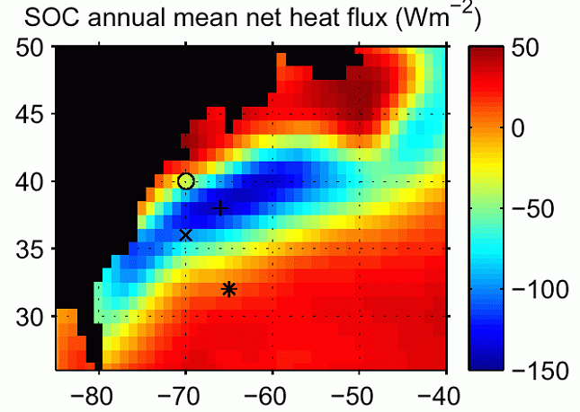

Figure Annual mean net heat flux in the Gulf Stream region from the SOC climatology. Symbols indicate the locations of the reference sites discussed in the text: Station W (open circle), BATS (star), originally proposed Gulf Stream site (cross), revised Gulf Stream site (plus sign).

