Site: LOCO North Atlantic (Irminger Sea)
Position: 59.25°N, 36-42°W
Categories: physical, biogeochemical observatory

Short description:
- 3 profiling CTD/ADCP moorings and 1sediment trap mooring
- Variables measured:
T,S: 100 to 2200 m (1 per day)
current speed and direction: upper 500m and lowest 500 m (1 per 30 min)
sediment flux: 2 and 250 m above bottom (1 per 2 weeks)
- Start date of the timeseries, service interval:
first deployment in August 2003, recovered and re-deployed in 2004
In July 2005 these moorings will be serviced and re-deployed, while a third profiling CTD mooring will also be deployed in 2005.

Scientific rationale:
From the Gulfstream system warm and saline water enters the sub-arctic North Atlantic Ocean. There its properties change due to air-sea interaction. In the cyclonic gyre of the North Atlantic Ocean Sub-Arctic Mode Water (SAMW) is progressively formed by convective mixing in successive winter. One of the last stages of SAMW is found in the centre of the cyclonic sub-gyre in Irminger Sea. Evidence is growing that in this ocean region occasionally deep convection occurs which homogenizes the water column to a depth of nearly 2000 m. The heat, released to the atmosphere during the transformation of Gulfstream water to the much cooler SAMW is an important factor for the North Atlantic climate.
Annual hydrographic surveys during the WOCE and CLIVAR programmes as well as satellite altimetry have shown that the inter-annual and seasonal variability of the hydrography in the Irminger Sea are of the same order of magnitude. Eddy variability is definitely smaller. How these different types of variability interact, and how convective mixing in winter depends on this variability is not well known. Therefore Royal Netherlands Institute for Sea Research (NIOZ) has started a monitoring programme with moored sensors in the summer of 2003.

Groups / P.I.s /labs /countries involved / responsible:
Department of Physical Oceanography, Royal NIOZ,
Dr. H.M. van Aken, Royal NIOZ, PO Box 59, 1790AB Den Burg, the Netherlands; e-mail: aken@nioz.nl
F. de Jong, MSc, Royal NIOZ, PO Box 59, 1790AB Den Burg, the Netherlands; e-mail, femke.de.jong@nioz.nl

Status:
- Operating
- time horizon / long-term plans: present to 2008.
- funding status, source of funding: Institute funding is available with additional funding for instrumentation obtained from Netherlands Organization for Scientific Research (NWO). Funding for an extension of the mooring period until 2010 has been applied for in a EU IP project.

Technology:
- Moored sensors
- daily temperature and salinity profiles measured by means of a McLane/FSI profiling CTD from ~100 to 2200 m (500m above the bottom)
- down looking ADCPs mounted to record the current profiles in the upper and lowest 500 m from the water column
- above the releases a self contained CTD (Seacat) has been mounted to record the near bottom salinity and temperature
- all instruments are self recording
- sediment trap mooring to monitor downward particle flux
- telemetry for real-time data is not available

Data policy:
- data public available in delayed mode, all variables

Data management:
- Metadata scheme: available vie NIOZ Data Management Group
- after data processing the delayed mode data will be made available via the NIOZ Data Management Group

Societal value / Users / customers: Climate related ocean research

Role in the integrated global observing system:
Monitoring of water mass modification and variability in the north-western North Atlantic Ocean

Contact Person: Dr. H.M. van Aken, Royal NIOZ, aken@nioz.nl

Links / Web-sites:
- for Project information : http://www.nioz.nl/fys
- for data access : http://www.nioz.nl/dmg

Compiled/ updated by: Hendrik van Aken, March 2005

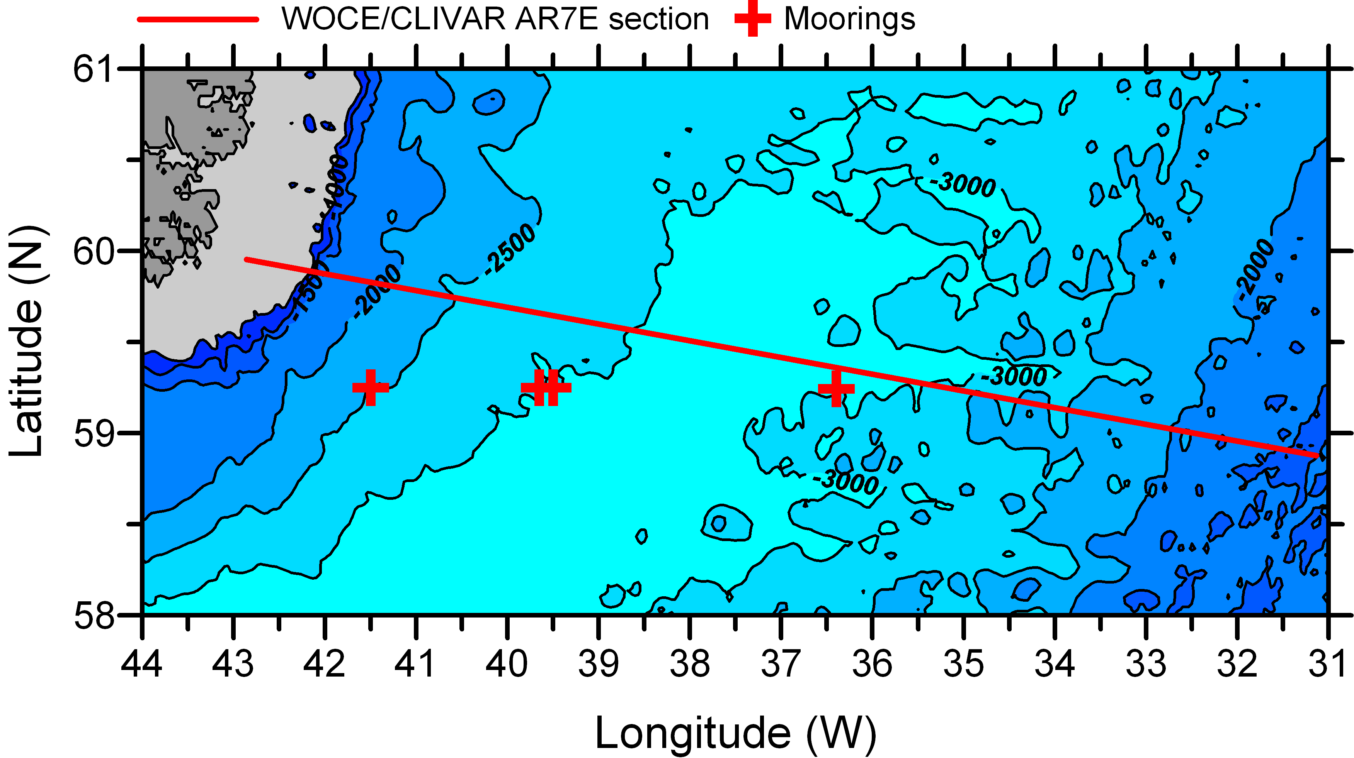

Figure: The approximate position of the LOCO north Atlantic moorings (red crosses). For reference the course of the WOCE A1E hydrographic section is shown as a red line.

