Site: K276, Azores Front / Madeira Abyssal Plain,
Position: 33°N 22°W, 5280 m

Categories:
- Observatory, physial and bio-geochemical measurements

Short description:
- Number of stations / moorings: 1 subsurface mooring
- Variables measured:
  - since 1980 currents and temperatures at 200, 500, 1000, 1600, 3000, 5230 m depth and partly additional depths every 2 h;
  - since 1993, biogeochemical fluxes in 2000 and 3000 m depth using particle traps, monthly to bi-monthly integrals.
- Serviced on annual to biannual scheme

Scientific rationale:
K276 was initiated as early as 1980 in the centre of the Madeira Abyssal Plain, 33°N, 022°W, 5280 m water depth, 240 nm west of Madeira. Originally designed to measure the frequency spectrum of meso-scale variability in the subtropical eastern North Atlantic in a deep ocean basin, its intention since 1993 is to create a long time series on an inter- and multidisciplinary basis in order to monitor and help understanding oceanic long-term variability at the northern rim of the North Atlantic's subtropical gyre on seasonal, interannual and decadal scales. While measurements at stations BATS and ESTOC represent inner-gyre conditions, K276 at the northern rim of the gyre is strongly influenced by the open-ocean Azores Front with its variability in physical properties and bio-geochemical fluxes which maybe related to the North Atlantic Oscillation. Physical measurements vertically cover all water masses in the eastern Atlantic. Bio-geochemical flux measurements are made in the deep water. Logistically, K276 is easy to reach by and be serviced with German research vessels in conjunction with other projects.

Groups / P.I.s /labs /countries involved / responsible:
Thomas J. Müller (tmueller@ifm-geomar.de ), IFM-GEOMAR Kiel, Germany
Detlef Schulz-Bull, IO Warnemünde, Germany

Status:
- Operated since 1980 (physical parameters) and 1993 (bio-geochemical fluxes)
- measuements will proceed into the future provided funding is available
- presently funded by national projects and instutional funding;

Technology:
- moored sensors; cross-frontal vmADCP and CTD/rosette casts during mooring services
- no real-time telemetry

Data policy:
- real-time data: not acquired
- delayed mode data: public 6 months after acqusition; use of data for publication in co-operation with the PI only.

Data management:
- Real-time data processing and distribution : presently not planned
- Metadata scheme (collection, distribution mean, format): IFM-GEOMAR formats

Societal value / Users / customers:
Delayed mode data has the potential to be used for model calibration

Role in the integrated global observing system:
K276 together with BATS and ESTOC, monitors the variability of the subtropical gyre of the North Atlantic.

Contact Person:
- for enquiry about addition of instrumentation or sensors to the site: Thomas J. Mueller, IFM-GEOMAR, Kiel, Germany, tmueller@ifm-geomar.de
- for possible ancillary measurements during cruises to the site: Thomas J. Mueller, IFM-GEOMAR, Kiel, Germany, tmueller@ifm-geomar.de

Links / Web-sites:
- for Project information : to be established
- for data access (if public) : to be established

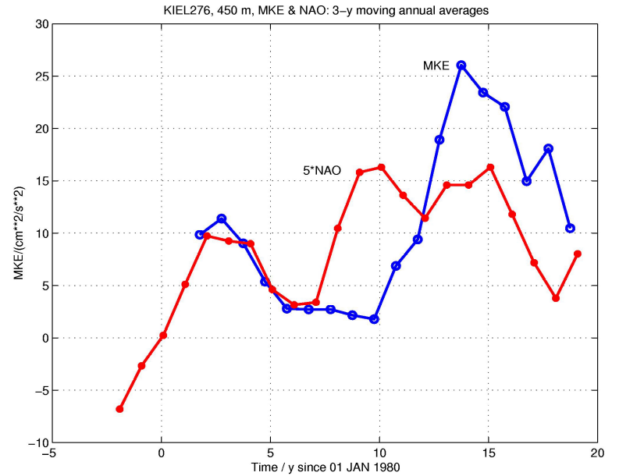

Figure 1: 20 year time series of the of mean kinetic energy per unit mass (MKE) at 450 m depth compared to the North Atlantic Oscillation (NAO) index, 3-y moving annual averages.

Compiled by: Thomas J. Mueller (Feb. 2006)

