Site: Repeat Hydrography Section AR7W, Labrador Sea
Position: 53º 41'N 55º 33'W to 60º 34'N 48º 14'W
Categories: Transport; physical, biogeochemical, CO2

Short description:
- 28 to 31 full depth Hydrographic / tracer sections crossing the Labrador shelf and Sea and the West Greenland shelf.
- Variables measured: Profiles are made with a dual sensor SeaBird CTD, a 24 bottle rosette and a LADCP system. Water samples are collected at up to 24 depths and analyzed for CFCs, total carbonate, alkalinity, DOC, POC, chlorophyll, plankton and nutrients. Samples are also collected for oxygen and salinity for CTD calibration purposes. Vertical net hauls are also done at most stations for zooplankton. Underway sampling for near surface T, S, chlorophyl, nutrients and velocity profiles is also conducted. Other tracers are collected by or for other groups on an ad hoc basis.
- Start date of timeserie, service interval: The section is occupied annually in May to July. The time series started in 1990.

Scientific rationale:
This repeat hydrographic section is of interest to the oceanographic and climate science community because it observes the interannual variability near the deep convection site for Labrador Sea Water and it continues the earlier OWS Bravo time series. Over the 60s and 70s, OWS Bravo documented the seasonal accumulation of freshwater in the upper layers over spring, summer and fall and the subsequent export of that freshwater to intermediate depths trough winter deep convection. It also documented the consequences when weak convection slowed that export mechanism and freshwater accumulated in the surface layers over several years. This station also documents the change of water properties and relative volumes of Labrador Sea Water, Northeast Atlantic Deep Water and Denmark Strait Overflow Water close to the main limb of the Atlantic Thermohaline Circulation. Repeated observations of carbon and other transient tracers at this site allow one to estimate the carbon flux into the North Atlantic deep and intermediate waters.

Groups / P.I.s /labs /countries involved / responsible:
Department of Fisheries and Oceans, BIO, Canada (Allyn Clarke and Igor Yashayaev) has expressed interest in continuing occupying AR7W on an annual basis. They have also indicated an interest in maintaining PALACE floats in the Labrador Sea.
Lamont (Schlosser), University of Washington (Rhines) have continued interest in collaborations related to this site.

Status:
BIO program is currently funded until 2005 but it is also identified as a Canadian contribution to GOOS so it should continue. The Canadian commitment is to occupy AR7W early each summer. It does not include a commitment for moored or autonomous instruments to observe the seasonal cycle.
In addition Canada currently (Feb 2005) has 10 profiling floats operating in the Labrador Sea.

Technology:
- Ship based sensors plus profiling floats
- real-time telemetry from profiling floats
- Profile measurements with CTD to full depth, profiling floats to 2000 metres

Data policy:
- Profiling float data T/S/P is public within 24 hours; oxygen data within 72 hours. CTD data is put on the GTS within 30 days.
- All data is public after delays for post cruise calibrations and final Q/C.

Data management:
CTD T/S data is encoded into a TSEAC messge in real time but these messages are not inserted onto the GTS until the vessel arrives back in port. This allows us to establish a preliminary calibration of the CTD at sea and produce a uniform CTD data set before the data goes to the GTS.

Societal value / Users / customers:
This is largely a climate program. This section (or this station) provides a dataset that can be used to determine whether state of the art climate models are adequately capturing changes in the Atlantic Thermohaline Circulation and oceanic heat transport. It will also provide an estimate of the sequestering of carbon by the North Atlantic. Principal users are governments through their climate research and assessment activities. There are some linkages between LSW variability and fisheries issues which are of interest to the Department of Fisheries and Oceans.

Role in the integrated global observing system:
Annual occupation of AR7W allows to continually check if climate and operational ocean models such as are being developed by GODAE are capturing the convective and mixing processes associated with the Atlantic Meridional Overturning Circulation.

Contact Person:
- for enquiry about addition of instrumentation or sensors to the site: Allyn Clarke
- for possible ancillary measurements during cruises to the site: Allyn Clarke

Links / Web-sites: -

compiled by: Allyn Clarke, March 2005

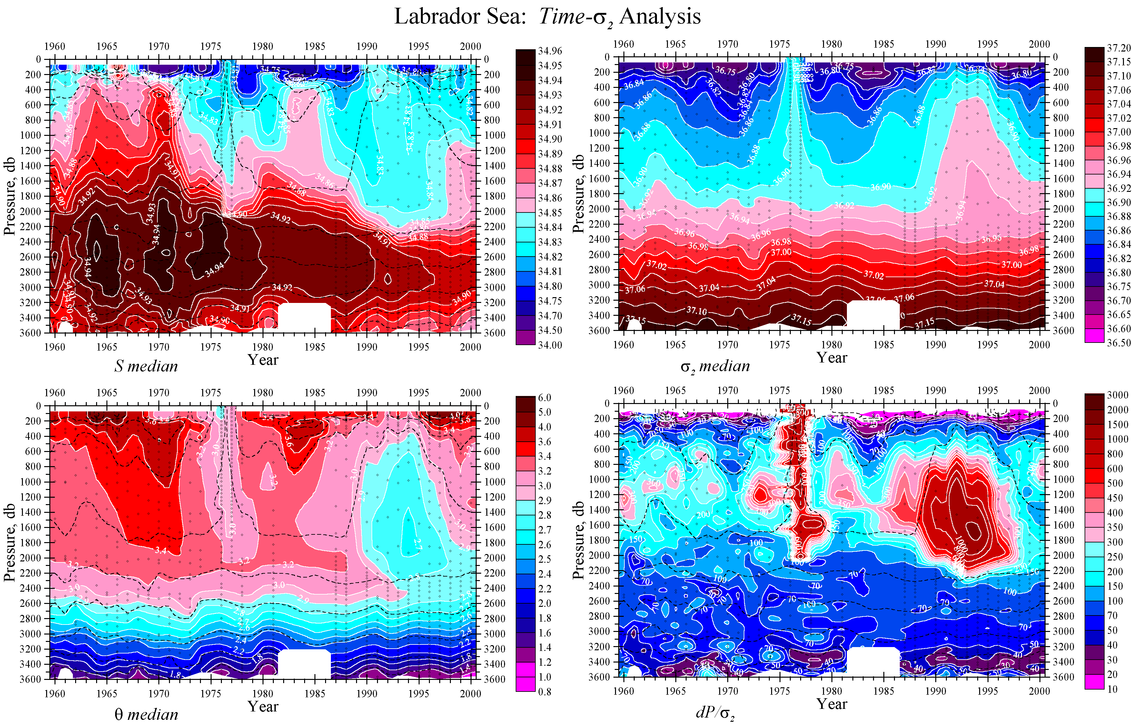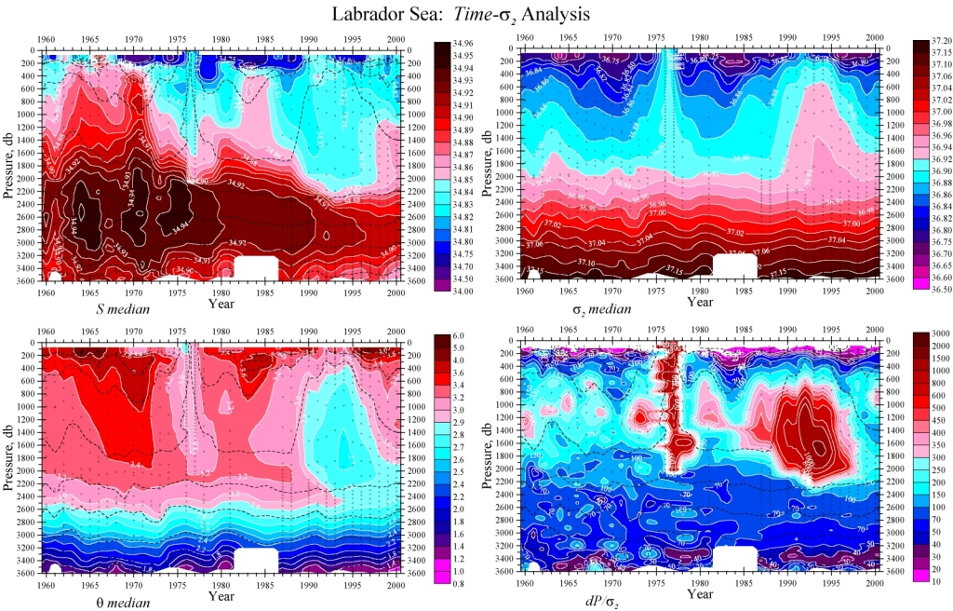
Figure 1:
Interannual changes of (a) salinity (b) potential temperature, (c) Sigma 2 and (d) potential vorticity in the Central Labrador Sea.

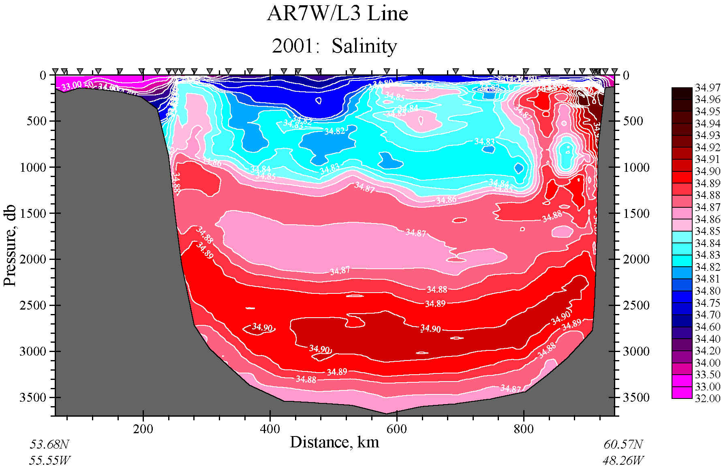 | Figure 2:  Salinity on the AR7W section across the Labrador Sea in June, 2001.

