Site: Labrador Sea export
Position: 53°N 51°W,
56° 31.5' N 52° 39.0' W,
55° 27.1' N 53° 43.8' W
Remarks:
- observatory, transport
- physical, convection site, water mass variability

Safety distance for ship operations: 2 nm
Short description:
- currently 3 moored stations (current meters, Seacats; no telemetry)
- deployed since 7/1999, exchanged for 2 more years in 2005

Scientific rationale:
To observe the deep circulation and its variability near the exit of the Labrador Sea in conjunction with the formation of Labrador Sea Water by deep convection. Water mass variability is measured by moored instruments, shipboard stations and profiling floats.

Groups / P.I.s /labs /countries involved / responsible:
J.Fischer , M. Visbeck and F. Schott, IFM-GEOMAR

Status:
- operating
- funded by Deutsche Forschungsgemeinschaft, SFB 460; funding until 2005;
for reduced continuation 2005-2007 funding is firm (3 stations)

Technology:
- moored sensors (current meters, Seacats – see figure 1)

Data policy:
- delayed mode data: available with restricted access

Data management:
- Metadata scheme: ascii

Societal value / Users / customers:
element of THC variability study system, comparison with model outputs.

Role in the integrated global observing system:

Contact Person:
- for possible ancillary measurements during cruises to the site: jfischer@ifm-geomar.de

Links / Web-sites for Project information: www.ifm-geomar.de

Compiled / updated by: Jürgen Fischer ( October 2005)
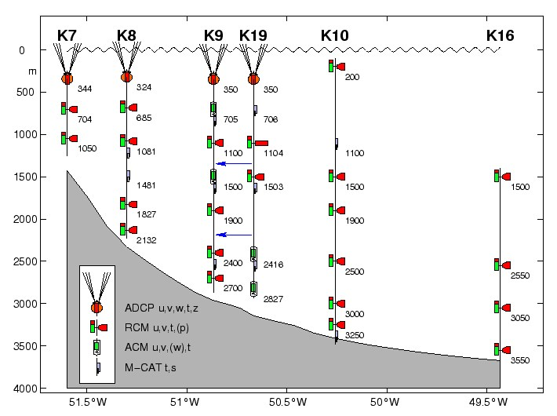
Figure 1
Instrumentation of the 53°N array (1997 - 1999); K9/19 are from the same location (indicated by arrows) for 1997-1998 (K9) and for 1998-1999 (K19).

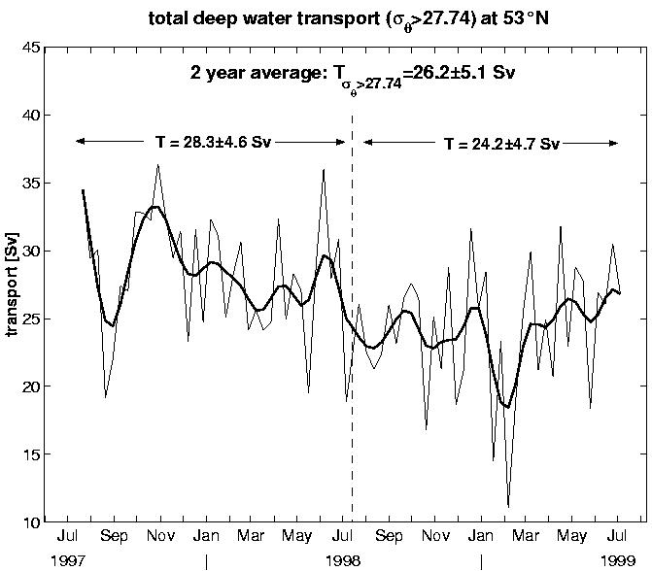

Figure2
Time series of total deep water transport in boundary current direction and below sigmatheta = 27.74 the upper limit of Labrador Sea Water. Thin line for 10-day means and solid for low pass filtered series (cut off at 60-days). Annual means and standard deviations are labelled.

