Site: Ligurian Sea, ODAS Italia 1 – W1-M3A
Position: 43.7894°N 009.1633°E
Categories: meteorological, physical

Safety distance for ship operations:
> 3 Km for conducting measurements at sea (e.g., CTD casts), otherwise no particular danger for the ship.
Short description:
- One station (the buoy) and a mooring close to the buoy including ADCP and CTDs.
- Variables measured:
Measured Variable | Level/Depth (m) | Sampling frequency
Horizontal wind speed | 14.5 | Hourly
Gust wind speed | 14.5 | Hourly
Direction from which the wind is blowing | 14.5 | Hourly
Short-wave solar radiation | 14.5 | Hourly
Long-wave solar radiation | 14.5 | Hourly
Dry bulb temperature | 10.0 | Hourly
Relative humidity | 10.0 | Hourly
Precipitation rate | 10.0 | Hourly
Atmospheric pressure | 8 m | Hourly
Average height of highest one third waves | - | Hourly
Direction of movement of waves | - | Hourly
Sea surface temperature | 0 | Hourly
Sea temperature | -6, -12, -20, -28, -36 | Hourly
Electrical conductivity | -6, -20, -36 | Hourly
Dissolved oxygen | -36 | Hourly
Turbidity | -36 | Hourly
Chlorophyll-a | -36 | Hourly
- Start date of the timeseries, service interval: February 2000 – January 2001, July 2002 - ongoing

Scientific rationale:
The Ligurian Sea (Western Mediterranean) is one of the most dynamically active and productive areas within the whole Mediterranean. A permanent cyclonic circulation with noticeable seasonal and interannual variability triggered by the Tyrrhenian current dominates the area. During the winter, processes of dense water formation often occur. The Ligurian Sea can be also clearly distinguished from all the other basins in the Mediterranean as to the number and variety of great pelagic fish: Cetaceans, Dolphins, Swordfish, Tuna that are present in the offshore waters, form the top level of an ecosystem distributed over a water column of more than 2000 m and strongly diversified as far as the planctonic components. Along the zooplancton trophic chains, this richness manifests itself with an abundance of the same species of krill that is present in the North-Atlantic (Meganyctyphanes Norvegica), representing a key-species in the trophic chains of large pelagics, directly (fin whales, young tuna, etc.) or indirectly (sperm whales, swordfish, etc.).
This area has been monitored for several years in terms of surface atmospheric and marine parameters also by performing regular research cruises.

Groups / P.I.s /labs /countries involved / responsible:

Research Centre | City - Country | P.I.
Consiglio Nazionale delle Ricerche - Istituto di Studi sui Sistemi Intelligenti per l’Automazione | Genova – ITALY | Roberto Bozzano
Consiglio Nazionale delle Ricerche - Istituto Scienze Marine | La Spezia - ITALY | Elisabetta Schiano
 | Trieste - ITALY | Stefania Sparnocchia
ENEA-CLIM | La Spezia - ITALY | Paola Picco

Status:
- operating
- time horizon / long-term plans: long-term – no “retirement” is foreseen except for maintenance purposes, or incidents and unexpected occurrences.
- funding status, source of funding: No funding on regular basis. Actually, only European research projects (MFSTEP, MERSEA) are supporting the activities.

Technology:
- “ODAS Italia 1” is a buoy moored by means of a long inverse catenary mooring; hence, it spans a watch circle of about 3 Km diameter. The water depth is about 1400 m.
It is a spar buoy, about 50 m long, with a steel pole body (0,6 m diameter) divided into four segments joint by flanges. The three upper segments are water-proof and the one in the middle has an enlarged portion to improve the buoy’s stability and buoyancy. The fourth segment is filled with water and has a stabilising disk which dampens the buoy vertical motion. A ballast hangs from below this segment.
A small laboratory unit is on top of the buoy body and consists of the following parts:
- a coupling, flanged segment with the same diameter of the lower buoy body is used as battery room.
- an indoor room (of about 3 cubic meter volume) partly cylindrical partly octagonal which can host up to eight cabinets with apparatus. Photovoltaic panels and a wind generator are mounted outside.
- a top trellis structure, about 14 m high from the sea surface with a short mast on top, holding most of the meteorological sensors, the flashing light and the antenna for the data communication.
The upper part of the indoor room is accessible through a ladder; a manhole leads to the laboratory unit. A narrow gallery around the laboratory offers access for maintenance of the photovoltaic panels. A radar reflector is positioned on top of the buoy.
- Acquired data are transferred via real-time telemetry.
- A water temperature sensor (SBE39) is positioned about 10 cm under the mean sea level.
- Six marine sensors (mainly CT) are positioned along the buoy body at different nominal depths (0, -6, -12, -20, -28, -36 m) hence providing a high coverage of the surface layer.

Data policy:
- Generally the data are only available through ad-hoc agreements and especially on the basis of working group involvement into research projects able to sustain and support the maintenance and further development of the observing system.
- Real-time data are only available through a static web page on which average values of a subset of most of the acquired parameters are included (Atmospheric pressure, Dry bulb temperature, Relative humidity, Horizontal wind speed, Wind direction relative to true north, Gust wind speed, Incident radiation, Long-wave incoming radiation, Precipitation rate, Platform heading relative to north, Sea temperature (0, -6, -12, -20, -28, -36 m), Electrical conductivity (-6, -20, -36 m), Dissolved oxygen (-36 m), Light transmission (-36 m)).
- Delayed mode data are usually only available to the partners of the project in which the buoy is involved. Within the framework of the European projects MFSTEP and MERSEA the following parameters are available: Atmospheric pressure, Dry bulb temperature, Relative humidity, Horizontal wind speed, Wind direction relative to true north, Gust wind speed, Incident radiation, Long-wave incoming radiation, Precipitation rate, Platform heading relative to north, Sea temperature (0, -6, -12, -20, -28, -36 m), Electrical conductivity (-6, -20, -36 m), Dissolved oxygen (-36 m), Light transmission (-36 m).

Data management:
- Satellite data collection system:
Actually, the Globalstar satellite communication network is used to transfer data to the receiving station ashore.
- Real-time data processing and distribution system :
Data quality control is applied in near-real time on a daily basis. Daily records are distributed to the partners of the European project through the Coriolis data centre (IFREMER, FR).
- Metadata scheme :
Quality controlled data are formatted in the Medatlas format and made available daily to the Coriolis data centre (IFREMER, FR).

Societal value / Users / customers:
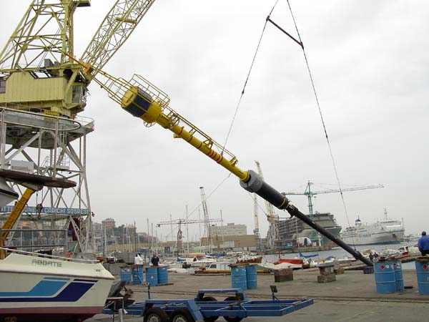
In the present phase, the main users are from the scientific community (model calibration and validation, assimilation and process studies).
Figure 1 An overall view of the buoy structure during the launch operation in April 2002.

Role in the integrated global observing system:
Reference station for physical and meteorological measurements

Contact Person:
Roberto Bozzano
CNR-ISSIA
Via de Marini 6
16149 Genova – ITALY
Phone: +39.010.64.75.656
Fax: +39.010.64.75.600
Email: boz@ge.issia.cnr.it

Links / Web-sites:
- for project information: http://www.odas.ge.issia.cnr.it
- for data access (if public): http://www.odas.ge.issia.cnr.it/Product/LastData.html

provided by: Roberto Bozano and Kostas Nittis, March 2005

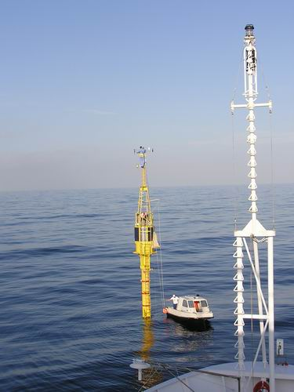

Figure 2 Maintenance operations on the top of the buoy and in the small laboratory inside.

