Site: NTAS (Northwest Tropical Atlantic Station)
Position: 15 º N 51 º W
Categories:
- operating
- Ocean Observatory, Air-Sea Flux reference site
- meteorological, physical

Safety distance for ship operations: 5 nm
Short description:
- 1 surface mooring
- Variables measured: surface meteorology at 1 min, subsurface T,S,U,V at various rates, <= 1 hr from 1 m to 150 m depth
- Start date of the timeseries, service interval: initiated March 2001, serviced annually

Scientific rationale:
The Northwest Tropical Atlantic Station (NTAS) flux reference site was established to document surface forcing in a region of the tropical Atlantic with strong SST anomalies and the likelihood of significant air-sea interaction on seasonal to decadal time scales. The modulation of the annual cycle of ITCZ migration, the degree to which SST variability is dominated by direct response to local surface fluxes on different time scales, the air-sea interaction processes controlling the cross-equatorial SST gradient, and the influence of the North Atlantic Oscillation (NAO) are among the outstanding questions in Tropical Atlantic Variability (TAV) research. The long-term goals of the NTAS project include investigation of (1) How well available air-sea flux products capture variability in surface forcing in the region, (2) The extent to which seasonal to interannual variability in SST is controlled by local forcing and (3) The impact of surface flux errors on seasonal to interannual SST variability. The NTAS site complements the existing PIRATA array and is co-located with the easternmost MOVE site.

Groups / P.I.s /labs /countries involved / responsible:
A. Plueddemann, Upper Ocean Processes Group, Woods Hole Oceanographic Institution, USA

Status:
- operating
- funded through 2006, 4 year continuation anticipated.
- funded by the NOAA Office of Climate Observation.

Technology:
- moored sensors
- real-time telemetry, hourly meteorology via Argos
- SBE-37 MicroCAT at ~1 m depth on mooring
- Discrete sensors along mooring line for T,S. Discrete sensors plus ADCP for currents.

Data policy:
- real-time data: public, surface meteorology (hourly)
- delayed mode data: public, surface met, fluxes, and subsurface data

Data management:
- Satellite data collection system: Present, Argos; future, Iridium
- Real-time data processed and distributed in NetCDF and ASCII by WHOI/UOP. See http://uop.whoi.edu/ntas.
- Metadata scheme: data archived in NetCDF, presently working towards compliance with OceanSITES, Cooperative Ocean/Atmosphere Research Data Service (COARDS) and Climate and Forecast (CF) conventions for the standardization of NetCDF files, and with the emerging Federal Geographic Data Committee (FGDC) framework data standard. Also participating in Marine Metadata Interoperability project (http://marinemetadata.org).
- Working with OceanSITES and MBARI MMI project (http://marinemetadata.org) to evolve metadata scheme.

Societal value / Users / customers:
The NTAS program contributes to the overall goals of the NOAA Climate Variability and Predictability (CLIVAR) program by improving understanding of surface fluxes and SST variability in seasonal to interannual time scales in a region of the tropical Atlantic influenced by a variety of climate-related phenomena.. CLIVAR goals include extending the range and accuracy of seasonal to interannual climate prediction and understanding and predicting the response of the ocean-atmosphere system to natural and anthropogenic climate change.

Role in the integrated global observing system:
This project directly addresses NOAAs Program Plan for Building a Sustained Ocean Observing System for Climate – Ocean Reference Stations, in synergy with other elements (Surface Drifting Buoy Network, Ships of Opportunity, Argo Profiling Floats, and satellites). The NTAS mooring also serves as a northwest extension of the PIRATA array.

Contact Person: Al Plueddemann, WHOI (aplueddemann@whoi.edu, 508-289-2789)

Links / Web-sites:
- for Project information : http://uop.whoi.edu/ntas
- for data access : http://uop.whoi.edu/ntas

Compiled by: Al Plueddemann (WHOI); March 2005

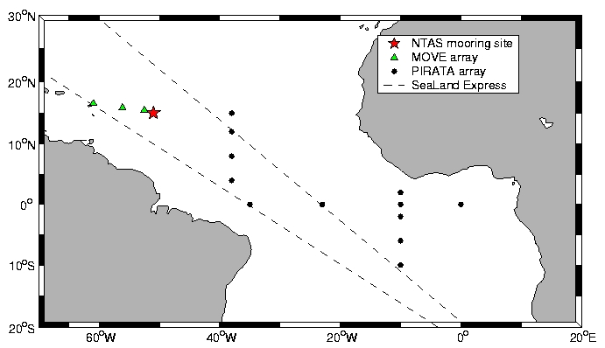 |  | Figure 1:  The NTAS mooring site in relation to the Meridional Overturning Variability Experiment (MOVE) moorings, the Pilot Research Moored Array in the Tropical Atlantic (PIRATA) and the track of the Volunteer Observing Ship Sealand Express (dashed lines).
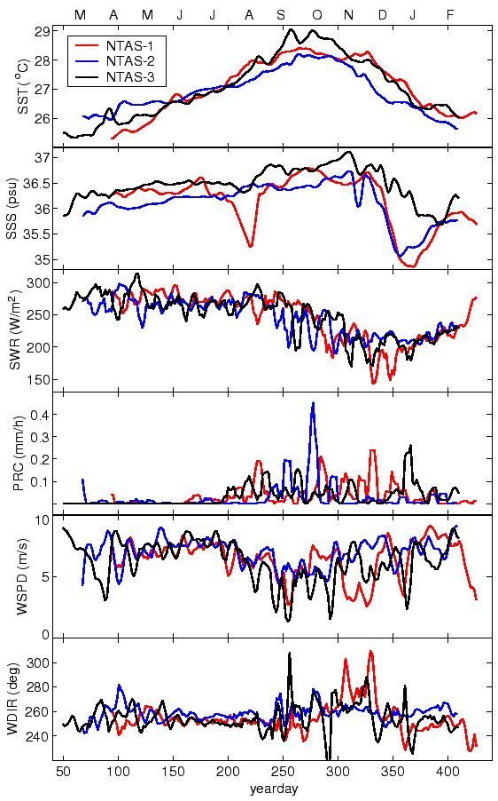 | Figure 2  The annual cycle of surface meteorology at the NTAS site as depicted by selected meteorological variables averaged over 1 week on a 13 month time base. Sea surface temperature (SST), sea surface salinity (SSS), downwelling shortwave radiation (SWR), precipitation rate (PRC), wind speed (WSPD) and wind direction (WDIR) are shown for deployments in 2001 (NTAS-1, red), 2002 (NTAS-2, blue) and 2003 (NTAS-3, black).

